Original Research Article
Economic Slowdown in China: A Reality Check for India’s Foreign Economic Policy

Abstract
Economic data from Beijing over the past years indicates the slumping GDP growth rate, elevated unemployment, rising deflation, and the sustained pace of trade surplus. It shows that all is not well with the world’s second-largest economy. The present study will examine the performance of the Chinese economy to India’s economy on indicators of GDP growth rate, unemployment rate, Inflation rate, and Balance of trade to do the evidence-based examination. Include at least two lines of the methodology The study finds that the relative performance of the Chinese economy is not so bad as to predict that China's growth is now gripped by a severe cyclical downward spiral that will persist for several years. It offers useful lessons to India’s foreign economic policy to reduce the trade deficit by importing critical raw materials from China for its import-competitive industries as the latter passes through a deflationary phase.

Key Words: Economic Slowdown, GDP growth rate, Unemployment Rate, Inflation Rate, and Balance of Trade, China, India.

Introduction
China is the primary factor influencing Indian foreign policy today. This is evident in India’s engagement in various regions South Asia, the Indian Ocean, Southeast Asia, the Indo-Pacific, with Russia, Europe and the US, and Africa. Furthermore, it has altered India’s trade, technology, and defence procurement policies. The rise of a global power on one’s doorstep, one that contests India’s territorial integrity and economic well-being, is bound to have transformative effects on one’s worldview. Therefore, India must understand the ongoing discussion and realities of China's economic slowdown.

Diplomacy is complex, encompassing various facets that shape the identity of a nation. China’s pivotal role in the global arena presents an opportunity to collaborate and leverage the rise of China, rather than expanding efforts to oppose or undermine it. A historical approach is required to understand China’s rise and its wherewithal to bear any short-term economic shocks. During the 1970s, China faced severe underinvestment in several sectors. To address this issue, Deng Xiaoping introduced reforms that opened up the economy. These reforms encouraged the establishment of rural enterprises and private businesses, as well as liberalised foreign trade and investment. However, the policy focused primarily on supply, rather than demand. As a result, China's GDP growth was driven by investments, rather than domestic consumption. Suppose China is often presumed to be pursuing power and interest-maximising aims via its foreign economic and commercial policies and tools. In that case, it is also usually assumed that China is highly capable of achieving those aims via its economic statecraft. Two factors are especially important in such assumptions: 1) the overall size and rapid growth of China’s economy that provide ample resources for use in economic statecraft and 2) the Chinese state’s influence over the economy and in particular its control over firms and banks, especially those directly owned by the state (Ferchen & Mattlin 2023, p. 981).

China has emphasised that the boundary issue is not the sole aspect of China-India relations. It should be viewed in the proper context within bilateral ties and handled accordingly. However, for mercantilist China, business is the real motto. This understanding is the key to decoding the nature of Chinese mercantilism, which in turn aids in unravelling the causes of the economic slowdown in China. The rise of Party-State nationalism in alignment with China indicates that the country's mercantile expansion is well-supported. Mercantilism in China is shaping its engagement terms within what is ostensibly a free market economy. The country's control over numerous product categories poses a risk of economic coercion, as the government can limit access to vital inputs for political gain. This is particularly apparent in the export of rare earth and critical minerals, which are crucial for the green transition efforts of various countries. For instance, China had asked its carmakers not to export their EV technology to India (Linda 2024). Any economic deceleration appears to be a temporary reorganisation aimed at moulding the economy to achieve its mercantile objectives. This also reflects the Chinese economy’s ability to adapt, suggesting that the core economic indicators are not susceptible to short-term variations. For instance, the standoff in eastern Ladakh has halted all aspects of bilateral relations, except trade.

Moreover, China has proposed the Beijing Consensus to play the game of liberal world order using Chinese cards. Beijing Consensus focuses on managed globalisation, industrial policy, and state capitalism (Berkshire Publishing Group LLC 2009, pp. 170- 171). It was developed to characterise the Chinese development model. It does not claim the existence of any universal value and principle. China’s Belt and Road Initiative (BRI), sometimes referred to as the New Silk Road, seems to be the logical outcome of the Beijing Consensus at the multilateral level. The BRI has been based on six principles: (1) policy coordination (2) infrastructure connectivity (3) trade (4) financial integration (5) people-to-people connections, and (6) Industrial cooperation. Basically, through the BRI, China wanted to resolve two major concerns, viz capital surplus and industrial overcapacity (Sachdeva 2023). Thus, it was the economic might that seemed to drive geopolitical narratives. India has reciprocated in kind and leveraged China's dominance in Active Pharmaceutical Ingredients (API) to bolster its pharmaceutical exports.

Dhaval Joshi of BCA Research pointed out in a report by The Guardian that China has generated 41% of the world’s growth in the past decade, nearly twice the 22% contribution from the U.S., and way more than the 9% contribution from the euro area. This means that China has generated 1.1 percentage points of the 2.6% real growth rate of the world economy (cited by Diksha Munjal, The Hindu). It made up this big chunk of the global growth because its economy was growing at about 8-9% a year. Now that its growth rate is half of that — its contribution would also be halved to about 0.5 points (Elliot 2023). It all shows China’s strategic economic depth and viability to establish itself as the new hub of the world economy. Furthermore, imports from China to India have surged, despite the imposition of restrictions. In 2023-24, imports from China exceeded $100 billion, up from $60 billion in 2014- 15. While the trade between India and China favours the latter, it's important to note that China's exports to India account for less than 3% of its total exports, while India's exports to China make up 3.6% of its total exports (tradingeconomies.com 2024 India Imports from China). This suggests that both countries have relatively low trade dependency on each other. However, India's consistent trade deficit indicates that boycotting Chinese goods would lead to Indian consumers paying higher prices for these imports from other markets. Moreover, given China's integral role in global supply chains, it is a challenge for India to disengage.

Additionally, from 1995 to 2012, Germany, Europe’s economic powerhouse, enhanced its industrial value by 37%, the largest chunk of which came from the supply chains of China (Gokhle 2021). Recent studies point to Australian GDP decreasing by 0.1 to 0.2% in response to a 1% fall in the Chinese GDP (Laurenceson & Zhou 2019). Furthermore, the widely discussed ‘China plus one’ narrative is also there. Contrary to popular belief, it does not imply that companies are relocating their operations from China to another location. Instead, it signifies that they are mitigating risks. 'China plus One' also refers to Chinese firms establishing branches closer to their markets, such as in Thailand, Malaysia, and Vietnam, among other regions (Hsu 2021). While the ‘China plus one’ phenomenon represents only a small portion of China's total production and exports, it is nonetheless indicative of a trend where both Chinese and multinational companies are moving away from an exclusive reliance on China-based operations. However, the China-Plus-One strategy is not about Western and global multinationals leaving China or relocating their facilities to countries like India. Major multinationals are not moving away from China significantly; US-China trade is thriving (Bhaswar Kumar 2024). The essence of China-Plus-One is to seek additional options beyond Beijing. For India, the choice isn’t between import substitution and total reliance on China. Rather, India should implement a China-Plus-One approach for imports to identify alternative sources and achieve diversification.
This illustrates China’s centrality in the global political economy. Moreover, For Adam Smith, ‘there is a great deal of ruin in a nation’. It means that the world can ill afford a shrinking economic pie of China. When China’s growth rate rises by 1 percentage point, growth in other countries increases by around 0.3 percentage points (Cerdeiro and Jain-Chandra 2023). China’s centrality in the global political economy and limitations of investment and export-led growth strategy due to the uncertain global economy might encourage it for long-needed reforms to substitute investment-led to consumption-led growth strategy to avoid the deflationary trends amid rising unemployment. Moreover, understanding China is crucial as it has emerged as a significant player, posing challenges across all key policy domains. Evaluating Chinese influence shapes our strategies within our immediate and broader neighbourhood, influencing our stance towards other major powers and international institutions. Moreover, “strategic autonomy” and “multi-alignment” have replaced the traditional concepts of “non-alignment” for an ascending India that is poised to be the third-largest economy. An India aspiring to achieve developed nation status by 2047 warrants a fresh strategic vocabulary and a novel geo-economic and geopolitical syntax.

Moreover, the global pandemic and the Russia-Ukraine conflict have jointly expedited the systemic shift that has been gradually unfolding since the 2008 financial crisis. Domestically, countries are experiencing a weakening of institutional resilience and an increase in socio-economic disparities. Internationally, there is a decline in investment in cooperative practices and institutions, a rise in inflationary competition for limited resources, and a deepening of geostrategic divisions. The shift towards protectionism, decoupling, and the weaponisation of interdependence can be attributed to both domestic political dynamics and strategic imperatives, signalling a system in dire need of upkeep and at risk of fragmentation.

This article will analyse the long-term GDP growth rate, unemployment rate, inflation rate, and balance of trade of China and India, covering both pre-pandemic and post-pandemic periods. It will serve two purposes: first, to compare the performance of these two Asian giants during a global economic slowdown, and second, to present a realistic picture of China's economic slowdown for India's foreign economic policy. These indicators are essential in determining the economic fundamentals of a country and justify political correctness. They also illustrate how economic determinants influence foreign economic policies. It focuses on China’s economic slowdown and its implications for India’s foreign economic policy (FEP).
Methodology
The proposed study will be conducted using empirical, analytical, and descriptive frameworks. Data from the past ten years, covering pre-pandemic and post-pandemic periods, on China and India's GDP growth rate, unemployment rate, inflation rate, and balance of trade will be analysed for two purposes; firstly, to compare the performance of these two Asian giants during a global economic slowdown, and secondly, to avoid the impact of short-term fluctuations. These indicators determine the economic fundamentals of the country and justify political correctness. Moreover, they illustrate how economic determinism influences foreign economic policies. The study’s time frame coincides with the change in political regimes in both countries, China and India, in 2013 and 2014, respectively. Both primary and secondary sources will be utilised.

Results and discussion

An Assessment of the Chinese Economy
The data of China on indicators such as GDP growth rate, unemployment rate, Inflation rate, and Balance of trade has been examined to study the economic performance in an uncertain global economy.

Fig 1-GDP Annual Growth Rate
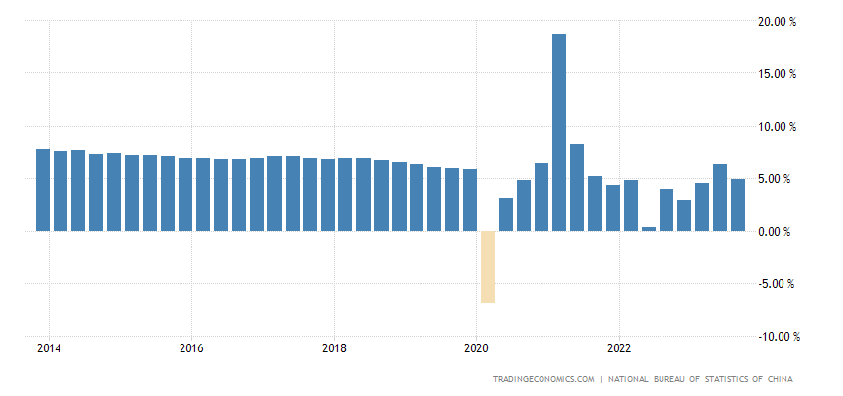

Source: China GDP Annual Growth Rate (tradingeconomics.com)

China’s economy has revolved around a 5 to 6% growth rate in these years. After a strong rebound in the first half of 2021, economic activity in China cooled rapidly in the second half of this year. The slowdown reflects less favourable base effects, diminished export support, and the government’s continued deleveraging efforts (The World Bank 2021, p. 6). The data from 2014 onwards explains no significant diversion from the average trend. “The national economy continued to recover, and high-quality development was solidly advanced, laying a solid foundation to attain the annual development goals.” In September 2023 alone, retail sales went up the most in 4 months, up for the 9th consecutive month; and industrial output growth stayed at its highest level since April. Meantime, the surveyed jobless rate fell to a 22-month low of 5%, while fixed investment continued to grow in the first 9 months of 2023. Data released earlier showed exports fell slower, partly because of a peak shipping season for Christmas products. Considering the first 9 months of the year, the economy advanced 5.2%. Last year, the GDP added 3%, missing the official goal of about 5.5% (Tradingeconomies.com 2024 China GDP Annual Growth Rate). China posted 4.9% growth in the July to September quarter from a year earlier, stronger than the median forecast for 4.6% (Tan 2023).
Unemployment Rate
China’s average unemployment rate hovers around 4.50 to 5% over the years since 2018. China's surveyed urban unemployment rate declined to 5.0% in September 2023 from 5.2% in August. It was the lowest jobless rate since November 2021.
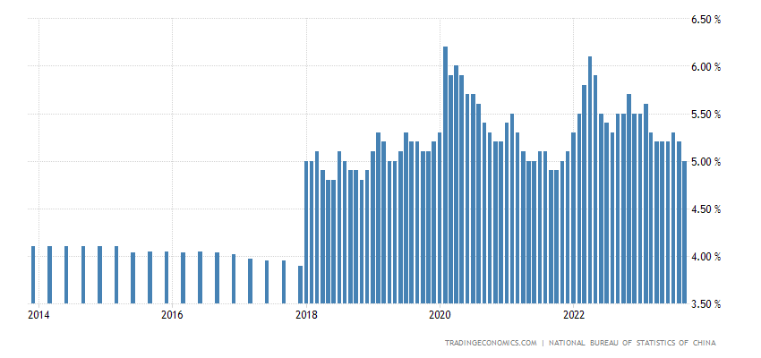
Fig 2- Bar graph showing Unemployment Rate
Source: China Unemployment Rate (tradingeconomics.com)
China's surveyed urban unemployment rate declined to 5.5% in December 2022 from November's six-month high of 5.7% amid easing zero-COVID policy restrictions. Around 70% of young people in China now go to university and so expect to get a white-collar job afterwards. They want desk jobs, staring at computers. But that's not possible (Hoskins 2023). The creation of gainful employment for an educated urban population seems to a major challenge for China. However, the theoretical proposition of the Phillips Curve argues that the deflationary trends amid unemployment leave space for increasing the employment rate through monetary and fiscal support as well as accelerated structural reforms.

Inflation Rate
However, China has been in quite a unique position. Unlike India, where average inflation rate hovers around 6.7% over the recent years, China has barely touched an inflation rate of 2%. As such, it does not need to worry about containing inflation. Their problem is increasingly sustaining the momentum of economic growth. Falling retail prices could lead households to postpone consumption on the expectation that goods would become cheaper tomorrow. That would reduce consumption and economic growth and lead to persistent deflation. Chinese households are sitting atop the biggest pool of new savings in history — accumulating $2.6tn of bank deposits last year alone as strict anti-coronavirus policies crushed consumer spending. The anticipation of a wave of pent-up demand, with consumers opening their wallets after China shifted decisively to tackling the pandemic, is underpinning hopes for a global economic recovery (The State Council of People’s Republic of China 2024, December 19).
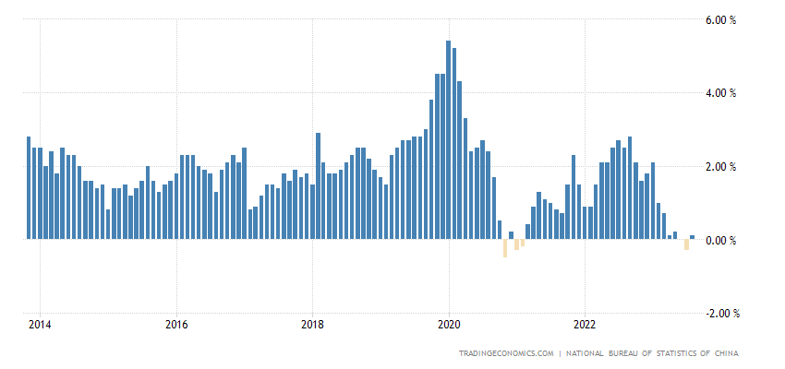
Source: China Inflation Rate (tradingeconomics.com)
Fig 3- Bar graph showing Inflation Rate
As a measure to ease the pain the Keynesian efforts to pump priming and leveraging the economy to arouse animal spirit and effective demand in the economy are recommended. China’s central bank has cut one of its key interest rates for the second time in three months as the world's second-largest economy struggles to bounce back from the pandemic (Hoskins 2023).
China’s Balance of Trade
China’s average trade surplus has been more than $50 billion US since 2014. Many countries are highly dependent on China for the imports of critical items. It has ensured China being the epicentre of global political economy. For instance, China supplies more than 90% of India’s Active Pharmaceutical Ingredient (API). Additionally, the trade between India and China touched an all-time high of USD 135.98 billion in 2022, while New Delhi's trade deficit with Beijing crossed the USD 100 billion mark for the first time despite frosty bilateral relations (The Economic Times 2023). However, the API that India imports serve as the raw material for our pharmaceutical industry. Once processed into medicines, its value increases manifold upon usage and export. China’s mercantilist practices are policies that prioritise the country’s economic interests over other countries’ interests. These practices are aimed at promoting exports and limiting imports to protect domestic industries. Consequently, China has amassed a significant trade surplus with its trading partners. For instance, according to Chinese customs data, bilateral trade between India and China in 2021 stood at 125.66 billion USD, up 43.3 per cent from 2020 when bilateral trade was worth USD 87.6 billion.
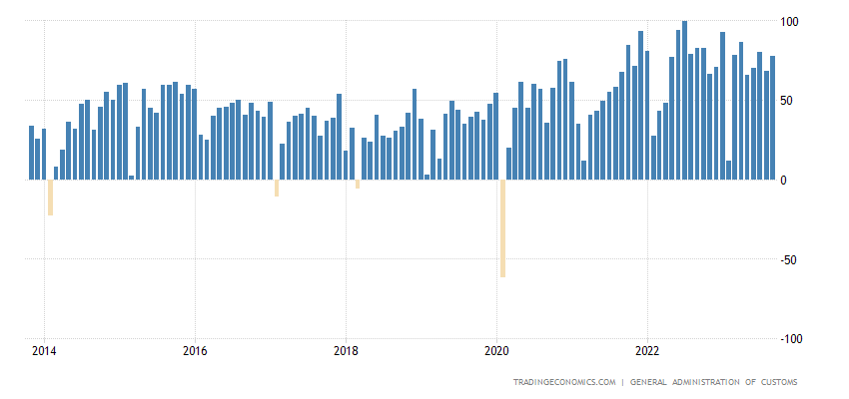
Source: China Balance of Trade (tradingeconomics.com)
Fig 4-Bar graph showing China’s Balance of Trade
China displaced India as Bangladesh’s top trading partner in 2015 and imports from China represented 34 % of Bangladesh’s total imports in 2019 (Chengappa 2022). However, China's higher tariffs on textile and clothing discourage the imports from India thereby utilising its comparative advantage in this area. Meanwhile, a protected Chinese textile and clothing industry has led to China becoming the world’s biggest exporter of clothing accounting for 1/3rd of global exports in 2021with $176 billion far ahead of Bangladesh (2nd largest textile exporting country with $34 billion) and India (5th largest textile exporter with &16 billion) (Leading clothing exporters by value worldwide 2021 | Statista).

China’s lower MFN tariffs on raw materials and intermediates favour the development of technically advanced industries. Trade deficits can destabilise the domestic economy but importing raw materials and intermediate goods can raise domestic competitiveness, providing better access to technology and keeping inflation low. China is better suited to exporting both low and high-end manufactured items, raw materials, and minerals to India. It plays an important role in refining strategic minerals, such as nickel, copper, lithium, and cobalt, with percentages ranging from 40% to 73% (Castillo, Rodrigo & Caitlin Purdy 2022, pp. 6- 8). China's dominance in key industries raises concerns about India’s dependence and highlights its strong global economic position. According to Biswajit Dhar, there are certain reasons behind India’s widening trade deficit with China. First, the viability and mobility of the Chinese economy to new development paradigms by shifting either towards the international market or its domestic market at will. Second, China imports a lot of raw materials in the form of iron ores and metals from India and exports a lot of finished or value-added products to India (Krishnakutty 2022). India has been in sustained trade deficits mainly due to the strong growth of imports, particularly of mineral fuels, oils and waxes, bituminous substances and pearls, precious and semi-precious stones and jewellery.

Moreover, China’s annual Central Economic Work Conference (CEWC) prioritises boosting household consumption in 2025. To achieve this, the government plans targeted fiscal policies, including subsidies for low-income households, enhanced pension benefits, and support for sectors like the debut economy, ice and snow economy, and silver economy. These measures aim to reignite consumption and sustain short-term economic recovery. The fiscal deficit ceiling will also rise to approximately 4 percent from 3 percent of GDP, enabling more investment in infrastructure and public services. It advocates for a “new development paradigm” focused on boosting domestic demand and advancing indigenous technology (The State Council of People’s Republic of China 2024, December 12).

An Assessment of the Indian Economy
The analysis of China’s economic performance on indicators of GDP growth rate, unemployment rate, Inflation rate, and Balance of trade has provided critical insight to explore economic determinism to drive India’s foreign Economic Policy (FEP). The similar indicators have been employed for India to examine the relative performance of India’s economy and suggest measures through which India can productively engage China.

Annual GDP Growth Rate
The average annual GDP growth rate in India has been 6 to 8% since 2014. As a result, it has been one of the fastest growing economies of the world. China is the only competitive country with India. There is much similarity in data points on this front. The current economic performance has slowed down, somewhat equally, in both India and China. However, GDP growth rate of India and China during pre-pandemic (FY 2018-2020) has been 5.7% and 6.5%, respectively which turned into 3.5% and 4.6%, respectively, during post-pandemic period (FY 2021- 2023).
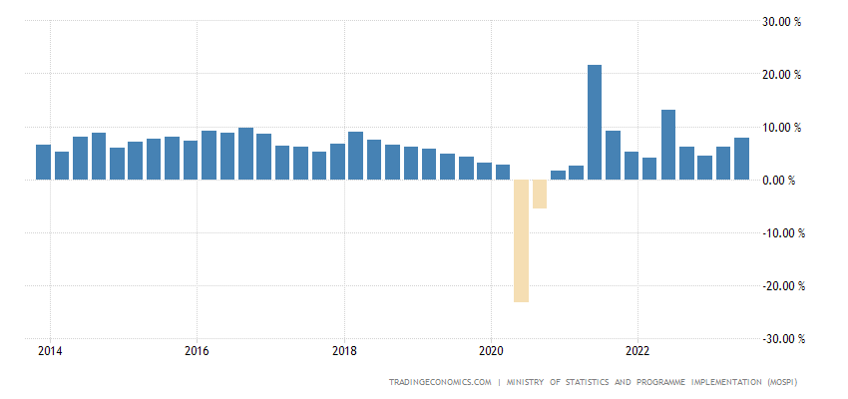
Fig 5- Annual GDP Growth Rate
Source: India GDP Annual Growth Rate (tradingeconomics.com)
The Indian services sector, which includes trade, hotels, transport, communication, financing, insurance, real estate, business, community, social, and personal services, is the country’s most significant and fastest-growing sector, contributing over 60% to its GDP. Agriculture, forestry, and fishing constitute 12% of the output but employ over 50% of the labour force, while manufacturing, construction, and mining, quarrying, electricity, gas, and water supply contribute 15%, 8%, and 5% respectively to the GDP (Tradingeconomies.com 2024 India GDP Annual Growth Rate). The labour force employed in Agriculture, forestry, and fishing signals shifting of excess labour force to manufacturing and services. India’s FEP can engage China to advance its manufacturing sector as the latter is in the grip of deflationary phase; that can ensure imports of items in India’s import competitive sectors at competitive prices.

Unemployment Rate
India's unemployment rate increased to its highest level in over two years in October, primarily due to rising joblessness in rural areas, according to data from the Centre for Monitoring Indian Economy Ltd. The overall unemployment rate rose to 10.05% in October, up from 7.09% in September, marking the highest rate since May 2021 (Bhatia 2023).
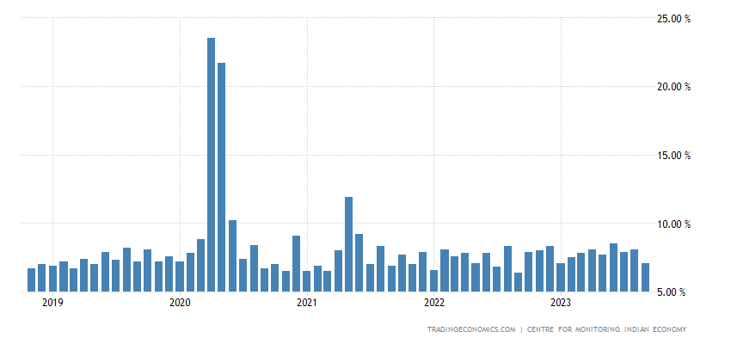
Fig 6- Unemployment Rate from 2019 to 2023
Source: India Unemployment Rate (tradingeconomics.com).
The country's unemployment rate stood at a 45-year-high of 6.1 per cent in 2017-18, according to the National Sample Survey Office’s (NSSO's) periodic labour force survey (Jha 2019). In comparison to China, the Indian economy has performed badly to create enough employment for its growing labour force. One of the reasons cited is the underdeveloped manufacturing sector that could have been the major source of employment drawing excess labour from agriculture, forestry, and fishing sectors.

Inflation Rate
Unlike China, where average inflation rate hovers around 2% over the recent years, India has touched an inflation rate of 6.7%. Moreover, the average annual GDP growth rate in India has been 6 to 8% since 2014. The higher inflation and higher unemployment rate signal the stagflation in the Indian economy.

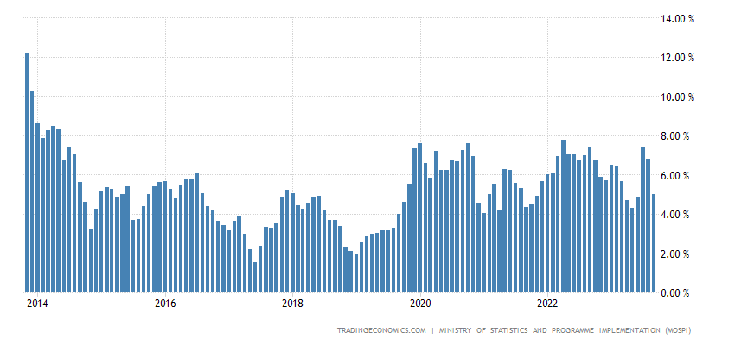
Fig 7- Inflation Rate from 2014 to 2022
Source: India Inflation Rate (tradingeconomics.com)
Consumer price changes in India can be very volatile due to dependence on energy imports, the uncertain impact of monsoon rains on its large farm sector, difficulties in transporting food items to market because of its poor roads and infrastructure and high fiscal deficit.
Balance of Trade
India has been in sustained trade deficits mainly due to the strong import growth, particularly of mineral fuels, oils and waxes bituminous substances, pearls, precious and semi-precious stones and jewellery. In recent years, the biggest trade deficits were recorded with China, Saudi Arabia, Iraq and Indonesia. India records trade surpluses with the US, United Arab Emirates, Hong Kong, United Kingdom and Vietnam (Tradingeconomies.com (2024)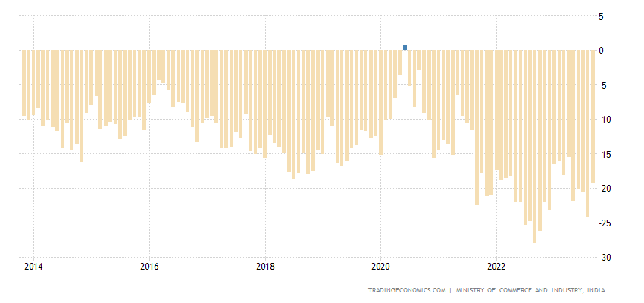
Source: India Balance of Trade (tradingeconomics.com)
Fig 8- Balance of Trade
The trade between India and China touched an all-time high of USD 135.98 billion in 2022, while New Delhi's trade deficit with Beijing crossed the USD 100 billion mark for the first time despite frosty bilateral relations (The Economic Times 2023).

Moreover, despite being the world's fastest-growing economy, India contributes merely about 2% to global merchandise exports. The untapped potential of India's manufacturing sector is a significant factor. In terms of GDP, India ranks as the third-largest economy worldwide. Its growth has primarily been driven by robust domestic demand and an expanding service sector. However, India's low merchandise exports and per-capita income continue due to its weak integration with Global Value Chains (GVCs) in manufacturing, unlike other emerging economies. India's benefits from the evolving global order have been confined mostly to assembly lines, largely because of its comparatively protectionist trade policy, which has hindered its integration into GVCs. Joining GVCs would enable Indian manufacturers to adopt the best technologies and management practices, gradually advancing up the value chain.

Furthermore, the concern and alignment of both territorial and economic securities necessitate authoritarianism and economic nationalism which illustrate mercantilism in the Chinese foreign economic policy. For instance, China’s reformed company law of 1993 ordered all companies both domestic and foreign- to allow Communist Party Cells (CPC) to operate within them. On the military front, an increase of 7.2 per cent in defence allocation for 2023 over and above the national economic growth target of around 5 per cent. The increase in allocation is to strengthen the move to build PLA into a world-class military and strengthen its ability to regain the “lost territory” (Kondapalli 2023). Consequently, China is becoming a mercantilist state, with a rise in Party-State, military spending, and trade surplus with India.
Conclusion
The COVID-19 outbreak has significantly disrupted China's economy, as it has for the rest of the world. However, there are signs of recovery in the country. This study suggests that it is premature to predict a severe, sustained economic slowdown in China. The issue is more of a cyclical problem, influenced heavily by the COVID-19 pandemic as an intervening variable, rather than a structural problem as seen in India.

The examination focuses on how India can perceive the Chinese economy comprehensively, objectively, and rationally. The Chinese economy continues to be a major driver of global growth, making significant contributions to the world economy. The current global economic slowdown across the globe signals limitations of investment and export-led growth strategy as the world is caught up with unilateralism, protectionism, decoupling, and the zero-sum game of the competitive world. This study suggests that it is premature to predict a severe, sustained economic slowdown in China. The issue is more of a cyclical problem rather than a structural problem. The recent green shoots of the Chinese economy have been noticed regarding recovery in the annual GDP growth rate and its sustained trade surplus regime. However, its performance on the deflation and unemployment fronts is worrisome. As a measure of recovery, China is expected to stimulate its economy, by improving household consumption and creating employment opportunities. It aims to shift to a consumption-led from export-led growth strategy. This makes China, having a huge population with enough household savings, one of the largest consumer markets.

India needs to re-evaluate its foreign economic policy and find ways to engage with China effectively and productively to occupy a competitive niche in its expanding consumer market. Despite China experiencing a deflationary phase, that reduces the cost of imports, and uncertain economic growth, it still maintains a trade surplus with India and holds various comparative advantages. Therefore, it would be beneficial for India to import essential raw materials from China for its import-competitive industries to reduce its trade deficit. Moreover, transactional diplomacy is more apt for securing and preserving strategic autonomy within a policy of multi-alignment. Seeking power and influence with a uniform approach often leads to a discordant noise detrimental to regional peace and security. Currently, diplomatic adeptness, rather than technical or economic prowess, is the preferred method to navigate through the seeming contradictions.

References
- Bhaswar Kumar (2024), “India must not brand itself with China-Plus-One tag: Experts at BS Manthan, Business Standard, March 28, India must not brand itself with China-Plus-One tag: Experts at BS Manthan | BS Events - Business Standard).
- Berkshire Publishing Group LLC (2009), “Beijing Consensus”, BeijingConsensus.pdf.
- Clement Tan (2023), “China’s third-quarter growth exceeds forecast, consumer spending and industrial production offer hope”, October 17, CNBC, China's third-quarter growth exceeds forecast, consumer spending and industrial production offer hope.

Castillo, Rodrigo & Caitlin Purdy. China’s role in supplying critical minerals for the global energy transition”, Leveraging Transparency to Reduce Corruption, July 2022.LTRC_ChinaSupplyChain.pdf (brookings.edu).

- Chengappa, Bidanda. China in South Asia: India needs to push back, Deccan Herald, October 11, 2022. China in South Asia: India needs to push back | Deccan Herald.

Kondapalli, Srikanth. Xi has set tone for third term; with a message for US, and for India. Deccan Herald, March 12, 2023. Xi has set tone for third term, with a message for US, and for India | Deccan Herald.

- Diksha Munjal (2023), “On China’s economic slowdown”, The Hindu, September 11, Explained | On China’s economic slowdown - The Hindu.
- Diego A. Cerdeiro and Sonali Jain-Chandra (2023), “China’s Economy is Rebounding, But Reforms Are Still Needed”, August 3, IMF, China’s Economy is Rebounding, But Reforms Are Still Needed.
- Ferchen, M., & Mattlin, M. (2023). Five modes of China’s economic influence: rethinking Chinese economic statecraft. The Pacific Review, 36(5), 978–1004. https://doi.org/10.1080/09512748.2023.2200029.
- James Laurenceson & Michael Zhou (2019), “Understanding Australia's economic dependence on China”, June 21, UTS, Understanding Australia's economic dependence on China | University of Technology Sydney.
- Krishnakutty, P (2022), “The long road to Atmanirbhar Bharat: India’s trade deficit with China hit a record $77 bn in FY22”, [online: web] Accessed on 25 April 2022 URL: https://theprint.in/economy/the-long-road-to-atmanirbhar-bharat-indias-trade-deficit-with-china-hit-record-77-bn-in-fy22/926987/
- Larry Elliot (2023), “China is too big for a Soviet Union-style collapse, but it’s on shaky ground”, August 20, The Guardian, China is too big for a Soviet Union-style collapse, but it’s on shaky ground | Larry Elliott | The Guardian.
- Linda Lew (2024), “China Asks Its Carmakers to Keep Key EV Technology at Home”, September 12, Bloomberg, China Asks Its Carmakers to Keep Key EV Technology at Home - Bloomberg.
- Peter Hoskins (2023), “China cuts key interest rate as recovery falters”, August 21, BBC, China cuts key interest rate as recovery falters.
- Ruchi Bhatia (2023), “India jobless rate rises to more than two-year high, CMIE says”, November 1, unemployment rate: India jobless rate rises to more than two-year high, CMIE says - The Economic Times.
- Sachdeva, Gulshan (2023), “10 years of China’s Belt and Road Initiative: The project, its aims and where it stands now”, October 29, The Indian Express, An Expert Explains | 10 years of China’s Belt and Road Initiative: The project, its aims and where it stands now | Explained News - The Indian Express.
- Sara Hsu (2021), “Which Asian Nations Can Benefit From the ‘China Plus One’ Strategy?”, The Diplomat, June 11, https://thediplomat.com/2021/06/which-asian-nations-can-benefit-from-the-china-plus-one-strategy/

- Somesh Jha (2019), “Unemployment rate at four-decade high of 6.1% in 2017-18: NSSO survey”, February 6, Business Standard, Unemployment rate at four-decade high of 6.1% in 2017-18: NSSO survey | Economy & Policy News - Business Standard.
- The Economic Times (2023), “India-China trade climbs to USD 135.98 billion in 2022, trade deficit crosses USD 100 billion for the first time”, January 13, china: India-China trade climbs to USD 135.98 billion in 2022, trade deficit crosses USD 100 billion for the first time - The Economic Times.
- The State Council of People’s Republic of China (2024), “China holds Central Economic Work Conference to make plans for 2025”, December 12, Xinhua, China holds Central Economic Work Conference to make plans for 2025.
- The State Council of People’s Republic of China (2024), “China's shift in monetary policy to bolster economic recovery”, December 19, Xinhua, China's shift in monetary policy to bolster economic recovery.
- The World Bank (2021), “Rebalancing Act: From Recovery to High-Quality Growth”, December 22, China Economic Update – December 2021.
- Tradingeconomies.com (2024) China Balance of Trade, Accessed November 16, 2024.
- Tradingeconomies.com (2024) China GDP Annual Growth Rate, Accessed on October 10, 2024.
- Tradingeconomies.com (2024) China Inflation Rate, Accessed July 27, 2024.
- Tradingeconomies.com (2024) China Unemployment Rate, Accessed on August 5, 2024.
- Tradingeconomies.com (2024) India Balance of Trade, Accessed on November 10, 2024
- Tradingeconomies.com (2024) India GDP Annual Growth Rate, Accessed on October 10, 2024
- Tradingeconomies.com (2024) India Inflation Rate, Accessed on October 15, 2024
- Tradingeconomies.com (2024) India Unemployment Rate, Accessed on August 5, 2024
- Tradingeconomies.com (2024), India Imports from China, Accessed on September 12, 2024.
- Vijay Gokhle (2021), “The sum and substance of the EU’s China dilemma”, June 7, The Hindu, The sum and substance of the EU’s China dilemma - The Hindu.

