Book Name: | Science and Technology: Developments and Applications
Manuscript Number: | 2024_BPR_4087
Title of the Manuscript: | Nanomaterials for Sustainable Pollution Management
Type of the Article | Book Chapter

General guidelines for the Peer Review process:

This Book’s peer review policy states that NO manuscript should be rejected only on the basis of ‘lack of Novelty’, provided the manuscript is scientifically robust and technically sound.
To know the complete guidelines for the Peer Review process, reviewers are requested to visit this link:

https://r1.reviewerhub.org/general-editorial-policy/

Important Policies Regarding Peer Review

Peer review Comments Approval Policy: https://r1.reviewerhub.org/peer-review-comments-approval-policy/
Benefits for Reviewers: https://r1.reviewerhub.org/book-benefits-for-reviewers

PART 1: Comments

 | Reviewer’s comment | Author’s Feedback (Please correct the manuscript and highlight that part in the manuscript. It is mandatory that authors should write his/her feedback here)
Please write a few sentences regarding the importance of this manuscript for the scientific community. A minimum of 3-4 sentences may be required for this part. | 1. This manuscript provides valuable insights into the innovative use of nanomaterials for effective environmental remediation strategies.  2. It highlights the potential of nanotechnologies to overcome limitations of traditional pollution management methods, offering sustainable alternatives.  3. The discussion on the challenges and risks associated with nanoparticle use emphasizes the need for responsible deployment in environmental applications.  4. By integrating recent advancements in nanotechnology, this work serves as a crucial resource for researchers seeking to tackle pressing pollution issues.
Is the title of the article suitable?  (If not please suggest an alternative title) | Yes
Is the abstract of the article comprehensive? Do you suggest the addition (or deletion) of some points in this section? Please write your suggestions here. | 1. Include a clearer definition of key terms such as "nanomaterials" and "photocatalysis" to enhance reader understanding.  2. Provide specific examples of pollutants that can be effectively addressed using these technologies to illustrate practical applications.  3. Mention ongoing research directions or future implications of nanomaterial-based solutions to strengthen the manuscript's relevance.  4. Add a brief statement on the importance of addressing environmental risks associated with these technologies for a balanced perspective.
Is the manuscript scientifically, correct? Please write here. | The manuscript appears to be scientifically sound, as it discusses the unique properties of nanomaterials and their applications in environmental remediation, which are well-established areas of research. The mention of specific nanoparticles such as carbon nanotubes, graphene, and titanium dioxide aligns with existing literature on their effectiveness in pollutant degradation, particularly under conditions like ultraviolet light.  However, for it to be fully scientifically rigorous, it is advisable to:  1. Include references to current research studies or reviews to support claims about the efficacy of nanomaterial-based technologies.  2. Discuss the mechanisms in more detail, particularly how different nanoparticles interact with various types of pollutants.  3. Consider addressing the varying degrees of success reported in the literature regarding the environmental impact and toxicity of certain nanomaterials, as this is a critical aspect of their deployment in pollution management.  Overall, while the core concepts presented are valid, enhancing the manuscript with more detailed explanations and supporting evidence would strengthen its scientific accuracy and credibility.
Are the references sufficient and recent? If you have suggestions of additional references, please mention them in the review form.  - | The references in the manuscript should be updated to include more recent studies for enhanced credibility. Here are suggestions for additional references, please add these references:  - A recent review of the synthesis of plant-derived iron oxide nanoparticles for metal ion removal, 10.1016/j.inoche.2024.112611  - Nanoparticles in Agriculture and Wastewater Treatment: Evaluating Dual Impacts Across Nations, 10.2023/EJRI/202312001  - Adsorption‐Based Approaches for Exploring Nanoparticle Effectiveness in Wastewater Treatment, 10.1002/slct.202400959
Is the language/English quality of the article suitable for scholarly communications? | Yes
Optional/General comments | - Consider adding recent references to support assertions made regarding the effectiveness of nanomaterials in air and soil remediation, as some citations appear outdated. Some are referred to the author please inclutate it in the manuscript.  - The section would benefit from clearer subheadings or transitions between different methods of remediation for better organization and readability.  - The conclusion section summarizes well but could include specific future research directions to enhance the scope and impact of the findings.  - Please clarify the terminology used, such as defining acronyms like "VOCs" and explaining specific nanomaterials briefly for readers who may be less familiar with the subject.  - Discuss the potential environmental hazards related to the long-term use of nanomaterials more comprehensively to balance their benefits against risks.  - Consider including illustrations or diagrams to visually represent the processes mentioned, which would aid in understanding complex mechanisms.  - The manuscript could highlight case studies or real-world applications of nanomaterials for remediation to demonstrate practical efficacy.  - Emphasize the importance of regulatory frameworks or guidelines for the safe use of nanomaterials in environmental applications.  - More detailed discussion on the challenges faced in implementing nanomaterial-based solutions in field settings would strengthen the manuscript.  - Ensure all claims about survey results or efficacy are backed up with quantitative data or references from peer-reviewed studies for scientific rigor.  - The figures and illustrations are not cited or discussed, which detracts from clarity.  - Consider including a flow chart or graphical abstract to visually summarize key concepts.  - The manuscript lacks empirical data and specific case studies to support assertions.  - There's no clear identification of a research gap, which should be addressed to highlight the manuscript's significance.

PART 2:

 | Reviewer’s comment | Author’s comment (if agreed with the reviewer, correct the manuscript and highlight that part in the manuscript. It is mandatory that authors should write his/her feedback here)
Are there ethical issues in this manuscript? | (If yes, Kindly please write down the ethical issues here in detail)  No
Are there competing interest issues in this manuscript? | No
If plagiarism is suspected, please provide related proofs or web links. | 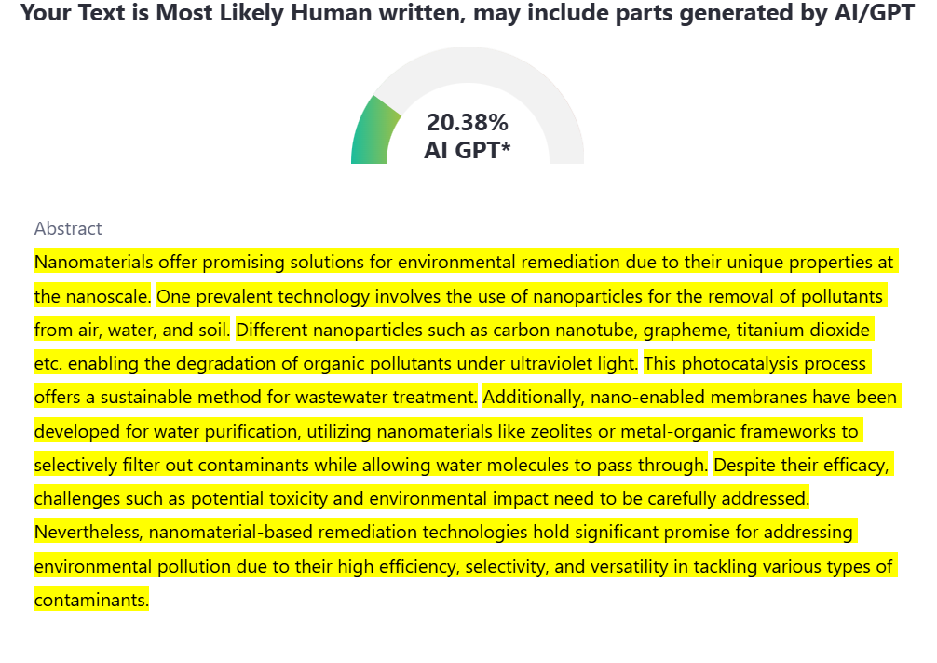  Yes, more than 20%

PART 3: Declaration of Competing Interest of the Reviewer:

Here reviewer should declare his/her competing interest. If nothing to declare he/she can write “I declare that I have no competing interest as a reviewer”

PART 4: Objective Evaluation:

Guideline | MARKS of this manuscript
Give OVERALL MARKS you want to give to this manuscript  ( Highest: 10 Lowest: 0 )  Guideline:  Accept As It Is: (>9-10)  Minor Revision: (>8-9)  Major Revision: (>7-8)  Serious Major revision: (>5-7)  Rejected (with repairable deficiencies and may be reconsidered): (>3-5)  Strongly rejected (with irreparable deficiencies.): (>0-3) | 6

Editorial Comments (This section is reserved for the comments from book editorial office and editors):

Author’s Feedback
1. Ensure all references are up to date and relevant to support the manuscript's claims effectively; consider adding recent studies to enhance credibility.
2. The manuscript structure could be improved by incorporating clearer headings and transitions between sections, and by ensuring that all figures are appropriately cited and referenced within the text.
3. Clarify acronyms and technical terms upon first use to assist reader comprehension, and add captions to all figures to explain their relevance and findings clearly.
4. Consider including diagrams or additional visual aids, such as flow charts or graphical abstracts, to visually represent key concepts and processes discussed.
5. The discussion of potential environmental hazards related to nanomaterials should be more comprehensive, with an emphasis on regulatory frameworks governing their use in remediation.
6. Highlight specific case studies or real-world applications for better contextual understanding and ensure that all claims are substantiated with quantifiable data or references to peer-reviewed studies.

Reviewer Details:
This section is mandatory to prepare the Reviewer Certificate.
Please complete this section carefully. Reviewer Certificate will be generated by using this information only.
Your Certificate will be wrong, if you provide incorrect information.
Please note modification of certificate will not be possible after generation.
Certificate will not be issued if incomplete information is provided.

Name of the Reviewer | Prerna Mehta
Department of Reviewer | Biotechnology
University or Institution of Reviewer | GD Rungta College of Science and Technology, Bhilai, Chhattisgarh, India
Country of Reviewer | India
Position: (Professor/lecturer, etc.) of Reviewer | Assistant Professor
Email ID of Reviewer | prernamehta326@gmail.com
WhatsApp Number of Reviewer (Optional) | +918770366011
Write 5-8 Keywords regarding expertise of Reviewer | - Genetics  - Nanoparticles  - Biochemistry  - Genetic engineering  - Radiation detection  - Melanin protection  - Rural enhancement system  - Smart resource management

