Non type 1 and 2 diabetes mellitus

INTRODUCTION

Non type 1 and 2 diabetes mellitus includes

- Latent Autoimmune Diabetes in Adults (LADA)
- ZMaturity Onset Diabetes in Young (MODY)
- Neonatal Diabetes Mellitus

Latent Autoimmune Diabetes in Adults
- Introduction
- Definition: Clinical Characteristics
- Pathogenesis
- Genetics of Latent Autoimmune Diabetes in Adults
- Chronic Complications in LADA
- LADA in the Indian Population
- Screening for Latent Autoimmune Diabetes in Adults
- Management of Latent Autoimmune Diabetes in Adults
- Newer Potential Therapies for LADA

LADA, or Latent Autoimmune Diabetes in Adults, represents a unique form of diabetes that shares characteristics of both type 1 and type 2 diabetes. Sometimes referred to as Slowly Progressing Insulin Dependent Diabetes Mellitus (SPIDDM), 1½ diabetes, Double Diabetes, or Youth onset diabetes of maturity, LADA is recognized for its distinct clinical features and progression.
To differentiate LADA from type 1 and type 2 diabetes, the Immunology of Diabetes Society has proposed three main criteria:
- adult age of onset (> 35 years of age),
- presence of at least one circulating autoantibody (GAD, ICA, IAA or IA-2) and
- insulin independence for the first 6 months after diagnosis.

Comparsion of LADA with type 1 and type 2 Diabetes Mellitus

Diabetes mellitus, a heterogeneous group of metabolic disorders characterized by elevated blood sugar levels, encompasses various subtypes, including type 1, type 2, and Latent Autoimmune Diabetes in Adults (LADA). While type 1 and type 2 diabetes have been extensively studied and are well-understood, LADA presents a distinct clinical entity that bridges the characteristics of both traditional types.

Clinical Presentation and Metabolic Control: Upon diagnosis, LADA patients often exhibit a notable ability to maintain adequate metabolic control through dietary modifications or oral hypoglycemic agents, a feature distinguishing them from individuals with type 1 diabetes. However, as LADA progresses, an increasing proportion of patients necessitate insulin therapy for sustained metabolic control, resembling the treatment trajectory of type 1 diabetes. This evolution underscores the progressive nature of LADA, reflecting the gradual decline in beta-cell function over time.
Metabolic Profile and Beta-Cell Dysfunction: In comparison to type 2 diabetes, LADA patients demonstrate more severe dysfunction of pancreatic beta cells, suggesting a prominent autoimmune component in the pathogenesis of the disease. Despite this autoimmune involvement, LADA patients typically present with a lower prevalence of metabolic syndrome features, including obesity, hypertension, and dyslipidemia. Parameters such as lower BMI, favorable waist-hip ratios, and distinctive lipid profiles, characterized by higher HDL cholesterol and lower triglyceride concentrations, distinguish LADA patients from their type 2 counterparts of similar age and disease duration.
Immunological Markers and Predictors of Insulin Dependency: The presence of specific autoantibodies, namely islet cell autoantibodies (ICA) and glutamic acid decarboxylase autoantibodies (GADab), plays a crucial role in diagnosing LADA and predicting its clinical course. While both markers are indicative of future insulin dependency, GADab emerge as superior predictors due to their greater stability and persistence over time. Unlike ICA, which tend to decline and disappear with disease progression, GADab remain reliable indicators, facilitating the early identification and management of LADA.

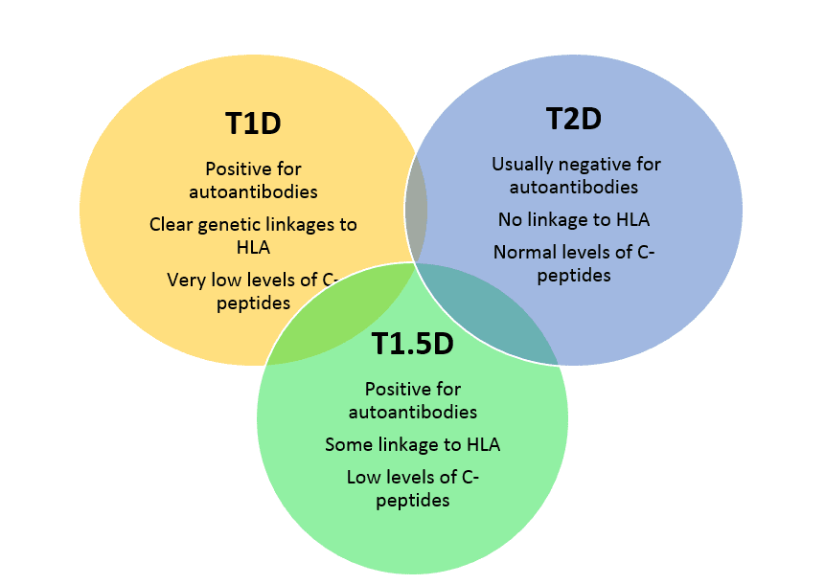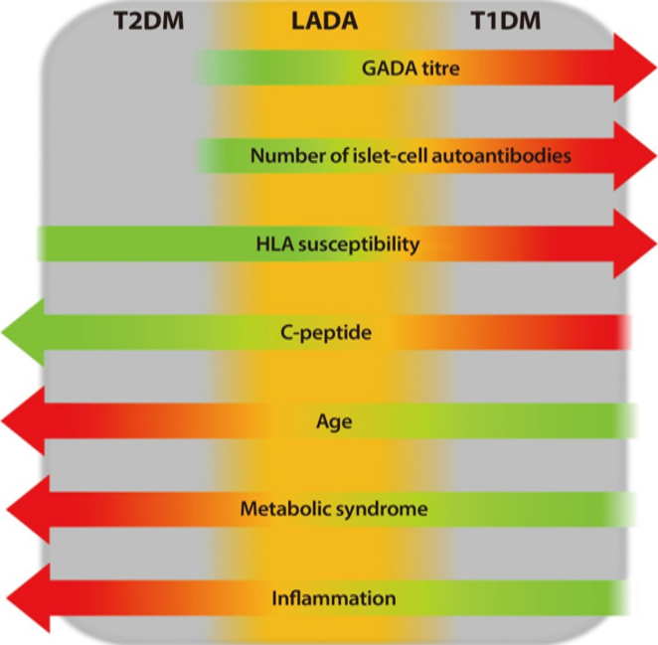

FIG 1¹ COMPARISON OF T1,T2 DIABETES MELLITUS AND LADA

PATHOGENESIS

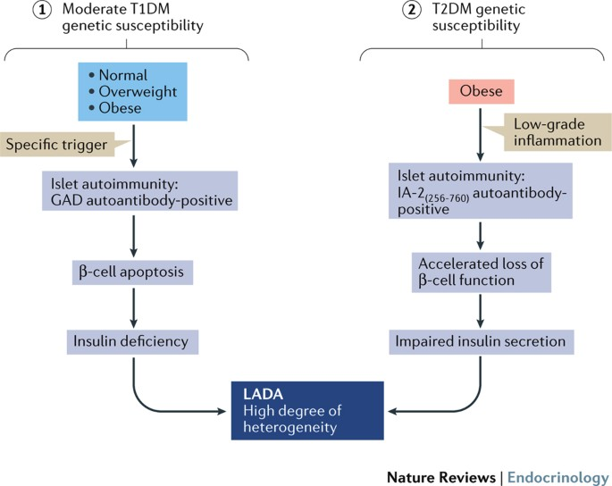

FIG2 PATHOGENESIS OF LADA²

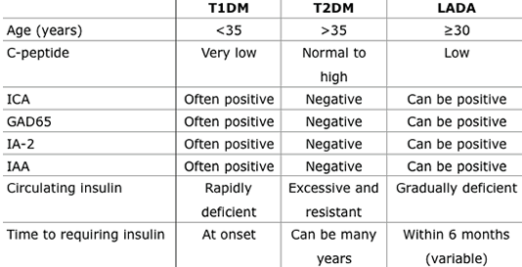

FIG3³ COMPARISION OF T1DM,LADA AND T2DM
CLINICAL FEATURES

Types
Clinical features
LADA
LADA I
LADA 2
• Age of onset > 35 years
• Non-insulin requiring for at least first 6 months after onset but often
requiring insulin later
• Higher titers of GAD
• Lower C-peptide, lower BMI, ketosis prone
• Lower titers of GAD
• Less ketosis, dyslipidemia prone

LADA has age of onset > 35 years and has non-insulin requirement for at least first 6 months after onset but often requiring insulin later. LADA I has higher titers of GAD,lower C-peptide, lower BMI and is ketosis prone. LADA 2 has lower titers of GAD,less ketosis and is dyslipidemia prone.

Genetic markers

DQB-0302(DR4) gene predisposes to LADA. MICA 5.1 predisposes to LADA while MICA 5 predisposes to type 1 diabetes(childhood/young onset).GAD 65-CAb if positive then person have high risk for progession towards insulin dependency (type 1 diabetes mellitus) while GAD65-MAb positive then person have more clinical and metaboliiccharacterstics similar as in type 2 diabetes mellitus.

CHRONIC COMPLICATIONS IN LADA

As an intermediate form of diabetes bridging characteristics of both type 1 and type 2 diabetes, Latent Autoimmune Diabetes in Adults (LADA) presents a unique perspective on the development and progression of chronic complications associated with the disease.
Retinopathy: Studies have indicated a higher prevalence of retinopathy in LADA subjects compared to individuals with GAD-negative type 2 diabetes.
Neuropathy: In the early stages of the disease, LADA subjects exhibit lower rates of neuropathy compared to those with type 2 diabetes, resembling the clinical profile observed in classical type 1 diabetes. This delayed onset of neuropathy in LADA underscores the complex interplay of autoimmune and metabolic factors in neuropathic complications
Coronary Heart Disease and Cardiovascular Mortality: Contrary to the higher prevalence of metabolic syndrome features in type 2 diabetes, LADA subjects demonstrate a lower prevalence of coronary heart disease and cardiovascular mortality. This phenomenon can be attributed to the unique metabolic profile of LADA, characterized by lower BMI, favorable lipid profiles, and reduced prevalence of metabolic syndrome features.

LADA IN THE INDIAN POPULATION

In a study by Kanungo et al. conducted in Eastern India, an extensive analysis of 210 patients clinically diagnosed with type 2 diabetes yielded valuable insights into the prevalence and significance of autoantibodies within the Indian population. Contrary to prevailing expectations, the study found that the frequency of glutamic acid decarboxylase 65 (GAD65) autoantibodies did not exhibit a statistically significant difference between patients and controls, with only 7% of individuals with type 2 diabetes testing positive for GAD65 compared to 2% in the control group. This unexpected finding challenges conventional assumptions regarding the role of GAD65 autoantibodies in the pathogenesis of type 2 diabetes within the Indian context.
Interestingly, in contrast to observations in Caucasian populations, the study revealed a striking pattern in the prevalence of insulinoma-associated-2 autoantibodies (IA-2) among younger Eastern Indian patients diagnosed with type 2 diabetes. IA-2 emerged as the predominant autoantibody, detected in a notable 36% of cases, highlighting the ethnic and geographical variability in autoimmune diabetes susceptibility within India.
Moreover, the study shed light on the association of islet cell antibody (ICA-12) with non-DR3/non-DR4 patients diagnosed with Latent Autoimmune Diabetes in Adults (LADA) in Northern India. This finding underscores the immunogenetic heterogeneity of LADA and emphasizes the need for tailored diagnostic approaches reflective of regional and ethnic differences.
A separate investigation focusing on lean diabetics from Southern India revealed a higher prevalence of GAD autoantibodies, indicative of autoimmune involvement, and a more severe diabetic phenotype distinct from classical type 1 diabetes categorized as LADA. However, it is noteworthy that many lean diabetics in Eastern India tested negative for GAD autoantibodies while maintaining good β-cell function, suggesting the presence of phenotype variants of type 2 diabetes within this population subgroup.
Overall, these findings underscore the complex and heterogeneous nature of LADA in India, representing a substantial proportion, potentially up to 10%, of adults with diabetes. Understanding the unique immunogenetic and clinical characteristics of LADA in diverse populations is crucial for accurate diagnosis and personalized treatment strategies, ultimately contributing to improved outcomes in diabetes management within the Indian context.

SCREENING FOR LATENT AUTOIMMUNE DIABETES IN ADULTS

In countries like India, where healthcare resources may be limited, conducting comprehensive testing for glutamic acid decarboxylase autoantibodies (GADab) in all adults diagnosed with type 2 diabetes poses significant challenges. Despite the acknowledged importance of GADab measurement in identifying individuals with Latent Autoimmune Diabetes in Adults (LADA) and predicting future insulin requirements, practical constraints often necessitate reliance on clinical judgment for treatment decisions.
In this context, the decision to initiate insulin therapy is predominantly guided by clinical considerations rather than GADab status. Clinicians must carefully assess factors such as glycemic control, disease progression, comorbidities, and individual patient characteristics to determine the most appropriate treatment approach. While GADab testing may not be routinely feasible, optimizing glycemic control and managing cardiovascular risk factors remain paramount for preventing the progression of microvascular and macrovascular complications associated with diabetes.
Effective management of diabetes complications, akin to strategies employed in both type 1 and type 2 diabetes, hinges on diligent glycemic control and the mitigation of cardiovascular risk factors. Regular monitoring of blood glucose levels, implementation of lifestyle modifications, appropriate pharmacotherapy, and patient education are essential components of comprehensive diabetes care, aimed at reducing the burden of complications and improving long-term outcomes.
Despite resource constraints, efforts to enhance diabetes care delivery in India and similar settings involve leveraging available infrastructure, adopting evidence-based guidelines, and fostering interdisciplinary collaboration among healthcare providers. Additionally, advocacy for increased access to diagnostic tools and therapeutic interventions, alongside initiatives aimed at raising awareness and promoting early detection of diabetes and its complications, are critical for improving patient outcomes and optimizing healthcare resource utilization.
In conclusion, while challenges related to GADab testing may exist in resource-limited settings, prioritizing glycemic control and cardiovascular risk management remains pivotal in preventing the progression of diabetes complications. By employing a patient-centered approach and maximizing available resources, healthcare providers can optimize diabetes care delivery and enhance health outcomes for individuals with type 2 diabetes in India and similar contexts

MANAGEMENT OF LATENT AUTOIMMUNE DIABETES IN ADULTS

In the absence of established treatment guidelines specifically tailored for Latent Autoimmune Diabetes in Adults (LADA), the standard approach often begins with a trial of oral hypoglycemic agents, such as sulfonylureas, metformin, and thiazolidinediones, followed by insulin therapy if necessary. However, the optimal timing and sequence of treatment modalities remain subject to debate and clinical judgment.
One rationale for considering early insulin therapy in LADA is the potential benefit of providing beta-cell rest, thus preventing beta-cell exhaustion that may result from the prolonged use of sulfonylureas. By sparing the beta cells from excessive stimulation, insulin therapy may help preserve their function and prolong endogenous insulin secretion. This approach aligns with the concept of preserving beta-cell function and delaying the need for exogenous insulin therapy in the long term.
While some evidence suggests potential benefits of early insulin initiation in LADA, the available data are not entirely conclusive. Further research is needed to elucidate the optimal timing, dosing, and duration of insulin therapy in LADA, as well as its impact on preserving beta-cell function and preventing diabetes-related complications.
Ultimately, treatment decisions in LADA should be individualized based on factors such as disease severity, beta-cell function, glycemic control, patient preferences, and comorbidities. Clinicians should weigh the potential benefits and risks of various treatment options and engage in shared decision-making with patients to tailor therapy to their specific needs and goals. Close monitoring and regular reassessment are essential to adjust treatment strategies as needed and optimize long-term outcomes in LADA management.
Treatment
Obese patients benefit from calorie restriction,sulfonylureas,early insulin therapy is recommended,insulin sensitizers are beneficial in treating metabollicsyndrome,incretin based therapy is not studuied yet while immune mdoulation via Dia pep 277 safety and tolereability have been proved. GAD65 (Diamyd)-Safety reported

NEWER POTENTIAL THERAPIES FOR LADA

The Diabetes Prevention Trial 1 (DPT-1) demonstrated the potential for preventing the progression of beta-cell exhaustion and subsequent insulin dependency, which could be beneficially applied to individuals with Latent Autoimmune Diabetes in Adults (LADA). A recent multicenter study in Japanese subjects compared the effects of insulin versus sulfonylurea treatment in GADab-positive patients. The study found that among those with a high GADab titer, a significantly higher proportion in the sulfonylurea group became insulin dependent over four years compared to the insulin-treated group. This suggests that early, low-dose insulin therapy may effectively prevent beta-cell failure in LADA subjects.
However, not all studies have demonstrated clear benefits of early insulin treatment in preserving beta-cell function in LADA. A prospective, three-year intervention study in LADA patients in Sweden did not find a significant beneficial effect of early insulin treatment on preserving beta-cell function. Nevertheless, the study did observe better preservation of HbA1c levels after 36 months in the insulin-treated group compared to the control group.
Innovative approaches to halt the progression of beta-cell destruction in LADA are also being explored. One such approach involves the use of a peptide called Diapep 277, derived from heat shock protein 60 (Hsp60), to interrupt the beta-cell destruction process. Diapep 277 works through antigen-specific suppression, aiming to halt the autoimmune attack on beta cells.
Additionally, GAD65 vaccination, such as the Diamyd vaccine, has been investigated as a means to slow down the progression of beta-cell destruction in individuals with LADA. By targeting specific autoantigens involved in the autoimmune response, GAD65 vaccination aims to preserve beta-cell function and delay the onset of insulin dependency.
Emerging therapies targeting inflammatory cytokines, such as tumor necrosis factor-alpha (Etanercept) and interleukin-1 beta, have also shown promise in modulating the inflammatory processes implicated in LADA pathogenesis. By interfering with these cytokines, these newer therapies aim to attenuate the autoimmune response and preserve beta-cell function in LADA patients.
Overall, while the management of LADA remains challenging due to its heterogeneous nature, ongoing research into innovative treatment approaches offers hope for improved outcomes and better preservation of beta-cell function in individuals with this form of diabetes.
Maturity onset diabetes of the young (MODY) syndromes
- MODY 1 chromosome 20, HNF-4 α
- MODY 2 chromosome 7, glucokinase
- MODY 3 chromosome 12, HNF-1α, TCF-1
- MODY 4 chromosome 13, IPF-1
- MODY 5 chromosome 17, HNF-1 β, TCF-2
- MODY 6 chromosome 2q32, neuro-D1/beta-2
- MODY 7 chromosome 2q25, Kruppel like factor (KFL)11
- MODY 8 chromosome 9q34, CEL (carboxyl ester lipase)
- MODY 9 chromosome 7q32, Pax 4
- MODY 10 chromosome 11p15.5, insulin gene
- MODY 11 chromosome 8p23, BLK gene
- MODY 12 chromosome 11p15, KCNJ 11
- MODY 13 chromosome 11p15, ABCC8
- MODY X mutation unidentified

Maturity-Onset Diabetes of the Young (MODY), a monogenic form of diabetes resulting from mutations in islet cell transcription factors or glucokinase genes. Here's a breakdown of the key features and subtypes:
Characteristics:
MODY is characterized by abnormalities in insulin secretion due to genetic mutations affecting beta-cell function. MODY is inherited in an autosomal dominant pattern, meaning that an affected individual has a 50% chance of passing the mutation on to each offspring. Glucose intolerance or diabetes is typically observed in at least three successive generations, with only one parent being affected. The onset of diabetes should occur before the age of 25 years in at least one, ideally two, family members. MODY typically presents with early-onset diabetes, often in the third decade of life. Individuals with MODY typically lack features of insulin resistance, such as acanthosis nigricans, and often have a normal body mass index (BMI). MODY patients are negative for diabetes-related autoantibodies, distinguishing them from autoimmune forms of diabetes such as type 1 diabetes.
Subtypes:
Glucokinase gene defect: This subtype is characterized by a defect in the glucokinase gene, which leads to a defective glucose sensor in pancreatic beta cells. Glucokinase plays a crucial role in glucose sensing and insulin secretion, and mutations in this gene result in impaired glucose regulation from birth.This subtype involves mutations in transcription factors that regulate beta-cell function. Beta-cell dysfunction occurs during adolescence or early adulthood, leading to impaired insulin secretion and subsequent diabetes onset.
Overall, MODY represents a distinct subset of diabetes characterized by genetic mutations affecting beta-cell function, with specific subtypes distinguished by the underlying genetic defect and age of onset. Recognition of the clinical features and subtypes of MODY is essential for accurate diagnosis and appropriate management strategies.

COMPARISON OF TYPE 1,TYPE 2 DIABETES MELLITUS AND MODY

CHARACTERSTICS | MODY | TYPE 1 DM | TYPE 2DM
AGE AT DIAGNOSIS | <25YEARS | 5-20 YEARS | >25YEARS
PARENTRAL HISTORY | 60-95% | <10% | 10-40%
INHERITANCE | AD AUTOIMMUNE DISEASE | AD AUTOIMMUNE DISEASE | POLYGENIC
OBESITY  INSULIN RESISTANCE  METABOLLIC SYNDROME | UNCOMMON | UNCOMMON | COMMON
BETA CELL ANTIBODIES | ABSENT | PRESENT | ABSENT
C PEPTIDE | NORMAL | UNDETECTABLE | HIGH-LOW
OPTIMAL TREATMENT | SULFONYLUREA (MODY 1,3,4) | INSULIN | OHA

TABLE1COMPARISION OF TYPE 1 DM WITH TYPE 2 DM WITH MODY

RELEASE OF INSULIN

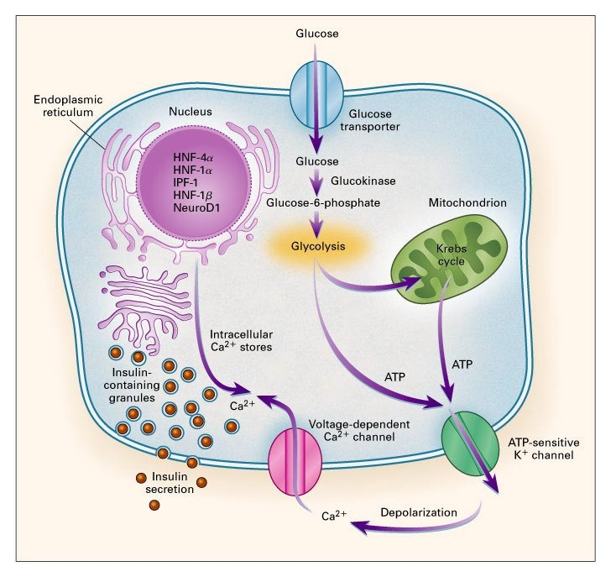

FIG4⁵INSULIN RELEASE PROCESS

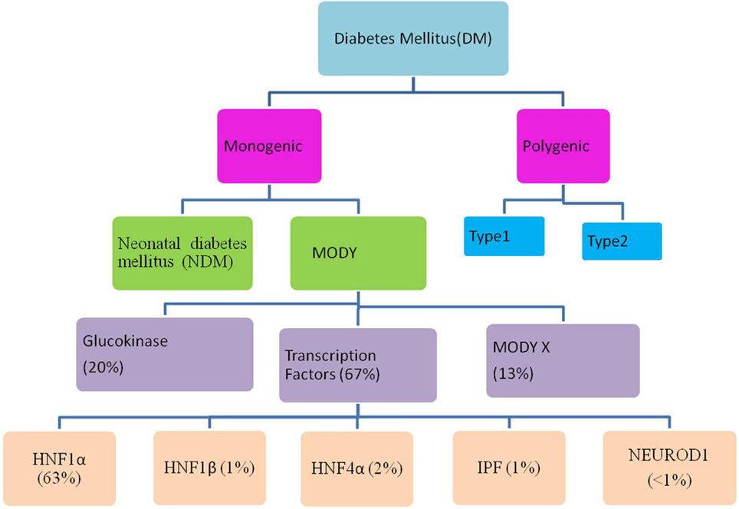

FIG5Flow through diagram showing types of diabetes mellitus including the relative prevalence of various maturity-onset diabetes of the young (MODY) causing genes.

DIFFERENT TYPE OF MODY AND THEIR CHARCTERSTICS
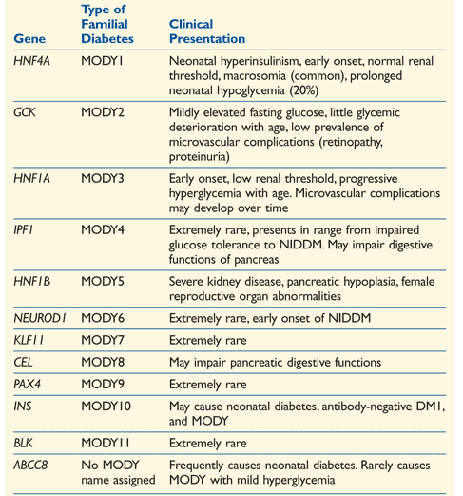

FIG 6⁷⁻⁹ CLINICAL PRESENTATION OF FAMILIAL DIABTES

CLINICAL CHARACTERISTICS OF MODY

In those with glucokinase defect the onset is at a much younger age, the glucose intolerance being mild and managed with diet, exercise and antidiabetic agents. In transcription factor defects (HNF-1alpha, HNF-1beta, HNF-4alpha) the onset is at adolescent age, progressively requiring oral antidiabetic drugs (OADs) and later insulin. MODY 3 (HNF-1 alpha defect) is the most common in adults. MODY 2 (glucokinase defect) is the most common variety among asymptomatic fasting hyperglycemia in children

MODY- 3
MODY-3, also known as HNF-1 alpha defect, is one of the most common subtypes of Maturity-Onset Diabetes of the Young (MODY). MODY-3 accounts for a significant portion of MODY cases and is considered one of the most prevalent forms. Due to its early onset and genetic nature, MODY-3 may be misdiagnosed as type 1 diabetes, particularly in younger individuals. MODY-3 typically develops before the age of 25 years, distinguishing it from other forms of diabetes. Initially, fasting blood glucose (FBG) levels may appear normal, but a significant rise (>5 mmol/L) in oral glucose tolerance test (OGTT) results is often observed. Over time, hyperglycemia tends to worsen, highlighting the progressive nature of MODY-3. Patients with MODY-3 often exhibit a low renal threshold for glucose, leading to glycosuria. Patients with MODY-3 are typically not obese, distinguishing them from individuals with type 2 diabetes. A significant familial history of diabetes is commonly observed in individuals with MODY-3, with affected parents and grandparents often present.
HNF-1 Alpha (HNF1A) Gene: The HNF-1 alpha gene (HNF1A) is located on chromosome 12q24.2 in humans. HNF-1 alpha is a transcription factor highly expressed in the pancreas, where it plays a crucial role in regulating the expression of various genes involved in glucose metabolism. HNF-1 alpha influences pancreatic islet cell function, including the regulation of insulin gene expression. Mutations in the HNF1A gene lead to impaired transcriptional regulation of genes involved in glucose metabolism, contributing to abnormal pancreatic function and subsequent diabetes development. HNF-1 alpha mutations can also affect the function of HNF-4 alpha (MODY-1), another transcription factor involved in pancreatic beta-cell function.
Overall, MODY-3, characterized by mutations in the HNF1A gene, represents a significant subtype of MODY with distinct clinical features and genetic underpinnings. Recognition of these features is crucial for accurate diagnosis and appropriate management of affected individuals.

CLINICAL PRESENTATION OF MODY

Patient will have mild to moderate hyperglycemia (typically 130–250 mg/dl, or 7– 14 mmol/l) discovered before 25 years of age. A first-degree relative with a similar degree of diabetes. Patient will have usual diabetic symptoms like polyuria, polydypsia& polyphagia and absence of positive antibodies or other autoimmunity (e.g., thyroiditis) in patient and family with persistence of a low insulin requirement (e.g., less than 0.5 u/kg/day) past the usual "honeymoon" period.

WHEN TO SUSPECT A DIAGNOSIS OF TYPE 1 DIABETES IN CHILDREN MAY NOT BE CORRECT ?

Family history of diabetes with a parent affected (2-4%) with evidence of endogenous insulin production outside the honeymoon’ phase (after 3 years of diabetes) with detectable c peptide (>200 nmol/l) when glucose > 8 mmol/l. (1-5% type 1). and when pancreatic islet autoantibodies are absent, especially if measured at diagnosis (3-30% type 1 patients)

WHEN TO SUSPECT A DIAGNOSIS OF TYPE 2 DIABETES IN CHILDREN MAY NOT BE CORRECT?

Patient is not markedly obese or diabetic family members who are normal weight (20%) with acanthosis nigricans not detected (10%) and ethnic background from a low prevalence type 2 diabetes race e.g. europeancaucasian (0-45%) and no evidence of insulin resistance with fasting C peptide within the normal range (0-20%)

Recent work done by Tim J, Mcdonald… showed that high sensitivity C- reactivity levels are lower in HNF a1 than type 1, type 2 diabetes or glucokinase (GCK) – MODY (diabetes care journal) . Recent work done S A. Mughal, R. Park… showed that serum Apo M levels are lower in HNF a1 than type 1. (diabetes med journal)

MANAGEMENT

Unfortunately, chronic hyperglycemia of any cause can eventually cause blood vessel damage and the microvascular complications of diabetes.
The principal treatment goals for people with MODY — keeping the blood sugars as close to normal as possible ("good glycemic control"), while minimizing other vascular risk factors — are the same for all known forms of diabetes.

PRIMARY MANAGEMENT

Patients with HNF-1a gene mutations can initially be treated with diet and exercise. Although they will have marked post prandial hyperglycaemia with high carbohydrate food as the beta-cell defect results in insufficient increase in insulin secretion with hyperglycaemia.
Most patients will need pharmacological treatment as they show progressive deterioration in glycaemic control throughout life and are at risk of considerable micro-vascular and macro-vascular complications.

The current international society for pediatric and adolescent diabetes/international diabetes federation guidelines published in 2009 suggest switching patients with proven HNF1a mutation (HNF1a–MODY) from insulin to sulfonylurea. Despite this, 40% of HNF1a patients with paediatric and adolescent-onset diabetes continued to receive insulin treatment.

PHARMACOLOGICAL TREATMENT

Sulphonylyureas

The first treatment to be used in children should be low dose sulphonylureas which results in a 4 fold greater lowering of glucose than metformin. These patients are extremely sensitive to sulphonylureas and as long as they do not have problems with hypoglycaemia can be maintained on these for many decades .Glycaemic control in sulphonylureas is often better than that achieved on insulin especially in children and young adults. The dose of sulphonylureas should initially be low (¼ - of the normal starting dose in adults) to avoid hypoglycaemia .
If there is hypoglycaemia, sulphonylurea preparation such as gliclazide a slow release preparation or meal time doses with a short acting agents like nateglinide may be considered.

Meglitinide analogues

Marianne Becker, Angela Galler and Klemens Raile had published case reports suggesting that meglitinides can be used as single or combined based therapy for MODY3 patients. The HbA1c with the use of meglitinide was 6.8% whereas with insulin was 7.5%.In combination with insulin HbA1c was 7.2%

Glucagon like peptide – 1 receptor agonist therapy

Maricor, Charles, Christine, Kevin published a case study report of three patients saying that GLP-1 receptor agonist therapy may be of value in managing glycemia in patients with MODY 3 They also experienced significant weight loss (10-15%) HbA1c was 7.4%, 6.4 % and 6.8 % respectively. With the help of GLP 1, they were able to discontinue insulin.

Other points

If obese, exercise should be prescribed to promote weight loss.
MODY 1, 3, 4: Respond very well to antidiabetic agents; insulin-replacement therapy in late stages particularly MODY 1 and 3.
MODY 2: Nonprogressive; can usually be managed with diet and exercise alone.
MODY 5: May require endocrine and exocrine replacements and therapy for other organ abnormalities

Neonatal Diabetes Mellitus

Neonatal Diabetes Mellitus presents within the first few weeks of life.
It needs insulin for at least 2 weeks and resolves by a median 12 weeks.
Rarely, it lasts until 12 months of age. In the west, TNDM represents 50–60% of cases of neonatal diabetes while in India, 5% had TNDM.

Mutations in transient neonatal diabetes mellitus

Chromosome 6q related ,Paternal uniparental disomy ,Duplication defects ,Hypomethylation related ,ABCC8 (SUR) mutation ( ATP Binding Cassette Subfamily C Membrane 8 ),KCNJ11 (Kir6.2) mutation ( Potassium Inwardly Rectifying Channel Subfamily J Member 11)

CLINICAL FEATURES

The cardinal features of TNDM are severe intrauterine growth retardation, hyperglycemia, dehydration, and absence of ketoacidosis. Neonates may present with breathlessness, lethargy and poor feeding. Insulin is required for fetal growth, and severe growth retardation could be due to insulin deficiency. Hyperglycemia is usually identified during routine investigations. Infants with 6q 24 related mutations may have macroglossia. Though transient, DM may recur in the pediatric age range, or later in adulthood in over 50% of cases. Annual evaluation for hyperglycemia is therefore mandatory in all children with TNDM during the remission phase.During relapse initial management may be by diet modificationBut subsequently, they may need insulin, as the response of oral sulfonylurea is uncertain.Women who have had 6q24-TNDM are at risk of relapse of diabetes during pregnancy .Thus, the “transient” form of the disease is most likely a permanent β-cell defect with variable expression during growth and development. Considerable overlap occurs between TNDM and PNDM and hence they cannot be distinguished based on clinical features alone can only be differentiated based on genetic testing. TNDM patients have lower insulin requirement in comparison to PNDM.PERMANENT NEONATAL DIABETES MELLITUS

This is a form of NDM which does not go into remission. In India, 61% had PNDM and only 5% had TNDM.About 60–75% of the PNDM with onset less than 6 months of age were found to be of genetic origin.Based on the genetics of neonatal diabetes, they could be either syndromic or non-syndromic.

Genetic defect | Associated features
Heterozygous mutations of the ABCC8 gene (SUR)  KCNJ11 (Kir6.2) | Developmental delay
Wolcott-Rallison syndrome with EIF2AK3 mutation | Epiphyseal dysplasia, renal and hepatic failure
IPEX syndrome with autoimmunity with FOXP3 mutation | Diarrhoea, eczema, thyroiditis
Homozygous glucokinase mutation | Heterozygote parents
IPF mutation | Heterozygote parents
PTF1A mutation | Cerebellar hypoplasia, pancreatic involvement
GLIS3 mutation | Hypothyroidism, glaucoma

Genetic defect | Associated features
HNF 1β mutation | Renal cysts, genital malformations
Enteroviral related diabetes
Others type A  Insulin resistance syndrome  Leprechaunism  Rabson-Mendenhall syndrome | Features of androgen excess with hyperinsulinemia

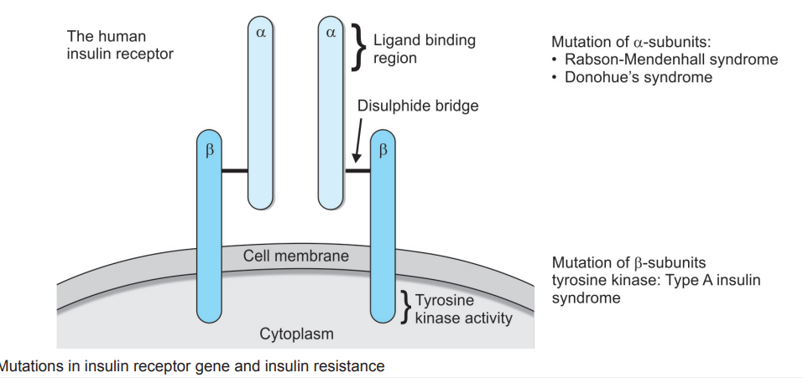

FIG 7¹⁰ MUTATONS IN INSULIN RECEPTOR

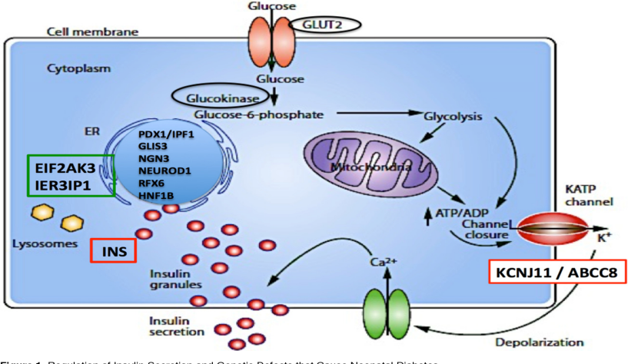

FIG 8¹¹ RELEASE OF INSULIN

CLINICAL PRESENTATION AND DIAGNOSIS OF NEONATAL DIABETES MELLITUS

Neonatal DM in the immediate newborn period is usually diagnosed incidentally.Hyperglycemia is more common and this usually resolves once the underlying disease process is treated. Differentiating this stress hyperglycemia from that of neonatal DM is challenging. Wait for the resolution of the underlying diseases process and the C peptide levels may give some useful information. Neonatal DM can present as diabetic ketoacidosis with classical features of acidosis with hyperglycemia especially in KCNJ11 mutations
It is not uncommon to misinterpret this acidosis as sepsis related lactic acidosis and delay the management of DM. In older infants, beyond 6 months of age, history of polyuria and polydipsia may be elicitable and a diagnosis of type 1 diabetes may be considered. This is usually confounded by presence of insulin autoantibody like the glutamic acid decarboxylase (GAD) antibody.Autoimmune etiology is less common in infants, all infants with diabetes should be carefully examined for any syndromic features, should undergo genetic evaluation for monogenic diabetes.
Confirmation of blood glucose more than once is mandatory to diagnose NDM.Anthropometry, dysmorphic features, features of androgen excess, evidence of bony abnormalities, features of hypothyroidism and a detailed developmental assessment. Serum C-peptide levels, HbA1c, thyroid function tests, serum uric acid, serum ammonia levels, ultrasonogram of the abdomen and genetic studies. Genetic studies are mandatory in all infants less than one year of age. Evaluate all children with onset at less than 2.5 years of age with history of liver failure for WRS.

Management of Neonatal Diabetes Mellitus

The specific management includes insulin therapy and in genetic mutations responsive to oral sulfonylurea oral medications are used. The inconsistent feeding pattern and the requirement of insulin in very small doses pose difficulty in day to day management. However, if the requirement is very low, once or twice a day dose of intermediate acting insulin may be useful.Insulin pumps have been successfully used in neonatal DM as early as the first month of life.
In case of requirement of insulin being less than 0.5 units/dose it is ideal to use the insulin diluent.Caution must be provided as accidental overdose of insulin can be hazardous. Some infants may be very sensitive and develop rapid hypoglycemia with rapid or short acting insulin.
Analog insulin like Glargine has been successfully used in extremely low birth weight neonates with DM

Switching over to Oral Drugs

Slow out-patient switch protocol (in OPD) | Rapid out-patient switch protocol (in IPD)
Height, weight and complete neurological examination to be documented prior to switch | Height, weight and complete neurological examination to be documented prior to switch
Day 1: Fasting HbA1c, C peptide levels. Give 0.1 mg/kg/dose of oral glibenclamide with breakfast. Continue evening dose with insulin, if blood glucose is more than 126 mg/dL | Day 1: Fasting HbA1c, C peptide levels. Give 0.1 mg/kg/dose of oral glibenclamide with breakfast. Continue evening dose with insulin, if blood glucose is more than 126 mg/dL
Reduce the insulin slowly keeping the sulfonylurea constant for 1 week | Day 2: Omit the isophane insulin and continue only short or rapid acting insulin throughout therapy. Oral sulfonylurea is increased to 0.2 mg/kg/dose given twice daily and reduce insulin by 50%

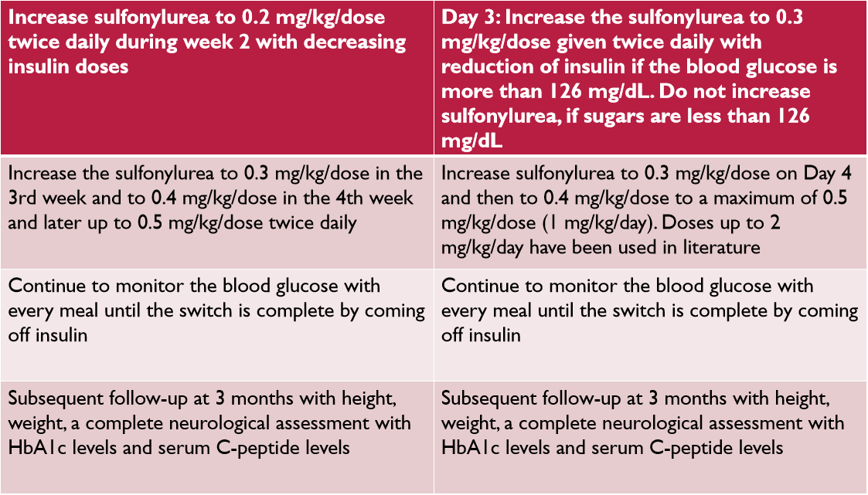

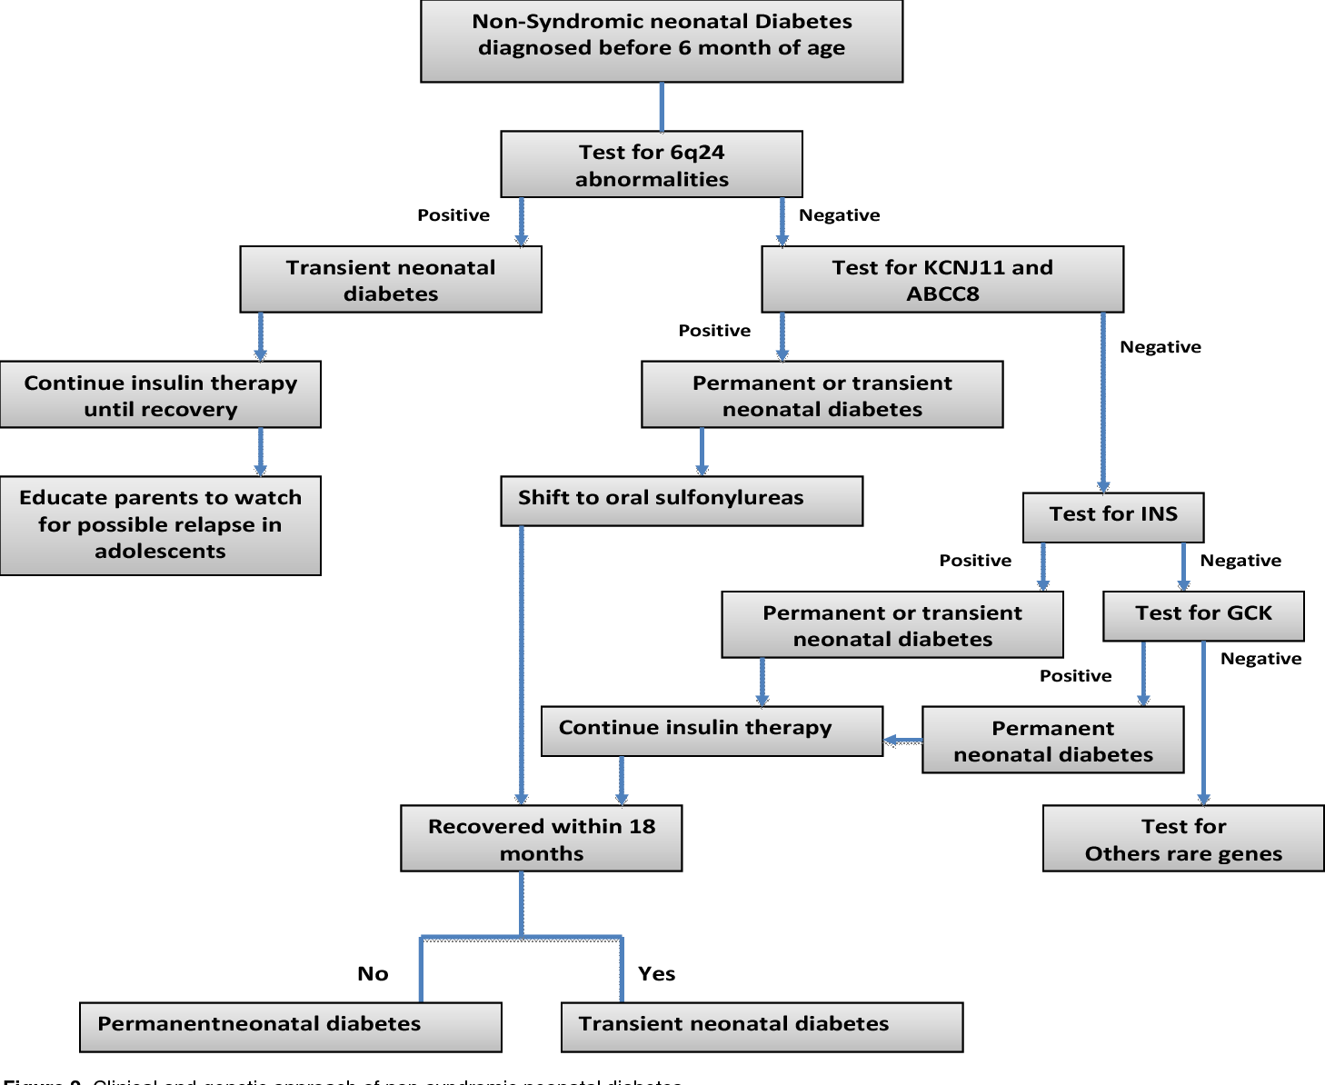

FIG 9¹²Clinical and genetic approach of non-syndromic neonatal diabetes

PROGNOSIS AND LONG-TERM OUTCOME

Neonatal diabetes is very different from other forms of diabetes in that the course of disease is variable. In some infants it is transient, in some it remits after varying periods of insulin dependency only to recur later in life In some infants it continues to be permanent DM. Outcome in the immediate neonatal period depends on the presentation, severity of dehydration and acidosis and how early it is recognized and treated appropriately. In the post neonatal period the prognosis is determined by associated conditions like neurological involvement or hepatic involvementThough it resolves in a few weeks, transient neonatal diabetes can later lead to diabetes over the years. Some of these genetic mutations predispose the pregnant mother who had TNDM in the past to develop DM during pregnancy. Hence, the infants with TNDM need to be followed up for relapse later.Some of the PNDM may require replacement therapy for the exocrine functions of the pancreas as well.
Finally, the level of metabolic control determines the timing of appearance of the long-term complications like any other diabetes.

REFERENCES
1.Pondicherry Journal of Nursing Vol 10 Issue 3 Sep – Dec 2017 TYPES OF DIABETES *P.Rajalakshmy
2.Raffelia Buzzetti Simona Zampetti&Ernesto Maddaloni Nature Reviews Endocrinologyvolume 13, pages 674–686 (2017)

3.Maturity onset diabetes of the young: diagnosis and treatment optionsS. Covantev, A. Chiriac, Ludmila Perciuleac, V. Zozina Published 17 December 2016Medicine Russian Open Medical JournaL

4Fajans SS, Graeme IB, Polonksy KS. Molecular mechanisms and clin
ical pathophysiology of maturity-onset diabetes of the young. N Engl J
Med. 2001;345:971–80

5 MODY 2 Diabetes: an unusual presentation of diabetesMarch 2016Salvador Pertusa-Martínez

6 Genetic Testing of Maturity-Onset Diabetes of the Young Current Status and Future Perspectives May 2018 Frontiers in Endocrinology Praveena Firdous et.al
7 Hattersley A, Bruining J, Shield J, et al. The diagnosis and management of monogenic diabetes in children and adolescents. Pediatr Diabetes. 2009;10(suppl 12):33-42.
8 The University of Chicago Kovler Diabetes Center. Types of MODY. http://monogenicdiabetes.uchicago.edu/what-is-monogenic-diabetes/mody-maturity-onset-diabetes-of-the-young/types-of-mody. Accessed April 17, 2013.
9 Vaxillaire M, Froguel P. Monogenic diabetes in the young, pharmacogenetics and relevance to multifactorial forms of type 2 diabetes. Endocr Rev.2008;29:254-264.

10.Secondary Diabetes =, Rssdi Text book of Medicine2015 - Scientific Figure on ResearchGate. Available from: https://www.researchgate.net/figure/Mutations-in-insulin-receptor-gene-and-insulin-resistance_fig1_299436989 [accessed 6 Jun, 2024]

11. Many faces of monogenic diabetes March 2014Journal of Diabetes Investigation5(2):121-133 Valerie M Schwitzgebel

12. Neonatal Diabetes Mellitus : Clinical and Genetic ApproachN. Attia Published 2018

