Book Name: | STORY OF SEPSIS
Manuscript Number: | Ms_BPR_ 4052
Title of the Manuscript: | STORY OF SEPSIS
Type of the Article | Complete Book

General guidelines for the Peer Review process:

This Book’s peer review policy states that NO manuscript should be rejected only on the basis of ‘lack of Novelty’, provided the manuscript is scientifically robust and technically sound.
To know the complete guidelines for the Peer Review process, reviewers are requested to visit this link:

https://r1.reviewerhub.org/general-editorial-policy/

Important Policies Regarding Peer Review

Peer review Comments Approval Policy: https://r1.reviewerhub.org/peer-review-comments-approval-policy/
Benefits for Reviewers: https://r1.reviewerhub.org/book-benefits-for-reviewers

PART 1: Comments

 | Reviewer’s comment | Author’s Feedback (Please correct the manuscript and highlight that part in the manuscript. It is mandatory that authors should write his/her feedback here)
Please write a few sentences regarding the importance of this manuscript for the scientific community. A minimum of 3-4 sentences may be required for this part. | This book is significant to the scientific and medical community. It presents a thorough analysis of sepsis, encompassing its historical origins, contemporary treatment protocols, and future directions. It imparts valuable insights for both novice and experienced medical practitioners by explaining the complex pathophysiology and management of sepsis. Additionally, the incorporation of pivotal clinical trials and prognostic biomarkers provides practical guidance that may enhance clinical outcomes.
Is the title of the article suitable?  (If not please suggest an alternative title) | Yes
Is the abstract of the article comprehensive? Do you suggest the addition (or deletion) of some points in this section? Please write your suggestions here. | The abstract is missing, and it would be better to add it at the start of each chapter.
Is the manuscript scientifically, correct? Please write here. | I note that the manuscript's scientific integrity is compromised by a significant level of plagiarism (45%). This raises substantial ethical concerns and undermines the credibility of the work.
Are the references sufficient and recent? If you have suggestions of additional references, please mention them in the review form.  - | There is a need to add more references, as many claims are left uncited. The reference style is also not consistent throughout the book; extra lines are present, and the Numbering style is also not persistent in references.
Is the language/English quality of the article suitable for scholarly communications? | The manuscript generally maintains a professional and scholarly tone suitable for academic communication.
Optional/General comments | Many major issues are present in this book; I request the writers to improve it.

PART 2:

 | Reviewer’s comment | Author’s comment (if agreed with the reviewer, correct the manuscript and highlight that part in the manuscript. It is mandatory that authors should write his/her feedback here)
Are there ethical issues in this manuscript? | (If yes, Kindly please write down the ethical issues here in detail)  NO
Are there competing interest issues in this manuscript? | NO
If plagiarism is suspected, please provide related proofs or web links. | Yes 45% plagiarism was detected with Turnitin. 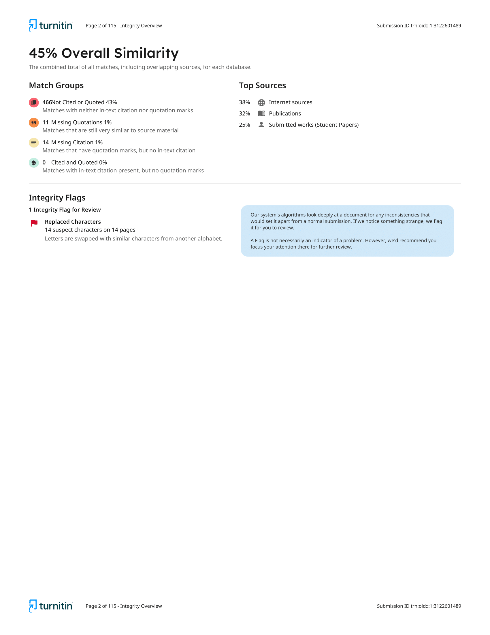

PART 3: Declaration of Competing Interest of the Reviewer:

Here reviewer should declare his/her competing interest. If nothing to declare he/she can write “I declare that I have no competing interest as a reviewer”
I declare that I have no competing interest as a reviewer

PART 4: Objective Evaluation:

Guideline | MARKS of this manuscript
Give OVERALL MARKS you want to give to this manuscript  ( Highest: 10 Lowest: 0 )  Guideline:  Accept As It Is: (>9-10)  Minor Revision: (>8-9)  Major Revision: (>7-8)  Serious Major revision: (>5-7)  Rejected (with repairable deficiencies and may be reconsidered): (>3-5)  Strongly rejected (with irreparable deficiencies.): (>0-3) | 6  Serious Major Revision

Editorial Comments (This section is reserved for the comments from book editorial office and editors):

Author’s Feedback

Reviewer Details:
This section is mandatory to prepare the Reviewer Certificate.
Please complete this section carefully. Reviewer Certificate will be generated by using this information only.
Your Certificate will be wrong, if you provide incorrect information.
Please note modification of certificate will not be possible after generation.
Certificate will not be issued if incomplete information is provided.

Name of the Reviewer | Ans Nadeem
Department of Reviewer | Department of Clinical Sciences
University or Institution of Reviewer | University of Veterinary and Animal Sciences, Lahore
Country of Reviewer | Pakistan
Position: (Professor/lecturer, etc.) of Reviewer | Researcher
Email ID of Reviewer | ansnadeem89f@gmail.com
WhatsApp Number of Reviewer (Optional) | +923017303342
Write 5-8 Keywords regarding expertise of Reviewer | Epidemology, Viral Infection, Molecular Study, Phylogenetic analysis, Public Health

