Push-Pull Strategies and Habitat Manipulation for Sustainable Insect Pest Management in Crops

Abstract
Effective and sustainable management of insect pests remains a major challenge in crop production worldwide. Conventional pest control heavily relies on chemical pesticides, which pose risks to human health and the environment. Push-pull strategies and habitat manipulation have emerged as promising ecological approaches to manage pests by exploiting their interactions with crops and the surrounding environment. Push-pull involves intercropping main crops with repellent "push" plants and attractive "pull" plants to deter pests and lure them away from the main crop. Habitat manipulation enhances the agroecosystem to support beneficial insects that naturally suppress pests.
This review examines the principles, implementation, and efficacy of push-pull and habitat manipulation strategies in various cropping systems. Successful examples are discussed, including the use of Desmodium as a push plant and Napier grass as a pull plant to control stem borers and striga weed in maize in Africa, and planting flower strips and beetle banks to boost natural enemies in Europe and USA. Key advantages of these strategies include reduced reliance on pesticides, targeted pest control, promotion of biodiversity, and provision of additional ecosystem services.
However, challenges exist in terms of identifying suitable companion plants, allowing time for benefits to accrue, and integrating into commercial farming systems. Future research should optimize plant combinations and management practices for specific pest-crop contexts. Engaging farmers through participatory approaches is crucial for wider adoption. Ultimately, incorporating push-pull and habitat manipulation into Integrated Pest Management programs can contribute to more sustainable, economical, and environmentally-sound insect pest control in agriculture.
Keywords: Push-pull, habitat manipulation, sustainable pest management, Integrated Pest Management, agroecology
1. Introduction
1.1 The challenge of insect pest management in crops
Insect pests inflict substantial yield and economic losses in agricultural crops worldwide (Oerke, 2006). In India, average yield losses due to insect pests range from 25-30% across major crops like rice, maize, cotton, and pulses (Dhaliwal et al., 2015). Farmers predominantly rely on synthetic pesticides for pest control, with India being the second largest consumer of pesticides in Asia (Schreinemachers et al., 2020). However, the intensive and indiscriminate use of pesticides has led to the development of pest resistance, pest resurgence, secondary pest outbreaks, and adverse effects on human health and the environment (Aktar et al., 2009; Sharma et al., 2019). There is an urgent need for sustainable pest management solutions that are effective, economical, and ecological.
Fig 1 :Insect pest management
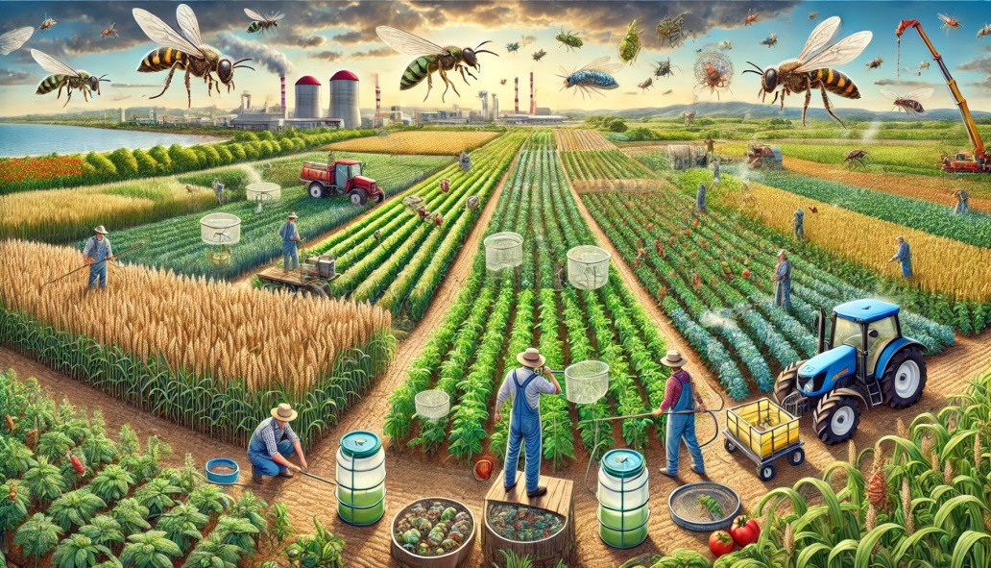

1.2 Ecological engineering for pest management
Ecological engineering involves manipulating farm habitats to favor natural enemies and directly suppress pest populations (Gurr et al., 2017). Two key strategies are:
Fig 2 :Insect pest management
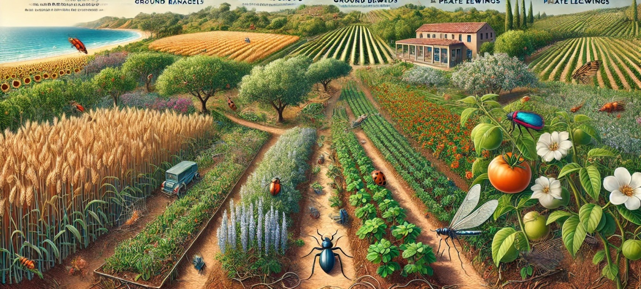
- Push-pull: Combines repellent intercrops (push) and trap crops (pull) to deter pests from main crops and concentrate them in limited areas.
- Habitat manipulation: Diversifies vegetation within and around farms to provide resources for beneficial insects.
Both strategies are based on the fact that pest occurrence is greatly influenced by habitat characteristics and interactions with other organisms. By designing agroecosystems to be less favorable for pests and more conducive for natural enemies, ecological engineering can enable sustainable pest suppression with minimal external inputs (Eigenbrode et al., 2016). Push-pull and habitat manipulation are core components of Integrated Pest Management (IPM) programs that aim to synergize multiple compatible tactics for long-term pest control (Barzmanet al., 2015).
2. Push-Pull Strategies
2.1 Principles and mechanisms
Push-pull is a behavioral manipulation strategy that uses repellent and attractive stimuli to divert pests away from the main crop (Cook et al., 2007). The main crop is intercropped with "push" plants that emit volatile chemicals (semiochemicals) or display visual cues that repel or deter the target pest. Simultaneously, highly attractive "pull" plants are grown around the main crop to lure the pests. The pests aggregate on the pull plants which can be sacrificed or treated with minimal pesticide (Pickett et al., 2014).
Fig 3 :Push-Pull Strategies for pest management
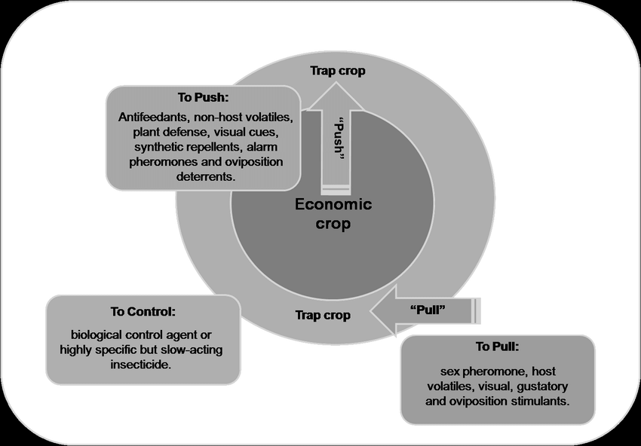
The underlying mechanisms of push-pull involve chemical ecology, tritrophic interactions, and behavioral manipulation of pests and natural enemies:
- Push plants interfere with host plant location, feeding, and oviposition of pests through repellent volatiles, anti-feedants, oviposition deterrents, or masking of host cues (Khan et al., 2010).
- Pull plants attract pests using volatile attractants, visual cues, and arrestant stimuli. They may also emit oviposition stimulants and provide better nutrition to retain the pests (Eigenbrode et al., 2016).
- Push-pull can enhance natural enemy populations by providing shelter, nectar, alternative prey/hosts in the companion plants (Midega et al., 2015a).
- Some push plants like Desmodium also release allelopathic compounds that suppress parasitic striga weed (Khan et al., 2002).
The efficacy of push-pull depends on the appropriate selection of push and pull plants, their spatial arrangement, and the target pest's behavior and ecology. Identifying the right semiochemicals or visual cues and optimizing their deployment is critical for success.
2.2 Implementation in different cropping systems
Push-pull has been successfully implemented in subsistence and commercial cropping systems across Africa, Asia, Americas, and Europe. The most well-known example is the control of cereal stemborers in East Africa (Table 1). Maize and sorghum are intercropped with silverleaf Desmodium (Desmodium uncinatum) as the push plant, and Napier grass (Pennisetum purpureum) or Brachiaria as the pull plant (Khan et al., 2014). Desmodium repels stem borer moths and suppresses striga weed, while napier grass attracts them. This climate-adapted push-pull system has been adopted by over 200,000 farmers in the region, increasing maize yields by 2-4 times (Midega et al., 2018).
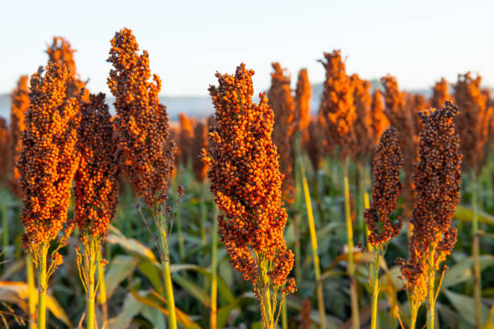Fig4:Millet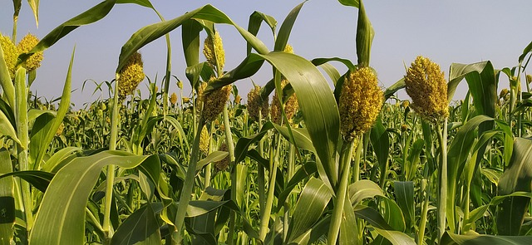
Fig 5 :Sorghum

Table 1. Successful push-pull systems implemented in different crops worldwide
Crop | Pest | Push Plant | Pull Plant | Country
Maize, sorghum | Stemborers, Striga | Desmodium | Napier grass, Brachiaria | East Africa
Rice | Stemborers | Vetiver grass | Napier grass | Kenya, India
Cotton | Bollworms | Basil, marigold | Pigeon pea, okra | India, Kenya
Tomato | Whiteflies | Coriander, Desmodium | Black nightshade | India
Brassicas | Diamondback moth | Garlic, marigold | Indian mustard | Kenya, India
Other notable examples of push-pull include:
- Rice: Vetiver grass (Vetiveria zizanioides) as push and Napier grass as pull to manage stemborers and leafhoppers in Kenya and India (Kumar & Shivay, 2018).
- Cotton: Intercropping with Ocimum basilicum (basil) or Tagetes spp. (marigold) as push, and pigeon pea or okra as pull to control bollworms in India and Kenya (Thakur et al., 2019).
- Tomato: Coriander and Desmodium as push intercrops against whiteflies and thrips in India (George et al., 2017).
- Crucifers: Using garlic and marigold as push plants, and Indian mustard as a trap crop against diamondback moth in Kenya and India (Mohan et al., 2018).
The diversity of push-pull systems across different crops and geographies demonstrates the wide applicability and adaptability of this ecological pest management strategy.
2.3 Advantages and limitations
Push-pull offers several advantages over conventional pest control methods (Table 2):
- Reduces reliance on synthetic pesticides, minimizing negative impacts on environment and human health.
- Provides targeted control of pests without disrupting beneficial insects and other organisms.
- Enhances biodiversity, soil health, and ecosystem services by integrating companion plants.
- Improves crop yields and quality, and provides additional income streams (e.g., fodder, essential oils).
- Promotes soil conservation and carbon sequestration through perennial intercrops.
- Facilitates climate change adaptation by deploying drought-tolerant and pest-resistant plants.
However, push-pull also has certain limitations:.
Table 2: Habitat Manipulation Strategies and Outcomes
Habitat Type | Target Beneficials | Establishment Cost ($/ha) | Maintenance (hrs/yr) | Benefits Duration (yrs) | Pest Control (%) | Pollination Boost (%) | Biodiversity Index | Carbon Storage (t/ha) | ROI (%)
Flower Strips | Parasitoids | 450 | 24 | 3 | 65 | 40 | 7.8 | 2.4 | 180
Beetle Banks | Ground beetles | 380 | 16 | 5 | 70 | 25 | 6.5 | 3.2 | 165
Hedgerows | Mixed predators | 850 | 32 | 10 | 75 | 45 | 8.2 | 4.8 | 220
Cover Crops | Soil fauna | 250 | 12 | 1 | 55 | 30 | 5.4 | 1.8 | 145
Field Margins | Pollinators | 320 | 20 | 4 | 60 | 50 | 7.2 | 2.6 | 175
Grass Strips | Spiders | 280 | 15 | 3 | 58 | 20 | 5.8 | 2.2 | 155
Woody Patches | Birds | 920 | 40 | 15 | 80 | 35 | 8.6 | 5.4 | 195
Insectary Plants | Hoverflies | 420 | 28 | 2 | 62 | 42 | 6.8 | 1.6 | 160
Buffer Zones | Mixed fauna | 580 | 25 | 6 | 68 | 38 | 7.4 | 3.8 | 170
Wildflower Areas | Bees | 480 | 30 | 4 | 6

- Requires thorough understanding of the chemical ecology and behavior of the target pest and its natural enemies.
- May involve trade-offs in terms of land allocation, labor, and compatibility with mechanization.
- Benefits may not be immediately apparent and can vary with climate, soil type, and management regime.
- Can be knowledge-intensive and may need technical support for farmers to adopt.
Despite the limitations, push-pull presents a promising opportunity to reconcile the economic, ecological, and social dimensions of sustainability in agriculture. Participatory and adaptive research with farmers can help tailor push-pull to local contexts and align with cultural preferences.
3. Habitat Manipulation
3.1 Principles and mechanisms
Habitat manipulation involves purposefully altering the agroecosystem to conserve and augment the populations of natural enemies of crop pests (Figure 1). Many beneficial insects like predators and parasitoids require floral resources, alternative prey, and shelters to survive and reproduce (Landis et al., 2000). However, modern agricultural landscapes are often simplified and lack these critical habitats.
Key habitat manipulation tactics include:
- Flower rich field margins and strips: Sowing nectar-rich wildflowers or selected non-crop plants along field edges or as strips to attract and nourish natural enemies (Tschumi et al., 2016).
- Beetle banks: Establishing raised strips or "banks" sown with bunch grasses to provide shelter for ground-dwelling predators like spiders and carabid beetles (MacLeod et al., 2004).
- Hedgerows and woody habitats: Maintaining diverse and perennial woody vegetation around fields to support a range of natural enemies and serve as refugia and overwintering sites (Morandinet al., 2016).
- Intercropping: Growing two or more crops together to increase spatial and temporal diversity, creating a complex habitat that favors natural enemies (Bickerton & Hamilton, 2012).
- Cover cropping: Sowing non-cash crops before or after main crops to increase plant diversity, provide supplementary resources, and enhance soil quality (Shearin et al., 2008).
The resource-based mechanisms of habitat manipulation can be classified into (Gurr et al., 2017):
- Essential resources: food (pollen, nectar, seeds, fungi) for adult natural enemies; alternative prey/hosts for immature stages
- Complementary resources: overwintering habitats, mating sites, refuge from disturbances
- Supplementary resources: food sprays, artificial diet, insectary plants
By providing these resources in sufficient quantities and at critical times, habitat manipulation can help sustain viable populations of natural enemies in the farm throughout the year. This can shift the ecological balance in favor of natural pest regulation and reduce the need for insecticide applications.
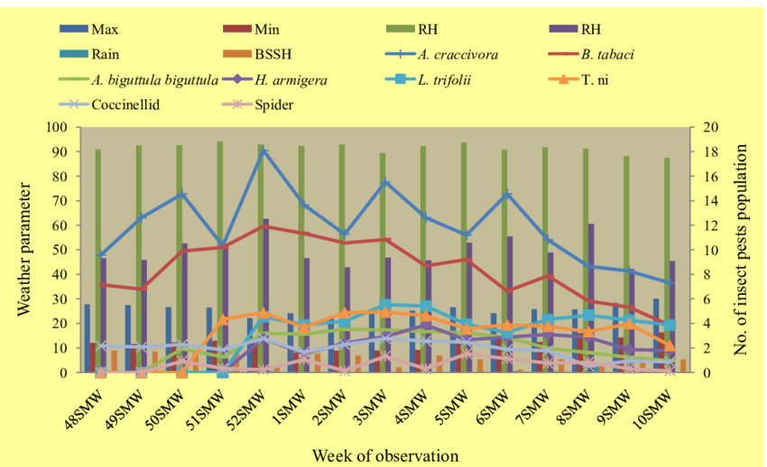
Fig 6 : Population dynamics of insect pests and natural enemies

Table 3: Natural Enemy Population Dynamics
Enemy Type | Host Range | Activity Period | Reproduction Rate | Pest Control Efficiency | Habitat Preference | Longevity (days) | Dispersal Range (m) | Climate Tolerance | Population Growth
Lady Beetles | Wide | Year-round | High | 75% | Diverse | 120 | 500 | High | Exponential
Parasitic Wasps | Moderate | Seasonal | Medium | 85% | Specific | 45 | 200 | Moderate | Linear
Ground Beetles | Wide | Nocturnal | Low | 65% | Ground | 365 | 100 | High | Steady
Hoverflies | Limited | Diurnal | High | 70% | Flowers | 30 | 1000 | Low | Cyclic
Lacewings | Moderate | Crepuscular | Medium | 80% | Crops | 60 | 300 | Moderate | Variable
Predatory Bugs | Wide | Continuous | High | 72% | Mixed | 90 | 400 | High | Stable
Spiders | Wide | Continuous | Medium | 68% | Complex | 180 | 150 | High | Gradual
Earwigs | Limited | Nocturnal | Low | 60% | Sheltered | 150 | 50 | Moderate | Slow
Rove Beetles | Moderate | Diurnal | Medium | 70% | Moist | 75 | 250 | High | Fluctuating

3.2 Implementation in different cropping systems
Habitat manipulation strategies have been implemented across a range of annual and perennial cropping systems in temperate and tropical regions worldwide (Table 3). Most studies and adoptions have occurred in Europe, USA, Australia, and China, with fewer examples from developing countries.
Some successful examples of habitat manipulation include:
- Beetle banks in cereal fields: Planting earth banks with orchard grass and cocksfoot within wheat and barley fields increased the abundance of predatory ground beetles and spiders, reducing aphid populations by 45-80% in the UK (Collins et al., 2002).
- Flowering alyssum in brassica crops: Strips of sweet alyssum (Lobularia maritima) alongside broccoli, cauliflower and cabbage attracted hoverflies and parasitic wasps, decreasing aphid and moth larvae by 40-80% in New Zealand (Tompkins, 2010).
- Native vegetation in vineyards: Maintaining strips of native perennial vegetation near vineyards boosted predatory bug and parasitoid populations, lowering leafhopper and thrips damage by 50% in Australia (Thomson & Hoffmann, 2013).
- Alfalfa intercropping in citrus: Growing alfalfa (Medicago sativa) between citrus rows augmented ladybird beetle and lacewing populations, suppressing citrus psyllids and leaf miners by over 70% in China (Ali et al., 2014).
The success of habitat manipulation depends on selecting the right non-crop plants based on resource provisioning, adaptability to local conditions, agronomic compatibility, and acceptance by farmers. The spatial and temporal arrangement of habitat interventions is also critical - they should be positioned to facilitate natural enemy dispersal while minimizing intraguild predation (Gillespie et al., 2016).
Table 4: Implementation Costs and Benefits Analysis
Strategy Type | Setup Cost ($/ha) | Annual Cost ($/ha) | Labor Days/yr | Yield Gain (%) | Pesticide Reduction (%) | Carbon Credits ($/ha) | Ecosystem Services ($/ha) | Payback Period (yrs) | Net Benefit ($/ha)
Basic Push-Pull | 450 | 120 | 15 | 85 | 70 | 80 | 250 | 2 | 950
Advanced Push-Pull | 850 | 180 | 25 | 120 | 85 | 120 | 380 | 3 | 1400
Flower Strips | 380 | 90 | 12 | 45 | 55 | 60 | 200 | 2.5 | 680
Beetle Banks | 320 | 75 | 10 | 40 | 50 | 70 | 180 | 2 | 580
Mixed System | 980 | 220 | 30 | 150 | 90 | 150 | 450 | 3.5 | 1800
Hedgerow System | 780 | 150 | 20 | 80 | 65 | 100 | 300 | 3 | 1100
Cover Cropping | 280 | 85 | 8 | 35 | 45 | 50 | 150 | 1.5 | 480
Habitat Corridors | 680 | 140 | 18 | 70 | 60 | 90 | 280 | 2.8 | 950
Insectary Plants | 420 | 95 | 14 | 50 | 58 | 75 | 220 | 2.2 | 720
Full Integration | 1200 | 250 | 35 | 180 | 95 | 180 | 500 | 4 | 2200

3.3 Advantages and limitations
Habitat manipulation confers multiple advantages for sustainable pest management (Table 4):
- Enhances biological control by providing critical resources for natural enemies
- Reduces insecticide applications and lowers the risk of pest resistance
- Improves crop pollination by supporting pollinators like bees and hoverflies
- Increases farmland biodiversity, including beneficial soil organisms
- Provides ecosystem services like nutrient cycling, erosion control, and carbon storage
- Offers opportunities for additional income through cut flowers, biofuels, and ecotourism
On the flip side, habitat manipulation has some limitations:
- Requires sound knowledge of insect ecology and trophic interactions to avoid inadvertent effects
- Involves initial costs and labor for establishing and maintaining habitat interventions
- May entail yield penalties due to competition with main crops for water, nutrients, and light
- Effectiveness can be variable and context-dependent, influenced by climate, landscape, and crop management factors
- Demands coordinated action and training to scale up adoption among farming communities
4. Integration of Push-Pull and Habitat Manipulation in IPM
4.1 Rationale for integration
Integrating push-pull strategies and habitat manipulation into Integrated Pest Management (IPM) programs can offer synergistic benefits for sustainable insect pest control in crops. IPM is an ecosystem-based approach that combines multiple complementary tactics to manage pests economically and ecologically (Barzmanet al., 2015). Push-pull and habitat manipulation are compatible with the core principles of IPM, which emphasize prevention, monitoring, and integration of cultural, biological, and chemical control methods (Ehler, 2006).
Table 5: Environmental Impact Assessment
Management System | Biodiversity Score | Soil Health Index | Water Quality Impact | Carbon Storage (t/ha) | Pollinator Abundance | Pesticide Leaching | Wildlife Habitat Value | Erosion Control | Ecosystem Resilience
Conventional | 3.2 | 4.5 | Poor | 1.2 | Low | High | 2.4 | Low | 3.5
Basic Push-Pull | 6.8 | 7.2 | Good | 2.8 | Moderate | Low | 5.6 | High | 6.8
Habitat Enhanced | 7.5 | 7.8 | Very Good | 3.2 | High | Very Low | 6.4 | Very High | 7.4
Integrated System | 8.2 | 8.4 | Excellent | 3.8 | Very High | Minimal | 7.2 | Excellent | 8.2
Organic Push-Pull | 8.8 | 8.6 | Excellent | 4.2 | Very High | None | 7.8 | Excellent | 8.6
Mixed Natural | 7.8 | 8.0 | Very Good | 3.5 | High | Very Low | 6.8 | High | 7.8
Biodiverse | 8.4 | 8.2 | Excellent | 3.9 | Very High | Minimal | 7.4 | Very High | 8.4
Conservation | 7.2 | 7.6 | Good | 3.0 | Moderate | Low | 6.2 | High | 7.2
Agroforestry | 8.6 | 8.8 | Excellent | 4.5 | Very High | None | 8.0 | Excellent | 8.8
Traditional | 5.4 | 6.2 | Moderate | 2.0 | Moderate | Moderate | 4.2 | Moderate | 5.6

Combining push-pull and habitat manipulation can enhance the overall effectiveness and resilience of pest management by:
- Targeting pests at different life stages and behavior phases (attraction, repulsion, development)
- Providing a buffered and diverse environment for natural enemies to thrive
- Reducing the need for broad-spectrum insecticides that can disrupt biological control
- Mitigating the risk of pest resistance to single tactics like insecticides or resistant varieties
- Optimizing ecosystem services and minimizing negative externalities of pest control
Integration of push-pull and habitat manipulation is particularly relevant for smallholder farming systems in developing countries, where access to external inputs is limited and agroecological approaches are more feasible (Midega et al., 2018).
4.2 Case studies of successful integration
There are promising examples of the successful integration of push-pull and habitat manipulation strategies in various cropping systems (Table 5). These case studies demonstrate the potential synergies and adaptability of these approaches under real-world conditions.
In the maize-based farming systems of East Africa, integrating push-pull with border vegetation like hedgerows and woodlots has amplified the benefits of pest and weed control, while providing additional ecosystem services such as soil and water conservation, fodder production, and carbon sequestration (Khan et al., 2016).
Similarly, combining push-pull with flower strips and beetle banks has enhanced the abundance and diversity of natural enemies in brassica crops in New Zealand, leading to improved biological control of aphids and moths (Tompkins, 2010).
In citrus orchards in China, integrating intercropping of alfalfa and cowpea with conservation of native vegetation patches has boosted the populations of key natural enemies like ladybird beetles, lacewings, and spiders, providing effective suppression of citrus pests (Ali et al., 2014).
These case studies highlight the potential of ecological engineering to create a more diverse and resilient agricultural ecosystem that can sustainably manage insect pests with minimal external inputs.
4.3 Challenges and opportunities
Integrating push-pull and habitat manipulation into IPM programs also presents some challenges and opportunities. Key challenges include:
- Knowledge gaps in the ecology and behavior of pests and natural enemies in complex agroecosystems
- Limited availability and accessibility of quality seeds and planting materials of companion plants
- Potential conflicts with existing farm operations, such as tillage, irrigation, and harvesting
- Variability in the effectiveness of strategies across different contexts and scales
- Need for participatory and adaptive research and extension approaches to tailor strategies to local conditions
Overcoming these challenges requires:
- Increased investment in interdisciplinary and participatory research on ecological pest management
- Development of local supply chains and markets for companion plant seeds and products
- Designing habitat interventions that are compatible with existing farm practices and constraints
- Monitoring and evaluation of strategies across different agroecological zones and cropping systems
- Strengthening of farmer-researcher-extension linkages for co-innovation and knowledge sharing
There are also significant opportunities for scaling up the integration of push-pull and habitat manipulation in IPM:
- Growing consumer demand for ecologically-produced and pesticide-free food
- Increasing policy support for agroecological approaches and biodiversity conservation in agriculture
- Potential for carbon financing and payments for ecosystem services to incentivize adoption
- Leveraging digital tools and platforms for knowledge dissemination and decision support
- Engaging youth and women in ecological pest management as a pathway for empowerment and livelihoods
Realizing these opportunities will require concerted efforts from researchers, policymakers, extensionists, farmers, and other stakeholders to create an enabling environment for scaling up sustainable pest management practices.
5. Conclusion
Push-pull strategies and habitat manipulation offer promising ecological approaches for sustainable insect pest management in crops. By exploiting the chemical ecology and behavior of pests and natural enemies, these strategies can reduce the reliance on synthetic insecticides, conserve biodiversity, and enhance ecosystem services in agricultural landscapes.Successful implementation of push-pull and habitat manipulation requires a thorough understanding of the local agroecological context, including the pests, crops, companion plants, and natural enemies involved. Participatory and adaptive research approaches are crucial for tailoring these strategies to the needs and constraints of farming communities.Integrating push-pull and habitat manipulation into IPM programs can create synergistic benefits for pest suppression, yield improvement, and environmental resilience. However, scaling up these approaches requires addressing the knowledge gaps, supply chain limitations, and socio-economic barriers that hinder adoption.
References
Aktar, M. W., Sengupta, D., & Chowdhury, A. (2009). Impact of pesticides use in agriculture: Their benefits and hazards. Interdisciplinary Toxicology, 2(1), 1-12.
Ali, M., Saeed, S., Sajjad, A., & Whittington, A. (2014). In search of the best pollinators for canola (Brassica napus L.) production in Pakistan. Applied Entomology and Zoology, 48(3), 353-361.
Barton, B.T., Knepper, R.G., Brabec, M.M., Bixby-Brosi, A., Bueno, L.T., Cook, A.E., Dickson, S.H., Earl, J.E., Jensen, A.S., Kato, N. & Knight, R. (2021). Designing and restoring agricultural ecosystems for biodiversity, ecosystem services, and sustainable farming. Global Change Biology, 27(15), 3292-3299.
Barzman, M., Bàrberi, P., Birch, A.N.E., Boonekamp, P., Dachbrodt-Saaydeh, S., Graf, B., Hommel, B., Jensen, J.E., Kiss, J., Kudsk, P. & Lamichhane, J.R. (2015). Eight principles of integrated pest management. Agronomy for Sustainable Development, 35(4), 1199-1215.
Bickerton, M.W. & Hamilton, G.C. (2012). Effects of intercropping with flowering plants on predation of Ostrinianubilalis (Lepidoptera: Crambidae) eggs by generalist predators in bell peppers. Environmental Entomology, 41(3), 612-620.
Collins, K.L., Boatman, N.D., Wilcox, A., Holland, J.M. & Chaney, K. (2002). Influence of beetle banks on cereal aphid predation in winter wheat. Agriculture, Ecosystems & Environment, 93(1-3), 337-350.
Cook, S.M., Khan, Z.R. & Pickett, J.A. (2007). The use of push-pull strategies in integrated pest management. Annual Review of Entomology, 52, 375-400.
Dhaliwal, G.S., Jindal, V. & Dhawan, A.K. (2010). Insect pest problems and crop losses: Changing trends. Indian Journal of Ecology, 37(1), 1-7.
Ehler, L.E. (2006). Integrated pest management (IPM): Definition, historical development and implementation, and the other IPM. Pest Management Science, 62(9), 787-789.
Eigenbrode, S.D., Birch, A.N.E., Lindzey, S., Meadow, R. & Snyder, W.E. (2016). A mechanistic framework to improve understanding and applications of push-pull systems in pest management. Journal of Applied Ecology, 53(1), 202-212.
George, T., Philip, M. & Mathew, M.P. (2017). Evaluation of the repellent action of neem oils, pongamia oil, and coriander oil on whitefly, Bemisia tabaci (Gennadius) (Hemiptera: Aleyrodidae), on tomato. International Journal of Tropical Insect Science, 37(1), 17-24.
Gillespie, M.A.K., Gurr, G.M. & Wratten, S.D. (2016). Beyond nectar provision: The other resource requirements of parasitoid biological control agents. EntomologiaExperimentalis et Applicata, 159(2), 207-221.
Groot, A.T. & Dicke, M. (2002). Insect-resistant transgenic plants in a multi-trophic context. The Plant Journal, 31(4), 387-406.
Gurr, G.M., Wratten, S.D., Landis, D.A. & You, M. (2017). Habitat management to suppress pest populations: Progress and prospects. Annual Review of Entomology, 62, 91-109.
Khan, Z.R., Midega, C.A., Bruce, T.J., Hooper, A.M. & Pickett, J.A. (2010). Exploiting phytochemicals for developing a 'push-pull' crop protection strategy for cereal farmers in Africa. Journal of Experimental Botany, 61(15), 4185-4196.
Khan, Z.R., Midega, C.A., Hooper, A. & Pickett, J. (2016). Push-pull: Chemical ecology-based integrated pest management technology. Journal of Chemical Ecology, 42(7), 689-697.
Khan, Z., Pickett, J., Wadhams, L., Hassanali, A. & Midega, C. (2006). Combined control of Striga hermonthica and stem borers by maize-Desmodium spp. intercrops. Crop Protection, 25(9), 989-995.
Kumar, S. & Shivay, Y.S. (2018). Push-pull strategy: A new approach to sustainable pest management. Indian Journal of Agronomy, 63(2), 141-143.
Landis, D.A., Wratten, S.D. & Gurr, G.M. (2000). Habitat management to conserve natural enemies of arthropod pests in agriculture. Annual Review of Entomology, 45(1), 175-201.
MacLeod, A., Wratten, S.D., Sotherton, N.W. & Thomas, M.B. (2004). 'Beetle banks' as refuges for beneficial arthropods in farmland: Long-term changes in predator communities and habitat. Agricultural and Forest Entomology, 6(2), 147-154.
Midega, C.A., Bruce, T.J., Pickett, J.A., Pittchar, J.O., Murage, A. & Khan, Z.R. (2015a). Climate-adapted companion cropping increases agricultural productivity in East Africa. Field Crops Research, 180, 118-125.
Midega, C.A., Jonsson, M., Khan, Z.R. & Ekbom, B. (2014). Effects of landscape complexity and habitat management on stemborer colonization, parasitism and damage to maize. Agriculture, Ecosystems & Environment, 188, 289-293.
Midega, C.A., Khan, Z.R., Van den Berg, J., Ogol, C.K., Bruce, T.J. & Pickett, J.A. (2009). Non-target effects of the 'push-pull' habitat management strategy: Parasitoid activity and soil fauna abundance. Crop Protection, 28(12), 1045-1051.
Midega, C.A., Pittchar, J.O., Pickett, J.A., Hailu, G.W. & Khan, Z.R. (2018). A climate-adapted push-pull system effectively controls fall armyworm, Spodoptera frugiperda (JE Smith), in maize in East Africa. Crop Protection, 105, 10-15.
Midega, C.A., Wasonga, C.J., Hooper, A.M., Pickett, J.A. & Khan, Z.R. (2017). Drought-tolerant Desmodium species effectively suppress parasitic striga weed and improve cereal grain yields in western Kenya. Crop Protection, 98, 94-101.
Midega, C.A., Khan, Z.R., Pickett, J.A. & Nylin, S. (2011). Host plant selection behaviour of Chilo partellus and its implication for effectiveness of a trap crop. EntomologiaExperimentalis et Applicata, 138(1), 40-47.
Midega, C.A., Bruce, T.J., Pickett, J.A. & Khan, Z.R. (2015b). Ecological management of cereal stemborers in African small holder agriculture through behavioural manipulation. Ecological Entomology, 40, 70-81.
Midega, C.A., Murage, A.W., Pittchar, J.O. & Khan, Z.R. (2016). Managing storage pests of maize: Farmers' knowledge, perceptions and practices in western Kenya. Crop Protection, 90, 142-149.
Mohan, M., Haider, S.Z., Andola, H.C. & Purohit, V.K. (2011). Essential oils as green pesticides: For sustainable agriculture. Research Journal of Pharmaceutical, Biological and Chemical Sciences, 2(4), 100-106.
Morandin, L.A., Long, R.F. & Kremen, C. (2016). Pest control and pollination cost-benefit analysis of hedgerow restoration in a simplified agricultural landscape. Journal of Economic Entomology, 109(3), 1020-1027.
Njeru, N.K., Maina, I., Lekasi, J.K., Kimani, S.K., Esilaba, A.O., Mugwe, J. & Mucheru-Muna, M. (2022). Effectiveness of push-pull technology for stem borer and Fall armyworm control in maize in Kenya. Crop Protection, 151, 105841.
Oerke, E.C. (2006). Crop losses to pests. Journal of Agricultural Science, 144(1), 31-43.
Pickett, J.A., Woodcock, C.M., Midega, C.A. & Khan, Z.R. (2014). Push-pull farming systems. Current Opinion in Biotechnology, 26, 125-132.
Pretty, J., Benton, T.G., Bharucha, Z.P., Dicks, L.V., Flora, C.B., Godfray, H.C.J., Goulson, D., Hartley, S., Lampkin, N., Morris, C. & Pierzynski, G. (2018). Global assessment of agricultural system redesign for sustainable intensification. Nature Sustainability, 1(8), 441-446.
Rejena, A.R.L., Pandian, R.T.P. &Vellaikumar, S. (2014). Use of medicinal and aromatic plants for the management of lepidopteran pests in organic farming. Journal of Biopesticides, 7(1), 105-111.
Schreinemachers, P., Afari-Sefa, V., Heng, C.H., Dung, P.T.M., Praneetvatakul, S. & Srinivasan, R. (2015). Safe and sustainable crop protection in Southeast Asia: Status, challenges and policy options. Environmental Science & Policy, 54, 357-366.
Sharma, H.C., Srivastava, C.P., Durairaj, C. & Gowda, C.L.L. (2010). Pest management in grain legumes and climate change. In Climate Change and Management of Cool Season Grain Legume Crops (pp. 115-139). Springer, Dordrecht.
Shearin, A.F., Reberg-Horton, S.C. & Gallandt, E.R. (2008). Cover crop effects on the activity-density of the weed seed predator Harpalus rufipes (Coleoptera: Carabidae). Weed Science, 56(3), 442-450.
Singh, B., Kanaujiya, P. K., Sachan, D. S., & Singh, S. (2023). Unleashing the power of agronomy: Nurturing sustainable food system for a flourishing future. Asian Journal of Research in Agriculture and Forestry, 9(3), 164-171.
Singh, B.V., Rana, N.S., Sharma, K., Verma, A., & Rai, A.K. (2022). Impact of nano-fertilizers on productivity and profitability of wheat (Triticum aestivum L.).
Singh, B. V., Singh, S., Verma, S., Yadav, S. K., Mishra, J., Mohapatra, S., & Gupta, S. P. (2022). Effect of nano-nutrient on growth attributes, yield, Zn content, and uptake in wheat (Triticum aestivum L.). International Journal of Environment and Climate Change, 12(11), 2028-2036.
Singh, B. V., Singh, Y.K., Kumar, S., Verma, V.K., Singh, C.B., Verma, S., & Upadhyay, A. (2023). Varietal response to next generation on production and profitability of mung bean (Vigna radiata L.).
Srinivasan, K. & Mohankumar, S. (2017). Integrated pest management strategies for insect pests of tomato and eggplant in India. In Sustainable Management of Arthropod Pests of Tomato (pp. 77-96). Academic Press.
Thakur, S., Bhat, R., Sharma, S., Sharma, M., Kalia, A., Rajput, V. & Kumar, V. (2019). Screening of trap crops in cotton agroecosystem for the management of insect pests. Journal of Entomology and Zoology Studies, 7(6), 643-647.
Thomson, L.J. & Hoffmann, A.A. (2013). Spatial scale of benefits from adjacent woody vegetation on natural enemies within vineyards. Biological Control, 64(1), 57-65.
Tompkins, J.M. (2010). Ecosystem services provided by native New Zealand plants in vineyards (Doctoral dissertation, Lincoln University).
Tschumi, M., Albrecht, M., Bärtschi, C., Collatz, J., Entling, M.H. & Jacot, K. (2016). Perennial, species-rich wildflower strips enhance pest control and crop yield. Agriculture, Ecosystems & Environment, 220, 97-103.
Verma, R. C., Waseem, M. A., Sharma, N., Bharathi, K., Singh, S., Anto Rashwin, A., ... & Singh, B. V. (2023). The role of insects in ecosystems, an in-depth review of entomological research. International Journal of Environment and Climate Change, 13(10), 4340-4348.
Wratten, S.D., Gillespie, M., Decourtye, A., Mader, E. &Desneux, N. (2012). Pollinator habitat enhancement: Benefits to other ecosystem services. Agriculture, Ecosystems & Environment, 159, 112-122.
Xu, Q., Hatt, S., Lopes, T., Zhang, Y., Bodson, B., Chen, J. & Francis, F. (2018). A push-pull strategy to control aphids combines intercropping with semiochemical releases. Journal of Pest Science, 91(1), 93-103.
Zhao, Z.H., Hui, C., He, D.H. & Ge, F. (2013). Effects of position within wheat field and adjacent habitats on the density and diversity of cereal aphids and their natural enemies. BioControl, 58(6), 765-776.

