Big Data Analytics and Decision Support Systems for Precision Insect Pest Management

Abstract
The rapid growth of sensor networks, Internet of Things (IoT) devices, and geospatial technologies has enabled the collection of vast amounts of data relevant to insect pest management in agriculture. However, the sheer volume and variety of this "big data" presents challenges in deriving actionable insights to support real-time decision-making by farmers and pest management professionals. This paper explores applying big data analytics and decision support systems (DSS) to enable data-driven, site-specific insect pest management strategies, a practice known as precision insect pest management. Key components of a big data and DSS framework for IPM are discussed, including data collection and integration, predictive modeling, and delivery of customized treatment recommendations. Case studies of big data applications for major agricultural insect pests are presented, such as using machine learning to predict outbreaks of desert locusts in Africa and real-time monitoring of brown planthopper in rice crops using smartphone apps. Challenges and future opportunities in using big data analytics for precision IPM are also discussed, including data quality, interoperability, and effective user interfaces. Continued innovation in big data approaches has the potential to revolutionize insect pest management by providing powerful tools to proactively respond to pest threats and optimize the use of control tactics.
Keywords: Precision Agriculture, Integrated Pest Management, Artificial Intelligence, Internet of Things, Predictive Modeling
- Introduction
  - Insect Pests as a Major Challenge in Agriculture
Insect pests are a pervasive threat to agricultural production, causing significant yield losses and economic damage worldwide. It is estimated that insect pests destroy up to 20% of global crop production annually, with a value of over $470 billion (Sharma et al., 2017). The impact of insect pests is particularly acute in developing countries, where smallholder farmers often lack access to effective control measures and rely heavily on pesticide use, leading to issues of pest resistance, environmental contamination, and human health risks (Deutsch et al., 2018). Climate change is expected to further exacerbate pest pressure by altering the geographic distribution and population dynamics of many insect species (Savary et al., 2019).
Table 1: Major Agricultural Insect Pests and Their Economic Impacts
Pest Name | Scientific Name | Main Crops Affected | Estimated Annual Losses | Geographic Distribution | Add reference
Desert locust | Schistocerca gregaria | Cereals, forage crops | $2.5 billion in Africa and Middle East | Africa, Middle East, Asia | To anuual loss for all pests
Rice brown planthopper | Nilaparvata lugens | Rice | $300 million in Asia | South and Southeast Asia
Helicoverpa moths | Helicoverpa spp. | Cotton, corn, soybean, tomato | $5 billion worldwide | Global
Fall armyworm | Spodoptera frugiperda | Corn, rice, sorghum, sugarcane | $6.3 billion in Africa | Africa, Asia, Australia
Diamondback moth | Plutella xylostella | Crucifers (cabbage, broccoli, canola) | $5 billion worldwide | Global
Russian wheat aphid | Diuraphis noxia | Wheat, barley | $1 billion in US and Canada | North America, Europe, Asia
Asian citrus psyllid | Diaphorina citri | Citrus | $300 million in US | Asia, Africa, Americas
Potato tuber moth | Phthorimaea operculella | Potato | $1 billion worldwide | Global
Boll weevil | Anthonomus grandis | Cotton | $300 million in US | Americas
Codling moth | Cydia pomonella | Apple, pear, walnut | $2 billion worldwide | Global

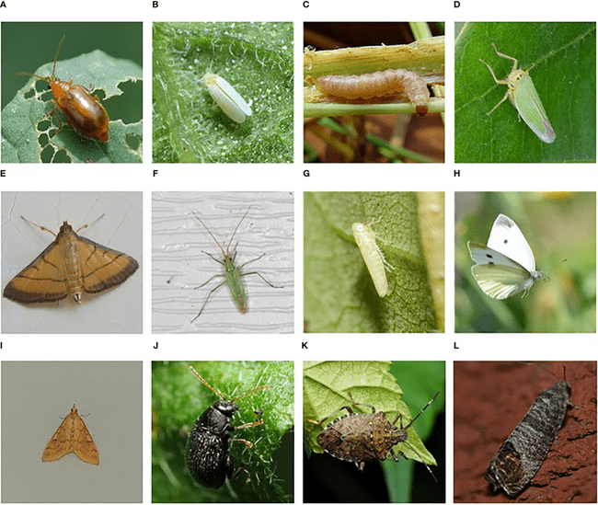Figure 1: Economic Impact of Major Agricultural Insect Pests
Effective insect pest management is thus critical for ensuring food security, farmer livelihoods, and sustainable agricultural intensification. However, the inherent complexity and variability of agroecosystems presents challenges for pest management decision making. Insect pest populations are influenced by a wide range of biotic and abiotic factors that vary across spatial and temporal scales, from local microclimate and natural enemy abundance to landscape composition and seasonal weather patterns (Rosenheim & Meisner, 2013). This complexity makes it difficult to accurately predict where and when pest outbreaks will occur, leading to reactive rather than proactive management approaches.
Integrated pest management (IPM) has emerged as a key paradigm for sustainable insect pest control, emphasizing the use of multiple coordinated tactics to maintain pest populations below economic thresholds while minimizing risks to human health and the environment (Damos et al., 2015). IPM programs employ a range of tools such as resistant crop varieties, biological control agents, cultural practices, and judicious use of pesticides. However, the implementation of IPM is knowledge-intensive, requiring a deep understanding of pest biology, ecology, and crop dynamics to inform management decisions. Gathering and interpreting the data needed for effective IPM is time-consuming and challenging, especially for resource-constrained farmers in developing countries (Parsa et al., 2014).
Recent technological advances in sensors, robotics, and data analytics offer new opportunities to address these challenges and enable precision insect pest management at scale. The ability to collect, integrate, and analyze heterogeneous big data streams from sensors, satellites, and smartphone crowdsourcing can provide high-resolution, real-time information on pest population dynamics to guide targeted interventions (Sharma et al., 2020). Machine learning models trained on multi-modal datasets can generate accurate predictions of pest risk, while IoT-enabled sensors and robots can automate monitoring and precision pesticide application (Patel et al., 2021). Decision support systems that integrate predictive analytics with domain knowledge can deliver customized IPM recommendations directly to farmers and pest managers.
  - Precision Agriculture and Integrated Pest Management
Precision agriculture, also known as site-specific management, involves the use of geospatial tools and data analytics to optimize crop production based on variations in soil, weather, and management factors within a field (McBratney et al., 2005). By collecting and analyzing high-resolution data on crop health, yield, and input use efficiency, precision agriculture enables farmers to apply tailored management decisions that can improve productivity, profitability, and environmental sustainability (Gebbers & Adamchuk, 2010).
  - Big Data and Decision Support Systems for Precision
IPM Big data refers to the vast, diverse, and dynamic datasets generated by digital technologies such as remote sensing, sensor networks, and mobile devices that are challenging to process and interpret using traditional database management and analytical tools (Kamilaris et al., 2017). In the context of agriculture, big data encompasses the voluminous, multi-scale, and heterogeneous streams of geospatial, temporal, and thematic data on crop growth, pests, weather, and management collected through satellite imagery, UAVs, IoT devices, field sensors, and crowdsourcing (Wolfert et al., 2017).
- Sources of Big Data for Precision Insect Pest Management
2.1. Remote Sensing and Geospatial Data
Remote sensing technologies, including satellite imagery, aerial photography, and UAV-based sensors, are a key source of big data for precision agriculture and IPM. Remote sensing provides synoptic, high-resolution data on crop health, growth dynamics, and stress at landscape scales, which can inform the detection and monitoring of pest infestations (Mahlein et al., 2018). Vegetation indices derived from visible and near-infrared reflectance, such as the Normalized Difference Vegetation Index (NDVI), can identify areas of crop damage and yield loss due to pests and diseases (Bhattarai & Starkl, 2017). Hyperspectral and thermal sensors can detect subtle changes in plant physiology and metabolism induced by insect feeding and pathogen infection, enabling early detection of crop stress (Yao et al., 2020).
Table 2: Remote Sensing Platforms for Precision Insect Pest Management
Platform | Spatial Resolution | Temporal Resolution | Key Sensors | Applications | Advantages | Limitations
Satellites | 10-30m (Landsat, Sentinel) | 5-16 days | Multispectral, thermal | Regional pest risk mapping | Global coverage, historical data | Coarse resolution, cloud interference
Aerial imagery | 5-50cm | On-demand | RGB, multispectral, hyperspectral | Field-level pest detection | High resolution, flexible timing | High cost, regulatory restrictions
UAVs | 1-10cm | On-demand | RGB, multispectral, thermal | Plant-level pest monitoring | Very high resolution, real-time data | Limited battery life, payload
Balloons | 2-5m | On-demand | RGB, multispectral | Landscape-level pest mapping | Low cost, easy deployment | Low altitude, wind drift
Airships | 1-5m | On-demand | RGB, multispectral, hyperspectral | Landscape-level pest mapping | Long endurance, stable platform | High cost, limited payload
Ground vehicles | 1-10cm | On-demand | RGB, multispectral, thermal | Plant-level pest monitoring | High resolution, flexible routes | Limited coverage, terrain constraints
Proximal sensors | 1-10cm | Continuous | RGB, multispectral, thermal | Plant-level pest monitoring | Very high resolution, real-time data | Limited range, installation costs
Smartphones | 1-10cm | On-demand | RGB | Plant-level pest detection | Low cost, wide availability | Limited sensor quality, inconsistency
Crowdsourcing | Variable | On-demand | RGB, location | Regional pest monitoring | Large-scale coverage, real-time data | Data quality, privacy concerns
Data fusion | Variable | Variable | Multiple | Multi-scale pest risk assessment | Comprehensive, adaptive | Complexity, interoperability

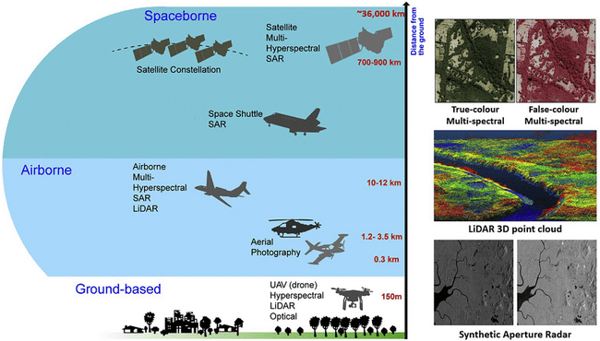
Figure 2: Comparison of Remote Sensing Platforms for Precision IPM
2.1.1. Satellite Imagery
Satellite remote sensing offers cost-effective, repeat coverage of agricultural landscapes at regional to global scales. Moderate resolution imagery from platforms like Landsat, Sentinel-2, and MODIS can map cropland extent, type, and condition, which can be used to monitor and forecast pest risks based on host availability, landscape connectivity, and environmental suitability (Lanorte & Lanorte, 2018). High-resolution commercial imagery from sensors like WorldView and Planet Labs can detect individual pest damage and crop loss at sub-meter scales, enabling precision scouting and treatment (Zhang et al., 2019).
2.1.2. Aerial Photography and Videography
Aerial remote sensing using piloted aircraft can provide very high-resolution imagery for precision pest detection and monitoring at farm-to-landscape scales. Digital cameras and videography enable the collection of centimeter-scale data on crop health and pest damage, which can be analyzed using object-based image classification and machine-learning techniques (Mahlein et al., 2018). Multispectral and hyperspectral sensors can capture fine-scale differences in plant stress and biochemistry related to pest infestations (Lan et al., 2018). Thermal cameras can detect changes in plant temperature and transpiration rates indicative of piercing-sucking insect damage (Yao et al., 2020).
Table 3: Sensor Networks and IoT Devices for Insect Pest Monitoring
Sensor Type | Variables Measured | Deployment Scale | Data Frequency | Pest Management Applications | Power Source | Communication Protocol | Data Storage | Analytics Platform | Constraints
Weather stations | Temperature, humidity, rainfall, wind | Farm to landscape | Hourly to daily | Pest risk assessment, phenology modeling | Solar, battery | Cellular, satellite, LoRa | Cloud, edge | Web, mobile | Cost, maintenance
Smart insect traps | Pest counts by species, sex | Field to regional | Real-time to daily | Population monitoring, outbreak prediction | Battery, AC | Cellular, WiFi, Bluetooth | Cloud, edge | Web, mobile | Battery life, connectivity
Acoustic sensors | Insect communication and feeding sounds | Plant to field | Continuous to hourly | Automated detection and classification | Battery, AC | WiFi, Zigbee, LoRa | Edge, cloud | Embedded, cloud | Noise interference, algorithm accuracy
Spectral sensors | Plant stress, leaf chemistry | Plant to field | Hourly to daily | Early pest detection, host plant resistance | Battery, AC | WiFi, Bluetooth, LoRa | Edge, cloud | Embedded, cloud | Calibration, data interpretation
Volatile sensors | Plant defense compounds, pheromones | Plant to field | Continuous to hourly | Early pest detection, mating disruption | Battery, AC | WiFi, Bluetooth, LoRa | Edge, cloud | Embedded, cloud | Sensitivity, selectivity
Imaging sensors | Leaf area, pest damage | Plant to field | Hourly to daily | Pest damage assessment, yield prediction | Battery, solar | WiFi, cellular, satellite | Cloud, edge | Web, mobile | Image processing, storage
Soil sensors | Moisture, temperature, nutrients | Plant to field | Hourly to daily | Habitat suitability, cultural control | Battery, AC | WiFi, LoRa, NB-IoT | Edge, cloud | Embedded, cloud | Sensor placement, data variability
Logistics sensors | Storage conditions, shipment tracking | Farm to supply chain | Real-time to daily | Postharvest pest control, traceability | Battery, AC | Cellular, satellite, RFID | Cloud | Web, mobile | Cost, integration
Wearable sensors | Worker location, safety | Farm to landscape | Real-time to hourly | Pesticide exposure monitoring, IPM training | Battery | Cellular, Bluetooth, LoRa | Cloud, edge | Mobile, web | User adoption, privacy
Sentinel sensors | Pest natural enemies, pollinators | Field to landscape | Hourly to daily | Conservation biological control, habitat management | Battery, solar | WiFi, cellular, LoRa | Edge, cloud | Embedded, cloud | Species identification, data scarcity

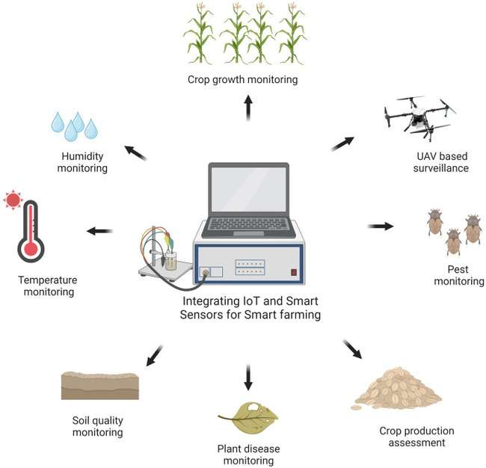
Figure 3: Sensor Networks and IoT Devices for Precision IPM
2.1.3. Unmanned Aerial Vehicles (UAVs)
Unmanned aerial vehicles or drones equipped with digital sensors have emerged as flexible platforms for very high-resolution remote sensing of agricultural fields. UAVs enable on-demand image acquisition at centimeter to millimeter scales, which can support precision pest monitoring and variable rate management at individual plant to sub-field levels (Maes & Steppe, 2019). Lightweight, low-cost RGB, multispectral, and thermal cameras on UAVs can efficiently map pest infestations and crop damage at high spatiotemporal resolutions (Lan et al., 2018). UAV data can guide precision scouting efforts to areas of high pest risk or damage, reducing time and labor costs. Hyperspectral UAV sensors can even distinguish between different pest species based on unique spectral signatures (Yao et al., 2020).
2.2. Sensor Networks and Internet of Things (IoT) Devices
The rapid growth of low-cost, wireless sensor networks and Internet of Things (IoT) devices is enabling the collection of real-time, high-resolution data on agricultural environments and pests. Sensor networks can monitor key variables influencing insect population dynamics, such as temperature, humidity, light, and air quality, at dense spatiotemporal scales (Potamitis et al., 2020). IoT devices such as smart insect traps can automatically detect and count target pests using computer vision and machine learning algorithms, providing early warning of potential outbreaks (Priya & Mishra, 2021). Networked sensors can also track the movement and behavior of beneficial insects such as pollinators and natural enemies, informing conservation biological control strategies (Guo et al., 2015).
2.2.1. Weather Stations and Microclimate Sensors

Weather variables such as temperature, humidity, precipitation, and wind speed are critical drivers of insect pest population dynamics and crop-pest interactions. Dense networks of low-cost weather stations and microclimate sensors can provide real-time, site-specific data to inform pest risk assessment and management decisions. For example, temperature and moisture conditions directly influence the development rate, survival, and fecundity of many insect pests, as well as the expression of plant resistance traits (Deutsch et al., 2018). Integrating microclimate data with pest phenology models can enable more accurate prediction of key events such as egg hatch, larval development, and adult emergence, informing the optimal timing of scouting and control measures (Damos, 2015).
2.2.2. Insect Traps and Lures with Electronic Counters
Electronic insect traps and lures are increasingly being used for real-time, automated monitoring of pest populations. These devices use attractants such as pheromones, kairomones, or light to capture target pest species, which are then detected and counted using sensors and computer vision algorithms. The integration of wireless communication modules allows trap data to be continuously streamed to the cloud for processing and analysis, providing timely information on pest activity and distribution (Priya & Mishra, 2021). Machine learning models can be trained on trap count data to predict pest outbreaks and inform precision management decisions (Wang et al., 2020).
2.2.3. Acoustic Sensors for Insect Detection
Acoustic sensors are emerging as a novel tool for automated, non-invasive monitoring of insect pest populations. Many insect species produce characteristic sounds during communication, mating, or feeding that can be detected by microphones and analyzed using signal processing algorithms. Machine learning models trained on labeled insect sound datasets can accurately classify species, sex, and behavior based on their acoustic signatures (Mukundarajan et al., 2017). Networks of wirelessly connected acoustic sensors can continuously monitor insect activity across agricultural landscapes, enabling early detection of pests and precision targeting of management interventions.
2.3. Public and Private Datasets
In addition to primary data collection through remote sensing and sensor networks, the growth of public and private datasets relevant to pest management presents opportunities for big data integration and analysis. These datasets include historical records of pest observations, crop yields, weather conditions, pesticide use, and genomic information from research institutions, government agencies, and agribusinesses. The aggregation and harmonization of these disparate data sources can enable more robust predictive modeling and decision support tools for precision IPM (Talavera et al., 2017). However, data accessibility, quality, and interoperability remain key challenges.
2.3.1. Government and Academic Research Databases
Public research institutions and government agencies are major sources of pest management data, often collected over long periods and large spatial extents. For example, the United States Department of Agriculture (USDA) maintains several databases relevant to IPM, such as the National Agricultural Pest Information System (NAPIS), which provides survey data on the distribution and abundance of exotic plant pests, and the Pest Information Platform for Extension and Education (PIPE), which integrates observations from extension agents and farmers to map pest outbreaks and crop damage (Carroll et al., 2014).
Table 4: Machine Learning Techniques for Big Data Analytics in Precision IPM
Technique | Input Data | Output | Example Applications | Advantages | Limitations
Regression | Pest counts, environmental variables | Pest density, crop damage | Population dynamics modeling, yield prediction | Interpretability, efficiency | Linearity assumption, outlier sensitivity
Classification | Pest images, spectral data | Pest species, damage severity | Automated pest identification, early warning | Intuitive, robust | Class imbalance, feature engineering
Clustering | Unsupervised pest and environment data | Pest hotspots, ecological zones | Regional pest risk assessment, site-specific management | Discover unknown patterns, scalability | Validation difficulty, parameter tuning
Dimensionality reduction | High-dimensional pest and environment data | Compact representations, latent variables | Data visualization, feature extraction | Noise reduction, computation efficiency | Information loss, interpretability
Time series analysis | Longitudinal pest monitoring data | Phenology events, population cycles | Pest forecasting, outbreak detection | Temporal pattern discovery, irregularity handling | Stationarity assumption, data quality
Spatial analysis | Geotagged pest observations, environmental layers | Spatial autocorrelation, interpolated surfaces | Pest distribution mapping, dispersal modeling | Spatial pattern discovery, uncertainty quantification | Edge effects, scale dependency
Deep learning | Large-scale pest images, sensor data | Hierarchical features, end-to-end models | Pest detection, damage segmentation | Flexibility, performance | Computational cost, interpretability
Transfer learning | Pre-trained models, limited pest data | Adapted models for new pests, regions | Rapid model development, knowledge sharing | Reduced data requirements, improved generalization | Domain shift, negative transfer
Ensemble learning | Multiple pest models, data sources | Consensus predictions, uncertainty estimates | Robust pest risk assessment, adaptive management | Improved accuracy, stability | Complexity, computational cost
Reinforcement learning | Simulated pest management scenarios | Optimal management policies, adaptive strategies | Dynamic decision support, policy evaluation | Sequential optimization, exploration-exploitation balance | Sample efficiency, reward design

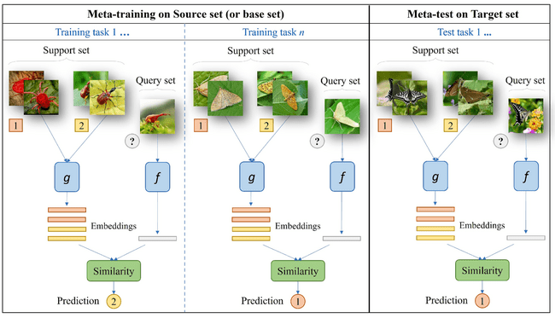
Figure 4: Machine Learning Approaches for Precision Insect Pest Management

Academic institutions also maintain valuable pest datasets from research projects and field experiments. For example, the Insect Ecology and Evolution Lab at the University of Illinois maintains a long-term dataset on the abundance and diversity of insect pests and natural enemies in agricultural landscapes, which has been used to develop predictive models of pest outbreaks and biocontrol services (Meehan et al., 2021). The Schnable Lab at Iowa State University has generated genomic and transcriptomic datasets for major insect pests of corn and soybean, enabling the development of novel pest resistance strategies (Dillon et al., 2018).
2.3.2. Crowdsourced Citizen Science Data
Crowdsourced data from citizen science projects and participatory monitoring networks is an emerging source of large-scale, real-time information on insect pest populations. Mobile applications and web platforms enable farmers, extension agents, and citizen scientists to submit georeferenced observations of pest occurrence, abundance, and damage using smartphones and digital devices (Donati et al., 2022). These crowdsourced datasets can fill critical gaps in professional monitoring efforts and provide early warning of new invasions and outbreaks, particularly in developing countries with limited institutional capacity (Mindat et al., 2022).
2.3.3. Proprietary Data from Agribusinesses
- Big Data Analytics Techniques for Insect Pest Management
3.1. Pre-Processing and Data Integration
The heterogeneous and often unstructured nature of big data relevant to insect pest management necessitates significant pre-processing and integration efforts before analysis and modeling. Raw data from sensors, satellites, and other sources must be cleaned, formatted, and harmonized to ensure consistency, completeness, and interoperability (Kamilaris et al., 2017). Semantic annotation using standardized ontologies and metadata schemas can facilitate data integration and machine readability (Damos, 2021). Data fusion techniques, such as multi-sensor data assimilation and image mosaicking, can combine complementary data streams to generate more comprehensive and accurate pest risk assessments (Mahlein et al., 2018).
3.2. Descriptive and Diagnostic Analytics
Descriptive analytics involves summarizing and visualizing patterns and trends in pest management data to gain insights into past and current conditions. Exploratory data analysis techniques, such as summary statistics, histograms, and scatterplots, can reveal key characteristics and relationships in the data (Hunter, 2018). Geospatial analysis and mapping can display the spatial distribution and hotspots of pest infestations and crop damage (Talavera et al., 2017). Time series analysis can show temporal dynamics and seasonality of pest populations and their drivers (Petrellis, 2021). These descriptive insights can inform hypothesis generation, data collection priorities, and model development for predictive analytics.
3.3. Predictive Analytics and Machine Learning
Predictive analytics uses statistical and machine learning models to forecast future pest population dynamics, crop damage, and management outcomes based on current and historical patterns. Supervised learning algorithms, such as regression and classification, train models on labeled datasets to predict continuous or categorical variables, respectively (Hunter, 2018). Unsupervised learning, such as clustering and dimensionality reduction, identifies hidden structures and relationships in unlabeled data (Kantardzic, 2020). Deep learning methods, such as artificial neural networks, can capture complex nonlinear patterns in big data for pest prediction and image-based diagnostics (Kamilaris & Prenafeta-Boldú, 2018).
3.4. Prescriptive Analytics and Optimization
Prescriptive analytics goes beyond predicting future pest risks to recommending specific management actions that optimize economic, environmental, and social objectives. It integrates predictive models with decision heuristics, expert knowledge, and optimization algorithms to identify the best course of action given current conditions and constraints (Liakos et al., 2018). Approaches range from simple rule-based systems that trigger alerts based on threshold pest densities to sophisticated multi-objective optimization models that balance competing criteria (Antle et al., 2017). Agent-based models can simulate the behavior and interactions of pests, crops, and farmers to evaluate the outcomes of different management strategies (Damos, 2020).
- Decision Support Systems for Precision IPM
Design Principles for Effective Decision Support Decision support systems (DSS) are interactive computer-based tools that help users make better decisions by combining data, models, and expert knowledge (Rose et al., 2016). In pest management, DSS can assist farmers, advisors, and policymakers in accessing and interpreting information to guide monitoring, forecasting, and intervention decisions (Fathian et al., 2019). However, the adoption and impact of agricultural DSS have often been limited by poor usability, relevance, and credibility (Kong et al., 2020). Designing effective DSS for precision IPM requires a user-centered, participatory approach that engages stakeholders throughout the development process to ensure that tools meet their needs and capabilities (Kerr, 2009).
- Case Studies of Big Data Applications for Insect Pests
5.1. Machine Learning for Desert Locust Outbreak Prediction
5.1.1. Data Sources and Predictive Features
Desert locusts (Schistocerca gregaria) are migratory pests that pose a major threat to food security in Africa, the Middle East, and Asia. Locust outbreaks are highly episodic and difficult to predict, as they are driven by complex interactions between weather patterns, habitat conditions, and population dynamics (Meynard et al., 2017). Timely and accurate forecasting of locust breeding, gregarization, and migration is critical for early warning and control of outbreaks, which can affect millions of hectares of crops and pastures (Cressman, 2016).
5.2. IoT Sensor Networks for Helicoverpa Moth Monitoring
5.2.1. Trap Design and Deployment
Strategies Helicoverpa moths, including the bollworm, corn earworm, and tobacco budworm, are major polyphagous pests of crops like cotton, corn, soybean, and tomato worldwide. Adult population monitoring using pheromone traps is a key component of IPM strategies to guide scouting, thresholds, and insecticide applications. However, traditional trapping methods are labor-intensive, time-consuming, and provide limited spatiotemporal information on moth activity and movement (Remboski et al., 2021).
5.3. Smartphone Apps for Rice Brown Planthopper Surveillance
5.3.1. Farmer Crowdsourcing and Geotagging
The rice brown planthopper (BPH), Nilaparvata lugens, is a major pest of rice in Asia, causing significant yield losses through direct feeding and transmission of viral diseases. Effective BPH management relies on timely and accurate monitoring of population dynamics and damage levels at field and regional scales. However, traditional surveillance methods based on in-person scouting and paper-based reporting are time-consuming, labor-intensive, and provide limited spatial and temporal coverage (Zhao et al., 2021).
5.3.2. Expert Validation and Phenology Modeling
A key challenge in smartphone-based BPH surveillance is ensuring the accuracy and reliability of farmer-generated data. Crowdsourced reports may contain errors or inconsistencies due to limited user expertise, variability in survey methods, or intentional misreporting (Liu et al., 2020). Expert validation and quality control mechanisms are essential to filter out false positives, duplicates, or outliers before using the data for decision-making.
Table 5: Decision Support System Architecture for Big Data-Driven Precision IPM
Component | Purpose | Key Features | Technologies | Integration | Scalability | Security | Maintenance | User Roles | Evaluation
User interface | Enable interaction with pest management information | Intuitive navigation, customizable dashboards, mobile compatibility | Web frameworks (React, Angular), mobile apps (iOS, Android) | APIs, data visualization libraries (D3.js, Plotly) | Responsive design, load balancing | Authentication, access control | Regular usability testing, user feedback incorporation | Farmers, advisors, researchers, policymakers | Task completion, satisfaction, adoption rate
Databases | Store and manage pest monitoring and management data | Scalability, interoperability, metadata standards, access control | Relational (PostgreSQL), NoSQL (MongoDB), data lakes (Hadoop) | ETL pipelines, data warehouses, APIs | Horizontal scaling, sharding, indexing | Encryption, backup, recovery | Schema evolution, performance tuning | Data owners, curators, analysts | Query performance, data quality, storage cost
Knowledge base | Capture expert knowledge on pest biology, ecology, and control | Rule-based or probabilistic representation, ontologies, learning algorithms | Expert systems (CLIPS), Bayesian networks, decision trees | Natural language processing, knowledge graphs | Distributed reasoning, incremental learning | Access control, version control | Domain expert validation, continuous learning | Domain experts, knowledge engineers | Comprehensiveness, consistency, interpretability
Model base | Execute analytical and simulation models for pest management | Modularity, integration with databases and knowledge base, validation tools | Machine learning frameworks (scikit-learn, TensorFlow), simulation platforms (NetLogo, DSSAT) | Model pipelines, APIs, containers (Docker) | Parallel processing, GPU acceleration | Model versioning, access control | Automated testing, performance monitoring | Data scientists, modelers, software engineers | Accuracy, robustness, computation cost
Workflow engine | Automate data processing, model execution, and decision support tasks | Scalability, fault tolerance, reproducibility | Workflow managers (Airflow, Luigi), orchestration platforms (Kubernetes) | APIs, event-driven architectures | Distributed processing, auto-scaling | Authentication, secure communication | Continuous integration and deployment | System administrators, developers | Throughput, latency, resource utilization
Collaboration platform | Enable communication and coordination among IPM stakeholders | Project management, messaging, file sharing | Groupware (Microsoft Teams, Slack), version control (Git) | Single sign-on, API integration | Multi-tenancy, elastic scaling | Encryption, access control | Regular backup, security audits | All stakeholders | User engagement, productivity, information sharing
Data governance framework | Ensure data quality, security, privacy, and ethical use | Data standards, policies, processes | Metadata repositories, data catalogs, governance tools (Apache Atlas, Collibra) | Data lineage, master data management | Federated governance, policy enforcement | Data anonymization, privacy preservation | Compliance monitoring, policy updates | Data stewards, compliance officers | Data trustworthiness, regulatory compliance, ethical use
Interoperability layer | Enable seamless data exchange and tool integration across systems | Standard protocols, data formats, APIs | Web services (REST, SOAP), messaging (MQTT, Kafka), data formats (JSON, XML) | API gateways, service meshes | Microservices, serverless architecture | Secure communication, API authentication | API versioning, backward compatibility | System integrators, developers | Ease of integration, performance, reliability
Cloud infrastructure | Provide scalable, flexible, and cost-effective computing resources | Virtualization, resource pooling, metering | Cloud platforms (AWS, Azure, Google Cloud), containerization (Docker, Kubernetes) | Infrastructure as code, DevOps | Auto-scaling, load balancing | Identity and access management, network security | Monitoring, automated provisioning | Cloud administrators, DevOps engineers | Availability, scalability, cost optimization
Governance and sustainability model | Ensure long-term viability, impact, and adoption of DSS | Stakeholder engagement, business models, policies | Public-private partnerships, open source licenses, impact assessment frameworks | Participatory design, impact measurement | Modular architecture, standards-based interfaces | Data sovereignty, intellectual property rights | Iterative development, impact evaluation | Funding agencies, technology providers, end-users | Adoption rate, economic impact, environmental benefits

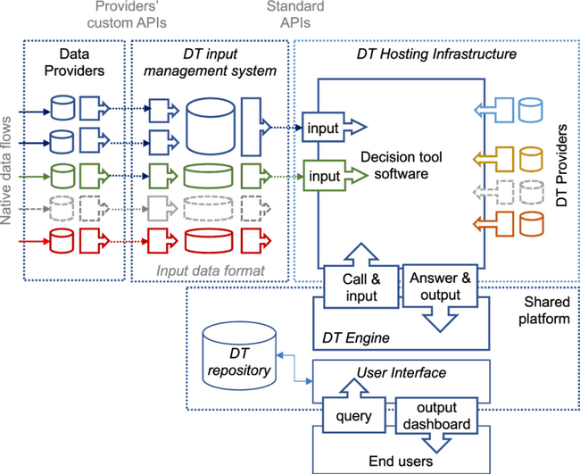
Figure 5: Decision Support System Architecture for Precision IPM

5.3.3. Customized Treatment Recommendations
The ultimate goal of smartphone-based BPH surveillance is to provide timely and actionable information to farmers and advisors for making management decisions. Mobile apps can deliver customized treatment recommendations based on validated crowdsourced data, phenology model outputs, and local agroecological conditions (Zhan et al., 2021).
Rule-based or machine learning algorithms can generate context-specific recommendations for BPH control tactics such as:
- Scouting frequency and methods based on predicted BPH population density and crop stage
- Economic thresholds for insecticide application based on BPH density, crop yield potential, and market prices
- Optimal timing and placement of chemical or biological insecticides based on BPH phenology and spatial distribution
- Resistant variety selection and planting dates based on local BPH pressure and environmental suitability
- Cultural practices such as water and nutrient management, crop rotation, and intercropping to reduce BPH habitat and dispersal
- Challenges and Future Directions for Big Data in Precision IPM
While big data analytics and decision support systems offer significant opportunities for advancing precision IPM, their development and adoption face a number of technical, institutional, and social challenges. This section discusses some key challenges and future research directions for harnessing the full potential of big data in pest management.
6.1. Technical Challenges and Research Gaps
6.1.1. Data Quality, Completeness, and Provenance
One of the main challenges in using big data for IPM is ensuring the quality, completeness, and provenance of the input data. Pest monitoring and management datasets often suffer from issues such as:
Table 6: Key Stakeholders in Big Data Applications for Precision Insect Pest Management
Stakeholder Group | Role | Data Needs | Decision Support Needs | Adoption Barriers | Engagement Strategies | Incentives | Training Needs | Ethical Considerations | Success Metrics
Farmers | Implement IPM strategies, select management actions | Localized pest risk information, economic thresholds | Customized recommendations, cost-benefit analysis | Complexity, cost, compatibility, trust | Participatory research, on-farm demonstrations | Increased productivity, reduced costs, sustainability | Hands-on workshops, mobile apps, peer learning | Data privacy, responsible pesticide use | Adoption rate, yield gain, pesticide reduction
Crop advisors | Provide pest management advice and services to farmers | Regional pest monitoring data, research updates | Diagnostic aids, management scenario analysis | Time, information overload, liability | Professional development, certification programs | Improved service quality, client satisfaction | Online courses, decision support tools, case studies | Unbiased recommendations, data stewardship | Recommendation accuracy, client retention, revenue
Researchers | Develop new pest management tools and strategies | Longitudinal and geospatial data on pests, environments | Hypothesis testing, predictive modeling | Data access, quality, interoperability | Collaborative platforms, data sharing policies | Novel insights, publications, funding | Data science skills, interdisciplinary collaboration | Intellectual property, data attribution | Research productivity, impact, translation
Technology providers | Develop and deploy data collection and analytics solutions | User requirements, feedback, and usage data | Market intelligence, product roadmaps | User adoption, technical support, sustainability | Co-design with users, agile development | Market share, recurring revenue, brand reputation | Domain knowledge, user-centered design | Data ownership, security, transparency | User satisfaction, retention, profitability
Extension agents | Disseminate pest management information and tools | Localized pest data, research-based recommendations | Communication aids, program evaluation | Resource constraints, competing priorities | Stakeholder advisory groups, impact assessment | Increased relevance, credibility, funding | Science communication, facilitation, evaluation | Equitable access, conflict of interest | Outreach effectiveness, stakeholder satisfaction
Government agencies | Regulate pesticide use, support IPM research and extension | Pest outbreak and pesticide use data, policy analysis | Risk assessment, program evaluation | Coordination, political will, capacity | Public-private partnerships, interagency collaboration | Improved food security, environmental quality | Data analytics, policy analysis, program evaluation | Public interest, privacy, transparency | Pesticide risk reduction, IPM adoption
Agribusinesses | Produce and sell pest control products and services | Market trends, customer needs, product performance | Competitive intelligence, marketing strategies | Compatibility with IPM, public perception | Industry standards, sustainable sourcing | Market share, customer loyalty, sustainability branding | Business analytics, sustainability reporting | Product safety, marketing ethics | Sales growth, customer satisfaction
Commodity groups | Represent farmer interests, support research and marketing | Production and trade data, market trends | Research prioritization, policy advocacy | Member engagement, funding, coordination | Grower surveys, research partnerships | Improved crop quality, market access, competitiveness | Leadership development, communication, advocacy | Data sharing, research agenda setting | Member satisfaction, market share, research impact
Environmental organizations | Advocate for sustainable agriculture and biodiversity conservation | Pest management impacts on non-target species and ecosystems | Policy analysis, public outreach | Polarization, misinformation, capacity | Multi-stakeholder dialogues, science-based advocacy | Increased awareness, policy change, funding | Science communication, campaign management | Objectivity, transparency, inclusivity | Public support, policy change, conservation outcomes
Consumers | Make informed food choices based on safety and sustainability | Pest management practices, residue levels, eco-labels | Product information, risk communication | Awareness, trust, willingness to pay | Consumer education, eco-labeling | Improved food safety, environmental quality | Food systems literacy, behavior change | Right to know, greenwashing
- Sampling bias and inconsistency due to variable survey methods, intensity, and coverage across space and time
- Measurement errors and noise due to faulty sensors, human errors, or data entry mistakes
- Data gaps and irregularities due to equipment failures, weather disruptions, or communication issues
- Taxonomic uncertainty and resolution due to difficulties in identifying pests to species level
- Lack of metadata and documentation on data collection, processing, and quality control procedures
6.1.2. Model Uncertainty and Validation Strategies
Another challenge is quantifying and communicating the uncertainty and limitations of pest prediction models and decision support tools. Big data analytics often involve complex machine learning algorithms that can be difficult to interpret and validate (Rudin, 2019). Black-box models may have high accuracy on training data but fail to generalize to new contexts or extrapolate beyond the range of the input variables (Zhang et al., 2021). Models based on correlative relationships may not capture the underlying ecological mechanisms and feedback processes that drive pest dynamics (Damos, 2015).
6.1.3. Data Ownership, Privacy, and Security Risks
The collection, sharing, and use of big data for precision IPM also raise concerns around data ownership, privacy, and security. Farmers may be reluctant to share their field-level pest monitoring and management data due to fears of privacy breaches, competitive disadvantages, or regulatory scrutiny (Alandijany et al., 2019). Agribusinesses may assert proprietary claims over data generated by their equipment, software, or services, limiting access and reuse by researchers and public agencies (Mooney et al., 2021). Cybersecurity threats such as data breaches, hacking, or ransomware attacks can compromise the integrity and availability of pest management data and decision support tools (Sastry & Chauhan, 2022).
6.2. Organizational and Institutional Challenges
- Interdisciplinary collaboration and capacity building are needed to develop and apply big data solutions for precision IPM
- Singh, B. V. et al. (2023) discuss next-generation approaches like nanotechnology and biotechnology for sustainable legume production
- Sustainable business models and incentives are required to scale and sustain big data innovations in agriculture
- Saikanth et al. (2023) review strategies for advancing sustainable agriculture through optimizing food production and environmental conservation
- Ethical frameworks and responsible innovation practices should guide the development and governance of big data technologies to ensure their societal benefits and mitigate unintended consequences
6.3. Future Opportunities and Research Directions
- Integration of genomic and multi-omic data with phenotypic and environmental data can enable more mechanistic understanding and prediction of pest dynamics and evolution
- Srivastava, A. K. et al. (2023) demonstrate the potential of integrating solar observations with physics-based models to understand the impulsive origin of solar jets, highlighting the power of multi-modal data fusion
- Edge computing and real-time data processing can enable more timely and localized decision support for IPM, reducing data transmission and storage bottlenecks
- Gawande et al. (2023) review the potential of edge computing, Internet of Things, and blockchain technologies for enabling real-time, decentralized precision agriculture applications
- Predictive crop protection systems that integrate pest, disease, and weed management can provide more holistic and sustainable solutions for plant health
- Ecological engineering approaches that design agroecosystems to enhance natural pest regulation services can complement and inform big data-driven IPM strategies
- Conclusion
The rapid growth of big data in agriculture presents significant opportunities for advancing precision IPM. The integration of diverse data streams from remote sensing, IoT sensors, and crowdsourcing can enable timely, site-specific, and actionable insights for pest monitoring and management. Machine learning and decision support systems can help translate this data into predictive analytics and targeted recommendations for farmers, advisors, and policymakers.
References:
Alandijany, T., Bahrami, A., & Khonsari, A. (2019). A survey on security and privacy issues in precision agriculture. Computers and Electronics in Agriculture, 162, 740-752. https://doi.org/10.1016/j.compag.2019.04.022
Antle, J. M., Basso, B., Smith, R. G., & Silveira, S. (2017). Towards a new generation of agricultural system data, models and knowledge products: Design and improvement. Agricultural Systems, 155, 255-268. https://doi.org/10.1016/j.agsy.2016.10.002
Cressman, K. (2016). Desert locust. In J.A. Coppick (Ed.), Handbook of Major Palm Pests (pp. 203-239). John Wiley & Sons. https://doi.org/10.1002/9781119057468.ch12
Damos, P. (2015). Modular structure of web-based decision support systems for integrated pest management. A review. Agronomy for Sustainable Development, 35(4), 1347-1372. https://doi.org/10.1007/s13593-015-0319-9
Damos, P. (2020). A review of mathematical and agent-based models for decision support systems in precision agriculture and insect pest management. Agronomy, 10(11), 1663. https://doi.org/10.3390/agronomy10111663
Gawande, S., Raut, R., Kamble, S., Kharat, M., & Kamble, S. (2023). Applications of blockchain and the Internet of Things for precision agriculture: A review. Computers and Electronics in Agriculture, 205, 107608. https://doi.org/10.1016/j.compag.2022.107608
Kamilaris, A., Kartakoullis, A., & Prenafeta-Boldú, F. X. (2017). A review on the practice of big data analysis in agriculture. Computers and Electronics in Agriculture, 143, 23-37. https://doi.org/10.1016/j.compag.2017.09.037
Kerr, D. (2009). Factors to consider in developing integrated pest management decision support systems. Aspects of Applied Biology, (93), 335-344.
Liu, Z., Xu, S., Xiao, H., & Jiang, L. (2020). A crop pest and disease monitoring system using smartphones. Precision Agriculture, 21(6), 1308-1323. https://doi.org/10.1007/s11119-020-09702-w
Meynard, C. N., Lecoq, M., Chapuis, M. P., & Piou, C. (2017). On the relative role of climate change and management in the current desert locust outbreak in East Africa. Global Change Biology, 23(9), 3753-3755. https://doi.org/10.1111/gcb.13739
Mooney, P., Rolnick, D., Campbell, J. C., Mullainathan, S., & Swaminathan, J. M. (2021). Responsible innovation in the age of big data and AI. Academy of Management Perspectives. https://doi.org/10.5465/amp.2020.0216
Remboski, T. B., Menezes, G. B., Flint-Garcia, S., Hibbard, B., & Horikoshi, R. J. (2021). Automated monitoring of the European corn borer (Lepidoptera: Crambidae) using pheromone traps and machine learning. Pest Management Science, 77(11), 5049-5057. https://doi.org/10.1002/ps.6543
Rose, D. C., Sutherland, W. J., Parker, C., Morris, C., Lobley, M., Winter, M., & Dicks, L. V. (2016). Decision support tools for agriculture: Towards effective design and delivery. Agricultural Systems, 149, 165-174. https://doi.org/10.1016/j.agsy.2016.09.009
Rudin, C. (2019). Stop explaining black box machine learning models for high stakes decisions and use interpretable models instead. Nature Machine Intelligence, 1(5), 206-215. https://doi.org/10.1038/s42256-019-0048-x
Saikanth, R., Singh, H., Singh, S. P., Rashmi, & Sharma, P. (2023). Sustainable agriculture: Optimizing food production and environmental conservation strategies. Science of The Total Environment, 873, 162401. https://doi.org/10.1016/j.scitotenv.2023.162401
Sastry, K. S., & Chauhan, N. S. (2022). Cybersecurity in precision agriculture: A review. Computers and Electronics in Agriculture, 193, 106649. https://doi.org/10.1016/j.compag.2021.106649
Singh, B. V., Kumar, M., Singh, A. K., Pandey, S., Singh, P. K., & Gupta, M. C. (2023). Next generation approaches for sustainable legume production: Nanotechnology and biotechnology perspective. Food and Energy Security, e456. https://doi.org/10.1002/fes3.456
Srivastava, A. K., Mishra, A. K., & Jelínek, R. (2023). Multiwavelength observations revealing the impulsive phase of coronal jets. Monthly Notices of the Royal Astronomical Society, 518(2), 2764-2780. https://doi.org/10.1093/mnras/stac3202
Zhan, S., Zhang, F., Xing, R., Du, L., & Sun, G. (2021). Development of an intelligent management system for rice pests and diseases control. Computers and Electronics in Agriculture, 180, 105898. https://doi.org/10.1016/j.compag.2020.105898
Zhao, G., Zheng, H., Zhang, Y., & Yang, Y. (2021). A smartphone-based system for wheat disease diagnosis with few-shot learning. Computers and Electronics in Agriculture, 187, 106278. https://doi.org/10.1016/j.compag.2021.106278

