Original Research Article

Remote Sensing and GIS Based Approach to Estimate the Monthly and Seasonally Evapotranspiration (ET) For Kharif Maize Using Landsat 8 Data and the QWaterModel Plugin

ABSTRACT
Evapotranspiration (ET) plays a crucial role in agricultural water management, particularly in semi-arid regions where efficient resource allocation is essential for sustainable production. This study utilizes remote sensing and GIS-based approaches to estimate monthly and seasonal ET for kharif maize using Landsat 8 satellite data from 2016 to 2020. The research was conducted at the Main Maize Research Station (MMRS) in Panchmahal, Gujarat, India, leveraging the QWaterModel plugin for ET calculations. Thermal and optical data from Landsat 8, including Land Surface Temperature (LST) and Normalized Difference Vegetation Index (NDVI), were processed to derive ET values for the maize-growing season (July to October). The findings reveal distinct temporal trends in ET. Monthly ET progressively increases from July (early growth stages) to September (peak growth), followed by a sharp decline in October (maturity stage). Across the study years, July ET ranged from 42 mm in 2016 to 62 mm in 2018, while September ET peaked at 251 mm in 2020. Seasonal ET varied between 427 mm (2016) and 463 mm (2019), reflecting fluctuations in climatic conditions and management practices. The observed trends highlight the critical water demand during maize's active growth phase, underscoring the importance of precise irrigation scheduling for optimizing water use. Remote sensing offers a cost-effective and scalable solution for large-area ET estimation compared to traditional methods which are limited in spatial coverage and resource-intensive. This study demonstrates the potential of satellite-based ET monitoring in supporting sustainable water resource management and improving crop water productivity. By integrating remote sensing technologies with advanced GIS tools, this approach provides a robust framework for addressing water scarcity challenges in agriculture. The results contribute to better understanding and planning of crop water requirements, ensuring efficient use of limited water resources in semi-arid regions.
Keywords: Evapotranspiration (ET), Landsat 8, LST, Maize, NDVI, QGIS, QWaterModel, Thermal Remote Sensing
- INTRODUCTION
Water plays a fundamental role in supporting overall agricultural productivity. Food production remains responsible for around 90% of humanity’s consumptive water footprint (D'Odorico et al., 2018). Accordingly, precise judgement on irrigation water demands (timing & magnitude) remains precarious to realize truer water sustainability of agricultural sector; specifically, for tropical situations like India. Such improved understanding on agricultural water and its productivity has greater significance for relevant researchers, field functionaries & farmers to identify those places/situations; where water demands or its variability could potentially compromise with reliability of diverse crops/production. Enormous studies have helped to expand our knowledge of crop water use and its dynamics, by adopting varied scientific approaches that partitions crop water requirements i.e. the volume of water needed to support crop evapotranspiration (ET) during its growing period; without experiencing water stress between ‘blue water’ and ‘green water’ (i.e. water from water bodies/aquifer & soil moisture, respectively).
Evapotranspiration (ET) is the combined water flux of evaporation from soil, plant and water surfaces as well as transpiration from plants (Allen et al., 1998). ET can be conceptually expressed in the forms of reference evapotranspiration (ET_{o}), actual evapotranspiration (ET_{a}) and potential evapotranspiration (PET). Realistically, the ET_{a} is considered the rate at which water is actually removed to the atmosphere from a surfaced during ET process which is most often measured by using lysimeter. Similarly, PET reflects the quantum of ET from a large vegetation covered land surface with adequate moisture at all times (Thornthwaite, 1948). While Allen et al. (1998) further revised this definition as the ET rate from a reference surface (hypothetical grass having 0.12 m height, a fixed surface resistance of 70 s/m and an 0.23 albedo). Actual ET is the transfer rate of water from soil and plants to the atmosphere, whereas PET is the theoretical maximum possible transfer rate for conditions without water shortage.
Usually, any kind of crop water requirement (CWR) refers to the amount of water required to compensate the ET losses from given cropped field during a specific period of time. Its value (even for same crop variety) might substantially vary from one location to other due to variations of climatic parameters, offering diverse actual values in respect of reference evapotranspiration (ET_{o}), planting date (date of sowing), length of growing season, crop coefficient (K_{c}), irrigation efficiencies and water productivity (WP). Such spatio-temporal variability of CWR (mm/day, mm/month, mm/season or mm/year) remains a critical input for sensible estimation of irrigation water demands, and scheduling irrigation/water delivery at varied scales of time & space. Water scarcity poses a significant challenge in arid and semi-arid areas, where restricted resources need to satisfy industrial, agricultural, and ecological needs (Mizyed et al., 2024; Okello et al., 2024). These areas frequently encounter considerable stress on water supplies, mainly caused by usage in irrigated farming (Singh et al., 2024; Kirda and Kanber, 1999). For sustainable crop production, the urgent need for effective water resource management is essential, and estimating crop evapotranspiration (ET) is crucial for irrigation planning and enhancing crop water productivity (Sharma et al., 2024; Xing and Wang, 2024).
Conventional large-scale ET measurement techniques, including lysimeters, eddy covariance systems, surface renewal methods, and soil water balance approaches, provide great accuracy but are expensive and restricted to particular sites, necessitating extrapolation with lower accuracy (Abdollahnejad et al., 2018; Gu et al., 2006). As a result, remote sensing technologies have attracted more focus for evaluating ET across wider spatial and temporal ranges (Xue et al., 2020). Various models, such as SEBAL (Surface Energy Balance Algorithm for Land) (Bastiaanssen et al., 1998), SEBS (Surface Energy Balance System) (Su, 2002), METRIC (Mapping EvapoTranspiration at High Resolution with Internalized Calibration) (Allen et al., 2007), and SSEBop (Operational Simplified Surface Energy Balance) (Senay et al., 2013), utilize remote sensing data to improve ET evaluation, rendering them essential instruments for managing water resources. From real physics point of view, the ET is always considered one of the most important process depletions of water in the production of crops and is normally estimated from weather data; namely, net solar radiation, wind speed and mean daily air temperature. This data is actually used as input to the Penman-Monteith method described in the FAO Irrigation and Drainage Paper No. 56. The Penman-Monteith equation has been incorporated in many soil-water balance, crop growth and hydrological models for estimation of crop ET (e.g. CropWat). CropWat has been one of the most widely used for estimation of ET and crop water requirement. In certain cases where, weather data is missing, Class A pan method has also been used for estimating ET. Moreover, the major drawbacks of Penman Monteith method remain conceptual improvements that requires multiple data such as maximum temperature, minimum temperature, maximum humidity, minimum humidity, wind speed and bright sun shine hours or solar radiation. Records of these input variables are sometimes incomplete or not available for a given location especially in developing countries (Martinez and Thepadia, 2010). Thus, there emerges an urgent need to evolve & evaluate simpler ET_{o} methods which require location specific minimum data relative to Penman Monteith method (Tabari, 2010), and remains valid for that specific location.
ET can be measured directly at local scales using methods like eddy covariance or estimated over larger areas through energy balance models. Many of these models rely on remotely sensed land surface temperatures (LST), which assume that areas with low ET appear as hot pixels, while high ET areas are represented as cold pixels (Timmermans et al., 2015). Advancements such as increased computational power, widespread access to free satellite imagery (e.g., Landsat 7 and 8), and the growing availability of portable thermal cameras, whether handheld or drone-mounted are significantly enhancing the application of energy balance models for ET estimation (Xia et al., 2016; Hoffmann et al., 2016; Maes and Steppe, 2012). With the advent of modern and smart technologies, specifically remotely sensed avenues via satellite based accurate deliverables; things are likely to change drastically in coming time. The intention of this proposed research work remains centered around this aspect, where the prime goal was set to retrieve huge sets of ET data/information from most recent, smart & effective satellite products of Landsat 8.
- MATERIALS AND METHODS
  - Study Area
The study was conducted at the Main Maize Research Station (MMRS), Godhra, under Anand Agricultural University in Panchmahal district, located in Middle Gujarat, India, as depicted in Fig. 1. This region falls within the semi-arid agro-climatic zone-III, characterized by an average annual rainfall of 650 to 750 mm. The area experiences a wide temperature range, with lows of 6 °C during cold winters and highs reaching 44 °C in hot summers. The predominant soil types in the region are sandy and sandy loam. The area experiences four distinct seasons: winter (November–February), summer (March–May), monsoon (June–September), and autumn (October). Farmers in this region practice multi-cropping, cultivating crops such as maize, rice, millet, legumes, and cotton, with two to three crop cycles annually (Balas et al., 2023a and 2023b).
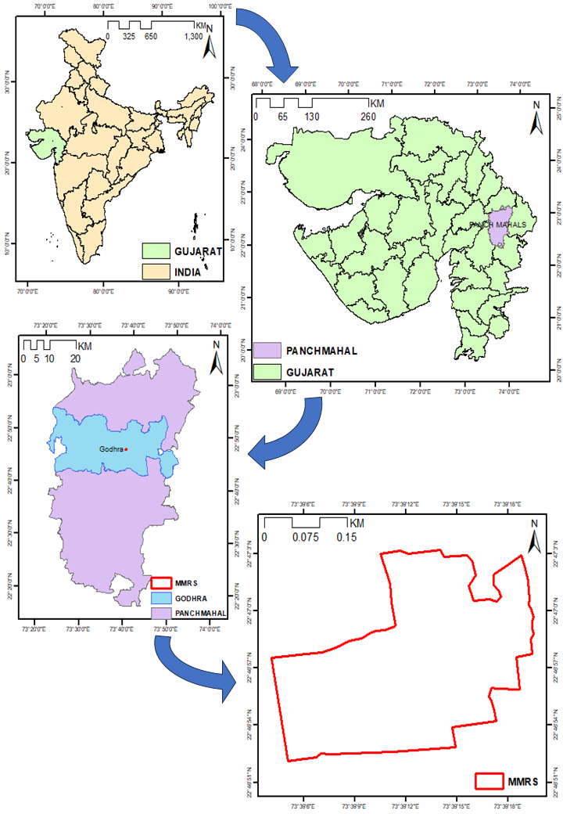
Fig. 1: Layout map of the study area
  - Satellite Data
The LANDSAT-8 OLI and TIRS images for the study area were acquired from the USGS Earth Explorer data center website (https://earthexplorer.usgs.gov/) for the period of July to October, spanning the years 2016 to 2020. Landsat 8 captures data with a spatial resolution of 15-30 meters, depending on the spectral band, and has a revisit cycle of 16 days. For this study, three specific bands (B4, B5, and B10) were utilized. The optical bands, B4 and B5, were used to compute the Normalized Difference Vegetation Index (NDVI), while the thermal band, B10, was employed to calculate Brightness Temperature (BT). A step-by-step explanation of the methodology is illustrated in Fig. 2. The characteristics of the Landsat-8 satellite, along with its specific bands, are presented in Table 1.

Table 1: Specification of Landsat-8 Satellite Bands
Landsat 8 | Band | Band Name | Wavelength (nm) | Resolution (m) | Applications
Operational Land Imager (OLI) | 1 | Coastal / Aerosol | 433-453 | 30 | Coastal and Aerosol studies
Operational Land Imager (OLI) | 2 | Blue | 450-515 | 30 | Distinguishing soil from vegetation and deciduous from coniferous vegetation
Operational Land Imager (OLI) | 3 | Green | 525-600 | 30 | Emphasizes peak vegetation, which is useful for assessing plant vigour
Operational Land Imager (OLI) | 4 | Red | 630-680 | 30 | Discriminates vegetation slopes
Operational Land Imager (OLI) | 5 | Near Infrared (NIR) | 845-885 | 30 | Emphasizes biomass content and shorelines
Operational Land Imager (OLI) | 6 | Short-wave Infrared (SWIR) 1 | 1560-1660 | 30 | Discriminates moisture content of soil and vegetation; penetrates thin clouds
Operational Land Imager (OLI) | 7 | Short-wave Infrared (SWIR) 2 | 2100-2300 | 30 | Improved moisture content of soil and vegetation and thin cloud penetration
Operational Land Imager (OLI) | 8 | Panchromatic | 500-680 | 15 | Sharper image definition
Operational Land Imager (OLI) | 9 | Cirrus | 1360-1390 | 30 | Improved detection of cirrus cloud contamination
Thermal Infrared Sensor (TIRS) | 10 | Long-wave Infrared (LWIR) 1 | 10300-11300 | 100 | Thermal mapping and estimated soil moisture
Thermal Infrared Sensor (TIRS) | 11 | Long-wave Infrared (LWIR) 2 | 1150-1250 | 100 | Improved thermal mapping and estimated soil moisture
  - Ground Data
The study focuses on major crop prevalent in the region, specifically examining the crop water demand at the Main Maize Research Station (MMRS) in Godhra.
Table 2: Detailed Description of the Research Station
District | Farm/Field | Longitude (E) | Latitude (N) | Major Crop
Panchmahal | Main Maize Research Station (MMRS), Godhra | 73°65'12.312" | 22°78'56.987" | Maize

The ground data of maize crop like sowing (July) and harvesting (October) dates were collected from the MMRS research station for the period of 2016 to 2020 to estimate the evapotranspiration (Table 2).

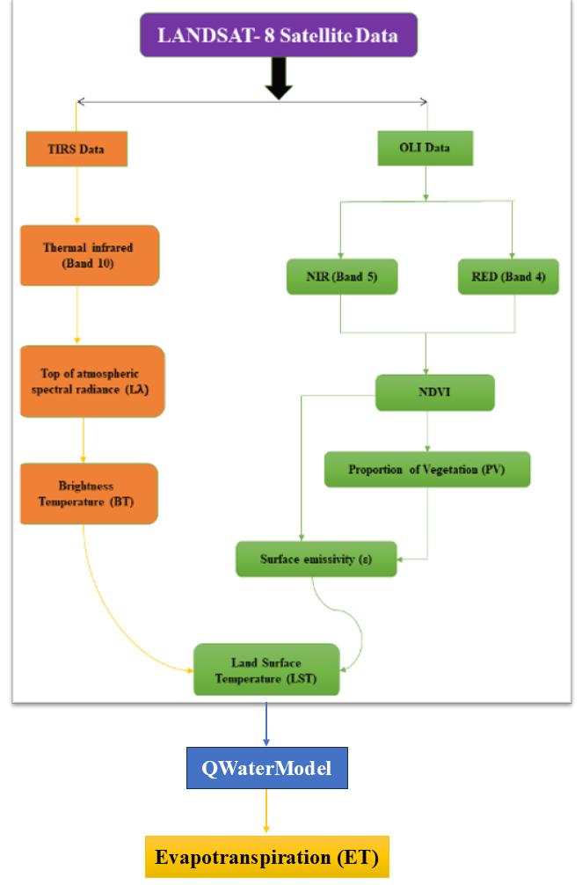
Fig. 2: The ET modelling workflow to estimate the Evapotranspiration (ET)
  - Workflow to Estimate the Evapotranspiration
The workflow was executed using ArcMap 10.8.2 and QGIS 3.36.0 for processing all satellite imagery. Steps up to Land Surface Temperature (LST) estimation were carried out in ArcMap, while the final step, involving evapotranspiration estimation, was completed in QGIS. For this purpose, the QWaterModel plugin, a simple tool developed by Ellsäßer et al. (2020) for QGIS users, was utilized to calculate evapotranspiration from thermal images. The entire process is visually represented in Fig. 2.
- RESULT AND DISCUSSION
The study estimate the month and season wised evapotranspiration (ET) for kharif maize from July to October over the years 2016 - 2020 using the Landsat-8 satellite dataset.
  - Monthly Evapotranspiration (ET)
The monthly evapotranspiration values for the months of July, August, September, and October from 2016 to 2020 are presented in Fig. 3 & Table 3.

Table 3: Monthly and seasonal ET value for maize
Month | Year | Monthly | Seasonal
July | 2016 | 42 | 427
Aug | 2016 | 110 | 427
Sept | 2016 | 200 | 427
Oct | 2016 | 75 | 427
July | 2017 | 52 | 443
Aug | 2017 | 115 | 443
Sept | 2017 | 204 | 443
Oct | 2017 | 72 | 443
July | 2018 | 62 | 462
Aug | 2018 | 120 | 462
Sept | 2018 | 211 | 462
Oct | 2018 | 69 | 462
July | 2019 | 59 | 463
Aug | 2019 | 123 | 463
Sept | 2019 | 240 | 463
Oct | 2019 | 41 | 463
July | 2020 | 55 | 453
Aug | 2020 | 111 | 453
Sept | 2020 | 251 | 453
Oct | 2020 | 40 | 453
From Fig. 3 and Table 3 it is evident that ET gradually increases from July to September, peaking in September when plant growth and temperatures are likely at their highest. By October, ET declines as temperatures start to fall or plant growth slows. Compared to 2016, July and August show slightly higher ET values, indicating potentially warmer conditions or more active vegetation. September maintains a similar peak, while October's ET shows a minor decline, consistent with the end of the growing season. For the year 2019 and 2020 the ET of October sharply drops below 40 mm, suggesting an earlier or more abrupt end to the growing season or a drop in temperature. In 2020, the ET value for September reached its highest point at 251 mm, possibly suggesting extreme heat or heightened vegetation activity.
  - Seasonal Evapotranspiration (ET)
Seasonal ET for maize (July-October) varied between 427 mm (2016) and 463 mm (2019) as shown in Fig. 4 & Table 3. The data shows a general upward trend in ET from 2016 to 2018, followed by stability in 2019 and a slight decrease in 2020. The yearly patterns show that 2016 had the lowest seasonal ET (427 mm) due to lower values in July and October, 2019 had the highest (463 mm) driven by high September ET, and 2020 was slightly lower than 2019 with higher September but lower October ET. This suggests variations in environmental conditions, with 2019 being the peak year for evapotranspiration within this period.

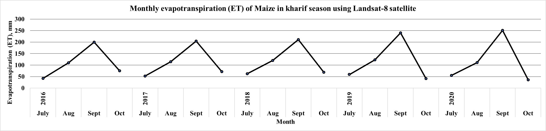
Fig. 3: Monthly ET using Landsat-8 Satellite data for Kharif Maize
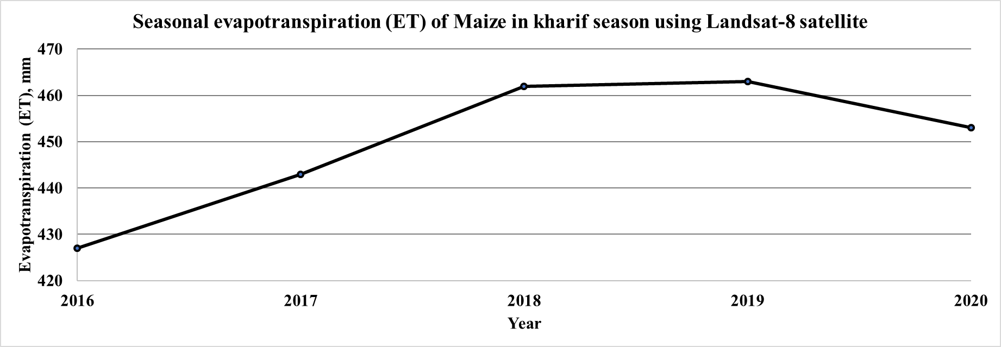
Fig. 4: Seasonal ET using Landsat-8 Satellite data for Kharif Maize

- CONCLUSION
The research was conducted at the Main Maize Research Station (MMRS), located in the semi-arid region of Panchmahal, Gujarat, India, to estimate maize crop evapotranspiration (ET) using thermal and optical data from Landsat 8, processed through the QWaterModel plugin. Monthly and seasonal evapotranspiration (ET) values for maize during the growing season (July to October) across the years 2016 to 2020 were estimated. The result showed that monthly ET values show clear trends throughout the growing season. July consistently has the lowest ET values, ranging from 42 mm in 2016 to 62 mm in 2018, reflecting the early growth stage of maize with lower water requirements. ET increases significantly in August and September, with peak values observed in September across most years, ranging from 200 mm (2016) to 251 mm (2020), corresponding to the peak water demand during the active growth stage. By October, ET decreases sharply, ranging from 40 mm (2020) to 75 mm (2016), indicating reduced water demand as the crop matures. Furthermore, seasonal ET values demonstrate slight variations over the years, with the lowest recorded in 2016 at 427 mm and the highest in 2019 at 463 mm. These fluctuations may be attributed to differences in climatic conditions, irrigation practices, or crop management across years. On average, the total seasonal ET for maize remains relatively stable, indicating consistent water requirements for maize production during the July–October period. Evapotranspiration (ET) from maize crops in semi-arid regions is crucial for optimizing water resource management and ensuring sustainable agricultural production. Remote sensing data enables accurate, large-scale ET estimation, helping to monitor crop water requirements and improve irrigation scheduling under water-scarce conditions.
- REFERENCES
Abdollahnejad, A., Panagiotidis, D., & Surový, P. (2018). Estimation and extrapolation of tree parameters using spectral correlation between UAV and Pléiades data. Forests, 9(2), 85.
Allen, R. G., Pereira, L. S., Raes, D., & Smith, M. (1998). Crop evapotranspiration-Guidelines for computing crop water requirements. FAO Irrigation and Drainage Paper 56. Rome, Italy: Food and Agriculture Organization.
Allen, R. G., Tasumi, M., & Trezza, R. (2007). Satellite-based energy balance for mapping evapotranspiration with internalized calibration (METRIC)—Model. Journal of Irrigation and Drainage Engineering, 133(4), 380-394.
Balas, D. B., Tiwari, M. K., & Patel, G. R. (2023a). Estimation of surface and subsurface soil moisture using microwave remote sensing: A typical analysis. International Journal of Environment and Climate Change, 13(10), 1804-1816.
Balas, D. B., Tiwari, M. K., Trivedi, M., & Patel, G. R. (2023b). Impact of land surface temperature (LST) and ground air temperature (Tair) on land use and land cover (LULC): An investigative study. International Journal of Environment and Climate Change, 13(10), 3117-3130.
Bastiaanssen, W. G., Menenti, M., Feddes, R. A., & Holtslag, A. A. M. (1998). A remote sensing surface energy balance algorithm for land (SEBAL). 1. Formulation. Journal of Hydrology, 212, 198-212.
D'Odorico, P., Davis, K. F., Rosa, L., Carr, J. A., Chiarelli, D., Dell'Angelo, J., Gephart, J., MacDonald, G. K., Seekell, D. A., Suweis, S. and Rulli, M. C. (2018). The global food‐energy‐water nexus. Reviews of Geophysics, 56(3), 456-531.
Ellsäßer, F., Röll, A., Stiegler, C., & Hölscher, D. (2020). Introducing QWaterModel, a QGIS plugin for predicting evapotranspiration from land surface temperatures. Environmental Modelling & Software, 130, 104739.
Gu, L., Meyers, T., Pallardy, S. G., Hanson, P. J., Yang, B., Heuer, M., Hosman, K. P., Riggs, J. S., Sluss, D. and Wullschleger, S. D., (2006). Direct and indirect effects of atmospheric conditions and soil moisture on surface energy partitioning revealed by a prolonged drought at a temperate forest site. Journal of Geophysical Research: Atmospheres, 111(D16).
Hoffmann, H., Nieto, H., Jensen, R., Guzinski, R., Zarco-Tejada, P., & Friborg, T. (2016). Estimating evaporation with thermal UAV data and two-source energy balance models. Hydrology and Earth System Sciences, 20(2), 697-713.
Kirda, C., & Kanber, R. (1999). Water, no longer a plentiful resource, should be used sparingly in irrigated agriculture.
Maes, W. H., & Steppe, K. (2012). Estimating evapotranspiration and drought stress with ground-based thermal remote sensing in agriculture: a review. Journal of Experimental Botany, 63(13), 4671-4712.
Martinez, C. J., & Thepadia, M. (2010). Estimating reference evapotranspiration with minimum data in Florida. Journal of Irrigation and Drainage Engineering, 136 (7), 494-501.
Mizyed, A., Moghier, Y., & Hamada, M. (2024). Employing the agricultural water footprint concept to enhance the sustainable management of water resources: a review. Water Practice & Technology, 19(11), 4435-4452.
Okello, C., Githiora, Y. W., Sithole, S., & Owuor, M. A. (2024). Nature-based solutions for water resource management in Africa's arid and sem-arid lands (ASALs): A systematic review of existing interventions. Nature-Based Solutions, 100172.
Senay, G. B., Bohms, S., Singh, R. K., Gowda, P. H., Velpuri, N. M., Alemu, H., & Verdin, J. P. (2013). Operational evapotranspiration mapping using remote sensing and weather datasets: A new parameterization for the SSEB approach. Journal of the American Water Resources Association, 49(3), 577-591.
Sharma, A., Surkar, P. P., Khare, R., Choudhary, M. K., & Prasad, V. (2024). Quantifying the irrigation requirements for major crops under the influence of Climate Change in a Semi-arid Region. Water Resources Management, 1-16.
Singh, P., Sehgal, V. K., Dhakar, R., Neale, C. M., Goncalves, I. Z., Rani, A., Jha, P. K., Das, D. K., Mukherjee, J., Khanna, M. & Dubey, S. K. (2024). Estimation of ET and crop water productivity in a semi-arid region using a large aperture scintillometer and remote sensing-based SETMI model. Water, 16(3), 422.
Su, Z. (2002). The Surface Energy Balance System (SEBS) for estimation of turbulent heat fluxes. Hydrology and Earth System Sciences, 6(1), 85-100.
Tabari, H. (2010). Evaluation of reference crop evapotranspiration equations in various climates. Water Resources Management, 24(10), 2311-2337.
Thornthwaite, C. W. (1948). An approach toward a rational classification of climate. Geographical Review, 38(1), 55-94.
Timmermans, W. J., Kustas, W. P., & Andreu, A. (2015). Utility of an automated thermal-based approach for monitoring evapotranspiration. Acta Geophysica, 63, 1571-1608.
Xia, T., Kustas, W. P., Anderson, M. C., Alfieri, J. G., Gao, F., McKee, L., Prueger, J. H., Geli, H. M., Neale, C. M., Sanchez, L., Alsina, M. M. & Wang, Z. (2016). Mapping evapotranspiration with high-resolution aircraft imagery over vineyards using one-and two-source modeling schemes. Hydrology and Earth System Sciences, 20(4), 1523-1545.
Xing, Y., & Wang, X. (2024). Precision Agriculture and Water Conservation Strategies for Sustainable Crop Production in Arid Regions. Plants, 13(22), 3184.
Xue, J., Bali, K. M., Light, S., Hessels, T., & Kisekka, I. (2020). Evaluation of remote sensing-based evapotranspiration models against surface renewal in almonds, tomatoes and maize. Agricultural Water Management, 238, 106228.

