In vitro exploration of botanicals, bio-agents and fungicides against Alternaria alternata (Fr.) Keissler, causing blight disease of brinjal

Abstract:
(Add one or two lines related to the crop) Blight disease of brinjal caused by Alternaria alternata is one of the most destructive diseases of brinjal which causes both qualitative and quantitative crop losses. In the present investigation, all plant extracts evaluated at 10% concentration exhibited antifungal activity against A. alternata. Soapnut rind extract was found the most effective which recorded least colony growth of 18.66 mm and the highest inhibition of 79.26%. Wild brinjal leaf extract was next best treatment with 31.33 mm growth and 65.18% inhibition. Among the eight bio-agents tested, Trichoderma koningii and T. longibrachiatum showed complete inhibition of mycelial growth of A. alternata. T. harzianum showed significant effectiveness, with the lowest colony growth of 20.33 mm and 77.41% inhibition. Among the fungicides, Tebuconazole 25.9% EC, Hexaconazole 5% EC, Propiconazole 25% EC, Hexaconazole 4% + Zineb 68% (72% WP), Captan 70% + Hexaconazole 5% (75% WP) and Carboxin 37.5% + Thiram 37.5% (75% WS) each @ 0.1% concentration were found most significantly effective in inhibiting the mycelial growth of A. alternata with 100 per cent inhibition over control.
Keywords: Alternaria alternata, Botanicals, Bio-agents, Fungicides, Blight, Brinjal (use the keywords which is not highlighted in the title of the manuscript or change the title of the manuscript)
Introduction:
Brinjal, also known as eggplant or aubergine (Solanum melongena), is a member of the nightshade family (Solanaceae). Unripe brinjal fruits are highly regarded for their inclusion in numerous dishes, especially curries. They are packed with vital vitamins and minerals, including phosphorus, calcium and iron. Brinjal contains a significant amount of total water-soluble sugars, free reducing sugars and amide proteins. Studies have shown that oblong-fruited eggplant varieties typically have higher overall soluble sugar content, whereas long-fruited varieties are generally richer in free reducing sugars, anthocyanins, phenolic compounds, glycoalkaloids, dry matter and amide proteins (Bajaj et al., 1979). In India, brinjal is predominantly cultivated by marginal, small and medium-scale farmers for both subsistence and income generation. However, its production and productivity are influenced by numerous factors contributing to low crop yields, with biotic factors being the most significant. The crop is susceptible to various diseases, including those caused by fungi, bacteria, viruses and phytoplasmas, which can adversely affect its overall yield. Among the various fungal diseases affecting brinjal, leaf blight caused by Alternaria alternata (Fr.) Keissler is the most prevalent and destructive, impacting a wide range of hosts and resulting in both quantitative and qualitative losses. The first report of leaf spot disease on brinjal in India was documented at the Indian Agricultural Research Institute (IARI) in New Delhi (Kapoor and Hingorani, 1958). Pandey and Vishwakarma (1998) noted that Alternaria species Alternaria alternata, Alternaria solani (Rajkar et al., 2021) responsible for leaf spot and fruit rot in brinjal contribute to significant yield reductions. The alternate host crop for brinjal leaf spot pathogen (Alternaria alternata, Alternaria solani) is tomato (Khaire et al., 2021). Additionally, Balai and Ahir (2013) recorded yield losses of up to 25% in the Jaipur district of Rajasthan attributed to leaf spot disease caused by Alternaria alternata (Fr.) Keissler. Current public perceptions and environmental concerns necessitate the exploration of alternative eco-friendly disease management strategies. An effective solution may lie in the integration of diverse cultural, biological and chemical methods to address these challenges (Barnwal et al., 2011; Jagan et al., 2013). Recently, there has been growing interest in employing biological control methods (Thakare et al., 2024), including bio-agents and plant extracts, in both conventional and organic farming systems (Khaire et al., 2021; Kota et al., 2024; Rhouma et al., 2024). Numerous plant extracts have shown significant antifungal activity, highlighting their potential as bio-fungicides within a comprehensive framework for environmental protection. Therefore, it is essential to implement an integrated disease management strategy that incorporates readily available plant extracts, bio-agents and fungicides. This comprehensive approach aims to reduce the reliance on fungicides to the minimum necessary level for effective plant disease control. By promoting sustainable and eco-friendly disease management practices, farmers can mitigate the impact of leaf blight disease, thereby minimizing yield losses and enhancing brinjal production.
Materials and methods:
The present study was conducted at the Department of Plant Pathology, College of Agriculture, Dr. Balasaheb Sawant Konkan Krishi Vidyapeeth, Dapoli during the years 2022-23 and 2023-24.
- In vitro efficacy of botanicals:
Aqueous extract of locally available nine botanicals each at 10% concentration were evaluated in vitro against the A. alternata by applying standard poisoned food technique (Nene and Thapliyal, 1993) and by using PDA as basal medium. Extracts from nine different plant species viz., garlic, neem, lantana, wild brinjal, glyricidia, tulsi, soapnut, rui and congress grass were prepared as per the methodology given by Bhatti (1998). For obtaining 10% plant extract, 10 ml of standard plant extract was mixed with 90 ml of PDA in 250 ml conical flask. Later, 20 ml of the PDA medium containing plant extracts was poured into sterilized Petri plates under aseptic conditions. Mycelial discs of 5mm size from seven days old actively grown pure culture was used to inoculate the poured Petri plates. Control was maintained on PDA without adding any plant extract in a medium. Three replications were taken for each treatment. These plates were incubated at 27±2⁰C for seven days and radial colony growth was measured.
- In vitro evaluation of bio-agents:
A total of nine bio-agents viz., Trichoderma harzianum, T. koningii, T. longibrachiatum, T. viride, Aspergillus niger, Pseudomonas fluorescens, Bacillus subtilis and Saccharomyces cerevisiae var. ellipsoideus were evaluated against A. alternata by applying Dual culture technique (Dennis and Webster, 1971) and using PDA as a basal medium. Seven days old culture of test fungus and test bio-agents were used for the study. Disc of PDA along with culture growth of test fungus and test bio-agents were cut out with cork borer and placed on Petri plates containing PDA at equidistance and exactly opposite to each other and the plates were incubated at 27 ± 2°C. PDA plates inoculated with only culture disc of test fungus were maintained as untreated control. Each treatment was replicated thrice in Completely Randomized Design.

- In vitro evaluation of fungicides
Various standard commercial formulation of fungicides was evaluated in-vitro against test pathogen by applying standard poisoned food technique (Nene and Thapliyal, 1993) and using potato dextrose agar as basal culture medium. Based on active ingredient, the required quantity of fungicide was calculated and mixed thoroughly with sterilized potato dextrose agar (PDA) medium in conical flasks to obtained desired concentration of fungicides. PDA medium without fungicides was served as untreated control. Fungicides amended PDA poured in Petri plates and allow to solidify at room temperature. After solidification of the medium, all the plated were inoculated with 5 mm culture disc of the test fungus obtained from a week-old growing pure culture of A. alternata. The disc was placed on PDA in inverted position in the centre of the Petri plate and plates were incubated at 27 ± 2⁰C temperature. Each treatment was replicated thrice.
Observation on radial mycelial growth were recorded when untreated control plate was fully covered with mycelial growth of test fungus. Per cent mycelial growth inhibition of the test fungus over untreated control was calculated by formula given by Vincent, (1947).
C - T
I = ---------------- × 100
C
Where,
I = Per cent Inhibition
C = Growth (mm) of the test fungus in untreated control plate
T = Growth (mm) of the test fungus in treated plates.
Results and Discussion
- In vitro evaluation of botanicals
The results (Table 1, Plate I and Fig. 1) revealed that all the plant extracts tested each @ 10% concentration showed antifungal activity against A. alternata. The mycelial growth of test fungus was ranged from 18.66 to 46.83 mm. Whereas, inhibition of mycelial growth of test fungus was ranged from 47.96 to 79.26 per cent. Among the nine plant extracts evaluated soapnut rind extract @ 10% concentration was found significantly superior to all treatments with least colony growth of 18.66 mm and highest inhibition of mycelial growth (79.26%) of A. alternata. The next best treatment was wild brinjal leaf extract (10%) which showed 31.33 mm mycelial growth & 65.18 per cent mycelial growth inhibition of A. alternata. Lantana leaf extract at 10 per cent concentration was also found effective with minimum mycelial growth of 34.83 mm and highest inhibition of mycelial growth with 61.30 per cent. It was followed by neem leaf extract (39.83 mm & 55.74%), congress grass extract (40.00 mm & 55.55%), garlic clove extract (44.66 mm & 50.37%), glyricidia leaf extract (44.66 mm & 50.37%) and rui leaf extract (44.83 mm & 50.18%) at 10% concentration. Least mycelial inhibition of A. alternata was recorded in tulsi leaf extract by 47.96% over control.
These results are in conformity with the earlier findings of those researchers who reported botanicals viz., garlic clove, neem leaf, tulsi leaf and lantana leaf extract at various concentrations had significantly inhibited mycelial growth of A. alternata, inciting leaf spot / blight disease of brinjal (Bochalya, 2010; Rajput, 2010; Sidhdhapara, 2014; Jakatimath et al., 2017; Kumar, 2017; Rajput and Chaudhari, 2018; Nagaraju et al., 2020; Naik et al., 2020; Deshmukh et al., 2020; Rajkar et al., 2021; Chauhan et al., 2023 and Yadav et al. 2024).

Table 1: In vitro efficacy of botanicals against A. alternata
Tr. No. | Common Name | Botanical Name | Conc. (%) used | Mean colony diameter  (mm) | Per cent inhibition
T₁ | Garlic | Allium sativum | 10 | 44.66 | 50.37
T₂ | Neem | Azadirachta indica | 10 | 39.83 | 55.74
T₃ | Lantana | Lantana camara | 10 | 34.83 | 61.30
T₄ | Wild brinjal | Solanum torvum | 10 | 31.33 | 65.18
T₅ | Glyricidia | Glyricidia sepium | 10 | 44.66 | 50.37
T₆ | Tulsi | Ocimum tenuiflorum | 10 | 46.83 | 47.96
T₇ | Soapnut | Sapindus mukorossi | 10 | 18.66 | 79.26
T₈ | Rui | Calotropis gigantea | 10 | 44.83 | 50.18
T₉ | Congress grass | Parthenium hysterophorus | 10 | 40.00 | 55.55
T₁₀ | Control | - | - | 90.00 | -
 | S.E.m ± |  |  | 0.53
 | C.D. at 1% |  |  | 1.59

2. In vitro evaluation of bio-agents
The results depicted in Table 2, Plate II and Fig. 2 indicated that, all the bio-agents evaluated were significantly effective in inhibiting the mycelial growth of A. alternata. Among the eight bio-agents tested, complete mycelial growth inhibition of A. alternata was recorded due to Trichoderma koningii and T. longibrachiatum. However, T. harzianum was also found effective with least colony growth of test pathogen (20.33 mm) with 77.41 per cent inhibition of mycelial growth followed by T. viride (30.83 mm & 65.74 %), Aspergillus niger (31.16 mm & 65.37 %) and Saccharomyces cerevisae var. ellipsoideus (41.50 mm & 53.88 %). Maximum colony growth and least inhibition was observed in case of Bacillus subtilis (56.50 mm & 37.22 %) and Pseudomonas fluorescens (59.00 mm & 34.44 %), respectively.
The results of present investigation are in consonance with the earlier findings of those researchers who reported bio-agents viz., T. viride, T. harzianum, Bacillus subtilis, Pseudomans fluorescens and Aspergillus niger had significantly inhibited mycelial growth of A. alternata, causing leaf spot / blight disease of brinjal (Rajput, 2010; Jakatimath et al., 2017; Naik et al., 2020; Dhere, 2021; Khursheed et al., 2021 and Rajkar et al., 2021).
Table 2: In vitro efficacy of bio-agents against A. alternata
Tr. No. | Bio agents evaluated | Mean colony diameter (mm) | Per cent inhibition
T₁ | Trichoderma harzianum | 20.33 | 77.41
T₂ | T. koningi | 0.00 | 100.00
T₃ | T. longibrachiatum | 0.00 | 100.00
T₄ | T. viride | 30.83 | 65.74
T₅ | Aspergillus niger | 31.16 | 65.37
T₆ | Pseudomonas fluorescens | 59.00 | 34.44
T₇ | Bacillus subtilis | 56.50 | 37.22
T₈ | Saccharomyces cerevisae var. ellipsoideus | 41.50 | 53.88
T₉ | Control | 90.00 | -
 | S.E.m ± | 0.28
 | C.D. at 1% | 0.86

3. In vitro evaluation of fungicides
The results furnished in Table 3, Plate III and Fig. 3 revealed that all, the fungicides tested at different concentrations were found significantly effective in inhibiting the mycelial growth of A. alternata. Among the systemic fungicides, Tebuconazole 25.9% EC, Hexaconazole 5% EC and Propiconazole 25% EC (each @ 0.1% concentration) and among combi fungicides, Hexaconazole 4% + Zineb 68% (72% WP), Captan 70% + Hexaconazole 5% (75% WP) and Carboxin 37.5% + Thiram 37.5% (75% WS) (each @ 0.1% concentration) were found most significantly effective in inhibiting the mycelial growth of A. alternata with 100 per cent inhibition over control. Among rest of the fungicides, Copper Hydroxide 77% WP (0.1%) resulted with minimum mycelial growth of 8.83 mm and with inhibition of 90.18% followed by Tebuconazole 50% +Trifloxystrobin 25% WG (0.05%) (10.00 mm & 88.88%), Copper oxychloride 50% WP (0.25%) (16.50 mm & 81.66%), Mancozeb 75% WP (0.2%) (19.20 mm & 78.66 %), Carbendazim + Mancozeb 63% (75% WP) (0.2%) (19.50 mm & 78.33%), Captan 50% WP (0.2 %) (22.50 mm & 75.00%) and Zineb 75% WP (0.2%) (30.66 mm & 65.93%), respectively with average mycelial growth and its corresponding average inhibition. Chlorothalonil 75% WP (0.2%) and Carbendazim 50% WP (0.1%) were found least effective in inhibiting the mycelial growth of test pathogen with maximum colony growth of 41.26 mm & 55.33 mm and least inhibition of mycelial growth by 54.15% & 38.52%, respectively.
These results are in conformity with the earlier findings of those researchers who reported fungicides viz., Propiconazole 25% EC, Difenconazole 25% EC, Hexaconazole 5% EC, Mancozeb 75% WP, Zineb 75% WP, Carbendazim 50% WP, Chlorothalonil 75% WP, Copper oxychloride 75% WP, Carbendazim 12% + Mancozeb 63% WP at different concnentartions had significantly inhibited mycelial growth of A. alternata, inciting leaf spot / blight disease of brinjal (Rajput, 2010; Jakatimath et al., 2017; by Kumar, 2017; Rajput and Chaudhari, 2018; Kumar, 2019; Deshmukh et al., 2020 andYadav et al. ,2024).
Table 3: In vitro efficacy of fungicides against A. alternata
Tr. No. | Fungicides | Conc. (%) used | Mean colony diameter (mm) | Per cent inhibition
T₁ | Tebuconazole 25.9% EC | 0.1 | 0.00 | 100
T₂ | Hexaconazole 5% EC | 0.1 | 0.00 | 100
T₃ | Propiconazole 25% EC | 0.1 | 0.00 | 100
T₄ | Carbendazim 50% WP | 0.1 | 55.33 | 38.52
T₅ | Captan 50% WP | 0.2 | 22.50 | 75.00
T₆ | Copper oxychloride 50% WP | 0.25 | 16.50 | 81.66
T₇ | Chlorothalonil 75% WP | 0.2 | 41.26 | 54.15
T₈ | Zineb 75% WP | 0.2 | 30.66 | 65.93
T₉ | Mancozeb 75% WP | 0.2 | 19.20 | 78.66
T₁₀ | Copper Hydroxide 77% WP | 0.1 | 8.83 | 90.18
T₁₁ | Carbendazim + Mancozeb 63% (75% WP) | 0.2 | 19.50 | 78.33
T₁₂ | Hexaconazole 4% + Zineb 68% (72% WP) | 0.1 | 0.00 | 100
T₁₃ | Captan 70% + Hexaconazole 5% (75% WP) | 0.1 | 0.00 | 100
T₁₄ | Tebuconazole 50% +Trifloxystrobin 25% WG | 0.05 | 10.00 | 88.88
T₁₅ | Carboxin 37.5% + Thiram 37.5% (75% WS) | 0.1 | 0.00 | 100
T₁₆ | Control | - | 90.00 | -
 | S.E.m ± |  | 0.31
 | C.D. at 1% |  | 0.91

Conclusion
From the results of present experiment, it is concluded that blight disease of brinjal incited by A. alternata can be effectively controlled by botanicals namely, soapnut rind extract and wild brinjal extract @ 10% concentration and bio-agents namely, Trichoderma koningii and T. longibrachiatum. Tebuconazole 25.9% EC, Hexaconazole 5% EC, Propiconazole 25% EC, Hexaconazole 4% + Zineb 68% (72% WP), Captan 70% + Hexaconazole 5% (75% WP) and Carboxin 37.5% + Thiram 37.5% (75% WS) (each @ 0.1%) are most effective which completely inhibits mycelial growth of A. alternata in vitro.

References
Bajaj, K.L., Kaur, G., and Chadha, M.L. 1979. Glycoalkaloid content and other chemical constituents of the fruits of some egg plant (Solanum melongena L.) varieties. J. Pl. Foods. 3(3): 163-168.
Balai, L.P. and Ahir, R.R. 2013. Survey and occurrence of leaf spot of brinjal caused brinjal by Alternaria alternata (Fr.) Keissler in Jaipur district. Advances in Life Sci. 2: 71-72
Balai, L.P. and Ahir, R.R. 2013. Survey and occurrence of leaf spot of brinjal caused brinjal by Alternaria alternata (Fr.) Keissler in Jaipur district. Advances in Life Sci. 2: 71-72.
Barnwal, M. K., Kumar, R. and Kumar, B. Integrated management of Alternaria blight, Melampsora rust and fungal wilt of linseed (Linum usitatissimum) in field. J. Mycol. Pl. Pathol. 2011; 41 (1): 53-56.
Bhatti, B.S., 1998. Utilization of toxic plants for control of nematode pest economic crop. Final technical report April, 1993 to March 31 1998. HAU, Hissar, India, pp. 56.
Bochalya, M.S. 2010. Some physio-pathological and management studies on Alternaria fruit rot of brinjal (Solanum melongena L.). SKRAU, Bikaner. M.Sc. (Pl. Patho.) thesis.
Chauhan, A., Kumar, V., and Singh, K. (2023). Management of Alternaria leaf spot of brinjal (Solanum melongena) caused by Alternaria alternata (Fr.) Keissler through botanicals (In vitro). Environ. Ecology, 41(3B): 1749-1754.
Dennis, K.L. and Webster, J. 1971. Antagonistic properties of species group of Trichoderma and hyphal interaction. Trans. British Mycol. Soc. 57: 363- 396.
Deshmukh H. V, Deokar C. D, Khaire P. B and Brahmane P. R (2020) Efficacy of different botanicals against the Alternaria solani under in vitro conditions. Journal of Pharmacognosy and Phytochemistry; 9(6): 1986-1989.
Deshmukh H. V, Deokar C. D, Raghuwanshi K. S, Khaire P. B and Brahmane P. R (2020). Efficacy of different fungicides against the Alternaria solani under in vitro conditions. Journal of Pharmacognosy and Phytochemistry; 9(6): 1057-1060.
Dhere, D.S. 2021. Integrated management of fungal fruit rot of brinjal (Solanum melongena L.). VNMKV, Parbhani. M. Sc. (Pl. Patho.) thesis.
Jagana, M., Zacharia, S., Lal, A. A. and Basayya. Management of Alternaria blight in Mustard. Ann. Pl. Prot. Sci. 2013; 21 (2): 441-442.
Jakatimath, S. 2016. Etiology and management of fruit rot of brinjal (Solanum melongena L.) caused by Alternaria alternata, Colletotrichum melongenae and Phomopsis vexans. Uni. Horticulture Sci., Bagalkot. M.Sc. (Pl. Patho.) thesis.
Kapoor, J.N. and Hingorani, M.K. (1958). Alternaria leaf spot and fruit rot of brinjal. Ind. J. of Agril. Sci. 28(1):109-114.
Khursheed, Z., Wani, T.A., Bhat, N.A., Rather, R.A., Shafat, A.A. and Farheen, C. (2021). Eco-friendly management of Alternaria leaf spot disease of brinjal in Kashmir. J. Phama. Phytochem. 10(1):100-105.
Khaire Pravin Babasaheb, Mane Someshree, Srivastava Ashwini Kumar (2021) Plant Disease Management Under Organic Farming Special Emphasis to Trichoderma spp. In book: Pest Management Strategies in Crop Protection Publisher: Learning Media Publication. 119-135.
Khaire P. B, Mane S. S and Pawar S. V (2021) Identification and management of fungal diseases of tomato-a review. Agri meet Multidisciplinary Magazine. Volume 01 Issue 01: January 2021.
Kota Tejasree, Narute T. K, Navale A. M. and Khaire P. B (2024). Bioconsortia: A Potential Ecofriendly Bio-Based Product to Enhance the Productivity of the Green Gram. Journal of Advances in Biology & Biotechnology. Volume 27, Issue 2, Page 159-170.
Kumar, P. 2017. Management of Alternaria leaf spot of brinjal (Solanum melongena L.) caused by Alternaria alternata (Fr.) Keissler. SKNAU, Jobner. M. Sc. (Pl. Patho.) thesis.
Nagaraju, K., Mishra, J.P., Prasad, R., Sekhar, J.C., Reddy, V.P. and Kumar, S. 2020. Isolation and in vitro evaluation of different botanicals on mycelia growth of Alternaria alternata (Fr.) Keissler causing leaf spot of brinjal. J. Pharma. Phytochem. 9(4): 889-891.
Naik S. C, Narute T. K, Narute T. T and Khaire P. B (2020). Effects of selected biological control agents and plant extracts on early blight disease management and yield of cherry tomato. Journal of Pharmacognosy and Phytochemistry; Sp 9(5): 587-592.
Naik S. C, Narute T. K, Narute T. T and Khaire P. B (2020). In vitro efficacy of plant extract (botanicals) against Alternaria solani (early blight of tomato). Journal of Pharmacognosy and Phytochemistry; Sp 9(5): 614-617.
Naik S. C, Narute T. K, Narute T. T and Khaire P. B (2020). In-vitro efficacy of biocontrol agents against Alternaria solani (Early Blight of Tomato). Journal of Pharmacognosy and Phytochemistry; Sp 9(5): 550-552.
Nene, Y.L. and Thapliyal, R.N. 1993. Evaluation of fungicides In Fungicides for plant disease control (3rd ed.). oxford, IBH Pub. Co. New Delhi. 331.
Pandey, K.K. and Vishwakarma, S.N. 1998. Growth, sporulation and colony characteristics of Alternaria alternata on different vegetable based media. J. Mycol. Pl. Pathol. 32(2): 346-347.
Rajkar, S., Zacharia, S. and Bawane, A.S. 2021. Eco-friendly management of Alternaria leaf spot of brinjal (Solanum melongena L.) Int. J. Curr. Microbiol. App. Sci. 10(07): 20-29.
Rajkar, S., Zacharia, S. and Bawane, A.S. 2021. Eco-friendly management of Alternaria leaf spot of brinjal (Solanum melongena L.) Int. J. Curr. Microbiol. App. Sci. 10(07): 20-29.
Rajput, R.B. 2010. Investigation on leaf spot disease (Alternaria alternata (Fr.) Keissler) of brinjal (Solanum melongena L.) under south Gujarat conditions. NAU, Navsari- Gujarat. M. Sc. (Pl. Patho.) thesis.
Rajput, R.B. and Chaudhari, S.R. 2018. Evaluation of various botanicals against Alternaria alternata (Fr.) Keissler in vitro conditions. J. Pharmacogn. Phytochem. 7(4):1306-1309.
Rhouma, Abdelhak; Hajji-Hedfi, Lobna; Kouadri, Mohamed El Amine; Chihani-Hammas, Noura; Khaire, Pravin Babasaheb (2024) Investigating plant growth promoting and antifungal potential of Metarhizium spp. against Fusarium wilt in tomato. Nova Hedwigia Band 119 Heft 1-2 (2024), p. 117 – 139.
Sidhdhapara, K.M. 2014. Leaf spot disease (Alternaria alternata (Fr.) Keissler of brinjal and its management. JAU, Junagadh. M.Sc. (Pl. Patho.) thesis.
Thakare Sirisha, Khaire Pravin. Dawale Mukund, Mane Someshree and Kolase Sanjay (2024) Biocontrol Products to Control Plant and Animal Diseases. In book: Industrial Applications of Soil Microbes. Volume 4, Page 219-245.
Yadav, A.P., Kumar, A., Gupta, H.K., Awasthi, R.A., Gera, R. and Shukla, V. 2024. In vitro efficacy of different chemical fungicides and plant extracts against Alternaria alternata causing Alternaria leaf spot disease in brinjal. J. Experimental Agri. Int. 46(6): 272-278.

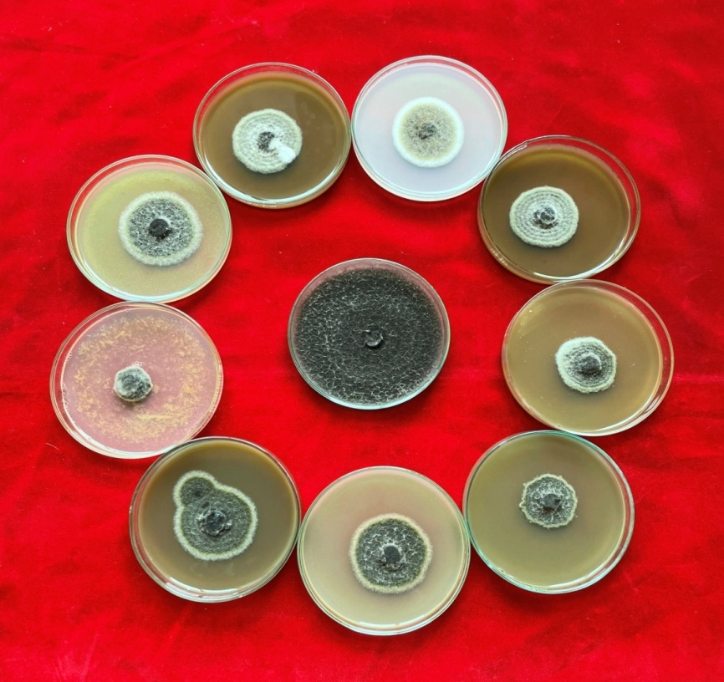
T₁
T₂
T₃
T₄
T₅
T₆
T₇
T₈
T₉
T₁₀
Plate I: In vitro efficacy of botanicals against A. alternata
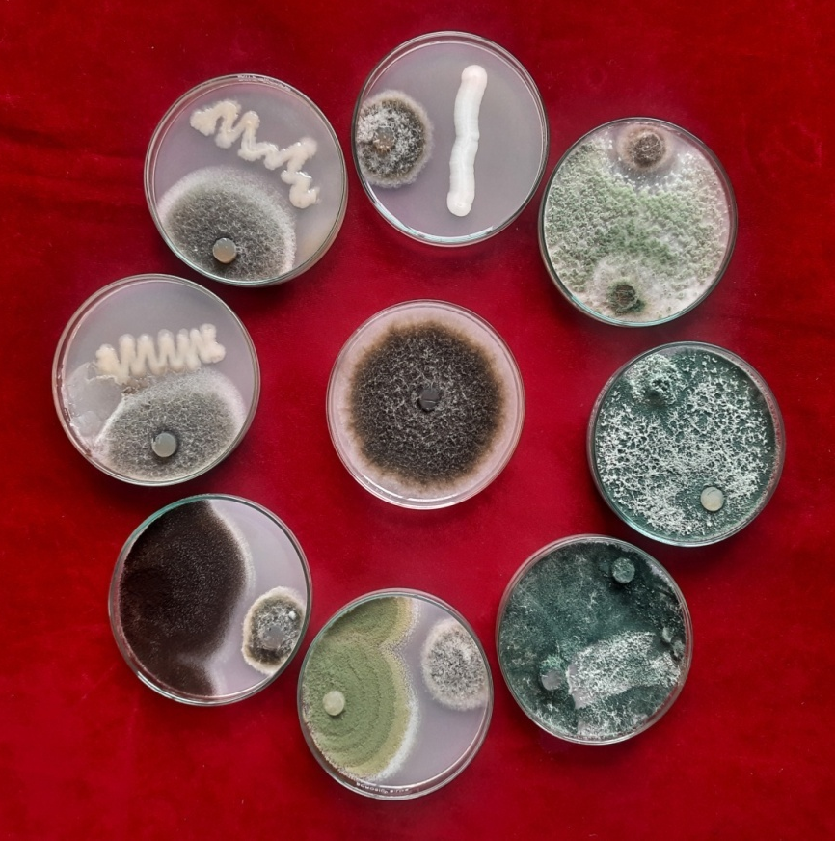
T₁
T₂
T₃
T₄
T₅
T₆
T₇
T₈
T₉
Plate II: In vitro efficacy of bio-agents against A. alternata

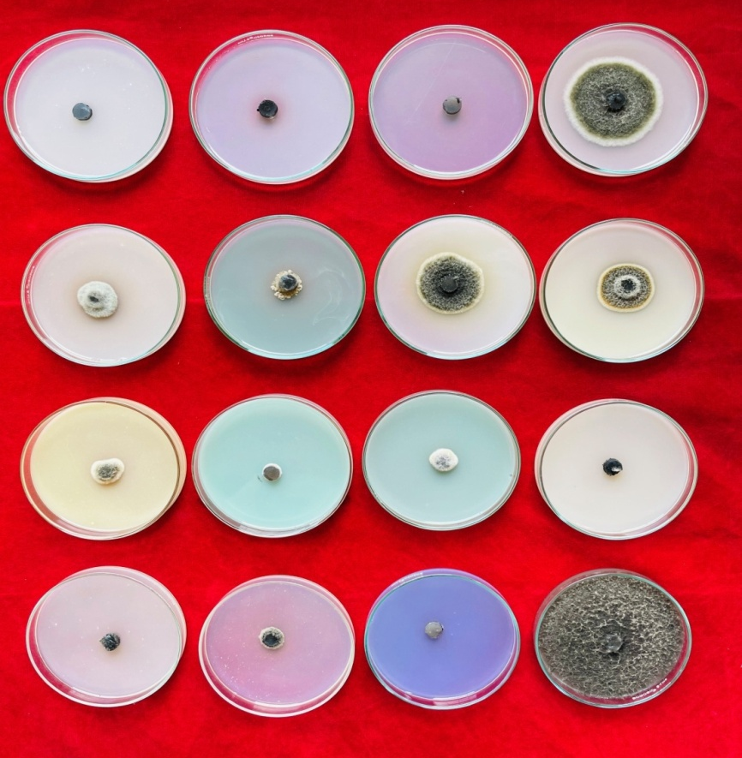
T₁
T₄
T₂
T₃
T₅
T₆
T₇
T₈
T₁₂
T₁₆
T₁₁
T₁₅
T₁₀
T₁₄
T₉
T₁₃
Plate III: In vitro efficacy of fungicides against A. alternata

