PHYTOCHEMICAL AND CYTOTOXIC EVALUATION OF THE FRUITS OF RAUWOLFIA VOMITORIA AFZEL. (APOCYNACEAE)

ABSTRACT
Rauwolfia vomitoria fruits has been claimed to possess cytotoxic activities. However, this activity has not yet been scientifically proven. This study focuses on investigating the cytotoxicity activity of this plant on Tadpoles (Raniceps ranninus). The powder was extracted with methanol and partitioned with n-hexane, dichloromethane and ethyl acetate in water and Ethanol. This crude extract and fractions were evaluated for cytotoxic potential in tadpoles. Bioactive extracts were analyzed on Gas chromatography-Mass spectrometry. The n-hexane fraction showed significant cytotoxicity at 20mg/ml, 10mg/ml and 5mg/ml while dichloromethane extract showed toxicity at 20mg/ml and 10mg/ml only. The methanol and ethyl fractions showed toxicity at 20mg/ml while the aqueous fraction showed no toxicity at all. The GC-MS analysis of n-hexane fraction identified Hexadecenoic acid, methyl ester and three (3) more compounds present while that of the dichloromethane fraction revealed n-hexadecenoic acid and three (3) more compounds. This study justifies the use of Rauwolfia vomitoria as a cytotoxic agent.
Keywords: Rauwolfia vomitoria, Cytotoxicity, fruits, GC-MS analysis.

- Introduction
Cytotoxicity is the quality of being toxic to cells. The cells may undergo necrosis, in which they lose membrane integrity and die rapidly as a result of cell lysis. The cells can stop actively growing and dividing (a decrease in cell viability), or the cells can activate a genetic program of controlled cell death (apoptosis). Assessing cell membrane integrity is one of the most common ways to measure cell viability and cytotoxic effects. Cytotoxicity assays measure the ability of cytotoxic compounds to cause cell damage or cell death. Cytotoxicity assays are widely used by the pharmaceutical industry to screen for cytotoxicity in compound libraries.
Cancer (neoplasm) is a class of diseases in which a group of cells display uncontrolled or abnormal growth through division beyond normal limit, invasion intrudes upon and destroys adjacent tissues and sometimes metastasis occur, which spreads to cells in other locations in the body via the blood or lymph. Cancers are classified by the type of cell that resembles the tumor and therefore the tissue it’s presumed to be the origin of the tumor. These are the histology and the location respectively. They include: Carcinomas, Sarcomas, Leukemia, Lymphoma and Blastoma [1]. The majority of cancers, some 90–95% of cases, are due to genetic mutations from environmental and lifestyle factors [2]. The remaining 5–10% are due to inherited genetics. Environmental refers to any cause that is not inherited, such as lifestyle, economic, and behavioral factors and not merely pollution [3]. Common environmental factors that contribute to cancer death include tobacco use (25–30%), diet and obesity (30–35%), infections (15–20%), radiation (both ionizing and non-ionizing, up to 10%), lack of physical activity, and pollution [4]. Psychological stress does not appear to be a risk factor for the onset of cancer, though it may worsen outcomes in those who already have cancer [5].
Cancer is the second leading cause of death globally, accounting for an estimated 9.6 million deaths, or 1in 6 deaths, in 2018. Lung, prostate, colorectal, stomach and liver cancer are the most common types of cancer in men, while breast, colorectal, lung, cervical and thyroid cancer are the most common among women [6]. Globally, the number of cancer deaths is projected to increase from 7.1 million in 2002 to 11.5 million in 2030 [7]. Although, great advancements have been made in the treatment and control of cancer progression, significant deficiencies and room for improvement remain. Thus, this has therefore stimulated investigation for cure from plant kingdom. Plants claimed to have potentials in treating cancer have not been confirmed scientifically and Rauwolfia vomitoria fruits is not excluded.
Rauvolfia (sometimes spelled Rauwolfia) is a genus of evergreen trees and shrubs, commonly known as devil peppers, in the family Apocynaceae. The genus is named to honor Leonhard Rauwolf. The genus can mainly be found in tropical regions of Africa, Asia, Latin America, and various oceanic island [8]. Herbal preparations of Rauwolfia vomitoria, a tropical shrub in the family of Apocynaceae, have been used in traditional folk medicine in Africa to treat a variety of ailments including fever, general weakness, gastrointestinal diseases, liver diseases, psychosis, pain, and cancers [9,10]. Rauwolfia vomitoria is claimed to be involved in certain herbal preparations used in the treatment of cancer. Investigations has to be carried out to assess the potential of the fruits in the killing of cancerous cells. Consequently, this study was aimed at investigating the cytotoxic activity of the fruits of Rauwolfia vomitoria using Tadpoles (Raniceps ranninus).
- MATERIALS AND METHODS
2.1 Plant Materials
The fruits of Rauwolfia vomitoria was purchased from Oja Oba Market, Ilorin, Kwara State. The fruit was identified by Dr. Suleiman and then was authenticated and deposited in the herbarium of the Department of Pharmacognosy and Phytotherapy, Faculty of Pharmaceutical Sciences. University of Port-Harcourt with a voucher number UPHA0625 assigned.
2.2 Extraction of the fruits of Rauwolfia vomitoria
The fruits of Rauwolfia vomitoria which was collected already was picked and separated from debris. These fruits were then milled to powdered form with the aid of a milling machine. About 425.40g of the powder was placed into a macerating jar and was macerated with 2L of methanol for 72h. The extract was filtered and concentrated further with the help of a rotary evaporator, the resultant extract was poured into crucibles and placed on a water bath in order to dry.
2.3 Partitioning process
About 50g of the methanol extract was finally partitioned with the following solvents: N-hexane, Dichloromethane, and Ethyl Acetate. This partitioning was done by dissolving 50g of the methanol extract with 100ml of ethanol and 200 ml of water and placed in a separating funnel. After which, one (1) liter of the N-hexane solvent was added (in 4 parts; 250 ml). The mixture was allowed to stand for 5 minutes, then the hexane fraction and the aqueous fraction was collected respectively. The above process was carried out using the other solvents. At the end of the partitioning procedure, n-hexane, Dichloromethane, Ethyl Acetate and Aqueous fractions were gotten respectively.
2.4 Determination of Cytotoxicity of Extract
Tadpoles were harvested from small water settlements around the areas of Alakahia, Rivers State. They were identified as the tadpoles of Raniceps ranninus and used accordingly [11]. Five (5) tadpoles were obtained in placed in wide mouthed jars and 15ml of water from their source was added and volume was made up to 50 ml. Then, 1ml of the respective concentrations of the methanol extract that was dissolved with 2% dimethyl sulfoxide to give the following concentrations; 20 mg/ml, 10 mg/ml, 5 mg/ml, 2.5 mg/ml and 1.25 mg/ml, was added to the corresponding labelled concentration jars containing the tadpoles. This procedure was repeated using the n-hexane, Dichloromethane, Ethyl acetate and aqueous fractions obtained from the partioning process of the crude methanol extract. This controls were not treated. The mortality rate of the tadpoles was observed for 24 hours.

2.5 Gas Chromatography-Mass Spectrometry (GC-MS)
For the determination of the constituents of the extract, the n-hexane and Dichloromethane fractions were used. They were sent to EBIC LAB in Rivers State. This was done on the hexane and dichloromethane extract using an Agilent chromatograph, coupled to a mass spectrometer equipped with DB DB-IMS capillary column, programmed from 120°C (5min) to 250°C at 3°C/min with 5 minutes hold time. Helium was used as the carrier gas (1.0ml/min) with a sample injection in split mode (50:1). Injector and detector temperatures were 250-280°C respectively. The mass spectrometer worked in electron impact mode at 70eV with electron multiplier at 1600V and ion source temperature at 180°C. Mass spectra data were acquired in the scan mode m/z range 50-550. The compounds characterized in the extracts were identified.

- RESULTS AND DISCUSSION
Table 1: Percentage Yield of the extracts from Rauwolfia vomitoria
SAMPLES | % YIELD
Crude Methanol extract | 17.44%
n-hexane fraction | 1.375%
Dichloromethanefraction | 0.195%
Ethyl acetate fraction | 0.133%
Aqueous fraction | 4.200%

Table 2: Cytotoxic Effect of the fractions of Rauwolfia vomitoria fruits on Tadpoles (Raniceps ranninus)

CONCENTRATION
EXTRACTS | 20mg/ml | 10mg/ml | 5mg/ml | 2.5mg/ml | 1.25mg/ml | CONTROL
Methanol fraction | 5/5 | 0/5 | 0/5 | 0/5 | 0/5 | CONTROL
n-Hexane fraction | 5/5 | 5/5 | 5/5 | 0/5 | 0/5 | CONTROL
Dichloromethane fraction | 5/5 | 5/5 | 0/5 | 0/5 | 0/5 | CONTROL
Ethyl acetate fraction | 3/5 | 0/5 | 0/5 | 0/5 | 0/5 | CONTROL
Aqueous fraction | 0/5 | 0/5 | 0/5 | 0/5 | 0/5
Distilled water |  |  |  |  |  | 0/5
2% DMSO |  |  |  |  |  | 0/5
Numerator = Number of deaths; Denominator = Number of tadpoles

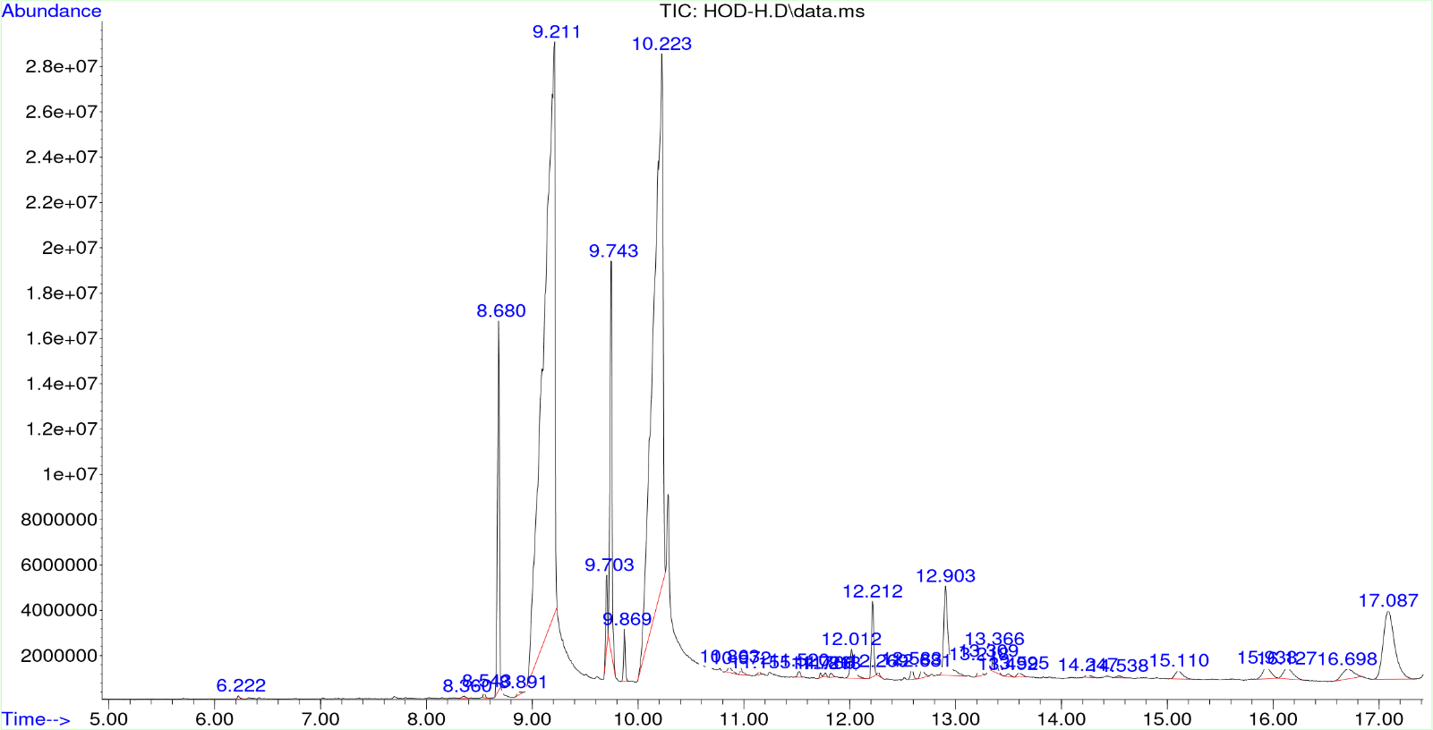
Figure 1: GC-MS Spectra (Chromatogram) of n-hexane extract fraction of Rauwolfia vomitoria
Table 3: Most abundant compounds in the GC-MS Chromatogram of n-hexane fraction of Rauwolfia vomitoria

S/No | Retention time | Area% | Compounds  (library ID) | Quality factor
1 | 8.680 | 4.61 | Hexadecenoic acid, methyl ester | 99
2 | 9.211 | 42.04 | n-Hexadecenoic acid | 99
3 | 9.743 | 5.22 | 9-Octadecenoic acid, methyl ester, (E | 99
4 | 10.223 | 32.33 | 6-Octadecenoic acid | 99
5 | 17.087 | 4.94 | Beta- Amyrin | 99

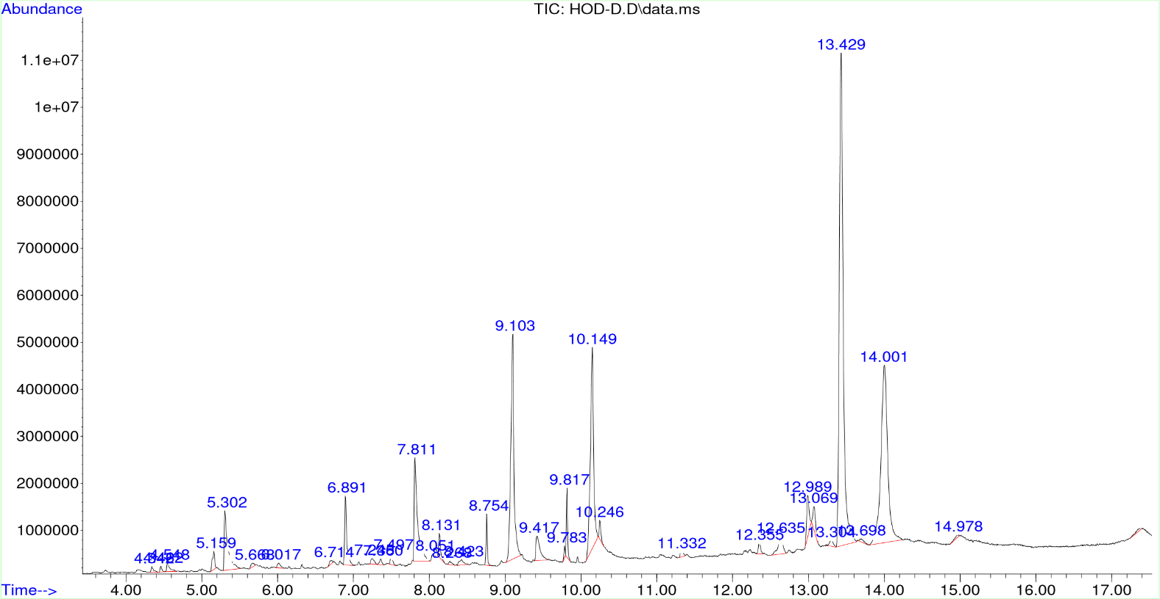
Figure 2: GC-MS Spectra (Chromatogram) of Dichloromethane fraction of Rauwolfia vomitoria

Table 4: Most abundant compounds in the GC-MS Chromatogram of Dichloromethane fraction fraction of Rauwolfia vomitoria
S/NO | RETENTION TIME | AREA % | COMPOUNDS (LIBRARY ID) | QUALITY FACTOR
1 | 9.103 | 11.45 | n-Hexadecenoic acid | 99
2 | 10.149 | 10.61 | 9-Octadecenoic acid | 99
3 | 13.429 | 31.54 | Ethyl 3,7,11,15-tetramethyl-2- hexadecenoate | 90
4 | 14.001 | 19.71 | Sarpagan-16- carboxylic acid, 17-oxo, methyl ester | 83

The essence of this research work was to evaluate the cytotoxic activity of Rauwolfia vomitoria fruits. This research works study focuses on the cytotoxic activity of this drug using tadpoles of species Raniceps ranninus as a test model. The percentage yield of the fruit extracts and fractions as presented in Table 1 shows that the fruit contain more polar constituent as the aqueous fraction tends to be higher in percentage (4.2%) when compare to other extractive solvents.
In the determination of the cytotoxic activity of the extract and fractions, five (5) tadpoles were used and different concentrations were used. It was observed from Table 4 that at the end of the 24-h period, the n-hexane fraction exhibited the most cytotoxic activity at 5 mg/ml, 10 mg/ml and 20 mg/ml while dichloromethane one showed total death at 10 mg/ml and 20 mg/ml. The aqueous fraction showed no death of tadpoles meaning that it has no cytotoxic effect and unfortunately highest in yield. The methanol extract only showed a total death at the highest concentration 20 mg/ml. The ethyl acetate fraction showed mild cytotoxic effect at the highest concentration 20 mg/ml with 3 deaths recorded.
The cytotoxicity of the n-hexane fraction is in tandem with the reported activity of one of the most abundant compounds (9-Octadecenoic acid, methyl ester (E)) identified by the GC-MS [12]. This is the same as the dichloromethane fraction which also has a cytotoxic effect due to its relation with one of the most abundant compounds, 9-Octadecenoic acid. It could also be suggested that the most abundant compound in the n-hexane (9-Octadecenoic acid, methyl ester (E)) that has cytotoxic effect or activity needs to be further investigated.
Gas chromatography-Mass spectroscopy is a method that is very important in the identification and detection of compounds. It is employed in analysis as it separates compounds in a sample, qualify these compounds and identify unknown peaks. From the GC-MS analysis results of the n-hexane fraction, the chromatogram revealed 35 compounds out of which 5 were selected due to their abundance and their activity also?. The selected compounds were Hexadecenoic acid methyl ester, n-Hexadecenoic acid, 9-Octadecenoic methyl ester (E), 6-Octadecenoic acid and beta-Amyrin at the respective times 8.680, 9.211, 9.743, 10.223 and 17.087 with a quality factor of 99 for each. These compounds have varying reported biological activity such as Anti-oxidant, Anti-inflammatory, Anti-bacterial, Anti-fungal, Cancer preventive, Cardio protective, Antinociceptive, Gastro protective and Hepatoprotective activities [13,14,15].
From the GC-MS analysis of the dichloromethane fraction, the chromatogram revealed about 35 compounds out of which 4 were selected due to their abundance. The selected compounds were identified by the Library ID to be; hexadecenoic acid methyl ester, 9-Octadecenoic acid, Ethyl 3, 7, 11, 15- tetramethyl-2-hexadecenoate and Sarpagan-16-carboxylic acid, 17-ox at the respective retention times 9.103, 10.149, 13.429 and 14.001 with quality factors of 99, 99, 90 and 83 respectively. These compounds have varying activities as stated earlier.

CONCLUSION
In conclusion, from the results obtained and in comparison, with the control groups and the cumulative cytotoxic effect, it can be said that n-hexane fraction and dichloromethane fraction of Rauwolfia vomitoria shows remarkable cytotoxic activity. The claim that Rauwolfia vomitoria possess cytotoxic activity might be justified in this study.

REFERENCES
[1] Yadav R. Cancer prevention and control: A review. Journal of Medical Education, 2012;56(1), 1-9.
[2] Anand P, Kunnumakara AB, Sundaram C. Cancer is a preventable disease that requires major lifestyle changes. Pharmaceutical Research 2008;25(9), 2097-2116.
[3] Manton KG, Gu X, Lowrimore GR. Cohort changes in active life expectancy in the U.S. elderly population: experience from the 1982–2004 National Long-Term Care Survey. The Journals of Gerontology: Series B, Psychological Sciences and Social Sciences, 2008;63(5), S269–S281.
[4] Islami F, Goding SA, Miller KD. Proportion and number of cancer cases and deaths attributable to potentially modifiable risk factors in the United States. CA Cancer Journal of Clinical science, 2018;68(6), 31-54.
[5] Cohen S, Murphy ML, Prather AA. "Ten Surprising Facts About Stressful Life Events and Disease Risk". Annual Review of Psychology. 2019;70, 577–597.
[6] World Health Organization. 2023 progress report on the Global Action Plan for Healthy Lives and Well-being for All.
[7] Mathers CD, Loncar D, Lopez AD, & Murray, C.J.L. Projections of global mortality and burden of disease from 2002 to 2030. PLoS Medicine, 2006;3(11), e442.
[8] Families J. Rauvolfia: A review of its medicinal uses and safety aspects. Journal of Ethnopharmacology, 2014;133(2), 402-411.
[9] Campbell-Tofte JIA, Mølgaard P, Josefsen K., et al. Randomized and double-blinded pilot clinical study of the safety and anti-diabetic efficacy of the Rauvolfia-Citrus tea, as used in Nigerian traditional medicine. Journal of Ethnopharmacology. 2011;133(2), 402-411.
[10] Bisong SA, Brown RE, Osim EE. Comparative extrapyramidal effects of Rauwolfia vomitoria, chlorpromazine and reserpine in mice. Journal of natural medicines. 2013;67, 107-112.
[11] Yu F, Lu S, Yu F, Shi J, McGuire PM, Wang R. Cytotoxic activity of an octadecenoic acid extract from Euphorbia kansui (Euphorbiaceae) on human tumour cell strains. J Pharm Pharmacol. 2008 Feb;60(2):253-9. doi: 10.1211/jpp.60.2.0015. PMID: 18237474.
[12] Ikpefan EO, Ayinde BA. Preliminary Phytochemical and Cytotoxic Activity of The Aqueous and Chloroform Fractions of The Leaf of Persea Americana Mill (Lauraceae). NIJOPHASR [Internet]. 2020 Aug. 2 [cited 2024 Dec. 25];5(1):15-20. Available from: https://www.nijophasr.net/index.php/nijophasr/article/view/107
[13] Zhong-hui PU, Yu-qun ZHANG, Zhong-qiong YIN, Jiao XU, Ren-yong JIA, Yang LU, Fan YANG. Antibacterial Activity of 9-Octadecanoic Acid-Hexadecanoic Acid-Tetrahydrofuran-3,4-Diyl Ester from Neem Oil, Agricultural Sciences in China. 2010;9(8):1236-1240,
[14] Waqas A, Imad A, Mubarika A, Faizullah K, Haroon K, Chapter 8 - Neuroprotective effect of terpenoids, Editor(s): Haroon K, Michael A, Hamed M, Phytonutrients and Neurological Disorders, Academic Press, 2023;227-244, ISBN 9780128244678, https://doi.org/10.1016/B978-0-12-824467-8.00006-1.
[15] Bhardwaj R. GC-MS analysis and antimicrobial activity of alkaloids of Tecomella undulata. J Med Plant Stud. 2018; 6(6):68–72.

