EVALUATION OF ANTI-INFLAMMATORY ACTIVITY OF HERBAL EXTRACTS OF FALLEN LEAVES OF CARICA PAPAYA L. (CARICACEAE) AND JUICE OF CITRUS AURANTIFOLIA CHRISTM. (RUTACEAE)

ABSTRACT

Introduction: Inflammation-related diseases are among the major causes of mortality and morbidity in almost every region of the world. Despite the availability of anti-inflammatory drugs, the mortality and morbidity rate of chronic inflammatory diseases continue to pose a threat to the world at large. Herbal preparations have long been used in traditional medicine for inflammation-related conditions. The aim of the study was to assess the anti-inflammatory potential of herbal preparations of fallen leaves of male and female Carica papaya in separate preparation with Citrus aurantifolia. Method: 100g of male Carica papaya and 100g of female Carica papaya were decocted with 375 ml of 20% ^{v}/_{v} Citrus aurantifolia separately. The mixtures were filtered and concentrated on a water bath at a temperature of 50℃. Phytochemicals of the extracts were screened. The extracts were assessed for anti-inflammatory using membrane stabilization model at concentration of 10 to 50ug/ ml and carrageenan induced paw oedema model at concentration of 200 to 800 mg/ml Result: The herbal preparations showed the presence of flavonoids, tannins, deoxy-sugars, phenols and triterpenes. The acute toxicity at maximum dose of 5000mg/kg was safe. The membrane stabilization effect of the two herbal preparations were significant and dose dependent. The inhibition of Carrageenan-induced paw oedema was also significant and dose-dependent for both herbal preparations. Conclusion: The herbal preparation of the fallen leaves of male Carica papaya and Citrus aurantifolia, and female Carica papaya and Citrus aurantifolia is safe and has a significant in vivo and in vitro anti-inflammatory activity.

Keywords: Carica papaya, Citrus aurantifolia, anti-inflammatory activity

- INTRODUCTION
Diseases and plants have had a long-time relationship from the time immemorial. Disease may lead to pain and pain may lead to disease. Disease is defined by Merriam-Webster as “a condition of the living animal or plant body or of one of its parts that impairs normal functioning and is typically manifested by distinguishing signs and symptoms”. Inflammation is a physiological response necessary to restore normal homeostatic functioning altered by diverse stimuli; however, when inflammation state is chronically established or an excessive response is expressed, deleterious effects can be involved. It is the body's natural response to eliminate harmful stimuli such as pathogens, damaged cells, toxic compounds or irradiation, and initiate tissue healing. If left untreated, inflammation can become chronic, leading to tissue or organ dysfunction (Kolawole et al., 2013). During inflammation, various chemical mediators and cells are released, resulting in vascular reactions.
Inflammation is usually examined in two groups: acute and chronic. Chronic inflammation instigates various kinds of diseases that cause premature mortality and morbidity such us cardiovascular diseases, cancer, diabetes mellitus, chronic obstructive pulmonary disease, obesity, metabolic syndrome, inflammatory bowel disease, rheumatoid arthritis, multiple sclerosis, osteoporosis, and neurological diseases via dysregulation of various signalling pathways such as nuclear factor kappa-B, signal transducer, activator of transcription 3, etc. These inflammation-related diseases are among the major causes of mortality and morbidity in almost every region of the world. The World Health Organization (WHO) ranks chronic diseases as the greatest threat to human health. Worldwide, 3 of 5 people die due to chronic inflammatory diseases like stroke, chronic respiratory diseases, heart disorders, cancer, obesity, and diabetes (Barcelos et al., 2019 and Tsai et al., 2019). Studies have shown that these diseases associated with inflammation have tended to increase worldwide.
Herbal medicine is gaining popularity in developing countries and herbal treatments involve mainly the use of plant extracts and other plant products. Carica papaya L. has been used in various parts of Nigeria for different purposes. According to a study by Bamisaye et al., (2013), the plant is used in the treatment of impotence, infertility, diarrhoea, measles, body pain, typhoid, malaria, yellow fever, tuberculosis, dysentery and gonorrhoea in various local government areas of Kwara State. Various pharmacological activities including anti-inflammatory, wound healing, antifertility, immunomodulatory and antimicrobial and anthelmintic have been reported (Fatima & Shahid, 2018). Quercetin, kaempferol, kaempferol 3-rutinoside, quercetin 3-(2G-rhamnosylrutinoside), quercetin 3-rutinoside, kaempferol 3-(2G-rhamnosylrutinoside), and myricetin 3-rhamnoside have also been isolated from the leaves of C. papaya (Nugroho et al., 2017).

According to Onyilofe et al., (2015), in Nigeria, C. aurantifolia fruit juice is added to sugar and palm oil or honey to relief cough. In Malayan medicine, the juice is considered as tonic for libido and as antidote for poison. It is also used to increase stamina, treat dysfunctional uterine bleeding, used as facial wash to rejuvenate the skin and remove stain, drunk to control epistaxis and given in pure form as remedy for arthralgia, diabetes and atherosclerosis. The diluted form of the C. aurantifolia fruit juice is used for mouth wash to treat sore mouth and sore throat. The juice has been found useful to treat irritation, diarrhoea and swelling due to mosquito bites. It is sometimes mixed with oil and used as vermifuge and also incorporated into weight management diet. Antibacterial, anticancer, antioxidant and anti-inflammatory, antifungal, anti-cholesterol of the C. aurantifolia were also reported by Indriyani et al., (2023). This research problem revolves around inflammation, which is linked to various diseases, including autoimmune disorders, cardiovascular diseases, neurodegenerative conditions, and cancer. Chronic inflammatory diseases are the most significant cause of death in the world. The World Health Organization (WHO) ranks chronic diseases as the greatest threat to human health. Worldwide, 3 of 5 people die due to chronic inflammatory diseases like stroke, chronic respiratory diseases, heart disorders, cancer, obesity, and diabetes (Barcelos et al., 2019 and Tsai et al., 2019). Current anti-inflammatory treatments like NSAIDs and corticosteroids have limitations and side effects, especially with long-term use. Additionally, the study recognizes the potential of fallen leaves from Carica papaya trees and Citrus aurantifolia juice extract as natural sources of anti-inflammatory compounds. However, there is limited research on how these sources work together synergistically.
- MATERIALS AND METHODS
2.1 Plant Material
The fallen leaves of both male and female Carica papaya were collected from Owhipa, Choba, Rivers State. Citrus aurantifolia fruits were bought from Choba market in November, 2023. Identification and authentication were carried out in the Herbarium of the Department of Pharmacognosy and Phytotherapy, Faculty of Pharmaceutical Sciences, University of Port Harcourt. Voucher numbers were obtained for the plants and fruit.
2.2 Extraction
The juice of ripe fruits of Citrus aurantifolia (lime) was obtained using a juice extractor. A 20% v/v of lime was prepared by dissolving 375ml of lime juice in 1500ml of distilled water. The fallen leaves of male paw-paw, Carica papaya, leaves were thoroughly cleaned, chopped into smaller pieces, dried and powdered using a milling machine, individually. 20% of lime was used extract the leaf powder by decoction. This involve 100g each of the male paw-paw fallen leaves being boiled in 20% of 1875ml of the solvent for 10 minutes. The mixtures were allowed to cool for 6 hours, filtered and dried in a water bath at a temperature of 50°C. the process was repeated for the female pawpaw leaves. The extracts were concentrated and stored under appropriate conditions.
2.3 Phytochemical Screening
The phytochemical screening was done as prescribed by Sofowora, (2008).
2.4 Experimental Animals
A total of eighteen male and female mice of weights 20-30g were obtained from the animal house of the Department of Pharmacology, Faculty of Pharmaceutical Sciences, University of Port Harcourt, River State. The animals were fed with standard feed and water, and allowed to acclimatize for a period of two weeks. The animals were used to test for acute toxicity.
Twenty-four adult male and female Wistar Rats weighing between 150-200g were obtained from the animal house of the Department of Pharmacology, Faculty of Pharmaceutical Sciences, University of Port Harcourt, River State. The rats were fed with standard feed and water, and allowed to acclimatize for a period of two weeks. The animals were used to test for Carrageenan paw-induced oedema.
2.5 Membrane Stabilizing Assay (Heat-Induced Hemolysis)
Stabilization of red blood cell membrane lysing technique by Mikailu et al., (2019) was used to assess the anti-inflammatory activity of the extracts 12. A 5 ml of fresh whole human blood from a healthy donor who has not taken any NSAIDS for 2 weeks prior to the experiment was collected and transferred to an ethylene-di-amine tetra-acetate (EDTA) centrifuge tube. The tube was centrifuged at 2000 rpm for 5 min and washed with normal saline. This was repeated two times with an equal volume of normal saline. The volume after centrifuging was measured and constituted as a 40% v/v suspension with isotonic phosphate buffer solution (pH 7.4). The buffer solution (5 ml) containing 20, 40, 60 and 80 µg/mL on each of the female and male pawpaw extracts were put in sets of four (4) centrifuge tubes per concentration and the control tubes containing 5 ml of vehicle, 5 ml of diclofenac 20, 40, 60 and 80 µg/ml. Unto each of the tubes, 0.005 ml (0.5µg/mL) erythrocytes suspension was added and gently mixed. A pair of the tubes from each set was incubated at 54°C for 20 min in a regulated water bath, and the other pair was maintained at 0-4°C in ice for 20 min. At the end of the incubation, the reaction mixture was centrifuged at 1000 rpm for 3 min, and the absorbance of the supernatant was measured using the spectrophotometer at 540 nm. The percentage inhibition of haemolysis was calculated using the formula:
1- [OD₂-OD₁/OD₃-OD₁] × 100
Where, OD₁ = Absorbance of test sample unheated
OD₂ = Absorbance of test sample heated
OD₃ = Absorbance of control sample heated
2.6 Determination of Acute Toxicity (LD₅₀)
The animals were divided into six groups (1,2,3,4,5 and 6) of three animals each. The aqueous plant extract was given to animals according to their body weights (20-30g). The acute toxicity study was carried out on experimentally healthy mice as described by Lorke (1983) to estimate the level of toxicity of the plant extract in other to ascertain the safety margin in mice. The experimental animals were starved overnight. In the first phase, three groups (1, 2, and 3) were treated orally with doses of 10,100, and 1000mg /kg body weight respectively. They were observed for 24 hours for death and any sign of toxicity. In the second phase, three groups (4, 5, and 6) were treated with doses of 1600, 2900 and 5000mg/kg body weight respectively. They were observed for 24 hours for signs of toxicity. The LD₅₀ was then be calculated using the formula:- LD₅₀=√A×B
A = Highest dose that gave no mortality
B= Lowest dose that caused mortality

2.7 Carrageenan-induced Paw Oedema Assay (Anti-Inflammatory Assay)
This test was carried out by the method of Sayeedur & Najeeb (2021).
- Group I - Animals served as positive control and were not treated with any drugs.
- Group II - Animals served as standard control and were administered standard drug, Diclofenac Sodium, in the dose of 10 mg/kg body weight.
- Group IIIA - Animals were treated with male pawpaw extract, 200 mg/kg body weight.
- Group IIIB - Animals were treated with male pawpaw extract, 400 mg/kg body weight.
- Group IIIC - Animals were treated with male pawpaw extract, 800 mg/kg body weight.
- Group IVA - Animals were treated with female pawpaw extract, 200 mg/kg body weight.
- Group IVB - Animals were treated with female pawpaw extract, 400 mg/kg body weight.
- Group IVC - Animals were treated with female pawpaw extract, 800 mg/kg body weight.
In this model, acute inflammation was induced by sub-plantar injection of 0.1 ml of 1% suspension of carrageenan in normal saline, in rat hind paw of all the following groups: II, IIIA, IIIB, IIIC, IVA, IVB, IVC and V. The test drugs and standard drug were administered 30 min prior to carrageenan injection. The thickness of hind paw was measured using a Vernier calliper. Inflammation was observed in animal after 1, 2, 3, 4 and 5 hours of carrageenan injection.
Paw thickness was measured just before the carrageenan injection, that is, at “0 hours” and then carrageenan sub-plantar injection was given, and paw thickness was measured at 1, 2, 3, 4, and 5 hours. Increase in paw thickness was measured as the difference in paw thickness at “0 hours” and paw thickness at respective hours. The percentage inhibition of inflammatory oedema in test and standard control group animals was calculated by the formula:
i = 100{1-(a-x)/(b-y)}
where a = Mean hind paw volume of test/standard group animals after carrageenan injection
b = Mean hind paw volume of positive control animals after carrageenan injection
x = Mean hind paw volume of test/standard group animals before carrageenan injection
y = Mean hind paw volume of positive control animals before carrageenan injection.

2.8 Statistical analysis
Data were expressed as percentages and mean ± standard error of mean. The significance was established by student’s t-test student’s t-test with P = .05.

- RESULTS
3.1 Yield of preparation
The percentage yield of the MCC and FCC was 1.51% and 1.47% from the preparation formula as presented in Table 1.
3.2 Phytochemical constituents
Saponins was the only class of secondary metabolite that was absent in both MCC and FCC mixture while other tested positive and indicated present in Table 2.
3.3 Toxicity study
According to the method adopted, the two herbal preparations did not exhibit any toxicity sign. All the animals in the study survived and LD₅₀ was estimated to be <5000 mg/kg.
3.4 Membrane stabilizing effect of MCC and FCC preparation
From table 3, it is obvious that all the various concentrations of MCC and FCC have over 90% percentage inhibition of haemolysis.
3.5 Inhibition of Carrageenan-induced paw oedema by MCC and FCC preparation
Table 4 showed that the various concentration of MCC exhibited inhibition of inflammation in a dose dependent manner from 1 hour to 5 hours. The highest significant inhibition of 75.42% was observed in the highest dose (800 mg/kg) at 4 hours after treatment. Similar trend was observed in the FCC where the highest percentage inhibition was 72.57% at 800 mg/kg in 5 hours in Table 5.
Table 1: Percentage Yield of Herbal Preparations
Parameter | MCC | FCC
Weigt after drying | 28.30 | 27.60
Percentage yield | 1.51% w/v | 1.47% w/v
MCC = Male Carica papaya and Citrus aurantifolia;
FCC = Female Carica papaya and Citrus aurantifolia

Table 2: Phytochemical Screening of Herbal Preparations
Phytochemical Constituents | MCC | FCC
Alkaloids | + | +
Anthraquinones | + | +
Saponins | - | -
Tannins | + | +
Flavonoids | + | +
Carbohydrates | + | +
Triterpenoids & steroids | + | +
Phlobatannins | + | +
Glycosides | + | +
+ = Present; - = Absent; MCC = Male Carica papaya and Citrus aurantifolia;
FCC = Female Carica papaya and Citrus aurantifolia

Table 3: Membrane Stabilizing Effect of MCC and FCC preparation
EXTRACT | Concentration  µg/ml | 0°C | 54°C | % haemolysis  inhibition
Control |  | 0.098 ± 0.001 | 0.629 ± 0.006
Diclofenac | 20 | 0.099 ± 0.003 | 0.103 ± 0.002 | 99.31
 | 40 | 0.099 ± 0.001 | 0.101 ± 0.002 | 99.75
 | 60 | 0.103 ± 0.001 | 0.114 ± 0.002 | 97.93
 | 80 | 0.105 ± 0.004 | 0.116 ± 0.006 | 97.99
 | 100 | 0.121 ± 0.002 | 0.122 ± 0.011 | 99.94
MCC | 20 | 0.122 ± 0.002 | 0.141 ± 0.003 | 96.42
 | 40 | 0.134 ± 0.001 | 0.149 ± 0.003 | 97.11
 | 60 | 0.149 ± 0.007 | 0.164 ± 0.002 | 97.11
 | 80 | 0.177 ± 0.004 | 0.181 ± 0.001 | 99.18
 | 100 | 0.188 ± 0.001 | 0.195 ± 0.004 | 98.81
FCC | 20 | 0.14 ± 0.002 | 0.153 ± 0.001 | 97.55
 | 40 | 0.156 ± 0.004 | 0.18 ± 0.006 | 95.48
 | 60 | 0.182 ± 0.011 | 0.221 ± 0.017 | 92.53
 | 80 | 0.224 ± 0.015 | 0.243 ± 0.003 | 96.42
 | 100 | 0.248 ± 0.006 | 0.274 ± 0.007 | 95.10
MCC = Male Carica papaya and Citrus aurantifolia;
FCC = Female Carica papaya and Citrus aurantifolia

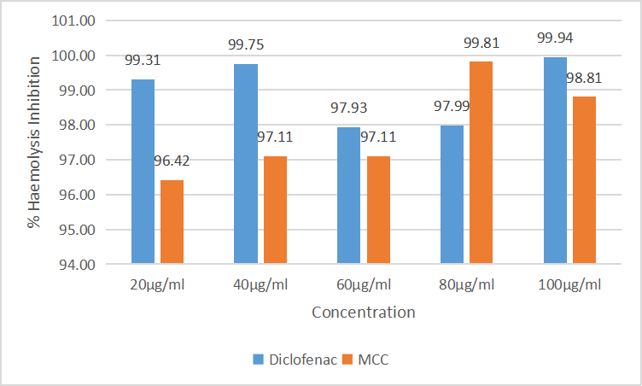
MCC = Male Carica papaya and Citrus aurantifolia
Fig 1: Percentage Inhibition of Haemolysis by Male Carica papaya and Citrus aurantifolia preparation

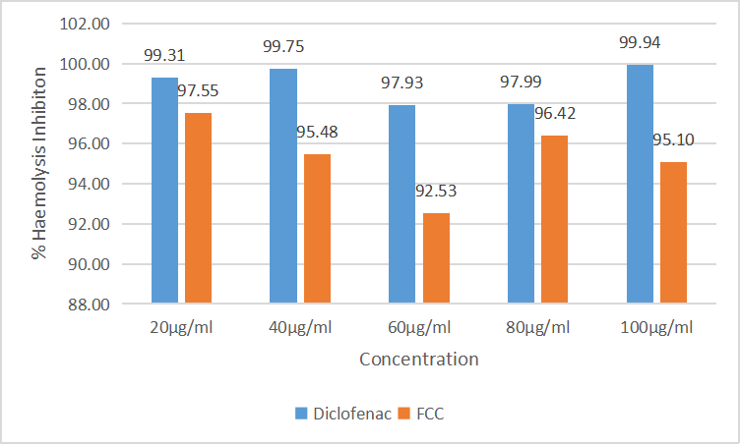
FCC = Female Carica papaya and Citrus aurantifolia
Fig 2: Percentage Inhibiton of Haemolysis by Female Carica papaya and Citrus aurantifolia preparation
Table 4: Inhibition of Carrageenan-Induced Paw Oedema by MCC preparation
EXTRACT | NORMAL |  |  | Time (Hours)
 |  | 0 | 1 | 2 | 3 | 4 | 5
Control | 3.88±0.428 | 4.82±0.420 | 5.52±0.404 | 5.58±0.423 | 5.87±0.418 | 5.85±0.410 | 5.84±0.420
Diclofenac 10mg/kg | 3.69±0.233 | 4.69±0.214 | 5.21±0.285 | 5.12±0.391 | 4.97±0.337 | 4.89±0.365 | 4.83±0.405
 |  | (-6.38) | (7.11) | (15.88) | (35.85) | (38.81) | (41.57)
MCC 200mg/kg | 3.64±0.191 | 4.60±0.180 | 5.20±0.193 | 5.24±0.179 | 5.48±0.211 | 5.41±0.176 | 5.40±0.173
 |  | (-1.77) | (4.67) | (6.08) | (7.37) | (9.83) | (10.05)
MCC 400mg/kg | 3.90±0.074 | 4.91±0.032 | 5.47±0.131 | 5.48±0.095 | 5.44±0.078 | 5.40±0.084 | 5.37±0.095
 |  | (-7.09) | (4.27) | (7.25) | (22.61) | (22.61) | (25.04)
MCC 800mg/kg | 3.77±0.145 | 4.70±0.136 | 4.95±0.232 | 4.55±0.186 | 4.44±0.139 | 4.25±0.193 | 4.33±0.162
 |  | (1.42) | (27.85) | (53.92) | (66.33) | (75.42) | (71.55)

Values represent mean ± standard deviation; n = 5; values in parenthesis represent % inhibition; MCC = Male Carica papaya and Citrus aurantifolia

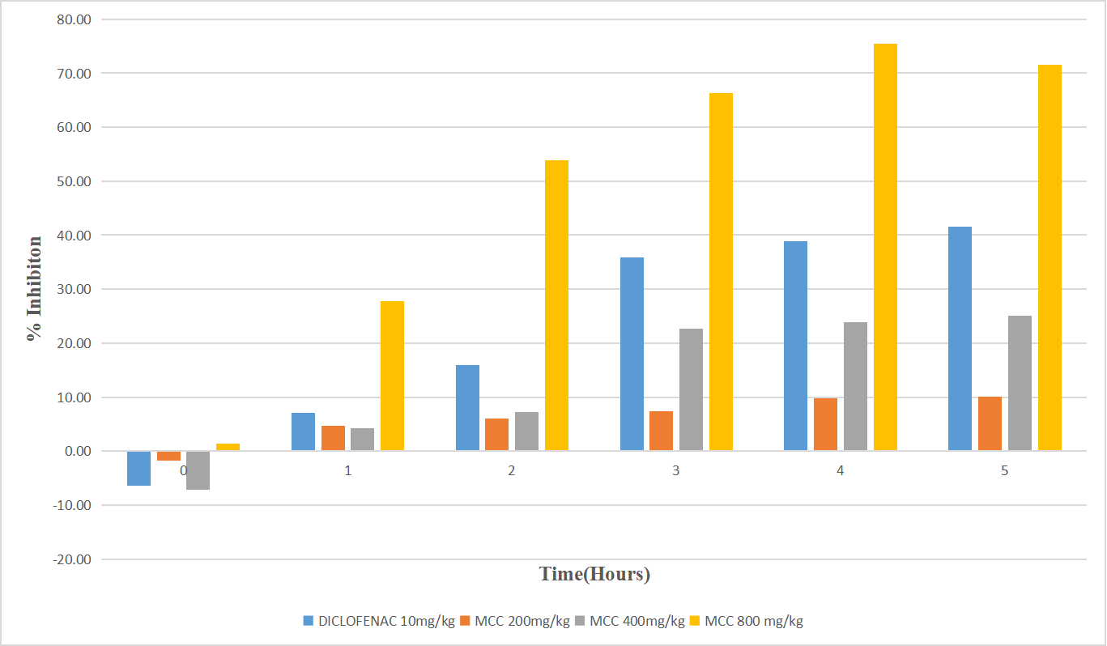
MCC = Male Carica papaya and Citrus aurantifolia
Fig 3: Percentage Inhibition of Paw-Oedema by Male Carica papaya and Citrus aurantifolia preparation
Table 5: Inhibition of Carrageenan-Induced Paw Oedema by FCC preparation
Values represent mean ± standard deviation; n = 5; values in parenthesis represent % inhibition; FCC = Female Carica papaya and Citrus aurantifolia

EXTRACT | NORMAL |  |  | Time (Hours)
 |  | 0 | 1 | 2 | 3 | 4 | 5
Control | 3.88±0.428 | 4.82±0.420 | 5.52±0.404 | 5.58±0.423 | 5.87±0.418 | 5.85±0.410 | 5.84±0.420
Diclofenac 10mg/kg | 3.69±0.233 | 4.69±0.214 | 5.21±0.285 | 5.12±0.391 | 4.97±0.337 | 4.89±0.365 | 4.83±0.405
 |  | (-6.38) | (7.11) | (15.88) | (35.85) | (38.81) | (41.57)
FCC 200mg/kg | 3.89±0.035 | 4.87±0.119 | 5.44±0.020 | 5.45±0.025 | 5.72±0.040 | 5.67±0.031 | 5.65±0.021
 |  | (-3.90) | (5.49) | (8.43) | (7.87) | (9.32) | (9.88)
FCC 400 mg/kg | 3.84±0.293 | 4.82±0.274 | 5.41±0.270 | 5.33±0.290 | 5.29±0.291 | 5.24 ±0.297 | 5.22±0.291
 |  | (-4.26) | (4.07) | (12.16) | (27.14) | (28.64) | (29.47)
FCC 800mg/kg | 3.92±0.340 | 4.90±0.604 | 5.29±0.326 | 4.78±0.380 | 4.64±0.416 | 4.53±0.367 | 4.46±0.335
 |  | (-3.90) | (16.67) | (49.61) | (63.82) | (68.81) | (72.57)

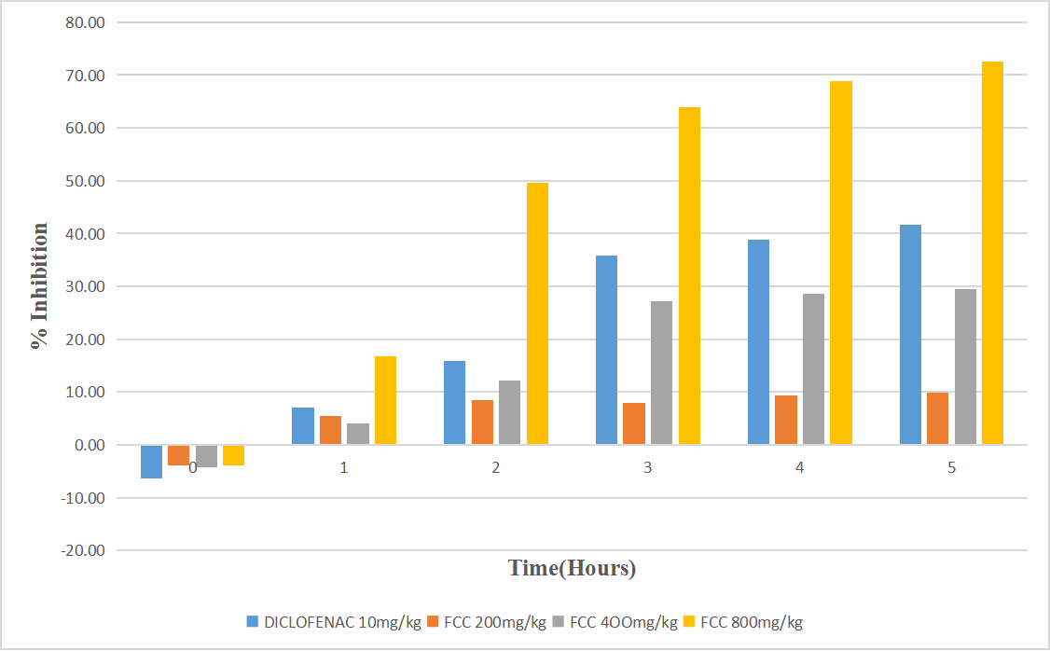FCC = Female Carica papaya and Citrus aurantifolia
Fig 4: Percentage Inhibition of Paw-Oedema by Female Carica papaya and Citrus aurantifolia preparation

DISCUSSION
There is no significant difference in the percentage yield of the MCC and FCC as observed from table 1. The phytochemicals present in the two extracts are also the same as presented in table 2.
A prominent and extensively documented factor contributing to inflammation is the denaturation of proteins. The research focuses on understanding the mechanism behind anti-inflammatory activity. Subsequent exploration assesses the extract's capacity to impede protein denaturation, a crucial aspect of the investigation. The efficiency in preventing the denaturation of albumin protein was notably observed. Suppression of the release of lysosomal contents from neutrophils at inflammation sites may hinder membrane destabilization (Nagababu & Lakshmaiah, 1994). The herbal preparations of FCC and MCC at concentration range from 20 μg/mL to 100 μg/mL protects the human erythrocyte membranes against lysis induced by heat. The MCC and FCC exhibited significant inhibition of haemolysis as presented in Table 3. However, MCC showed a higher percentage inhibition of 99.81% at 80 µg/ml in a dose dependent manner in comparison to FCC with highest inhibition of 97.55% at 20 µg/ml (fig. 1 and 2). The effect of the two extracts were not different from diclofenac (10 µg/ml). As human red blood cell membranes share similarities with lysosomal membrane components, the protection against heat-induced lysis of HRBC membranes was utilized as an indicator of the anti-inflammatory activity of drugs.
The rat paw oedema model induced by carrageenan serves as a reliable assay for assessing the efficacy of anti-inflammatory drugs, commonly employed to evaluate the drug's anti-oedematous effects. Carrageenan, a potent chemical trigger, is utilized for inducing the release of inflammatory and proinflammatory mediators such as prostaglandins, leukotrienes, histamine, bradykinin, and TNF-α. The acute inflammatory process unfolds in two distinct phases. The initial phase involves the release of histamine, serotonin, and kinins within the initial hours following the injection of a phlogistic agent (Bhukya et al., 2009). Subsequently, the second phase, occurring around 2-3 hours later, is associated with the release of prostaglandin-like substances. This second phase is responsive to both clinically beneficial steroidal and nonsteroidal anti-inflammatory agents (Brooks & Day, 1991). Prostaglandins emerge as key contributors to acute inflammation, with the herbal preparations potentially harbouring anti-inflammatory agents capable of impeding prostaglandins and the inflammatory pathway.
The safety of the MCC and FCC that was established to be greater than 5000 mg/kg supports it popularly accepted use in ethnomedicine. In carrageenan-induced paw oedema test, intraperitoneal injection of carrageenan in rats showed a time-dependent increase in paw oedema. The maximum increase in oedema was observed at the 4th hour of carrageenan administration in control group. The percentage inhibition of paw oedema by MCC and FCC at the treatment doses showed a dose dependent order with significant effect from 1 hour as presented in fig. 3 and 4. The results in table 5 and 6 indicated that there was no significant difference in the effect of MCC and FCC when compared with diclofenac. This shows that all doses of FCC significantly and dose dependently inhibited paw oedema in both initial phase that involves the release of histamine, serotonin, and kinins within the initial hours, and the second phase occurring around 2-3 hours later which is associated with the release of prostaglandin-like substances.
In the context of this inflammation model, both the herbal preparations of male Carica papaya and Citrus aurantifolia, and female Carica papaya and Citrus aurantifolia, consistently exhibited noteworthy anti-inflammatory activity, resulting in a significant reduction in rat paw thickness. Previous research has also posited the anti-inflammatory properties of Carica papaya (Pandey et al., 2016) and Citrus aurantifolia (Fernanda et al., 2024). The inhibition of the cyclooxygenase pathway, responsible for prostaglandin synthesis, appears to be a plausible mechanism by which both herbal preparations exerted their effects in this model. The result is in consonant with Owoyele et al., (2007) report, stating that oral administration of the herbal preparations not only downregulated proinflammatory cytokines but also upregulated anti-inflammatory cytokines, impacting prostaglandin synthesis, which is instrumental in inflammation.
The results of this investigation imply that the herbal formulations possess properties akin to NSAIDs, as they effectively suppress the later stages of carrageenan-induced paw oedema. Both herbal preparations exhibited anti-inflammatory characteristics, underscoring their potential therapeutic importance.

CONCLUSION
The anti-inflammatory activity of the herbal preparations was established in both in vivo and in vitro anti-inflammatory studies. This therefore supports the usage of the preparation as a pain relief in folklore medicine.

REFERENCES

Bamisaye, F., Ajani, E., & Minari, J. (2013). Prospects of Ethnobotanical Uses of Pawpaw (Carica Papaya). J Med Plants Studies, 1, 171-177.

Barcelos, I. P., Troxell, R. M., Graves, J. S. (2019). Mitochondrial Dysfunction and Multiple Sclerosis. Biology (Basel), 8(2). Retrieved from https://www.ncbi.nlm.nih.gov/pmc/articles/PMC6630993/

Bhukya, B., Anreddy, R. N. R., William, C. M., & Gottumukkala, K. M. (2009). Analgesic and anti-inflammatory activities of leaf extract of Kydia calycina Roxb. Bangladesh Journal of Pharmacology, 4(2), 101–104.

Brooks, P. M., & Day, R. O. (1991). Nonsteroidal anti-inflammatory drugs: Differences and similarities. New England Journal of Medicine, 324, 1716–1725.

Fatima, U., & Shahid, S. (2018). Pharmacological Activities of Carica papaya Linn. Journal of Basic & Applied Sciences, 14, 210-216. doi: 10.6000/1927-5129.2018.14.33.

Fernanda, L., Moscatelli, G., Moroni, S., Ramírez, J. C., Warszatska, B., González. N., et al. (2024) Efficacy of short-course treatment for prevention of congenital transmission of Chagas disease: A retrospective cohort study. PLoS Negl Trop Dis, 18(1), e0011895. doi: 10.1371/journal.pntd.0011895.

Indriyani, N. N., Anshori, J. A., Permadi, N., Nurjanah, S., Julaeha, E. (2023). Bioactive Components and Their Activities from Different Parts of Citrus aurantifolia (Christm.) Swingle for Food Development. Foods, 12(10), 2036. doi: 10.3390/foods12102036.

Kolawole, O. T., Akiibinu, M. O., Ayankunle, A. A., & Awe, E. O. (2013). Evaluation of Anti-inflammatory and Antinociceptive Potentials of Khaya senegalensis A. Juss (Meliaceae) Stem Bark Aqueous Extract. Journal of Advances in Medicine and Medical Research, 3(2), 216–229. https://doi.org/10.9734/BJMMR/2013/1931

Lorke, D. (1983). A new approach to practical acute toxicity testing. Archives of toxicology, 54, 275-287.

Mikailu, S., Okorafor, M. C., & Abo, K. A. (2019). Alpha-amylase inhibition and membrane stabilizing effect of the stem bark of Maesobotrya dusenii Hutchinson. Int J Pharm Sci & Res 10(11), 5154-59. doi: 10.13040/IJPSR.0975-8232.10(11).5154-59.

Nagababu, E., & Lakshmaiah, N. (1994). Inhibition of microsomal lipid peroxidation and monooxygenase activities by eugenol. Free Radic Res, 20(4), 253-66. doi: 10.3109/10715769409147521.

Nugroho, A., Heryani, H., Choi, J. S., Park, H. J. (2017). Identification and quantification of flavonoids in Carica papaya leaf and peroxynitrite-scavenging activity. Asian Pacific Journal of Tropical Biomedicine, 7(3): 208-213.

Onyilofe, S. E., Ibukun, O. O., Madu, S. B., Isaiah, S. O., Mohammed, M. S., Suleiman, F. A. (2015). Ethnomedical Importance of Citrus Aurantifolia (Christm) Swingle. Pharma Innovation 2015;4(8), 01-06.

Owoyele, B. V., Soladoye, A. O (2007) Analgesic and anti-inflammatory activity of ethanolic extract of Chromolaena odorata leaves. Recent Progr. Med. Plants 18:397-406.

Pandey, S., Cabot, P. J., Shaw, P. N., & Hewavitharana, A. K. (2016). Anti-inflammatory and immunomodulatory properties of Carica papaya. J Immunotoxicol, 13(4), 590-602.

Sayeedur, R., & Najeeb, J. (2021). Acute Toxicity Study on Crude and Detoxified Leaves of Mazaryun (Daphne oleoieds Schreb.) on Wistar Female Rats. 22, 181-189.

Sofowora, A. (1993). Medicinal plants and traditional medicine in Africa. 3rd Edition

Tsai, D. H., Riediker, M., Berchet, A., Paccaud, F., Waeber, G., Vollenweider, P., Bochud, M. (2019). Effects of short- and long-term exposures to particulate matter on inflammatory marker levels in the general population. Environ Sci Pollut Res Int, 26(19), 19697-19704.

