Host rangeAND DISTRIBUTION OF INVASIVE , RUGOSE SPIRALLING WHITEFLY ALEURODICUS RUGIOPERCULATUS MARTIN IN Telangana..

Abstract
Rugose Spiralling Whitefly (RSW), Aleurodicus rugioperculatus Martin (Hemiptera: Sternorrhyncha: Aleyrodidae), is an invasive and destructive pest that invaded India in 2016, causing significant damage to coconut and other host crops in states like Tamil Nadu, Kerala, Karnataka, and Andhra Pradesh. RSW infestation stresses plants by depleting water and nutrients through feeding, coupled with excessive honeydew excretion that facilitates the growth of sooty mold reducing photosynthetic efficiency. The present study conducted field surveys across major oil palm-growing districts of Telangana, including Bhadradri Kothagudem and Khammam, to assess the pest's distribution, damage intensity, infestation levels, and host range. This research provides critical insights for developing effective pest management strategies to mitigate the impact of RSW on economically significant crops.
Fifty host plants from 29 families were identified as hosts for RSW. Of these, 10 plants, including coconut, oil palm, banana, sapota, mango, and guava, supported all life stages of RSW, while the remaining host plants exhibited only the egg stage. The damage caused by RSW was particularly severe in coconut, oil palm, sapota, mango, and guava, highlighting their susceptibility. This comprehensive study underscores the varying levels of host suitability and damage intensity across different plant species, providing valuable insights into the pest's biology and its impact on key crops.

- Introduction
The rugose spiralling whitefly (RSW), Aleurodicus rugioperculatus Martin, an invasive species, was first reported feeding on gumbo limbo (Bursera simaruba) in South Florida in 2009. In India, it was initially observed on coconut (Cocos nucifera) in Pollachi, Tamil Nadu, during August 2016 (Selvaraj et al., 2016: Sundharaj and Selvaraj, 2017) Subsequently, RSW was found feeding on banana, Indian almond, sapota, maize, oil palm, mango, cashew, custard apple, and various ornamental plants across Karnataka, Kerala, Andhra Pradesh, Telangana, Goa, Assam, and more recently in West Bengal, Lakshadweep, Maharashtra, Gujarat, Odisha, Chhattisgarh, and Meghalaya. Continuous feeding by nymphs and adults causes water and nutrient loss in host plants, while the release of honeydew on the upper surfaces of lower leaves promotes the growth of sooty mold. This sooty mold significantly reduces the plant's photosynthetic efficiency, further impacting its health and productivity (Capinera, 2008). In the Indian subcontinent, this invasive pest has spread to numerous locations, colonizing a wide range of host plants, where previous studies reported infestation levels of 40–60% on coconut and 25–40% on banana. In several areas of Tamil Nadu and Kerala, the infestation was severe enough to cause complete drying of banana leaves (Selvaraj et al., 2016).
In India, six species known to infest coconut palms are Aleurocanthus arecae David and Manjunatha, Aleurodicus dispersus Russell, Aleurodicus rugioperculatus Martin, Aleurotrachelus atratus Hempel, Paraleyrodes minei Iaccarino, and Paraleyrodes bondari Peracchi (Selvaraj et al., 2019).
Several natural enemies, such as Encarsia guadeloupae Viggiani (Hymenoptera: Aphelinidae), Encarsia dispersa, chrysopids, and coccinellids, were observed feeding on RSW. A notable degree of shared parasitism was identified between coconut and intercrop herbivores, indicating that pest populations could be suppressed through indirect interactions. Given the rapid spread of RSW, it is essential to study the extent of damage across various agroclimatic zones in Telangana, identify its favourable hosts and natural enemies, and analyze its coexistence patterns. With these objectives, the present study was conducted to examine the distribution, host range, and status of the invasive rugose spiralling whitefly (Aleurodicus rugioperculatus) in Telangana.

2. Materials and Methods
Identification of host range and estimation of extent of damage by A. rugioperculatus in Telangana
Using the scale and infestation index formula developed by Srinivasan et al. (2016), the identified host plants were surveyed and assessed to evaluate the extent of Rugose Spiralling Whitefly infestation across various host plants.
Table: 1 Damage rating scale for the infestation of A. rugioperculatus
No. of egg spirals /leaflet | Grade | Category | Infestation Index
No spirals – Sooty mold encrustation noticed | 0 | Nil | 0.0
Less than 10 spirals/leaflet – Presence of Sooty mold encrustation in 5 to 6 lower fronds | 1 | low | 0.01 -1.00
10 to 20 spirals/leaflet -Presence of Sooty mold encrustation in 10 to 12 fronds | 2 | Medium | 1.01 – 2.00
More than 20 spirals/leaflet - Presence of Sooty mold encrustation in more than 12 fronds | 3 | High | 2.01 - 3.00

The infestation index for RSW was computed in coconut and oil palm based on the formula given below to categorize the coconut and oil palm gardens as low, medium and high intensity infestation by RSW.
Infestation index = (No. of palms under scale 0 × 0) + (No of palms under scale 1 × 1) +
(No of palms under scale 2 × 2) + (No of palms under scale 3 × 3)

Total no. of palms observed

Clearly mention the statistical formula or observations u are going to analyse after summarising data with which software?

3. Results and Discussion
Understanding the host range of a pest is crucial for developing an effective Integrated Pest Management (IPM) strategy. Given that A. rugioperculatus is a relatively new invasive pest in India, and specifically in Telangana, the present study aims to identify its host range. This information will help assess the pest's potential impact, particularly on horticultural crops in the region.
In the present study, comprehensive surveys were conducted in the Bhadradri Kothagudem and Khammam districts of Telangana, providing valuable insights into the host range of A. rugioperculatus (RSW). During the study period, A. rugioperculatus was recorded on 50 plant species across 29 families, each harboring different life stages of the pest. Of these, 17 families were represented by a single species, while five families Poaceae, Asparagaceae, Strelitziaceae, Anacardiaceae and Annonaceae each hosted two species. Six families— Moraceae, Euphorbiaceae, Fabaceae, Malvaceae, Anacardiaceae and Annonaceae each hosted three species. Notably, 22 new host plants for RSW were identified: Coccinia grandis, Curcumal longa, Magnolia champaca, Pongamia pinnata, Cassia angustifolia, Hyophorbe lagenicaulis, Jatropha curcas, Saraca asoca, Acalypha wilkesiana, Dypsis lutescens, Dracaena refexa, Epipremnum aureum, Canna indica, Sterlizia reginae, Ixora coccinea, Aegel marmelos, Grewia asiatica, Citrus ssp, Annona reticulata, Aloe vera, Ficus religiosa and Mentha spicata.
Among the recorded hosts, coconut (Cocos nucifera), oil palm (Elaeis guineensis), sapota (Achras zapota), Guava (Pisidium guajava) and Banana (Musa paradisiaca) were found to be heavily infested with A. rugioperculatus, likely due to the pest's host preference, which is primarily driven by its nutritional needs. The infestation of RSW was also observed on the reproductive parts of banana, guava, mango and sapota, where egg spirals and sooty mold deposition were evident, as shown in Plate 4 respectively.
Interestingly, some plant species such as castor, maize, banyan tree and sugarcane appeared to deter the complete development of RSW, though adult whiteflies were still observed feeding and laying eggs on these plants. The hosts listed in Table 2 and depicted in Plate 1 supported all life stages of RSW (from egg to adult). Among the identified hosts, plants from families like Arecaceae and Strelitziaceae were particularly favored by the pest for infestation.
Host that supported all the life stages are ivy gourd, banyan tree, champak, karanj, cassia, acalypha, butterfly palm, travellers tree, song of india, devil`s ivy, oil palm, coconut, phalsa, sweet orange, mango, banana, sapota, guava, custard apple, jack fruit, indian almond, aloe, and neem.
Host that supported both egg and adult stages are Drumstick, sugarcane, turmeric, castor, jatropha, bird of paradise, and ixora.
Host that supported only egg stages are ivy gourd, drum stick, maize, sugar cane, banyan tree, turmeric, castor, champak, karanj, cassia, royal bottle palm, jatropha, ashoka, acalypha, butterfly palm, hibiscus, spider plant, travellers tree, song of india, devil`s ivy, canna, bird of paradise, silver oak tree, ixora, areca nut, cashew nut, cocoa, oil palm, coconut, napier grass, bael, phalsa, sweet orange, citrus, water rose apple, ramphal, mango, banana, sapota, guava, custard apple, jack fruit, jamun, indian almond, aloe, neem, camphor tree, indian gooseberry, peppel, and mint.
During the study, it was observed that intercropping might be a primary factor contributing to the widespread prevalence of A. rugioperculatus (RSW) on multiple host plants. Intercropped plants initially serve as substrates for egg-laying and pest development. While early infestations were unstable over several generations, the pest became well-established on these new host plants. Eventually, these hosts acted as sources of inoculum, facilitating the spread of the pest to other plants.
The infestation of RSW was also observed in nurseries, orchards, horticultural gardens, and plantations along highways. When the surface characteristics of a new host plant differed from those of previous hosts, the pest appeared to modify its feeding habits to adapt to the new host. This adaptation may be attributed to epigenetic changes in the pest, enabling it to survive on the new plant species.
Whittaker (1970) suggested that allelochemicals present in various plant species can significantly influence the growth and development of feeding insects. This may explain the higher incidence of A. rugioperculatus on certain crop families, such as Arecaceae, Musaceae, and Myrtaceae.
Mannion (2010) documented a wide range of host plants for RSW, including woody ornamentals, palms, and fruits. In Florida, between 2009 and 2012, 22% of the RSW-infested hosts were palm species, 16% were gumbo limbo, 10% were Calophyllum sp., 9% were avocado, 4% were dark olive, and 3% were various mango varieties (Francis et al., 2016). Shanas et al. (2016) reported a total of 17 plant species from 11 families as preferred hosts of RSW in Kerala. Selvaraj et al. (2016) observed 25–40% leaf infestation on banana, with total leaf drying in several areas of Tamil Nadu and Kerala.
Srinivasan et al. (2016) recorded several preferred hosts, including coconut, sapota, custard apple, citrus, nutmeg, hibiscus, banana, okra, and guava, as well as alternate hosts such as parthenium, cassava, areca nut, and pepper. However, not all of these hosts supported the complete life cycle of the pest in Tamil Nadu.
Selvaraj et al. (2019) documented the incidence of RSW in West Bengal on a range of host plants, including coconut, banana, mango, sapota, Spanish cherry, hibiscus, guava, citrus, jamun, ficus, custard apple, areca nut, jackfruit, water apple, akashmoni, areca palm, and betel vine.
The findings of the present study are consistent with those of previous researchers, including Mannion (2010), Francis et al. (2016), Shanas et al. (2016), Selvaraj et al. (2016), Srinivasan et al. (2016), and Selvaraj et al. (2019).
In the present study, nine ornamental plants were observed that did not support all stages of A. rugioperculatus (RSW). This finding aligns with the observations of Krishnarao et al. (2019), who noted that while certain ornamental plants did not facilitate the complete development of RSW, adult whiteflies were still attracted to these plants for feeding and egg-laying. In field crops like maize and sugarcane, only eggs were recorded, with no other developmental stages of the pest. This is consistent with the findings of Bhavani et al. (2020), who reported that while distinctive egg spirals were found on leaves, no nymphs or pupae were observed.
The results are in agreement with the findings of Elango and Nelson (2020) and Alagar et al. (2020), who also reported that neem and Indian almond supported only the egg stage of RSW when compared to the present study.
The study also recorded 22 new host plants, indicating that the host range of RSW is expanding, with new reports emerging from different areas. The spread of the pest appears to be influenced by the transport of planting material containing various developmental stages of the pest, as well as human activity. Additionally, prevailing winds and favourable climatic conditions play a significant role in the pest's dispersal to new areas. Given that whiteflies can survive extreme weather conditions and have a high dispersal rate, effective management of this pest will require the adoption of an integrated pest management (IPM) strategy.
What are the drawbacks of ur findings?

Sl.no | Common Name | Scientific Name | Order | Family | Life Stage |  |  | No. of egg spirals / leaflet/leaf | Grade | Category
 |  |  |  |  | Egg | Nymph | Adult | No. of egg spirals / leaflet/leaf | Grade | Category
Vegetable crops
1 | Ivy gourd | Coccinia grandis | Cucurbitales | Cucurbitaceae | + | + | + | <10 | 1 | Low
2 | Drum stick | Moringa oleifera | Brassicales | Moringaceae | + | - | + | <10 | 1 | Low
Field crops
1 | Maize | Zea mays | Poales | Poaceae | + | - | - | <10 | 1 | Low
2 | Sugar cane | Saccharum officinarum | Poales | Poaceae | + | - | + | <10 | 1 | Low
Forest tree
1 | Banyan tree | Ficus benghalensis | Rosales | Moraceae | + | + | + | <10 | 1 | Low
Spices
1 | Turmeric | Curcuma longa | Zingiberales | Zingiberacecae | + | - | + | <10 | 1 | Low
Oil seed crop
1 | Castor | Ricinus communis | Malpighalies | Euphorbiaceae | + | - | + | <10 | 1 | Low
Avenue trees
1 | Champak | Magnolia champaca | Magnoliales | Magnoliaceae | + | + | + | 10-20 | 2 | Medium
2 | Karanj | Pongamia pinnata | Fabales | Fabaceae | + | + | + | 10-20 | 2 | Medium
3 | Cassia | Cassia angustifolia | Fabales | Fabaceae | + | + | + | 10-20 | 2 | Medium
Table: 2 Crops identified in which all life stages of A. rugioperculatus noticed in Telangana during 2022-2024

Table :3 Crops identified in which all life stages of A. rugioperculatus noticed in Telangana during 2022-2024
Sl.no | Common Name | Scientific Name | Order | Family | Life Stage |  |  | No. of egg spirals /leaflet/leaf | Grade | Category
 |  |  |  |  | Egg | Nymph | Adult | No. of egg spirals /leaflet/leaf | Grade | Category
Oranamental crops
 | Royal bottle palm | Hyophorbe lagenicaulis | Arecales | Arecaceae | + | - | - | <10 | 1 | Low
 | Jatropha | Jatropha curcas | Malpighiales | Euphorbiaceae | + | - | + | <10 | 1 | Low
 | Ashoka | Saraca asoca | Fabales | Fabaceae | + | - | - | <10 | 1 | Low
 | Acalypha | Acalypha wilkesiana | Malpighiales | Euphorbiaceae | + | + | + | <10 | 1 | Low
 | Butterfly palm | Dypsis lutescens | Arecales | Arecaceae | + | + | + | <10 | 1 | Low
 | Hibiscus | Hibiscus rosa-sinensis | Malvales | Malvaceae | + | - | - | <10 | 1 | Low
 | Spider planet | Chlorophytum comosum | Asparagales | Asparagaceae | + | - | - | <10 | 1 | Low
 | Travellers tree | Ravenala madagascariensis | Zingiberales | Strelitziaceae | + | + | + | 10-20 | 2 | Medium
 | Song of India | Dracaena reflexa | Asparagales | Asparagaceae | + | + | + | <10 | 1 | Low
 | Devil`s ivy | Epipremnum aureum | Alismatales | Araceae | + | + | + | <10 | 1 | Low

Table :4 Crops identified in which all life stages of A. rugioperculatus noticed in Telangana during 2022-2024
Sl.no | Common Name | Scientific Name | Order | Family | Life Stage |  |  | No. of egg spirals / leaflet/leaf | Grade | Category
 |  |  |  |  | Egg | Nymph | Adult | No. of egg spirals / leaflet/leaf | Grade | Category
Ornamental crops
- 1 | Canna | Canna indica | Zingiberales | Cannaceae | + | - | - | <10 | 1 | Low
2 | Bird of paradise | Strelitzia reginae | Zingiberales | Strelitziaceae | + | - | + | 10-20 | 2 | Medium
3. | Silver oak tree | Grevillea robusta | Proteales | Proteaceae | + | - | - | <10 | 1 | Low
4. | Ixora | Ixora coccinea | Gentianales | Rubiaceae | + | - | + | <10 | 1 | Low
Plantation crops
 | Areca nut | Areca catechu | Arecales | Arecaceae | + | - | - | <10 | 1 | Low
 | Cashew nut | Anacardium occidentale | Sapindales | Anacardiaceae | + | - | - | <10 | 1 | Low
 | Cocoa | Theobroma caca | Malvales | Malvaceae, | + | - | - | <10 | 1 | Low
 | Oil palm | Elaeis guineensis | Arecales | Arecaceae | + | + | + | >20 | 3 | High
 | Coconut | Cocos nucifera | Arecales | Arecaceae | + | + | + | >20 | 3 | High
Fodder crops
1. | Napier grass | Pennisetum purpureum | Poales | Poaceae | + | - | - | <10 | 1 | Low

S. No. | Common Name | Scientific Name | Order | Family | Life Stage |  |  | No. of egg spirals /leaflet/leaf | Grade | Category
 |  |  |  |  | Egg | Nymph | Adult | No. of egg spirals /leaflet/leaf | Grade | Category
Fruit crops
 | Bael | Aegle marmelos | Sapindales | Rutaceae | + | - | - | <10 | 1 | Low
 | Phalsa | Grewia asiatica | Malvales | Malvaceae | + | + | + | <10 | 1 | Low
 | Sweet orange | Citrus sinesis | Sapindales | Rutaceae | + | + | + | <10 | 1 | Low
 | Citrus | Citrus ssp | Sapindales | Rutaceae | + | - | - | <10 | 1 | Low
 | Water Rose apple | Syzygium aqueum | Myrtales | Myrtaceae | + | + | - | <10 | 1 | Low
 | Ramphal | Annona reticulata | Magnoliales | Annonaceae | + | - | - | <10 | 1 | Low
 | Mango | Mangifera indica | Sapindales | Anacardiaceae | + | + | + | <10 | 1 | Low
 | Banana | Musa spp. | Zingiberales | Musaceae | + | + | + | >20 | 3 | High
 | Sapota | Manilkara zapota | Ericales | Sapotaceae | + | + | + | Spirals on entire leaf | 3 | High
 | Guava | Psidium guajava | Myrtales | Myrtaceae | + | + | + | >20 | 3 | High
Table: 5 Crops identified in which all life stages of A. rugioperculatus noticed in Telangana during 2022-2024

S. No. | Common Name | Scientific Name | Order | Family | Life Stage |  |  | No. of egg spirals/// leaflet/leaf | Grade | Category
 |  |  |  |  | Egg | Nymph | Adult | No. of egg spirals/// leaflet/leaf | Grade | Category
Fruit crops
 | Custard apple | Annona squamosa | Magnoliale | Annonaceae | + | + | + | <10 | 1 | Low
 | Jack fruit | Artocarpus heterophyllus | Rosales | Moraceae | + | + | + | <10 | 1 | Low
 | Jamun | Syzygium cumini | Myrtales | Myrtaceae | + | - | - | <10 | 1 | Low
 | Indian Almond | Terminalia catappa | Myrtales | Combertacea | + | + | + | <10 | 1 | Low
Medicinal crop
 | Aloe | Aloe vera | Asparagales | Asphodelaceae | + | + | + | <10 | 1 | Low
 | Neem | Azadirachta indica | Sapindales | Meliaceae | + | + | + | <10 | 1 | Low
 | Camphor trees | Cinnamomum camphora | Laurales | Lauraceae | + | - | - | <10 | 1 | Low
 | Indian gooseberry | Phyllanthus emblica | Malpighiales | Phyllanthaceae | + | - | + | <10 | 1 | Low
 | Peppel | Ficus religiosa | Rosales | Moraceae | + | - | + | <10 | 1 | Low
 | Mint | Mentha | Lamiales | Lamiaceae | + | - | + | <10 | 1 | Low
Table: 6 Crops identified in which all life stages of A. rugioperculatus noticed in Telangana during 2022-2024

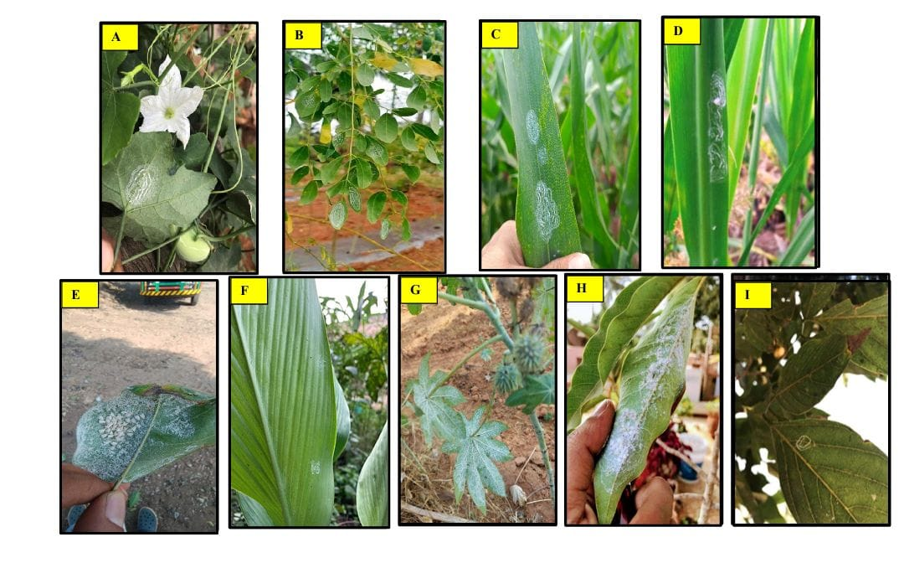
Plate: 1 Host plants of A. rugioperculatus A) Ivy gourd B) Drumstick C) Maize D) Sugar cane E) Banyan tree F) Travellers tree G) Castor H) Champak I) Karanj

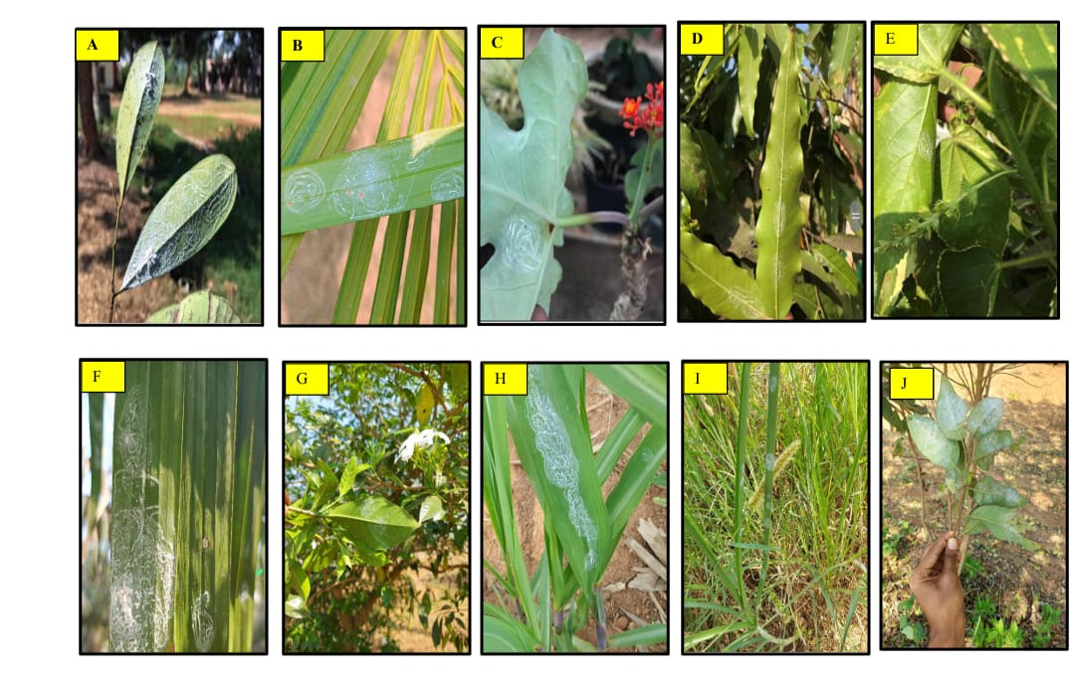
Plate: 2 Host plants of A. rugioperculatus A) Cassia B) Royal bottle palm C) Jatropha D) Ashoka E) Acalypha F) Butterfly palm G) Jasmine H) Sugarcane I) Napier grass J) Custard apple

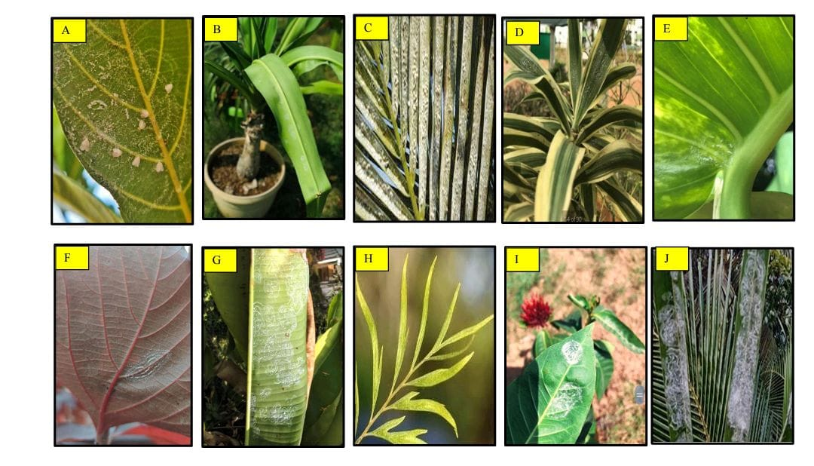
Plate: 3 Host plants of A. rugioperculatus A) Jack fruit B) Spider planet C) Travellers tree D) Song of India E) Devils ivy F) Canna G) Bird of paradise H) Silver oak tree I) Ixora J) Areca nut

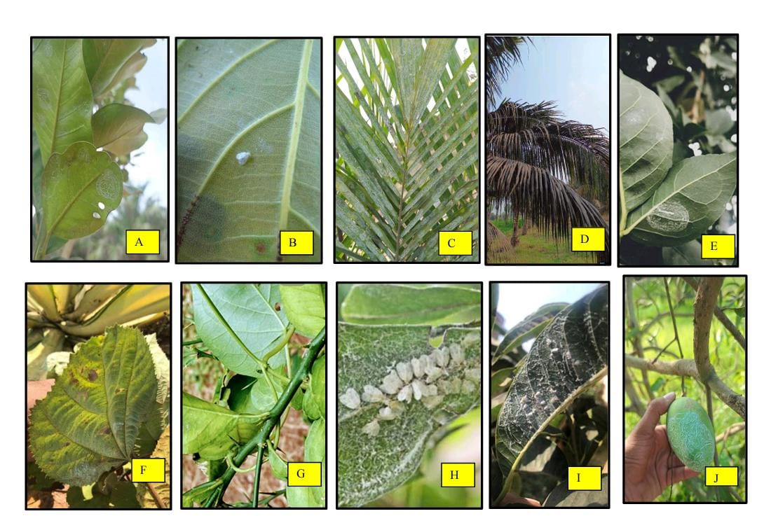
Plate: 4 Host plants of A. rugioperculatus A) Cashew nut B) Cocoa C) Oil palm D) Coconut E) Bael F) Phalsa G) Sweet orange H) Water rose apple I) Ram phal J) Mango fruit.

Conclusion

The Rugose Spiralling Whitefly (RSW), Aleurodicus rugioperculatus Martin, is an invasive pest that first appeared in India in 2016, severely affecting crops like coconut, oil palm, banana, sapota, mango, and guava. RSW depletes plant water and nutrients and promotes sooty mold growth through honeydew secretion, significantly reducing photosynthetic efficiency.
A field study conducted across Telangana, particularly in Bhadradri Kothagudem and Khammam districts, identified 50 host plants from 29 families. While 10 crops, including coconut and oil palm, supported all life stages of RSW, other plants predominantly exhibited only the egg stage. Infestation was particularly severe in coconut and oil palm, with intercropping identified as a key factor in RSW's spread.
Infestation levels were classified into low, medium, and high categories based on egg spiral counts, and a damage rating scale was established. Several ornamental plants and field crops like maize and sugarcane only supported the egg stage, suggesting partial host suitability. Additionally, 22 new host plants were identified, indicating an expanding host range.
Natural enemies, including Encarsia guadeloupae and other parasitoids, were observed, showing potential for biological control. However, RSW's adaptability to new hosts and rapid dispersal due to favourable conditions highlight the urgency of adopting Integrated Pest Management (IPM) strategies.
This study emphasizes understanding host suitability, infestation patterns, and natural enemies to mitigate RSW's impact on economically significant crops in India. Effective management will require a combination of cultural practices, biological control, and targeted use of insecticides.

REFERENCES
Alagar, M., Sivakumar, V., Chinnaduari, S., Saravanan, P.A., Srinivasan, T and Praneetha, S. 2020. Bio intensive management of invasive rugose spiralling whitefly in coconut. Biotica Research Today. 2(8): 768-771.
Bhavani, B., Kishore Varma, P and Bharatha Lakshmi, M. 2020. First report of rugose spiralling whitefly, Aleurodicus rugioperculatus Martin, an invasive pest on sugarcane in Andhra Pradesh, India. Journal of Entomology and Zoology Studies. 8(6): 1993-1999.
Capinera, JL. (2008) Encyclopedia of entomology. 2nd edn. Springer, Netherlands, p 4346.
Elango, K., and Nelson, S.J. 2020. Effect of host plants on the behaviour of rugose spiralling whitefly (Aleurodicus rugioperculatus) and their natural enemies. Research Journal of Agricultural Sciences. 11(1): 120-123.
Francis, A.W., Stocks, I.C., Smith, T.R., Boughton, A.J., Mannion, C.M and Osborne, L.S. 2016. Host plants and natural enemies of Rugose spiralling whitefly (Hemiptera: Aleyrodidae) in Florida. Florida Entomologist. 99(1): 150-153.

Krishnarao, G and ChalapathiRao, N.B.V. 2019. Surveillance and Eco-friendly management of new invasive alien pest, rugose spiralling whitefly, Aleurodicus rugioperculatus Martin: Inherent menace. Journal of Applied Zoological Research. 30 (2): 148-158.
Mannion, C. 2010. Rugose spiralling whitefly, a new whitefly in South Florida. Tropical Research and Education Center, University of Florida. 5(23):17-18.
Selvaraj, K., Sundararaj, R., Venkatesan, T., Ballal, C.R., Jalali, S.K., Gupta, A. Mrudula, H.K. (2016) Potential natural enemies of the invasive rugose spiralling whitefly, Aleurodicus rugioperculatus Martin in India. J Biol Control. 30(4):236–239.
Selvaraj, K., Sundararaj, R and Sumalatha, B.V. 2019. Invasion of the palm infesting whitefly, Aleurotrachelus atratus Hempel (Hemiptera: Aleyrodidae) in the Oriental region. Phytoparasitica. 47(7): 327-332.
Shanas, S., Job, J., Joseph, T and Krishnan, G.A. 2016. First report of the invasive rugose spiralling whitefly, Aleurodicus rugioperculatus Martin (Hemiptera: Aleyrodidae) from the old world. Entomon. 41(4): 365-368.
Srinivasan, T., Saravanan, P.A., Josephrajkumar, A., Rajamanickam, K., Sridharan, S., David, P.M.M., Natarajan, N and Shoba, N. 2016. Invasion of the rugose spiralling whitefly, Aleurodicus rugioperculatus Martin (Hemiptera: Aleyrodidae) in Pollachi tract of Tamil Nadu, India. Madras Agricultural Journal. 103(10-12): 349-353.
Sundararaj, R and Selvaraj, K. (2017) Invasion of rugose spiralling whitefly, Aleurodicus rugioperculatus Martin (Hemiptera: Aleyrodidae): a potential threat to coconut in India. Phytoparasitica. 45(1):71–74.
Whittaker, R.H. 1970. The biochemical ecology of higher plants. Chemical ecology. 3: 43-70.

