Regional Variations and Adaptive Morphology of Apis cerana Forelegs Across India

Abstract
This study investigates the foreleg morphometry of Apis cerana across 16 diverse locations in India, spanning northern, southern, and northeastern regions, to explore regional adaptations and environmental influences. The foreleg measurements were analyzed for five key segments: coxa, trochanter, femur, tibia, and tarsus. Significant regional differences were observed, with northern populations exhibiting larger dimensions, southern populations showing smaller forelegs, and northeastern populations demonstrating intermediate measurements. These variations are likely linked to the distinct climatic conditions and flora in each region, suggesting adaptive responses to environmental pressures. The tibia showed consistent dimensions across all regions, indicating its evolutionary conservation for basic leg functions, while the coxa and trochanter exhibited higher variation, reflecting fine-tuned adaptations to local ecological demands. This research provides valuable insights into the morphological diversity and functional adaptations of Apis cerana, contributing to our understanding of how environmental factors shape honeybee morphology.
Keywords: Apis cerana, foreleg morphometry, regional adaptations, environmental influences, tibia, coxa, trochanter, morphological diversity.
1. Introduction
The foreleg of a honeybee is a remarkable example of evolutionary adaptation, featuring several specialized structures essential for the insect's survival and daily activities. Located on the prothorax, each foreleg contains one of the bee's most distinctive features: the antennae cleaner, also known as the strigilis. This specialized structure consists of a curved, movable spur and a semi-circular notch lined with fine bristles, allowing the bee to meticulously clean its antennae by pulling them through this natural grooming device [1]. Beyond the antennae cleaner, the foreleg is equipped with specialized eye brushes - fine bristles that help keep the bee's compound eyes free from pollen and debris. Like all insect legs, the honeybee's foreleg follows a segmented structure consisting of the coxa, trochanter, femur, tibia, and tarsus, each segment powered by specific muscles enabling precise movements. These segments work in concert to support various critical activities, from basic locomotion to complex social behaviors like the waggle dance. Through this intricate combination of structures, the honeybee's foreleg serves multiple functions: maintaining clean sensory organs, assisting in grooming, handling food and nest materials, and supporting balance during crucial activities like foraging and communication within the colony [2].
In this study, we aim to analyze the foreleg characteristics of Apis cerana collected from 16 different locations across India. These locations viz., Andhra Pradesh, Assam, Cuddalore (Tamil Nadu), Gujarat, Hissar (Haryana), Karnataka, Manipur, Nagaland, Odisha, Palampur (Himachal Pradesh), Pantnagar (Uttarakhand), Punjab, Rajasthan, Srinagar (Jammu and Kashmir), Tamil Nadu, and West Bengal, were carefully selected to represent diverse geographic and ecological conditions. By examining specific foreleg traits, we seek to uncover variations influenced by environmental factors and regional adaptations, contributing to a deeper understanding of the morphological diversity and evolutionary adaptations of A. cerana across its distribution range.
2. Materials and methods
2.1 Sample Collection and Morphometric Analysis
A comprehensive study on Apis cerana by collecting bees from 16 diverse locations across India, including Andhra Pradesh, Assam, Cuddalore (Tamil Nadu), Gujarat, Hissar (Haryana), Karnataka, Manipur, Nagaland, Odisha, Palampur (Himachal Pradesh), Pantnagar (Uttarakhand), Punjab, Rajasthan, Srinagar (Jammu and Kashmir), Tamil Nadu, and West Bengal. These locations were strategically selected to encompass a wide range of latitudes, altitudes, and climatic conditions, ensuring a diverse representation of the species. From each location, 30 bees were collected, and foreleg was studied per individual. This approach allows us to investigate the geographic and ecological variations influencing the morphometric diversity of A. cerana, providing valuable insights intospecies differentiation and regional adaptations [3].
2.2 Foreleg Dissection and Analysis
The dissection and morphometric study of honeybee forelegs requires careful preparation and precise execution following a systematic protocol. Initially, gather all necessary materials including fresh honeybee specimens, dissection microscope, fine forceps, scissors or scalpel, glass slides, coverslips, petri dish, physiological saline solution, and glycerin. The dissection process begins by anesthetizing fresh specimens, followed by placing them in a dissecting dish containing saline solution. Under microscopic guidance, carefully hold the bee's thorax and gently detach the foreleg at the coxal joint, ensuring the complete removal of the leg without damaging its segments. The dissected leg should then be cleaned of attached tissues and mounted on a glass slide using glycerin, covered with a coverslip for detailed examination.The morphometric study involves comprehensive measurements and analysis of various structural components. Begin by measuring the total leg length and individual segment lengths including coxa, trochanter, femur, tibia, and all five tarsal segments.
2.3 Statistical analysis
The foreleg characteristics of Apis cerana collected from 16 different locations across India were subjected to statistical analyses using Principal Component Analysis (PCA) and cluster analysis. These methods were employed to identify patterns and groupings within the data, highlighting the variations and similarities among populations from diverse geographic and ecological regions. PCA was used to reduce the dimensionality of the dataset while retaining the most significant traits contributing to the variability. Cluster analysis was performed to group populations based on their morphological similarities, providing insights into potential subspecies differentiation and regional adaptations. This integrated approach ensures a comprehensive understanding of the morphometric diversity in A. cerana.
3. Result
3.1 Regional Variations in Foreleg Morphometry
The study examined five key segments - coxa, trochanter, femur, tibia, and tarsus - across sixteen different locations spanning northern, southern, and northeastern India. The data shows distinct regional patterns, with northern Indian populations (including Srinagar, Palampur, Punjab, Hissar, and Pantnagar) consistently displaying larger measurements with an average total length of 4.854 mm, while southern populations (Tamil Nadu, Karnataka, Andhra, and Cuddalore) exhibit smaller dimensions averaging 4.757 mm. The northeastern populations (Assam, Manipur, and Nagaland) demonstrate intermediate measurements with an average of 4.823 mm, reflecting their unique ecological position. Fig. 1 illustrates the hierarchical analysis of foreleg measurements from different regions of India, while Fig. 2 presents the cluster analysis, highlighting regional groupings. Table 1 provides detailed foreleg characteristics across various Indian regions, and Table 2 shows the eigenvalues of the correlation matrix used in the analysis
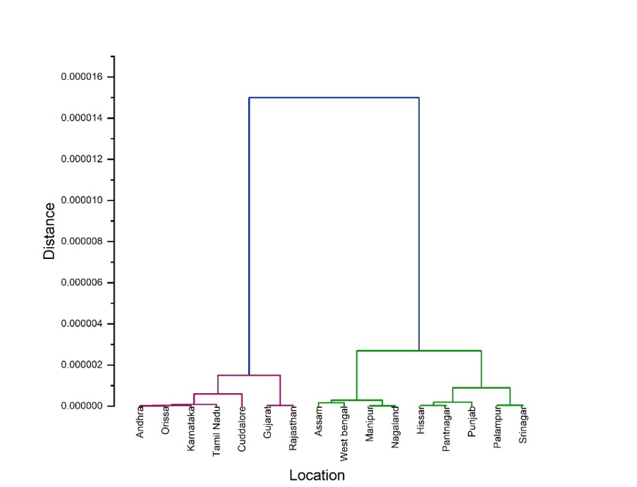
Fig 1. Hierarchal Analysis of foreleg from different regions of India

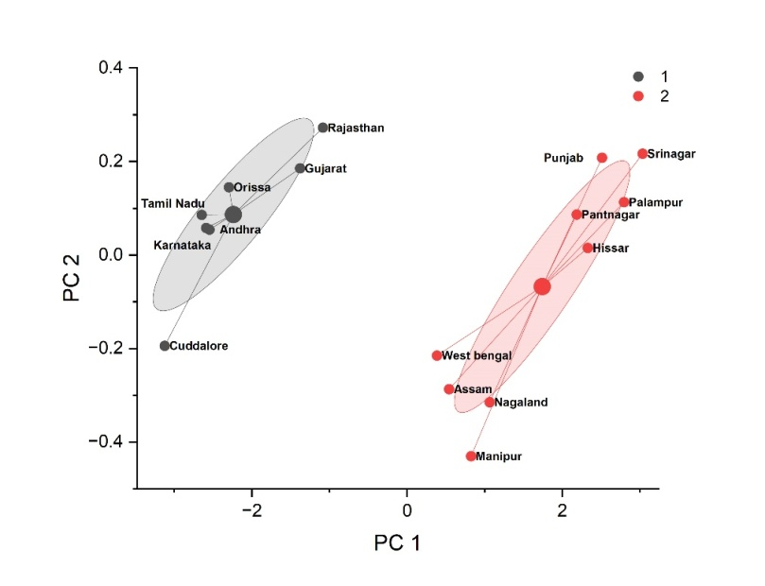
Fig 2. Cluster Analysis of foreleg from different regions of India
Table 1. Foreleg characteristic from different region from India
Location | Coxa | Trochander | Fumer | Tibia | Tarsus | Total
Andhra Pradesh | 0.399 ± 0.01 | 0.463 ± 0.017 | 1.197 ± 0.011 | 1.504 ± 0.017 | 1.197 ± 0.018 | 4.76 ± 0.017
Assam | 0.412 ± 0.02 | 0.476 ± 0.018 | 1.212 ± 0.012 | 1.5169 ± 0.01 | 1.202 ± 0.019 | 4.818 ± 0.018
Cuddalore | 0.396 ± 0.02 | 0.46 ± 0.1777 | 1.195 ± 0.014 | 1.504 ± 0.018 | 1.195 ± 0.017 | 4.75 ± 0.011
Gujarat | 0.403 ± 0.04 | 0.467 ± 0.016 | 1.203 ± 0.017 | 1.508 ± 0.019 | 1.201 ± 0.016 | 4.781 ± 0.019
Hissar | 0.416 ± 0.04 | 0.484 ± 0.016 | 1.22 ± 0.018 | 1.523 ± 0.019 | 1.207 ± 0.019 | 4.85 ± 0.012
Karnataka | 0.399 ± 0.05 | 0.462 ± 0.017 | 1.197 ± 0.017 | 1.504 ± 0.017 | 1.197 ± 0.014 | 4.759 ± 0.015
Manipur | 0.412 ± 0.08 | 0.478 ± 0.017 | 1.214 ± 0.014 | 1.518 ± 0.0188 | 1.202 ± 0.011 | 4.824 ± 0.014
Nagaland | 0.412 ± 0.07 | 0.479 ± 0.011 | 1.215 ± 0.016 | 1.519 ± 0.017 | 1.203 ± 0.012 | 4.828 ± 0.018
Orissa | 0.4 ± 0.09 | 0.463 ± 0.017 | 1.198 ± 0.019 | 1.505 ± 0.018 | 1.198 ± 0.015 | 4.764 ± 0.017
Palampur | 0.418 ± 0.07 | 0.489 ± 0.057 | 1.221 ± 0.011 | 1.523 ± 0.016 | 1.208 ± 0.016 | 4.859 ± 0.019
Pantnagar | 0.416 ± 0.010 | 0.483 ± 0.017 | 1.219 ± 0.014 | 1.522 ± 0.014 | 1.207 ± 0.015 | 4.847 ± 0.015
Punjab | 0.417 ± 0.017 | 0.485 ± 0.051 | 1.221 ± 0.0189 | 1.522 ± 0.011 | 1.208 ± 0.018 | 4.853 ± 0.013
Rajasthan | 0.404 ± 0.018 | 0.468 ± 0.0471 | 1.204 ± 0.016 | 1.509 ± 0.012 | 1.201 ± 0.019 | 4.786 ± 0.018
Srinagar | 0.418 ± 0.014 | 0.489 ± 0.071 | 1.223 ± 0.0178 | 1.524 ± 0.013 | 1.209 ± 0.017 | 4.863 ± 0.016
Tamil Nadu | 0.398 ± 0.015 | 0.462 ± 0.071 | 1.197 ± 0.0198 | 1.504 ± 0.014 | 1.197 ± 0.019 | 4.758 ± 0.013
West bengal | 0.41 ± 0.017 | 0.476 ± 0.071 | 1.211 ± 0.0165 | 1.516 ± 0.017 | 1.202 ± 0.015 | 4.815 ± 0.011
C.D | 2.25 | 1.82 | 2.35 | 2.65 | 2.74 | 4.25

Table 2. Eigenvalues of the Correlation Matrix
 | Eigenvalue | Percentage of Variance | Cumulative
1 | 4.82867 | 96.57% | 96.57%
2 | 0.10433 | 2.09% | 98.66%
3 | 0.02814 | 0.56% | 99.22%
4 | 0.02277 | 0.46% | 99.68%
5 | 0.01609 | 0.32% | 100.00%
3.2 Detailed Segmental Morphometric Analysis of Forelegs
In detailed segment analysis, the coxa measurements range from 0.396 mm to 0.418 mm, with Palampur and Srinagar showing the largest dimensions and Cuddalore the smallest. The trochander varies from 0.460 mm to 0.489 mm, following a similar pattern. The femur measurements span from 1.195 mm to 1.223 mm, with Srinagar exhibiting the largest and Cuddalore the smallest dimensions. Tibia measurements range from 1.504 mm to 1.524 mm, showing the most consistency across populations while maintaining the north-south gradient. The tarsus segment varies from 1.195 mm to 1.209 mm, with Srinagar again showing the largest measurements and Cuddalore the smallest. These variations create a total length difference of 0.113 mm between the largest and smallest specimens, representing significant morphological adaptation.
4. Discussion
4.1 Comparison with Existing Morphometric Data
The CABI Compendium describes Apis cerana workers as being approximately 10 mm long, with fore leg ranging from 7.4 to 9.0 mm. The foreleg lengths measured in your study (ranging between 4.75 mm to 4.863 mm across locations) fit well within the expected proportionality for a 10 mm-long worker bee. This suggests that our measurements are consistent with the morphological characteristics of Apis cerana [4, 5, 6].
4.2 Environmental Adaptations of Honeybee Forelegs in India
In Indian conditions, honeybee forelegs have developed specific adaptations suited to the subcontinent's diverse climate and flora. The Indian honeybee (Apis cerana), found across different regions of India, shows remarkable foreleg adaptations that align with the varied environmental conditions from the Himalayas to the coastal areas. The consistently larger measurements found in northern populations, particularly in Srinagar (total length 4.863 mm) and Palampur (4.859 mm), likely represent adaptations to higher altitudes and colder climates. These larger dimensions could provide several adaptive advantages: enhanced muscle mass for better thermoregulation, improved stability in stronger mountain winds, and better handling of the distinct highland flora. The increased size might also facilitate more efficient collection of pollen from the unique high-altitude flowers that characterize these regions [7].
4.3 Climate-Driven Adaptations in Forelegs
In contrast, the southern populations, exemplified by Cuddalore (4.750 mm) and Tamil Nadu (4.758 mm), show consistently smaller measurements across all segments. This reduction in size could be an adaptation to warmer climates, potentially offering better heat dissipation through a higher surface-area-to-volume ratio. The smaller dimensions might also reflect adaptations to the predominantly tropical flora of southern India, where smaller, more delicate floral structures might require less robust handling apparatus. The intermediate measurements observed in northeastern populations (Assam 4.818 mm, Manipur 4.824 mm, Nagaland 4.828 mm) are particularly interesting as they suggest a unique adaptive response to the region's distinctive climate and flora. These intermediate values might represent an optimal compromise between the requirements for handling diverse subtropical flora and dealing with variable climatic conditions characteristic of this region [8, 9].
4.4 Segment-Specific Functional Adaptations in Forelegs
Segment-specific variations provide additional insights into functional adaptations. The tibia, showing relatively consistent proportions across populations (range 1.504-1.524 mm), suggests strong evolutionary conservation of this segment's functional role, possibly due to its critical importance in basic leg mechanics and pollen handling [10]. Conversely, the higher relative variation in coxa and trochanter measurements might indicate their role in fine-tuning leg function to local environmental demands [11]. These findings align with Bergmann's rule, which suggests larger body sizes in colder climates, though applied here at a more localized scale [12, 13]. The consistent gradients in measurements also support the concept of clinal variation in response to environmental gradients, a well-documented phenomenon in insect populations.
5. Conclusion
This study highlights significant regional and segmental variations in the foreleg morphology of Apis cerana across diverse locations in India, revealing important ecological and evolutionary adaptations. The larger foreleg dimensions observed in northern populations suggest adaptations to colder, high-altitude climates, while the smaller foreleg measurements in southern populations may reflect adaptations to warmer, tropical environments. Intermediate measurements in northeastern populations likely represent a balance between climatic and floral factors. The consistency in tibia measurements across regions suggests evolutionary conservation for basic leg functions, while the variation in coxa and trochanter dimensions underscores the role of fine-tuning leg functionality to local conditions. These findings provide valuable insights into the adaptive evolution of Apis cerana, demonstrating how morphological traits are shaped by regional environmental pressures.
Data availability statement: The data that support the findings of this study are available from the corresponding author upon reasonable request

Reference
- Gana B. Comparative Studies on the Ecology, Morphometric, and Honey Composition of Apis Mellifera L.(Hymenoptera: Apidae) in Kwara State, North-Central Nigeria. Master's thesis, Kwara State University (Nigeria). 2018.
- Rajak B, Basavarajappa S. Morphometric analysis of giant honeybee, apis dorsata worker bees of different areas of Mysore district, Karnataka, India. Journal of Pharmacy and Biological Sciences (2016);11(6): 07-12.
- Andere C, Garcia C., Marinelli C, Cepeda R, Rodriguez EM, Palacio A. Morphometric variables of honeybees Apis mellifera used in ecotypes characterization in Argentina. ecological modelling 2008; 214(1): 53-58.
- Shanas S, Krishnan GA, Mashhoor K. Identity of cavity nesting honey bees of the Indian subcontinent with a description of a new species (Hymenoptera, Apidae, Apinae, Apini, Apis). Entomon. 2022; 47(3).
- Deka TN, Sudharshan MR, Saju KA. New record of bumble bee, Bombus breviceps Smith as a pollinator of large cardamom. Current Science 2011: 926-928.
- Schönitzer K. Comparative morphology of the antenna cleaner in bees (Apoidea). Journal of Zoological Systematics and Evolutionary Research 1986; 24(1): 35-51.
- Du, Y, Xu K, Ma W, Su W, Tai M, Zhao H, Jiang Y, Li X. Contact chemosensory genes identified in leg transcriptome of Apis cerana cerana (Hymenoptera: Apidae). Journal of Economic Entomology. (2019);112(5): 2015-2029.
- Ebru H, Kozak T, Gül M, Kars H, Şen F. Bee anatomy: a comprehensive overview of bee morphology and physiology. Journal of Scientific Reports-B. 2023: 1-19.
- Mahwish R, Ahmad S, Shah M, Khan I. Identification of varroa mite species of honeybee, Apis mellifera in Khyber Pukhtunkhawa Peshawar, Pakistan. Sarhad Journal of Agriculture 2018; 34(2): 414-417.
- Rehman M, Ahmad S, Shah M, Khan I. Identification of Varroa mite species of honeybee, Apis mellifera in Khyber Pukhtunkhawa Peshawar, Pakistan. 2018; 414-417.
- Hongyi N, Geng H, Lin Y, Xu S, Li Z, Zhao Y, and Su S. "Genome‐Wide Identification and Characterization of Fox Genes in the Honeybee, Apis cerana, and Comparative Analysis with Other Bee Fox Genes. International Journal of Genomics 2018; 5702061.
- Peter R, Aumeier P, Ziegelmann B. Biology and control of Varroa destructor. Journal of invertebrate pathology 2010;103:S96-S119.
- Ajao AM, Oladimeji YU, Babatunde SK, Obembe A. Differential morphometric patterns of apis mellifera and adaptation to climatic variations in Kwara State, Nigeria. Global Journal Bio-science and Biotechnology (2014); 3(1); 34-40.

