Original Research Article

Estimation of Wheat Crop Evapotranspiration from Meteorological Dataset for Anand using CROPWAT model

.
ABSTRACT

The goal of evapotranspiration estimation research is to measure water loss through transpiration and evaporation in order to enable effective management of water resources, enhance irrigation techniques, evaluate the effects of climate change, and support sustainable ecological and agricultural planning. The study was conducted at Regional Research Station (RRS) is located in Anand and part of Anand Agricultural University (AAU) positioned in Middle Gujarat, India. The Penman-Monteith (FAO-PM) method of the Food and Agriculture Organization was used to estimate long-term trends in wheat evapotranspiration in Anand. Monthly and seasonal evapotranspiration for the years 2011 to 2020 was calculated using CROPWAT software. When estimating reference evapotranspiration (ET_{o}) using meteorological parameters, the FAO-PM approach was used as it is known for its reliability. Temperature, humidity, wind speed, solar radiation, and other ground-based data were gathered from the meteorological observatory and analyzed to calculate ET_{o} and, in turn, crop evapotranspiration (ET_{c}) for wheat while taking crop-specific coefficients (K_{c}) into account. The monthly evapotranspiration for wheat, as calculated using the FAO-PM method from 2011 to 2020, ranged from 34 to 40 mm in December and 253.7 to 285.2 mm in February. The seasonal ET for the same period varied between 501.2 mm and 561.3 mm. Study concludes that crop has higher water demands during their peak growth stage. Wheat evapotranspiration showed upward trend from 2011 to 2020. The findings provide insight into the relationship between wheat water demand and climatic parameters, temporal fluctuations in ET_{c}, and effective irrigation planning techniques in the face of shifting weather patterns.

Keywords: Crop evapotranspiration, CROPWAT, Evapotranspiration, FAO-PM, Wheat

1. INTRODUCTION
Water shortage in irrigated agriculture is expected to get worse quickly by 2050 as a result of population expansion and increased food demand. An essential component of overall agricultural output is water. Approximately 90% of the water footprint that humans use is still caused by the production of food (D'Odorico et al., 2018). In arid and semi-arid regions, where limited resources must be used to meet ecological, agricultural, and industrial demands, water shortage is a major problem (Mizyed et al., 2024; Okello et al., 2024). Water supplies in these areas are regularly under a lot of stress, mostly due to irrigated cultivation (Singh et al., 2024; Kirda and Kanber, 1999). Effective water resource management is urgently needed for sustainable crop production, and crop evapotranspiration (ET) estimation is critical for irrigation planning and increasing agricultural water productivity (Sharma et al., 2024; Xing and Wang, 2024).
Estimating evapotranspiration (ET) is essential for understanding environmental systems, managing water supplies, and improving agricultural operations. It is an essential part of the water cycle since it symbolizes the total amount of water lost through plant transpiration and soil evaporation. By identifying water stress in ecosystems, accurate ET calculation aids in drought monitoring and irrigation planning, ensuring crops receive enough water without wasting any. Climate modeling, evaluating the condition of natural ecosystems like forests and wetlands, and managing groundwater and reservoirs sustainably all depend on it. ET estimate facilitates efficient decision-making in environmental sustainability, urban planning, and agriculture by guiding water budgeting and conservation plans (Alexandratos and Bruinsma, 2012; Elliott et al., 2014; Molden, 2013; Ray et al., 2013). It is typically time-consuming and costly to assess the real evapotranspiration of crops directly.
Accurately measuring evapotranspiration (ET) is challenging due to the complexity of the process and the influence of various environmental factors. Usually, reference evapotranspiration (ET₀) is multiplied by a crop-specific coefficient (K_{c}) to determine crop evapotranspiration (ET). Based on meteorological data, a variety of empirical and semi-empirical models have been created to estimate crop or reference evapotranspiration. A few of these are models that are based on radiation (e.g., Thornthwaite, 1948; Doorenbos and Pruitt, 1977), models that are based on temperature (e.g., Hargreaves and Samani, 1985), and models that are based on combinations (e.g., FAO-56 PM; Allen et al., 1998). However, depending on the climate, these models' accuracy varies (Akhavan et al., 2019). India's agricultural development is closely linked to wheat, one of the most significant cereal crops in the nation. Today, India is the second-largest wheat producer in the world. Wheat farming in India faces several challenges that affect productivity, sustainability, and farmer livelihoods. These challenges are rooted in environmental, socio-economic and technological factors. Addressing these challenges requires a multi-faceted approach, including promoting sustainable farming practices and improved water management. For wheat cultivation to be both productive and sustainable, evapotranspiration estimation is essential. It supports effective resource management and financial stability for farmers while enhancing crop yields, conserving water, and enhancing climate change resilience. By incorporating ET estimate into farming methods, India can improve agricultural sustainability and food security (Goyal, 2004).
2. material and methods

2.1 Description of Study Area
The Regional Research Station (RRS) located in the Anand district of Anand Agricultural University (AAU) in Middle Gujarat, India, was the site of the study as depicted in Figure 1. This area mostly belongs to agroclimatic zone III, which is semi-arid. While the winter months (October to February) bring warm and comfortable temperatures between 10°C and 25°C, the summer months (March to June) in middle Gujarat are hot and dry, frequently reaching temperatures above 40°C. The region receives between 800 and 1200 mm of rain on average each year, most of which falls during the monsoon season. Because it supports crops including maize, wheat, rice, cotton, groundnuts, and a variety of fruits and vegetables, this rainfall is essential for agriculture. The research area's soils have a medium texture. The terrain is mostly flat, with occasional undulating plains, making it ideal for agriculture. The physical and chemical characteristics of soil differ significantly depending on the type of land. The pH of the soils ranges from 7.9 to 8.2, making them rather alkaline in character. Agriculture in Anand heavily depends on irrigation from canals, tube wells and ponds, supported by the Mahi River and its tributaries. In winter (November–February), summer (March–May), monsoon (June–September), and fall (October) are the four distinct seasons that the region experiences. With two to three crop cycles every year, farmers in this area engage in multi-cropping, growing crops such cotton, rice, millet, maize, and legumes (Balas et al., 2023a Balas et al., 2023b).
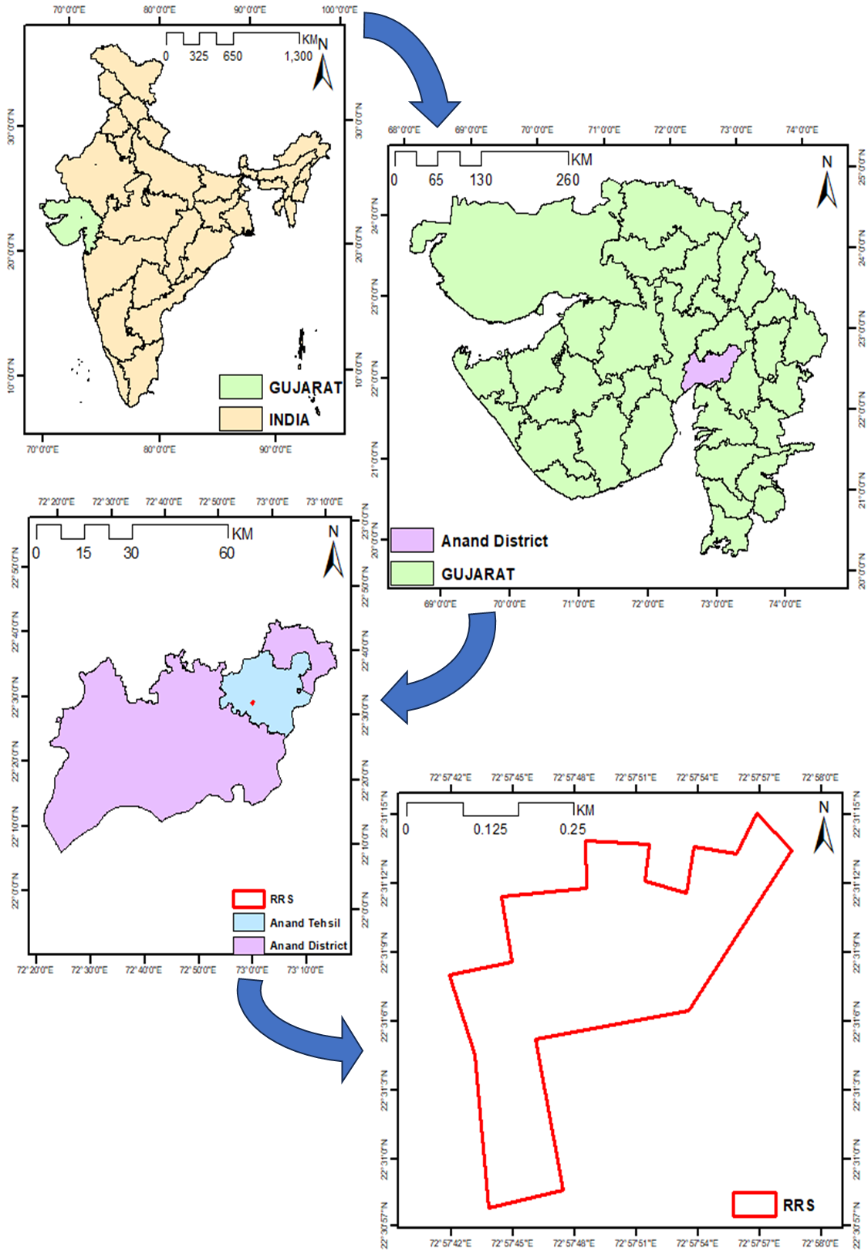

Figure 1. Study Area Map

2.2 Description of Data, Observations and other Information
To determine and predict the evapotranspiration for the wheat crop, meteorological data for the ten-year period from 2011 to 2020 was gathered and examined. Weather data was gathered at the nearby research station's observatory, including climatic parameters like, minimum and maximum temperatures, evaporation, rainfall, daylight hours and more. Geographic data related to latitude and longitude (location of fields), crop type, irrigation intervals, number of irrigations, crop period, base period, sawing data, harvesting date and other field data were collected from the surveying fields, experts, published reports etc. The study focuses on major crop prevalent in the region, specifically examining the crop water demand at the Regional Research Station (RRS) in Anand. The ground data of Wheat crop from sowing (December) to harvesting (March) were collected from the RRS research station for the period of 2011 to 2020 to estimate the evapotranspiration (Table 1).
Table 1: Detailed Description of the Research Station
District | Farm/Field | Longitude (E) | Latitude (N) | Major Crop
Anand | Regional Research Station (RRS), Anand | 72°57'50.59"E | 22°31'8.15"N | Wheat

2.3 Crop Evapotranspiration
Crop evapotranspiration theory represents the total amount of water lost from a cropped area by combining the processes of crop transpiration and soil water evaporation. ET is influenced by crop-specific characteristics including development stage and canopy structure in addition to meteorological variables like temperature, solar radiation, wind speed, and humidity. Crop coefficients are then used to adjust reference evapotranspiration (ET₀), which is estimated using a standardized process by the FAO Penman-Monteith method. For agricultural production optimization, water resource management, and irrigation scheduling, accurate ET estimation is essential (Allen et al., 1998). ET monitoring is improved by contemporary technologies such as climate models and remote sensing, which promote sustainable agriculture (Jensen et al., 1990; Allen et al., 1998).

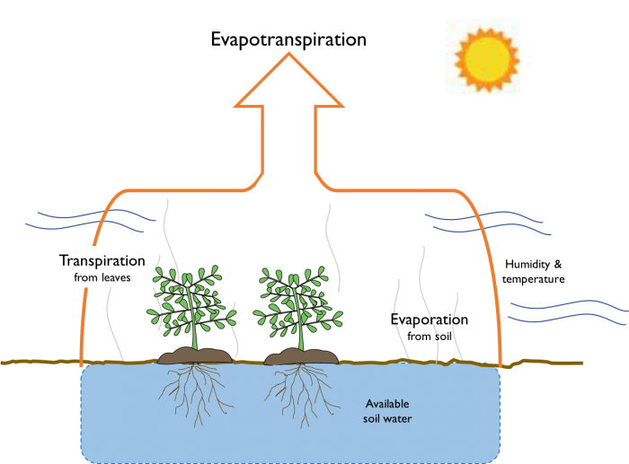

Figure 2. Crop Evapotranspiration Process

2.4 Software Used
This study made use of CROPWAT, a decision-support tool created by the Food and Agriculture Organization (FAO) for irrigation management and planning. It helps academics, politicians, and agricultural experts arrange irrigation schedules based on soil and climate data and determine how much water various crops require. CROPWAT analyzes climate variables like temperature, relative humidity, and wind speed to calculate reference evapotranspiration (ET_{o}). Next, it calculates how much water the crop will need at each stage of growth. In order to provide accurate water management across various growth stages, crop evapotranspiration (ET_{c}) was calculated by multiplying the reference (ET_{o}) by the crop coefficient (K_{c}), which varies depending on each crop's developmental phase. This method maximizes water use and agricultural efficiency by enabling users to customize irrigation schedules according to the unique water requirements of crops at different stages. CROPWAT is used for crop evapotranspiration estimation because it provides a reliable and standardized tool to calculate water requirements for crops. This ensures accurate irrigation planning, water resource management, and optimization of agricultural practices. Crop evapotranspiration (ET_{c}) was calculated in this study using the CROPWAT 8.0 version.

2.5 FAO penman Monteith Based Evapotranspiration Estimation Methodology
The study location daily weather data for a ten-year period was obtained from a local agro-meteorological observatory and was used to calculate ETo on a monthly and seasonal basis using the widely recognized FAO Penman-Monteith model. The standard methodological stages were as follows.
A consultation of experts and researchers was organized by FAO in May 1990 in cooperation with the International Commission for Irrigation and Drainage and the World Meteorological Organization to review FAO methodologies on crop water requirements and to provide advice on revision and updates of procedures. This was done in light of the limitations of various conventional climate base methods and the need to develop a single standard method for the computation of ETo. Because the Penman-Monteith combination approach explicitly combines both physiological aerodynamic characteristics and accurately approximates the grass ETo at the examined area, its adoption was advised. The approach overcomes the drawbacks of the earlier FAO Penman method (Doorenbos and Pruitt, 1977) and yields results that are more in line with global agricultural water usage statistics. Everyday grass-reference The Penman–Monteith (PM-ETo) equation's standardized ASCE version was used to calculate ET (Allen et al., 1998).
$${ET}_{0}=\frac{0.408Δ(R_{n}-G)+γ\frac{900}{T+273}u_{2}(e_{s}-e_{a})}{Δ+γ(1+0.34u_{2})}$$ | (1)
Where,
ET_{o} = reference evapotranspiration (mm/day)
R_{n} = net radiation (MJ/m²/day)
G = soil heat flux density (MJ/m²/day)
T = mean daily air temperature at 1.5-2.5 m height (°C)
u₂ = wind speed at 2 m height (m/s)
e_{s} = saturation vapour pressure at 1.5-2.5 m height (kPa)
e_{a} = actual vapour pressure at 1.5-2.5 m height (kPa)
Δ = slope of saturated vapour pressure temperature curve (kPa/°C)
γ = psychrometric constant (kPa/°C)
e_{s}-e_{a} = saturated vapour pressure deficit (kPa)
Using above generated ground based agro-meteorological data and conceptual framework (i.e. FAO PM); the popular software CROPWAT was used to generate the ET values based on ground observed data on various prime entities as involved in FAO PM model.

2.5.1 CROPWAT
The FAO's Land and Water Development Division created one of the most widely used decision support tools. It appropriately enables the creation of suggestions for better irrigation techniques, the scheduling of irrigations under various water supply circumstances, and the evaluation of output under rain-fed or deficiency irrigation circumstances. It is consistently regarded as a successful program that calculates reference evapotranspiration (ET_{o}) using the Penman-Monteith methodology. Crop water requirements and irrigation schedule decisions were then made using these calculations. Evapotranspiration is estimated by CROPWAT using monthly data, which is then smoothed into daily values for rainfall, air relative humidity (%), daylight duration (h), wind speed at 2 m high (m/s), minimum and maximum temperatures (°C), and crop coefficients. The crop water need has been the ultimate result of these input sets. The following are the fundamental procedures used to calculate this entity. The crop water requirement (CWR), which is measured in ET per day, or mm/day, is the amount of water equivalent to what is lost from a cultivated area by the ET. Crop evapotranspiration (ET_{c}), which was determined using the following formula, is the basis for estimating CWR. Considering the crop water requirement (CWR) as the amount of water equal to what is lost from a cropped field by the ET; it is expressed in terms of ET per day i.e. mm/day. Estimation of CWR is derived from crop evapotranspiration (ET_{c}) which was calculated by the following equation.
ET_{c} = K_{c} × ET₀ | (2)
where K_{c} is the crop coefficient.

Due to the ET differences during the growth stages, the K_{c} for the crop remain varied (Figure 3) over the crop developing period which is divided into four distinct stages; namely, initial, crop development, mid-season and late season.
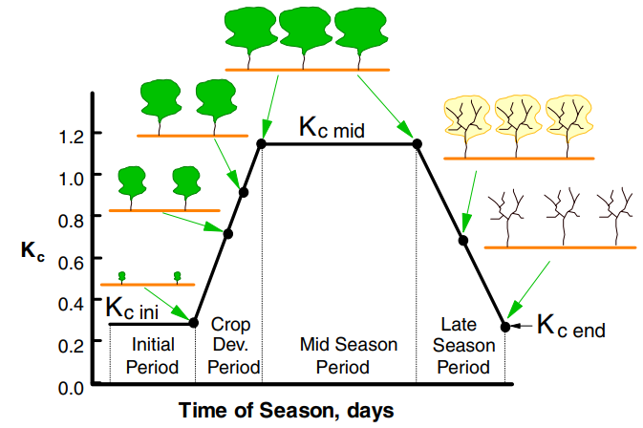
Figure 3. Standard Curve on K_{c} Variability for Crops Owing to Weather and Crop-based Factors (Source: Allen et al., 1998)
Determination of Crop Coefficient (K_{c}): FAO standard crop coefficients (K_{c}) for wheat were used in this study. These values provide a baseline for estimating wheat water requirements in irrigation scheduling and hydrological modelling.

3. results and discussion
The results obtained from the study are presented here in Table 2. The study analyzes monthly and seasonal evapotranspiration for wheat from December to March over the years 2011-2020 using the FAO-PM method.

3.1 Monthly Evapotranspiration (ET)
The monthly evapotranspiration values for the months of December, January, February and March from 2011 to 2020 are presented in Figure 4 and Table 2.
Table 2. Monthly and Seasonal Evapotranspiration (mm) Value for Wheat
Month | Year | Monthly | Seasonal
December | 2011 | 38 | 561.3
January | 2011 | 106.2 | 561.3
February | 2011 | 285.2 | 561.3
March | 2011 | 131.9 | 561.3
December | 2012 | 34.8 | 501.2
January | 2012 | 95.5 | 501.2
February | 2012 | 253.7 | 501.2
March | 2012 | 117.2 | 501.2
December | 2013 | 35 | 502
January | 2013 | 96 | 502
February | 2013 | 254 | 502
March | 2013 | 117 | 502
December | 2014 | 38 | 513
January | 2014 | 98 | 513
February | 2014 | 260 | 513
March | 2014 | 117 | 513
December | 2015 | 34 | 519
January | 2015 | 100 | 519
February | 2015 | 265 | 519
March | 2015 | 120 | 519
December | 2016 | 39 | 522
January | 2016 | 102 | 522
February | 2016 | 260 | 522
March | 2016 | 121 | 522
December | 2017 | 40 | 528
January | 2017 | 105 | 528
February | 2017 | 263 | 528
March | 2017 | 120 | 528
December | 2018 | 39 | 536
January | 2018 | 108 | 536
February | 2018 | 266 | 536
March | 2018 | 123 | 536
December | 2019 | 38 | 543
January | 2019 | 110 | 543
February | 2019 | 270 | 543
March | 2019 | 125 | 543
December | 2020 | 38 | 547
January | 2020 | 109 | 547
February | 2020 | 272 | 547
March | 2020 | 128 | 547

• December: ET values range between 34.8 mm (2012 and 2015) and 40 mm (2017), showing relatively stable but slightly fluctuating values over the years.
• January: ET values for January vary from 95.5 mm in 2012 to 110 mm in 2019, with a gradual increase over the years.
• February: February consistently records the highest ET values each year, ranging from 253.7 mm in 2012 to 272 mm in 2020. This peak indicates that February is the most active month for evapotranspiration, likely due to optimal temperatures and increased soil moisture or vegetation activity during this time.
• March: ET values for March increase gradually from 117.2 mm in 2012 and 2013 to 128 mm in 2020, indicating a continued rise in evapotranspiration as the season transitions from winter to early spring. This trend suggests warming conditions and sustained vegetation activity through this period.

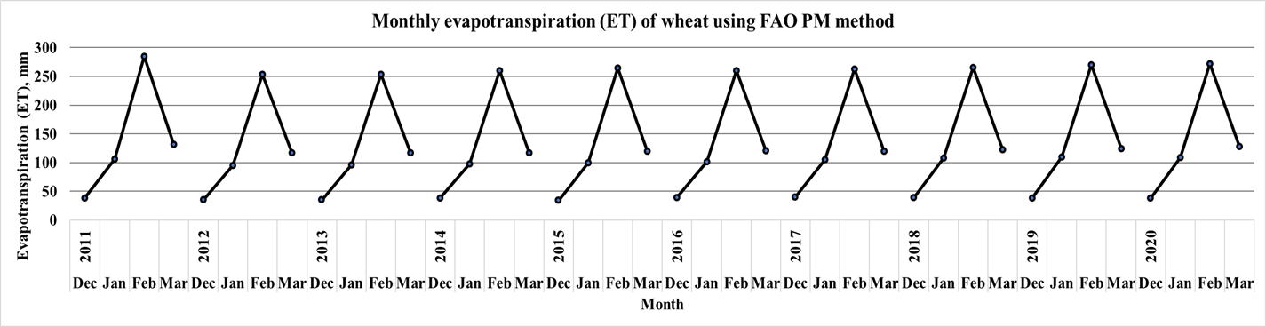
Figure 4: Monthly ET using FAO PM for Wheat

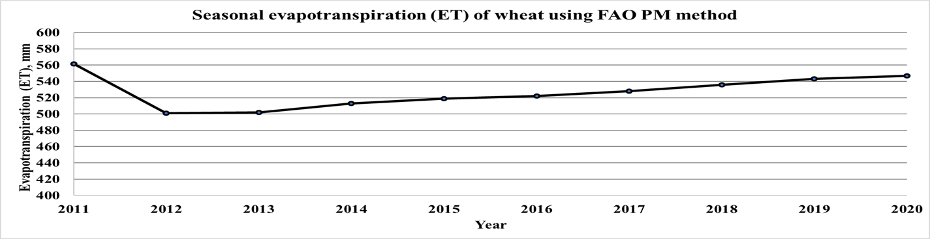
Figure 5: Seasonal ET using FAO PM for Wheat

3.2 Seasonal Evapotranspiration (ET)
The seasonal evapotranspiration values from 2011 to 2020, with et decreasing from 561.3 mm in 2011 to 501.2 mm in 2012, and then gradually increasing each year, reaching 547 mm in 2020. This trend indicates a period of reduced water loss in 2012 and 2013, followed by a consistent rise, suggesting progressive climatic warming, increased precipitation, or higher vegetation activity contributing to enhanced evapotranspiration rates over time. The gradual increase highlights the impact of these environmental factors, emphasizing the importance of monitoring et patterns for effective water resource management and understanding ecosystem responses to climate changes. Similar trends in evapotranspiration and a rise in CWR were noted by Manasa and Shivapur (2016). Graphical presentation shown in figure 5.

4. Conclusion
The current study was conducted to estimate monthly and seasonal evapotranspiration using FAO-PM for wheat crop at Regional Research Station (RRS) located in the Anand district of Anand Agricultural University (AAU) in Middle Gujarat, India. Monthly and seasonal evapotranspiration (ET) values for wheat during the growing season (December to March) across the years 2011 to 2020 were estimated. 12. The monthly evapotranspiration for wheat, as calculated using the FAO-PM method from 2011 to 2020, ranged from 34 to 40 mm in December and 253.7 to 285.2 mm in February. The seasonal ET for the same period varied between 501.2 mm and 561.3 mm. Present study concludes that selected crop has higher water demands during their peak growth stage. The findings provide insight on how ET_{c} varies over time, how weather influences wheat water demand, and how to effectively plan irrigation in the face of shifting weather patterns.

References
Akhavan, S., Kanani, E., & Dehghanisanij, H. (2019). Assessment of different reference evapotranspiration models to estimate the actual evapotranspiration of corn (Zea mays L.) in a semiarid region (case study, Karaj, Iran). Theoretical and Applied Climatology, 137, 1403-1419.
Alexandratos, N., & Bruinsma, J. (2012). World agriculture towards 2030/2050: the 2012 revision.
Allen, R. G. (1998). Crop evapotranspiration. FAO irrigation and drainage paper, 56, 60-64.
Balas, D. B., Tiwari, M. K., & Patel, G. R. (2023a). Estimation of surface and subsurface soil moisture using microwave remote sensing: A typical analysis. International Journal of Environment and Climate Change, 13(10), 1804-1816.
Balas, D. B., Tiwari, M. K., Trivedi, M., & Patel, G. R. (2023b). Impact of land surface temperature (LST) and ground air temperature (Tair) on land use and land cover (LULC): An investigative study. International Journal of Environment and Climate Change, 13(10), 3117-3130.
D'Odorico, P., Davis, K. F., Rosa, L., Carr, J. A., Chiarelli, D., Dell'Angelo, J., Gephart, J., MacDonald, G. K., Seekell, D. A., Suweis, S. and Rulli, M. C. (2018). The global food‐energy‐water nexus. Reviews of Geophysics, 56(3), 456-531.
Doorenbos, J., & Pruitt, W. O. (1977). Guidelines for predicting crop water requirements.
Elliott, J., Deryng, D., Müller, C., Frieler, K., Konzmann, M., Gerten, D., ... & Wisser, D. (2014). Constraints and potentials of future irrigation water availability on agricultural production under climate change. Proceedings of the National Academy of Sciences, 111(9), 3239-3244.
Goyal, R. K. (2004). Sensitivity of evapotranspiration to global warming: a case study of arid zone of Rajasthan (India). Agricultural water management, 69(1), 1-11.
Hargreaves, G. H., & Samani, Z. A. (1985). Reference crop evapotranspiration from temperature. Applied engineering in agriculture, 1(2), 96-99.
Jensen, M. E., Burman, R. D., & Allen, R. G. (1990). Evapotranspiration and Irrigation Water Requirements. ASCE Manual No. 70.
Kirda, C., & Kanber, R. (1999). Water, no longer a plentiful resource, should be used sparingly in irrigated agriculture.
Manasa, H. G., & Shivapur, A. V. (2016). Implications of climate change on crop water requirements in Hukkeri Taluk of Belagavi District, Karnataka, India. International Journal of Research in Engineering and Technology, 5 (6), 236-241.
Mizyed, A., Moghier, Y., & Hamada, M. (2024). Employing the agricultural water footprint concept to enhance the sustainable management of water resources: a review. Water Practice & Technology, 19(11), 4435-4452.
Molden, D. (2013). Water for food water for life: A comprehensive assessment of water management in agriculture. Routledge.
Okello, C., Githiora, Y. W., Sithole, S., & Owuor, M. A. (2024). Nature-based solutions for water resource management in Africa's arid and sem-arid lands (ASALs): A systematic review of existing interventions. Nature-Based Solutions, 100172.
Ray, D. K., Mueller, N. D., West, P. C., & Foley, J. A. (2013). Yield trends are insufficient to double global crop production by 2050. PloS one, 8(6), e66428.
Sharma, A., Surkar, P. P., Khare, R., Choudhary, M. K., & Prasad, V. (2024). Quantifying the irrigation requirements for major crops under the influence of Climate Change in a Semi-arid Region. Water Resources Management, 1-16.
Singh, P., Sehgal, V. K., Dhakar, R., Neale, C. M., Goncalves, I. Z., Rani, A., Jha, P. K., Das, D. K., Mukherjee, J., Khanna, M. & Dubey, S. K. (2024). Estimation of ET and crop water productivity in a semi-arid region using a large aperture scintillometer and remote sensing-based SETMI model. Water, 16(3), 422.
Thornthwaite, C. W. (1948). An approach toward a rational classification of climate. Geographical review, 38(1), 55-94.
Xing, Y., & Wang, X. (2024). Precision Agriculture and Water Conservation Strategies for Sustainable Crop Production in Arid Regions. Plants, 13(22), 3184.

