Original Research Article

Performance Analysis of Desiccant Dehumidifier with an Expanded Regeneration Section

Abstract
Storage of certain perishable agricultural products required lower relative humidity less than 75% as high relative humidity leads to sprouting or rotting. As a solution to this problem, a rotary desiccant dehumidifier system has been proposed for air dehumidification. Through an experimental study conducted, performance evaluation of rotary desiccant dehumidification system has been performed based on the parameters including regeneration air temperature and humidity ratios of inlet process air. It was found that the highest dehumidification effectiveness was achieved at a regeneration temperature of 80 ℃ at an air flow rate of 360 m³/h.
Keywords: Dehumidification, desiccant, relative humidity, regeneration air temperature
Introduction
The quality of agricultural products is significantly influenced by various factors after harvest. Key post-harvest factors include temperature, humidity, atmospheric gas composition, light exposure, mechanical damage, and diseases or infections, all of which can be optimized. Managing temperature and humidity is particularly critical for prolonging the storage and shelf life of agricultural products. Ambient temperature and relative humidity play a vital role in post-harvest handling to control both physiological and pathological deterioration. By regulating metabolic processes such as respiration and transpiration, quality loss can be minimized (Kader, 2013).
Moisture can be extracted from the air using desiccant and mechanical techniques. In mechanical cooling systems, dehumidification occurs as the air is cooled to its dew point, causing the moisture to condense to the desired level of dehumidification. Numerous research efforts have explored the utilization of liquid and solid desiccants within air conditioning systems. These studies demonstrate that solid desiccants possess greater water vapor adsorption capabilities and higher drying capacities compared to liquid desiccants. Consequently, solid desiccants are widely favored for diverse drying and cooling purposes (Ali et al., 2022). Due to their effective dehumidification properties, solid desiccants are commonly utilized in stationary or rotary wheel beds containing desiccant material (Abd-Elhady et al., 2022).
Optimizing post-harvest storage conditions is vital for prolonging the shelf life and reducing post-harvest losses of agricultural commodities, with key factors including ambient air temperature and humidity (Nalbandi et al., 2016). Hence, controlling temperature and humidity is essential for extending the shelf life of harvested products. To maintain the quality of agricultural goods, the relative humidity plays a significant role in the transpiration process. Water loss can be minimized by maintaining high ambient relative humidity, low atmospheric temperatures, and increased pressure. For most fruits, the optimal relative humidity ranges from 85% to 95%, while for vegetables, it is between 90% and 98% (El-Ramady et al., 2015). Excessive transpiration resulting in moisture loss from these products can impact various aspects including their physical appearance such as wilting and shriveling, flavor, texture including softening, net weight, and ultimately, their nutritional value (Mishra and Gamage, 2007; Lal Basediya et al., 2013). The net rate of transpiration differs across various products and can be affected by factors such as air temperature, relative humidity, and airflow rate (Rao, 2015). The main driving force for transpiration is the difference in water vapor pressure between the product and its surrounding environment (Sultan et al., 2016).
Similar work done by various researcher includes Ishaq et al. (2022) investigated energy-efficient standalone desiccant air conditioning (DAC) systems and Maisotsenko cycle-based desiccant air conditioning (M-DAC) systems for their potential application in storing fruits and vegetables. The study focused on the thermodynamic performance of these systems, evaluating their ability to maintain optimal temperature and humidity levels, cooling capacity, and coefficient of performance (COP). The findings highlighted that the M-DAC system demonstrated superior performance compared to the standalone DAC system. Hussain et al. (2022) investigated a Maisotsenko cycle evaporative cooling-assisted solid desiccant air-conditioning (M-DAC) system designed for agricultural storage applications. The research involved developing a lab-scale solid silica gel-based desiccant air-conditioning (DAC) system. The S-DAC system demonstrated temperature and relative humidity ranges of 39–48 °C and 35–66%, respectively, with a Qp of 17.55 kJ/kg and a COP of 0.37. In comparison, the M-DAC system achieved temperature and relative humidity ranges of 17–25 °C and 76–98%, respectively, with a Qp of 41.80 kJ/kg and a COP of 0.87. The study concluded that the M-DAC system holds significant potential as an air-conditioning solution for agricultural storage. This dehumidification system with indirect evaporative cooling is suitable for storage conditions where the temperature is above 15 °C and high humidity levels are required. However, it is not effective for storage temperatures below 10 °C, especially when a significant reduction in both temperature and humidity is necessary. Many fruits and vegetables need optimal conditions to extend their shelf or storage life. This study emphasizes the enhanced surface area of a desiccant wheel and evaluates the system's performance.
Description of the desiccant dehumidifier unit
The desiccant dehumidifier unit consists of rotary desiccant wheel, having sinusoidal airflow passage, coated with silica gel as adsorbent for dehumidification process. Silica gel, having a high-water adsorption capacity, dehumidifies the process air to achieve the desired humidity level. Consequently, the wheel gets saturated with moisture during the dehumidification process and needs to be regenerated with high temperature and dry air. The temperature of the ambient air is increased by the heater bank and hot air is transferred to the desiccant wheel for regeneration. In this way, continuous operation of the dehumidification processes is ensured.
The desiccant dehumidifier unit consists of a desiccant wheel (25 cm thickness), two centrifugal fans and a heater bank (Fig.1). The air flow in both the regeneration and process air section is supplied by two centrifugal fans. Thus, the unit has 4 channels comprising inlet and outlet channels for processing and regeneration air. The technical specifications of the components of the desiccant unit are mentioned in Table 1 below. The heater can raise the temperature of regeneration air up to 100 ℃. The temperature and relative humidity at both inlet and the outlet of the desiccant dehumidifier was measured by Temperature/Humidity transmitter with accuracy ±3 %, ±0.15 ℃. The air mass flow rate in inlet and outlet of both regeneration section and process section are shown in Table 1.
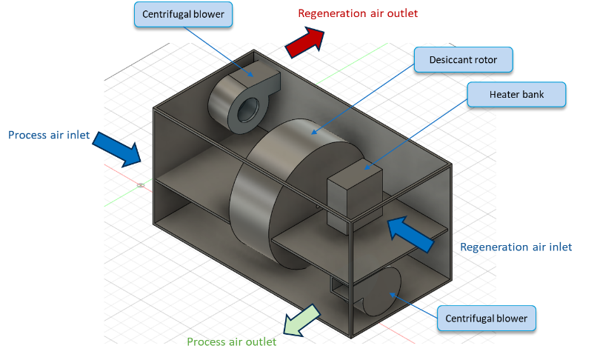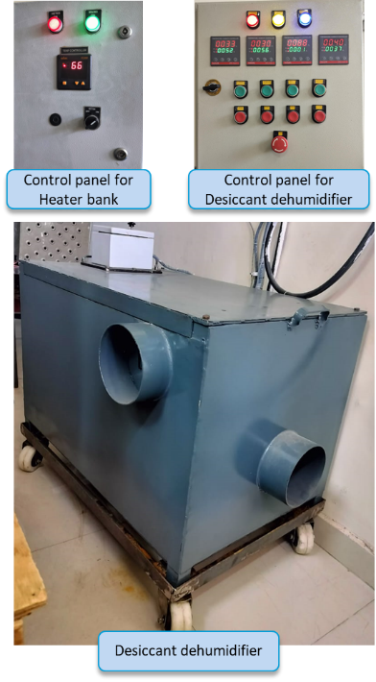
Fig.1. Desiccant dehumidifier showing internal components (left) and its control panel (right).
Experimental setup
A rotary desiccant dehumidifier was fabricated, and tests were conducted in an indoor environment in the Food Packaging and Transportation Laboratory, ICAR-CIPHET in Ludhiana. The proposed system utilised 50% of the desiccant wheel for regeneration. The technical specifications of the desiccant wheel are given in Table 1.
A schematic diagram of the system components is shown in Fig. 2. The temperature of the ambient air entering the regeneration section rises with the help of heater attached to the inlet. Regeneration inlet air, which is moderately hot, is transported to the desiccant wheel via a centrifugal fan. This airflow, termed as regeneration air, serves to remove moisture from the surface of rotary wheel, thereby ensuring the dehumidification process. The regeneration air gets saturated with moisture accumulated in the desiccant wheel and is discharged from the regeneration outlet. The operation of regeneration of desiccant wheel and dehumidification of process air occurs simultaneously.
The tests were conducted in an indoor environment to evaluate the system’s performance. A J type thermocouple (accuracy ±2.2 ℃) was used to measure the temperature of hot inlet regeneration air. Temperature and relative humidity of process and regeneration air at both inlet and outlet are measured with Temperature/Humidity transmitter having accuracy of ±3 % and ±0.15 ℃ whereas volumetric air flow rate is measured by anemometer with accuracy ±3 %.
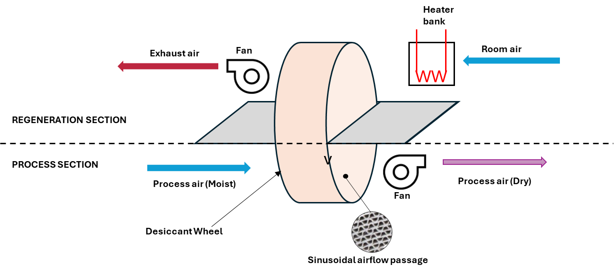

Fig.2. Schematic diagram of desiccant dehumidifier system.
Table 1 Specifications of Dehumidifier Components
Centrifugal fan | - Process section  Power  Voltage  Maximum flow rate  RPM | 240 W  415 V  760 m³/h  2450 rpm
Centrifugal fan | - Regeneration section  Rated power  Voltage  Maximum flow rate  RPM | 110 W  415 V  350 m³/h  2800 rpm
Desiccant wheel | Process air amount  Regeneration air amount  Power  RPM  Process air outlet diameter  Regeneration air outlet diameter | 760 m³/h  360 m³/h  60 W  5 rpm  60 mm  60 mm
Heater Bank | Power  Number of heating coil | 6 kW  6

Table 2 Technical specifications of the measuring equipment
Equipment | Parameter | Range
Temperature/Humidity transmitter | Temperature range  Relative humidity range  Accuracy | 0 to 150 ℃  0 to 100 %  ±3 %, ±0.15 ℃
J-type thermocouple | Temperature range  Accuracy | 0 to 760 ℃  ±2.2 ℃
Anemometer | Velocity range  Accuracy | - to 25 m/s  ±3 %

Performance analysis of the desiccant dehumidifier
The regeneration process involves using hot air with a relatively high temperature and low relative humidity to continuously remove moisture accumulated in the desiccant wheel, thereby maintaining the dehumidification of the process air. During the dehumidification and regeneration phases, heat and mass transfer occur in opposite directions. The desiccant materials in the wheel capture moisture from the incoming process air, leaving the air relatively dry and warm as it exits the wheel. The rotating wheel is then regenerated by introducing another stream of hot, dry air (known as regeneration air) to remove the captured moisture. This regeneration step is crucial for maintaining continuous dehumidification in the desiccant wheel. The performance of the desiccant dehumidifier was analyzed according to ANSI/ASHRAE Standard 139–2015.
Dehumidification effectiveness (η)
It signifies the capacity of the dehumidifier to reduce humidity. It is determined by the ratio of moisture removed from the process air during the dehumidification process to the humidity level of the process air at the inlet.
η = $\frac{ω_{1}-ω_{2}}{ω_{1}}$ (1)
where,
ω₁= specific humidity of process air at inlet (kg/kg)
ω₂= specific humidity of process air at outlet (kg/kg)
Moisture removal capacity (MRC)
It is the amount of moisture ejected in the dehumidifier per unit time (Vivekh et al., 2018).
,MRC = ρ × V_{p} × (ω₁- ω₂) (2)
where,
V_{p} = volumetric flow rate of process air (m³/h)
ρ = air density (kg/m³)
Dehumidification coefficient of performance (COP)
It expresses the amount of moisture based on the temperature difference between the regeneration air and the process air.
COP = $\frac{{ρ_{1} × V}_{p} × h ×(ω_{1}-ω_{2})}{{ρ_{1} × V}_{r} × c_{p} ×(T_{ri}-T_{pi})}$ = $\frac{{ V}_{p} × h ×(ω_{1}-ω_{2})}{{ V}_{r} ×(h_{3}-h_{1})}$ (3)
$h$ = -0.614342 × 10⁻⁴ × T_{pi}³ + 0.0158927 × 10⁻² × T_{pi}² – 0.236418 × 10 × T_{pi} + 0.250079 × 10⁴ (4)
where,
h = specific enthalpy (J/kg)
V_{r} = volumetric flow rate of regeneration air (m³/h)
V_{p} = volumetric flow rate of process air (m³/h)
V_{r} = volumetric flow rate of regeneration air (m³/h)
$h$ = latent heat of vaporization of water
T_{pi} = temperature of process air at inlet
T_{po} = temperature of process air at outlet
T_{ri} = temperature of regeneration air at inlet
c_{p} = specific heat (J/kgK)
Sensible energy ratio (SER)
It indicates the sensible energy transmitted from the regeneration air to the process air.
SER = $\frac{{ρ_{1} × V}_{p} × c_{p} ×(T_{po}-T_{pi})}{{ρ_{1} × V}_{r} × c_{p} ×(T_{ri}-T_{pi})}$ = $\frac{V_{p} ×(T_{po}-T_{pi})}{V_{r} ×(T_{ri}-T_{pi})}$ (5)
Higher η and COP values indicate better dehumidification performance. However, a low SER is desired for applications with cooling processes after dehumidification. As the temperature of the process air increases, the corresponding cooling load will also increase substantially.
Results and Discussion
To assess the performance of the rotary wheel desiccant dehumidification system, various tests were conducted under different inlet conditions by altering the humidity levels of the process air entering the dehumidifier and the temperatures of the regeneration air. Throughout these tests, the flow rates of the process air (350 m³/h) and the regeneration air (760 m³/h) remained constant. The process air's inlet relative humidity ranged from 60% to 100%, while the regeneration air temperatures varied from 60°C to 80°C.
Rotary desiccant dehumidifier inlet-outlet parameters
During the performance evaluation at different regeneration air temperature and different humidity of process air inlet, the temperature-humidity values at the inlet-outlet of the dehumidifier were recorded and presented in graphical environments Fig. 4, 5, 6. In the figures, solid lines represent temperature, and dashed lines represent relative humidity values.
The corresponding temperature humidity values of the process and regeneration air are given in Table 3. Analysis of the parameters in Table 3 indicates that
i) Process air inlet temperatures were in the range of 27.75-36 ℃ in all tests.
ii) Regeneration air inlet and outlet temperatures were between 59 ℃–78.5 ℃ and 37.75 ℃–57.5 ℃, respectively.
iii) RH of process air was recorded as 61%, 70.25%, 80.5%, and 91% at the inlet of the dehumidifier and was reduced to 33.5%, 38.75%, 43.5% and 48.75% during the dehumidification process.
iv) At a regeneration air temperature of 60 ℃ and a process air inlet relative humidity of 60%, the lowest dehumidification performance was recorded at 5.5 g/kg. In contrast, the highest dehumidification performance, 13.35 g/kg, was achieved when the process air inlet relative humidity reached 90% with a regeneration air temperature of 80 ℃.

Fig.3. Impact of Regeneration Air (60 ℃) and Process Air RH (60-90%) on Outlet Air Temperature and RH Over Time.

Fig.4. Impact of Regeneration Air (70 ℃) and Process Air RH (60-90%) on Outlet Air Temperature and RH Over Time.

Fig.5. Impact of Regeneration Air (80 ℃) and Process Air RH (60-90%) on Outlet Air Temperature and RH Over Time.

Table 3 Temperature and relative humidity values of process and regeneration air at dehumidifier inlets and outlets
Parameter | Regeneration inlet | Regeneration outlet | Process inlet | Process outlet
At Regeneration temperature = 60 ℃ & RH of process air = 60 %
Temperature | 59.5 | 38 | 30.25 | 41
RH | 11.5 | 40.25 | 60.25 | 49
At Regeneration temperature = 60 ℃ & RH of process air = 70 %
Temperature | 61.75 | 45.75 | 32.25 | 40.25
RH | 7.25 | 31.75 | 70.25 | 44
At Regeneration temperature = 60 ℃ & RH of process air = 80 %
Temperature | 59 | 37.75 | 28.75 | 35.5
RH | 9.5 | 47.75 | 80.5 | 56.75
At Regeneration temperature = 60 ℃ & RH of process air = 90 %
Temperature | 61 | 37.75 | 27.75 | 36
RH | 8.25 | 53.5 | 91 | 59
At Regeneration temperature = 70 ℃ & RH of process air = 60 %
Temperature | 69.25 | 51.75 | 35 | 43.75
RH | 10 | 23 | 61 | 37.5
At Regeneration temperature = 70 ℃ & RH of process air = 70 %
Temperature | 72.5 | 45 | 31.5 | 40
RH | 4 | 32.75 | 71 | 41.5
At Regeneration temperature = 70 ℃ & RH of process air = 80 %
Temperature | 67.75 | 45.5 | 31.25 | 40.5
RH | 3.75 | 35.75 | 80.75 | 47.75
At Regeneration temperature = 70 ℃ & RH of process air = 90 %
Temperature | 68 | 45.5 | 31.25 | 41
RH | 4.5 | 40.5 | 90 | 52.75
At Regeneration temperature = 80 ℃ & RH of process air = 60 %
Temperature | 78.5 | 57.5 | 36 | 46.75
RH | 3 | 16.5 | 61 | 33.5
At Regeneration temperature = 80 ℃ & RH of process air = 70 %
Temperature | 78.25 | 49.5 | 29.75 | 40.75
RH | 3.5 | 20.5 | 70.25 | 38.75
At Regeneration temperature = 80 ℃ & RH of process air = 80 %
Temperature | 78.25 | 46.5 | 30.5 | 42.5
RH | 3 | 32.75 | 80.5 | 43.5
At Regeneration temperature = 80 ℃ & RH of process air = 90 %
Temperature | 78 | 45.5 | 31 | 42
RH | 4 | 34.75 | 91 | 48.75
Performance analysis of dehumidifier
This section outlines the performance evaluation of the dehumidifier using data gathered during experimental tests. It includes calculations for parameters such as dehumidification efficiency (η), dehumidification capacity (MRC), dehumidification performance coefficient (COP), and sensible energy ratio (SER) derived from the recorded data.

Dehumidification effectiveness (η)
Figure 6 illustrates the dehumidification effectiveness based on the inlet and outlet air conditions of the dehumidifier during the testing period. Results corresponding to 60%, 70%, 80%, and 90% relative humidity (RH) of the process air inlet are also presented. The highest effectiveness, 0.93, was achieved at a regeneration air temperature of 80℃. It was observed that dehumidification effectiveness remained consistent at a given regeneration air temperature and was minimally influenced by the inlet process air's relative humidity. Additionally, the performance was nearly identical at 80% and 90% RH. These findings demonstrate that the rotary desiccant wheel is particularly effective in removing moisture in highly humid environments.

Fig.6. Dehumidification effectiveness at different relative humidity (60%, 70%, 80% and 90%) of process air.
Moisture Removal capacity (MRC)
To assess the dehumidification performance of the rotary desiccant wheel, the Moisture Removal Capacity (MRC) was analyzed, representing the quantity of moisture extracted from the process air per unit of time. The results are presented in Fig. 8. At steady-state conditions, the MRC values were determined as follows: 5.5, 10.1, and 13.17 kg/h for process air with 60% relative humidity (RH); 6.9, 10.27, and 13.22 kg/h for 70% RH; 7.22, 10.40, and 13.24 kg/h for 80% RH; and 7.39, 10.74, and 13.36 kg/h for 90% RH of the inlet process air, respectively. The maximum MRC, recorded at 13.36 kg/h, was achieved for process air with 90% RH at a regeneration inlet air temperature of 80°C.

Fig. 7. Moisture removal capacity at different relative humidity (60%, 70%, 80% and 90%) of process air.
Dehumidification coefficient of performance (DCOP)
The results obtained from the calculations for the dehumidification performance coefficients are shown in Fig. 8. While the RH of inlet process air was 90%, the highest DCOP value was achieved as 0.99. However, the lowest DCOP obtained was 0.86 at 60% at relative humidity of the process air inlet. It can be deduced that the dehumidifier has a higher dehumidification capacity. Additionally, when the regeneration air temperature is 60 ℃ the lowest DCOP values were obtained due to the receiving relatively low regeneration air temperatures as compared to that of 80 ℃. An increase in either parameter raises the moisture content, enhancing the driving force for moisture transfer and improving dehumidification efficiency. Additionally, the coefficient of performance improves with higher inlet air RH or humidity ratio due to the increased cooling capacity (Vivekh et al., 2018). An increase in regeneration temperature enhances the desiccant's ability to remove moisture, enabling it to adsorb more water during the dehumidification process. This significantly boosts its moisture adsorption capacity (Hu et al., 2015).

Fig.8. DCOP at 60%, 70%, 80% and 90% relative humidity of inlet process air.
Sensible energy ratio (SER)
The SER value represents the extent to which the regeneration air heats the process air. For air conditioning applications, a relatively low SER is generally preferred. The calculated results are illustrated in Fig. 9. The minimum SER value, 0.101, was observed at a process air inlet relative humidity of 60% and a flow rate of 760 m³/h. Conversely, the maximum SER value, 0.13, occurred at a relative humidity of 90% under the same flow rate. For applications such as supplying dehumidified air to cold storage, the process air temperature may need to be lowered after dehumidification. In such cases, a cooling unit would be required to reduce the temperature of the warmed process air before it is delivered to the storage chamber. However, in this study, cooling the process air was unnecessary, and no external cooling was applied.

Fig.9. Sensible energy ratio at 60%, 70%, 80% and 90% relative humidity of inlet process air.
Conclusion
In the current study, a dehumidification system with 50% of regeneration area was experimentally tested in a laboratory environment and its dehumidification performance under different inlet conditions were investigated. Subject to the experimental findings, analyses were conducted on moisture removal efficiency, moisture removal capacity, dehumidification performance coefficient, and sensible energy ratio of the dehumidification unit. Key concluding remarks are outlined as follows;
The highest regeneration air temperature set for the dehumidification was 78.5 ◦C at a flow rate of 350 m³/h. It can be deduced that the temperature of the regeneration air entering the dehumidifier declines as relative humidity of the process inlet air increases.
The maximum dehumidification efficiency was observed at a regeneration air temperature of 80 ℃. At this temperature, the outlet air temperature from the process ranged between 42 and 46.75 ℃, making it optimal for the system across all relative humidity levels (60%, 70%, 80%, and 90%).
The process air temperatures entering the dehumidifier rose by approximately 6.75–12 ℃, while the regeneration air temperatures decreased by about 16–32.5 ℃, as anticipated during the regeneration process. The experimental results demonstrate that an enlarged desiccant wheel which is 50% of the total area in the regeneration section significantly improves moisture reduction in the process air. During dehumidification, the process air gradually becomes dry and gets heated, while the regeneration air loses heat and becomes humidified.
Moreover, these findings hold potential for practical applications, particularly in the drying and storage of high-value crops. Future research will explore the expanded regeneration section in the rotary desiccant dehumidification system, integrated with either a vapor compression cooling unit or an indirect evaporative heat exchanger.

Nomenclature
MRC |  | moisture removal capacity
SER |  | Sensible energy ratio
η |  | dehumidification effectiveness
ω |  | specific humidity (kg/kg)
V_{p} |  | volumetric flow rate (m³/h)
ρ |  | air density (kg/m³)
DCOP |  | coefficient of performance
h |  | specific enthalpy (J/kg)
$h$ |  | latent heat of vaporization of water
T_{pi} |  | temperature of process air at inlet
T_{po} |  | temperature of process air at outlet
T_{ri} |  | temperature of regeneration air at inlet
c_{p} |  | specific heat (J/kgK)

References
Abd-Elhady, M. M., Salem, M. S., Hamed, A. M., & El-Sharkawy, I. I. (2022). Solid desiccant-based dehumidification systems: A critical review on configurations, techniques, and current trends. International Journal of Refrigeration, 133, 337-352.
Ali, M., Habib, M. F., Sheikh, N. A., & Akhter, J. (2022). Experimental investigation of an integrated absorption-solid desiccant air conditioning system. Applied Thermal Engineering, 203, 117912.
El-Ramady, H. R., Domokos-Szabolcsy, É., Abdalla, N. A., Taha, H. S., & Fári, M. (2015). Postharvest management of fruits and vegetables storage. Sustainable Agriculture Reviews: Volume 15, 65-152.
Hu, L. M., Ge, T. S., Jiang, Y., & Wang, R. Z. (2015). Performance study on composite desiccant material coated fin-tube heat exchangers. International journal of heat and mass transfer, 90, 109-120.
Hussain, G., Aleem, M., Sultan, M., Sajjad, U., Ibrahim, S. M., Shamshiri, R. R., ... & Bilal, M. (2022). Evaluating evaporative cooling assisted solid desiccant dehumidification system for agricultural storage application. Sustainability, 14(3), 1479.
Ishaq, M., Sultan, M., Aleem, M., Bilal, M., Ullah, H. S., Mahmood, M. H., & Miyazaki, T. (2022). Desiccant Dehumidification System for Storage of Fruits and Vegetables. Energy-Efficient Systems for Agricultural Applications, 65-83.
Kader, A. A. (2013). Postharvest technology of horticultural crops-An overview from farm to fork. Ethiopian Journal of Applied Science and Technology, (1), 1-8.
Lal Basediya, A., Samuel, D. V. K., & Beera, V. (2013). Evaporative cooling system for storage of fruits and vegetables-a review. Journal of food science and technology, 50, 429-442.
Mishra, V. K., & Gamage, T. V. (2007). Postharvest physiology of fruit and vegetables. In Handbook of food preservation (pp. 37-66). CRC press.
Nalbandi, H., Seiiedlou, S., Ghasemzadeh, H. R., & Rangbar, F. (2016). Innovative Parallel Airflow System for forced-air cooling of strawberries. Food and Bioproducts Processing, 100, 440-449.
Rao, C. G. (2015). Engineering for storage of fruits and vegetables: cold storage, controlled atmosphere storage, modified atmosphere storage. Academic Press.
Sultan, M., Miyazaki, T., Saha, B. B., & Koyama, S. (2016). Steady-state investigation of water vapor adsorption for thermally driven adsorption based greenhouse air-conditioning system. Renewable Energy, 86, 785-795.
Vivekh, P., Kumja, M., Bui, D. T., & Chua, K. J. (2018). Recent developments in solid desiccant coated heat exchangers–A review. Applied energy, 229, 778-803.

