Original Research Article

Effect of chitosan-based edible films on the storage quality of ready-to-eat paneer

ABSTRACT
Aims: The aim of the study is to find the effect on sensory and microbiological characteristics of chitosan film packed ready to eat paneer during storage at ambient and refrigeration temperature.
Study design: This study was experimental and conducted in a lab.
Place and Duration of Study: The study was conducted at the Department of Dairy Technology, Dairy Science College, Hebbal, Bengaluru, Karnataka, India, between October 2022 and July 2023.
Methodology: The ready to eat paneer prepared with 5 per cent fructooligosaccharides, 40 per cent sugar and 15 per cent orange juice will be aseptically wrapped with chitosan based edible film made of 1.5% chitosan and 0.75% glycerol. The product will be analysed at both ambient temperature (27±1°C) with 1days interval and refrigeration temperature (4±1°C) with 3 days interval. Sensory analysis by 9-point hedonic scale and microbial analysis of total plate count, coliforms count, yeast & mold count were assessed. ANOVA was the method used for statistical analysis, and the significance between the control and sample was assessed using a critical difference (CD) at a 5% significance level.
Results: The sensory attributes ratings of the control paneer and edible chitosan film packed ready to eat paneer samples are non-significant (P>0.05) to each other and decreased consistently throughout storage at both conditions. Throughout storage, the coliform count was undetectable. During storage, the total plate count, as well as the yeast and mould counts, increased. The yeast and mould count of 0.48 log₁₀ cfu/g and total plate count of 2.30 log₁₀ cfu/g were the initial load of the chitosan film packed ready to eat paneer which increase growth on storage days and were much less than control paneer during storage.
Conclusion: The storage studies revealed that control paneer can be stored for 1 days at ambient temperature and 6 days at refrigeration temperature without any spoilage and chitosan film packed ready to eat paneer can be stored for 2 days at ambient temperature and 9 days at refrigeration temperature without any spoilage.

Keywords: Ready to eat paneer, chitosan, edible film, sensory analysis, microbial analysis

1. INTRODUCTION
Paneer is highly perishable due to their diverse nutrient composition, which make them an ideal environment for the growth and propagation of spoilage microorganisms and milk borne pathogens. Hence, it is imperative to adopt effective adequate preservation technologies to maintain the quality and safety. In recent years, there is substantial increase in the demand of high quality, convenient, safe milk products with extended shelf life. Packaging is an important tool for dispensing as well as for maintaining the quality of food products (Goyal and Goyal, 2016).
Paneer is primarily used in culinary dishes, but it can also be used as a ready-to-eat food product that can be consumed without further processing. The main advantage of ready-to-eat paneer is that it improves its functional properties as well as its preservation quality. (Ali et al.,2023).
Paneer is highly nutritious as it contains a high level of protein and fat, minerals and vitamins. However, paneer has quite low shelf life at ambient temperature mainly due to its high moisture and fat content. Several preservation techniques including packaging, heat treatment, addition of preservatives or spices, thermal processing, low temperature storage etc. have been employed to extend its shelf life (Rajinder et al., 2018). Growth of microorganisms on the surface is the root cause of spoilage of paneer Because of the high moisture content (about 55 per cent), it has a shelf life of only one day at ambient temperature and up to a week at refrigeration (7 days). (Mishra et al., 2021).
Numerous advancements in packaging technology, such as vacuum packing, modified atmospheric packaging, retort packaging, etc., had proved successful in extending the shelf life of paneer. But almost all of the packaging components used in modern food packaging are not biodegradable. Therefore, the idea of creating eco-friendly, biodegradable and edible packaging materials that preserve paneer's distinguishing qualities while also extending its shelf life is of particular interest to the food sector.
The effects of fat content and coagulation temperature have been found significant in controlling the sensory score (Badshah et al., 2023). Mishra et al. (2021) on his studies where sensory evaluation of paneer stored at refrigeration temperature for 12 days has colour and appearance decreased in paneer from 8.03 to 6.21 body and texture score decreased from 7.88 to 6.93 flavour score decreased from 7.63 to 5.15 and overall acceptability score reduced from 7.98 to 5.40 on 12 days of storage. Sensory evaluation of paneer done at room temperature for 2 days showed colour and appearance decreased in prepared paneer from 8.03 to 5.60 body and texture score decreased from 7.88 to 5.87 flavour score decreased from 7.63 to 5.17 and overall acceptability score reduced from 7.98 to 5.63 on 2 days of storage (Mishra et al., 2021). Punnagaiarasi et al. (2016) evaluated the sensory quality of edible film coated paneer using cinnamon oil and concluded that higher sensory scores were obtained for paneer coated with whey protein based edible coating with cinnamon oil up to level of 1 percent.
Paneer stored at 30±1º C revealed yeast and molds counts were 1.43 log₁₀ cfu/g on 0th day which increased to 2.10 log₁₀ cfu/g on 1st day the total plate count 4.41 log₁₀ cfu/g on day 0 increased to 5.05 log₁₀ cfu/g 1st day, samples were unacceptable after 1st day of storage as there was visible growth. Paneer stored at 7±1º C showed yeast and molds counts were 1.43 log₁₀ cfu/g on 0th day which increased to 2.46 log₁₀ cfu/g on 8th day the total plate count 4.41 log₁₀ cfu/g on day 0 and 5.47 log₁₀ cfu/g 8th day, samples were unacceptable after 8th day of storage as there was visible growth. (Mishra et al., 2016).
2. MATERIAL AND METHODS
2.1 Materials
Procured fresh cow's milk from the Dairy Science College's Students Experimental Dairy Plant (SEDP) in Hebbal, Bengaluru, citric acid from Prince Chemical Co., Bengaluru, Karnataka, Fructooligosaccharide liquid from Foslife manufactured by Revelation biotech, Hyderabad, sugar from Shree Renuka sugars ltd, Mumbai, Maharashtra. The orange juice of 35 per cent orange pulp from Mala’s fruits crush, Panchgani, Maharashtra. Meron-Marine hydrocolloids, located in Kochi, Kerala, provided the chitosan powder that had over 90% deacetylation. 1% food grade acetic acid was purchased from Umang Industries in Shahdara, New Delhi. Bioven Ingredients, located in Greater Noida, G.B. Nagar, Uttar Pradesh, produced the food-grade glycerol that was used.
2.2 Preparation of ready to eat paneer
Paneer was prepared by modified procedure of Shanaziya et al., 2018 The standardised milk is heated to 90℃ no hold and cooled to 80℃. With moderate stirring, the coagulating agent citric acid is introduced to milk in a 2 per cent percent solution at 80℃. The added milk was left undisturbed for 2 minutes. After that, a muslin cloth is used to separate the clear whey. fructooligosaccharides 5% (to the weight of coagulum), powdered sugar 40% (to the weight of coagulum) and orange juice 15% (to the weight of coagulum) are combined well into the paneer curd. The coagulum pressed for 30 minutes (2 kg/cm²). It is then submerged for 30 minutes in pasteurised cold water (4°C).
2.3 Preparation of chitosan based edible film
The chitosan based edible film was prepared by modified method of Singh et al., 2015. Chitosan-based edible film was made by dissolving chitosan powder of 2% in 1per cent v/v acetic acid solution and plasticizer glycerol of 0.75% and heating for 20 minutes on a hot plate magnetic stirrer at 90°C with regular stirring. The solution was uniformly cast on fibre glass plates and dried for 48 hours at 40 °C. The dried films were peeled off and kept in a chamber with a humidity of 50 per cent and a temperature of 25°C.
2.4 To study the shelf stability of chitosan packed ready to eat paneer
The ready to eat paneer will be aseptically wrapped with chitosan based edible film and packaged in LDPE pouches and sealed. The resultant product will be subjected for storage studies to assess the shelf stability of the product. The product will be analysed at both ambient temperature (27±1°C) with 1days interval and refrigeration temperature (4±1°C) with 3 days interval.

2.4.1 Sensory Evaluation
The organoleptic quality of paneer samples will be evaluated at regular intervals by semi trained judges on a 9-point hedonic scale. The samples for evaluation will be coded appropriately before serving the samples to the judges for sensory evaluation. Sensory evaluation of the samples will be carried out in the sensory evaluation lab. The panellists are requested to grade the sample on the basis of sensory attributes: colour and appearance, flavour, body & texture and overall acceptability (Dongare et al.,2019).
2.4.2 Microbiological Analysis
The LDPE pouch containing the developed edible chitosan film packed ready to eat paneer will be opened and chitosan film will be unwrapped.11 g of the product will be weighed and transfer to 99 ml of 2 per cent sodium citrate diluent aseptically. Further dilution to desired level will be carried out by serially transferring 1 ml of diluted sample to 9 ml sterile diluent blanks (Girdharwal 2018)
2.4.2.1 Total plate count
Total plate count will be determined by plating 1, 2 and 3 dilutions of paneer. The molten media of standard plate count agar will be poured to diluted sample plates and incubated for 24-48 hours at 37℃ after solidification. Counts will be taken after the completion of incubation period.
2.4.2.2 Coliforms count
Coliform count will be determined by plating 1, 2 and 3 dilutions of paneer. The molten media of Violet red bile agar will be poured to each diluted sample plates and incubated for 18-24 hours at 37℃ after solidification. Counts will be taken after the completion of incubation period.
2.4.2.3 Yeast & mold count
Yeast & mold count will be determined by plating 1, 2 and 3 dilutions of paneer. The pH of the molten Potato dextrose agar medium will be adjusted to 3.5 by adding 10 per cent of 1.6ml sterile lactic acid solution to 100 ml media. Media is poured to diluted plates and incubated for 3 – 5 days at 30ºC. Counts will be taken after the completion of incubation period.
2.5 Statistical Analysis
The data was analysed using IBM SPSS statistics software for statistical computing. Data on the response variables were collected for three replications for each of the treatments. ANOVA tables were prepared to analyse the data and where the F value was significant, the critical difference was calculated (P=0.05) and used to identify whether significant differences existed and indicated in the table using superscripts. Storage study analysis was done by repeated ANOVA method.
The formula for the critical difference (CD) is
√2 × 𝑀(𝐸) × 𝑡𝛼
𝑟
Where,
MSS (E) = Mean Sum of squares of the error
r = number of replications
tα = table t value of the α level of significance at 0.95
3. results and discussion
3.1 Effect on sensory attributes of chitosan film packed ready to eat paneer during storage at ambient temperature (27±1º C)
After each day of judging there was decrease in sensory scores. The control sample got spoiled on day 2 and chitosan film packed ready to eat paneer sample got spoiled on day 3 when stored at room conditions (27±1° C). There was no significant (P<0.05) difference in sensory score of control sample and chitosan film packed ready to eat paneer sample in all days. The colour and appearance score decreased from was 8.33 to 8.25 for the control sample whereas for chitosan film packed ready to eat paneer it decreased from 8.0 to 7.42. Body and texture score of control on initial day was 8.33 then later reduced to 8.17 on days 1 and for chitosan film packed ready to eat paneer Days 0 the score was 8.17 which reduced to 7.33 on day 2.
For the control sample, the flavour score dropped from 8.17 to 7.92, whereas it dropped from 8.33 to 7.42 for ready-to-eat paneer packaged in chitosan film. The overall acceptability score for the control on the very initial day was 8.33 and then decreased to 7.67 on days 1 whereas the score for the chitosan film-packaged, ready-to-eat paneer on days 0 was 8.33 and later decreased to 7.33 on days 2. The results obtained during this research work were similar with the trend of Mishra et al., (2021) on his work related to effect of black pepper extract on sensory attributes and shelf life of paneer were scores decreased during storage at ambient (30±1°C) temperature and the score of developed paneer when compared to control paneer which was less on each day and in all parameters, was very close to our findings.
Table 1: Effect on sensory attributes of chitosan film packed ready to eat paneer during storage at ambient temperature (27±1º C)
Sample | Colour & Appearance | Body & Texture | Flavour | Overall Acceptability
DAY 0
CP | 8.33ª | 8.33 ª | 8.17 ª | 8.33 ª
CFRP | 8.00 ª | 8.17 ª | 8.33 ª | 8.33 ª
CD  (P=0.05) | NS | NS | NS | NS
DAY 1
CP | 8.25 ª | 8.17 ª | 7.92 ª | 8.17 ª
CFRP | 7.92 ª | 7.50 ª | 7.83 ª | 7.67 ª
CD  (P=0.05) | NS | NS | NS | NS
DAY 2
CP | Spoiled | Spoiled | Spoiled | Spoiled
CFRP | 7.42 | 7.33 | 7.42 | 7.33
CD  (P=0.05) | - | - | - | -
DAY 3 Spoiled
Note: CP – Control paneer, CFRP – Chitosan film packed ready to eat paneer, CD – Critical difference, NS – Non significant, All the values are average of three trials, Similar superscripts indicate non - significance at the corresponding critical difference
3.2 Effect on sensory attributes of chitosan film packed ready to eat paneer during storage at refrigeration temperature (4±1º C)
The sensory scores decreased after each day of judging. On day 3, the control sample and chitosan film packed ready to eat paneer sample held at room temperature (4±1°C) deteriorated. On all days, there was no significant (P>0.05) difference in sensory score between the control sample and the chitosan film packed ready to eat paneer sample. The colour and appearance score reduced from 8.33 to 7.92 for the control sample and from 8.0 to 7.25 for the chitosan film packed ready to eat paneer. The control's body and texture score on day 0 was 8.33, which was later reduced to 7.88 on day six, whereas the chitosan film packed ready to eat paneer score on day zero was 8.17, which was later lowered to 7.01 on day nine.
The flavour score for the control sample dropped from 8.17 to 7.58, while it dropped from 8.33 to 7.08 for ready-to-eat paneer packed in chitosan film. The overall acceptability score for the control on the initial day was 8.33 and then reduced to 7.67 on day six, whereas the score for the chitosan film-packaged, ready-to-eat paneer on day 0 was 8.33 and then decreased to 7.00 on day nine. The findings of this study were consistent with the findings of Mishra et al., (2021) in their study on the effect of black pepper extract on sensory characteristics and shelf life of paneer, which found that scores dropped after storage at refrigerated temperature (7±1°C) and the black pepper paneer scored lower than the control paneer on every single day and in all metrics, which was very similar to our findings.
Table 2: Effect on sensory attributes of chitosan film packed ready to eat paneer during storage at refrigeration temperature (4±1º C)
Sample | Colour & Appearance | Body & Texture | Flavour | Overall Acceptability
DAY 0
CP | 8.33 ª | 8.33 ª | 8.17 ª | 8.33 ª
CFRP | 8.00 ª | 8.17 ª | 8.33 ª | 8.33 ª
CD  (P=.05) | NS | NS | NS | NS
DAY 3
CP | 8.33 ª | 8.33 ª | 8.17 ª | 8.33 ª
CFRP | 7.83 ª | 7.67 ª | 7.83 ª | 7.83 ª
CD  (P=.05) | NS | NS | NS | NS
DAY 6
CP | 7.92 ª | 7.88 ª | 7.58 ª | 7.67 ª
CFRP | 7.33 ª | 7.08 ª | 7.50 ª | 7.33 ª
CD  (P=.05) | NS | NS | NS | NS
DAY 9
CP | Spoiled | Spoiled | Spoiled | Spoiled
CFRP | 7.25 | 7.01 | 7.08 | 7.00
CD  (P=.05) | - | - | - | -
DAY 10 Spoiled
Note: CP – Control paneer, CFRP – Chitosan film packed ready to eat paneer, CD – Critical difference, NS – Non significant, All the values are average of three trials, Similar superscripts indicate non - significance at the corresponding critical difference
3.3 Effect on microbiological characteristics of chitosan film packed ready to eat paneer during storage at ambient temperature (27±1º C)
The coliform count showed nil for all the samples (control and chitosan film packed ready to eat paneer) throughout the period of storage whereas total plate count and yeast and molds counts increased upon increasing the period of storage. The control and chitosan film packed ready to eat paneer samples have total plate counts of 2.83 and 2.30 log₁₀ cfu/g, respectively. On the first day of storage, the total plate count in control climbed to 4.99 log₁₀ cfu/g. On the second day of storage, the total plate count in chitosan film packed ready to eat paneer samples raised to 5.88 log₁₀ cfu/g.
The fresh control and chitosan film packed ready to eat paneer samples show 0.21 and 0.48 log₁₀ cfu/g counts of yeast and molds respectively. On first day of storage yeast and molds increased in control increased to 2.12 log₁₀ cfu/g and day two of storage chitosan film packed ready to eat paneer increased to 2.10 log₁₀ cfu/g. On 2nd day of storage control paneer samples found unacceptable at ambient temperature. On 3rd day of storage, the chitosan film packed ready to eat paneer samples found unacceptable at ambient temperature. There was a significant (P<0.05) difference in control and chitosan film packed ready to eat paneer on total plate count and yeast and mold count. The findings in the study are in agreement with the work of Mishra et al. (2016) on effect of pH on sensory, textural, microbial quality and shelf-life of paneer where the microbial analysis of paneer was conducted during storage at ambient temperature (30±1°C).
Table 3- Effect on microbiological characteristics of chitosan film packed ready to eat paneer during storage at ambient temperature (27±1º C)
Sample | Total plate count | Yeast and Molds | Coliform
Sample | log₁₀cfu/g
DAY 0
CP | 2.83 ª | 0.21 ª | Nil
CFRP | 2.30 ^{b} | 0.48 ^{b} | Nil
CD  (P=0.05) | 0.37 | 0.12 | -
DAY 1
CP | 4.99 ª | 2.12 ª | Nil
CFRP | 3.80 ^{b} | 1.64 ^{b} | Nil
CD  (P=0.05) | 0.37 | 0.23 | -
DAY 2
CP | Spoiled | Spoiled | Spoiled
CFRP | 5.46 | 2.10 | Nil
CD  (P=0.05) | - | - | -
DAY 3 Spoiled
Note: CP – Control paneer, CFRP – Chitosan film packed ready to eat paneer, CD – Critical difference, All the values are average of three trials, Similar superscripts indicate non - significance at the corresponding critical difference
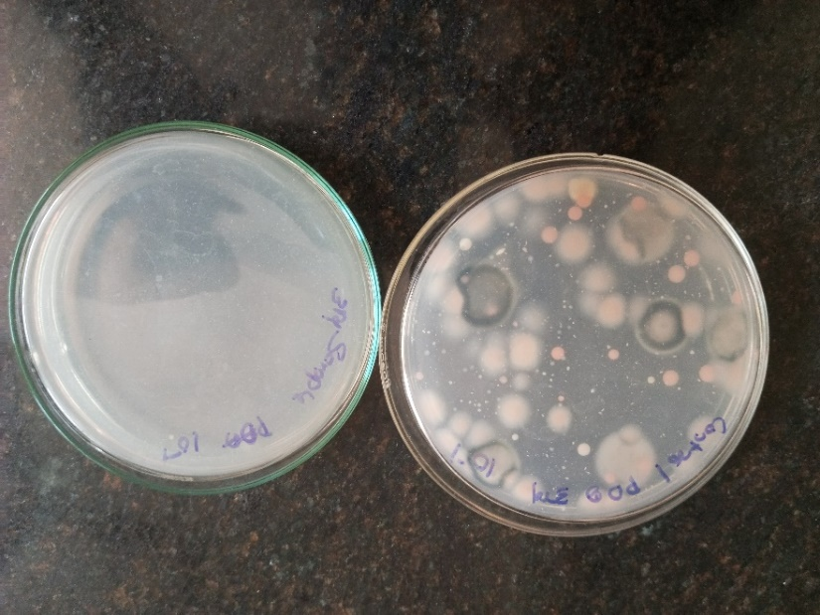
Fig.1: Yeast and molds plates of control paneer (left) and chitosan wrapped ready to eat paneer (right) when stored at ambient temperature on 3rd day
Effect on microbiological characteristics of chitosan film packed ready to eat paneer during storage at refrigeration temperature (4±1º C)
The coliform count was absent for all samples (control and chitosan film packed ready to eat paneer) throughout the storage time, however the total plate count, yeast and mould counts increased as the storage period increased. Total plate counts for the control and chitosan film packed ready to eat paneer samples were 2.83 and 2.30 log₁₀ cfu/g, respectively. On sixth day for control and ninth day for chitosan film packed ready to eat paneer of storage, the total plate count in control increased to 5.28 log₁₀ cfu/g and 4.14 log10 cfu/g in chitosan film packed ready to eat paneer.
Fresh control and chitosan film packed ready to eat paneer samples have yeast and mould counts of 0.21 and 0.48 log₁₀ cfu/g, respectively. On sixth day for control and ninth day for chitosan film packed ready to eat paneer of storage, yeast and moulds grew to 2.08 log₁₀ cfu/g in the control and 2.16 log₁₀ cfu/g in the chitosan film packed ready to eat paneer. On the seventh day of storage control paneer was unsuitable and on ninth day chitosan film packed ready to eat paneer was unsuitable at refrigeration temperature. There was a significant (P<0.05) difference in total plate count and yeast and mould count between the control and chitosan film packed ready to eat paneer. The study's findings coincide with the work of Mishra et al., (2016) on Effect of pH on sensory, textural, microbiological quality and shelf-life of paneer, where microbial analysis of paneer was done under storage refrigeration temperature (7±1°C).
Table 4: Effect on microbiological characteristics of chitosan film packed ready to eat paneer during storage at refrigeration temperature (4±1º C)
Sample | Total plate count | Yeast and Molds | Coliform
Sample | log₁₀cfu/g
DAY 0
CP | 2.83 ª | 0.21 ª | Nil
CFRP | 2.30 ^{b} | 0.48 ^{b} | Nil
CD  (P=0.05) | 0.37 | 0.12 | -
DAY 3
CP | 4.04 ª | 1.43 ª | Nil
CFRP | 3.61 ^{b} | 1.11 ^{b} | Nil
CD  (P=0.05) | 0.16 | 0.16 | -
DAY 6
CP | 5.28 ª | 2.08 ª | Nil
CFRP | 3.79 ^{b} | 1.74 ^{b} | Nil
CD  (P=0.05) | 0.18 | 0.14 | -
DAY 9
CP | Spoiled | Spoiled | Spoiled
CFRP | 4.14 | 2.16 | Nil
CD  (P=0.05) | - | - | -
DAY 10 Spoiled
Note: CP – Control paneer, CFRP – Chitosan film packed ready to eat paneer, CD – Critical difference, All the values are average of three trials, Similar superscripts indicate non - significance at the corresponding critical difference
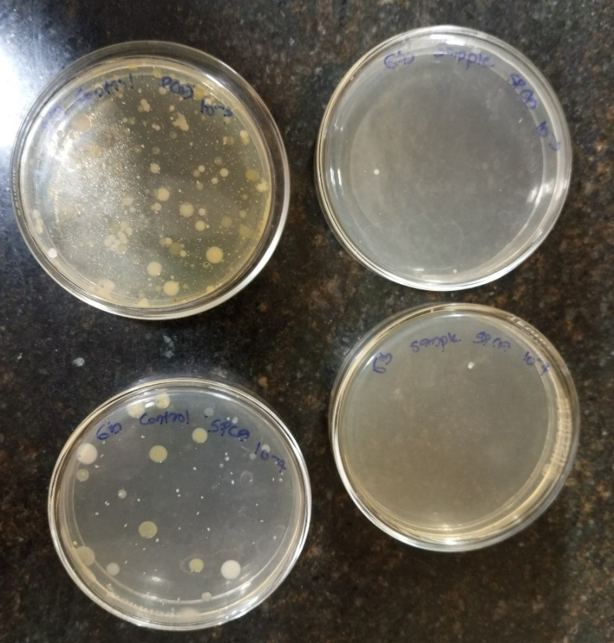
Fig:2 TPC plates of control paneer (left) and chitosan wrapped ready to eat paneer (right) when stored at refrigeration temperature on 6th day
4. CONCLUSION
The storage studies demonstrated that as the storage days progressed, the sensory attributes ratings of the control paneer and edible chitosan film packed ready to eat paneer samples decreased consistently throughout storage at both ambient temperature (27±1°C) and refrigeration temperature (4±1°C).
The microbiological analysis was carried out for total plate count, coliform and yeast and mould count in control and chitosan film packed ready to eat paneer during storage at both ambient temperature (27±1°C) and refrigeration temperature (4±1°C). Throughout storage, the coliform count was undetectable. During storage, the total plate count, as well as the yeast and mould counts, increased. The total plate count, yeast and mould count (0.48 log₁₀ cfu/g) and total plate count (2.30 log₁₀ cfu/g) of the chitosan film packed ready to eat paneer were much lower than those of the control paneer.
The edible chitosan film prepared with 2 per cent chitosan, 0.75 per cent glycerol, 1 per cent acetic acid solution were used to wrap the ready to eat paneer prepare with addition of 5 per cent fructooligosaccharides, 40 per cent sugar, 15 per cent orange juice. The storage studies at ambient temperature (27±1°C) and refrigeration temperature (4±1°C) revealed that control paneer can be stored for 1 days at ambient temperature and 6 days at refrigeration temperature without any spoilage and chitosan film packed ready to eat paneer can be stored for 2 days at ambient temperature and 9 days at refrigeration temperature without any spoilage.

REFERENCE
Ali A. T. S., Venkatesh, M., Kumar, A. H., Praveen, A. R., Ramachandra, B., & Pushpa, B. P. (2023). Optimisation of ready to eat paneer with different levels of fructooligosaccharides, sugar and orange juice based on sensory characteristics. International Advanced Research Journal in Science, Engineering and Technology., 10(9), 57-64.
Badshah, J., Kumar, S., Kumar, S., Bharti, B. K., & Jha, A. K. (2023). Study on sensory characteristics of paneer for process standardization from buffalo milk: Sensory characteristics of paneer. Indian Journal of Dairy Science, 76(5), 427-432.
Dongare, S. A., Dige, Y. P., & Syed, H. M. (2019). Storage study and textural profile analysis of paneer at different temperature. Journal of Pharmacognosy and Phytochemistry, 8(2), 864-868.
Girdharwal, N. (2018). Microbiological study of Indian paneer-a case study of Delhi city. International Journal of Pharmaceutical Sciences and Research, 9(9), 4008-4014.
Goyal, S. & Goyal, G.K. (2016). Maximizing shelf life of paneer—A review. Critical Reviews in Food Science and Nutrition, 56(8), 1253-1261.
Mishra, D., Rao, J., & Anand, S. (2021). Chemical quality changes in black pepper paneer during storage. Pharm Innovation J., 10(4), 742-745.
Mishra, D., Rao, J., & Anand, S. (2021). Effect of black pepper extract on sensory attributes and shelf life of paneer. Pharm Innovation J., 10(4), 732-736.
Mishra, D., Rao, K. J., Bhardwaj, R., Sutariya, H., Kavitkar, R. S., & Subhash, W. S. (2016). Effect of pH on sensory, textural, microbial quality and shelf-life of paneer. Int J. Food Fermentation Tech., 6(2), 405-414.
Punnagaiarasi, A., Elango, A., Kalaikannan, A., & Selvaraju, M. (2016). Evaluation of sensory quality of edible coated paneer using cinnamon oil. International Journal of Science and Nature, 7 (3), 591-593.
Rajinder, K., Kumar, S. S., Rekha, C., & Gopika, T. (2018). Studies on optimization of paneer nuggets: a ready to eat steam cooked product. Ind. J. of Dairy Sci., 71(1), 13-19.
Shanaziya, A. S. F., Mangalika, U. L. P., & Nayananjalie, U. L. P. (2018). Effect of different coagulants on the quality of paneer made from cow milk. Int. J. Scientific and Res. Publications, 8 (4), 189-194.
Singh, T. P., Chatli, M. K., & Sahoo, J. (2015). Development of chitosan based edible films: process optimization using response surface methodology. Journal of Food Science and Technology, 52, 2530-2543.

