Eco-FriendlyStabilityIndicatingHPLCMethodforEstimationofElbasvir and Grazoprevir by Quality by Design Approach

Abstract
Introduction: The pharmaceutical industry faces a significant problem as a resultoftheworldwiderequirementtomodifyprocessesinordertocomplywith the green analytical chemistry (GAC) requirements. An enormous amount of organic hazardous waste is produced by high-performance liquid chromatography (HPLC), one of the methods employed the most frequently at different stages in the pharmaceutical sector. Aim: To develop analytical quality by design-aided stability indicating green high-performance liquid chromatography(HPLC)methodforestimationofElbasvirandGrazoprevirin a dosage form. Material and Methods: The critical chromatographic factors werethe%ofethanolinthemobilephase,flowrate,andtheiroveralleffecton theresponseslikeasymmetry,theoreticalplates,andresolutionwerestudiedto optimizethemethod.Greenanalyticalchemistry(GAC)hasmainlyfocusedon developing analytical methods that are safe for the environment. Therefore, it is imperative that the GAC principles be applied in pharmacological analysis. A rotatable central composite design was employed, and the optimized conditions for chromatographic separation were made with a run time of 5 minutes using Zorbax C18 column (4.6× 150 mm, 5 µm) with 0.1% Trifluoroaceticacid andethanol (40:60v/v) ascomponentsofa mobilephase, flowing atarateof1.0 ml/minute. Photodiode arraydetection wascarried out at 253 nm. Results: The retention time was 1.8 min for EBS and 2.84 min for GZP.AccordingtotheICHguidelines,theproposedmethodwasvalidatedand stressstudiesrevealedthatElbasvirandGrazoprevirarepronetoacidic,basic, and oxidation stress conditions. An analytical eco-scale score evaluated the greennessprofileandasoftware-basedevaluation.Conclusion:Thedeveloped HPLC method is eco-friendly and shall be adoptedin the routine quality control of Elbasvir and Grazoprevir in a tablet dosage form.
Keywords:Greenassessment,ElbasvirandGrazoprevir,Method Validation, QBD, Stability testing.
- Introduction
Greenchemistryiswidelyusedinworldwidemanufacturing,governmentpolicy,educationalpractice, and technology development. The main purpose of the circular economy is to establish a balance between economic growth, resource sustainability, and environmental protection. Green analytical chemistry(GAC),whichresultsinachange inattitudesandbehaviourinthechemicalindustry,canbe viewedasanimportanttoolforachievingsustainability.[1]TheGACreferstothedevelopmentofnew, effectiveanalyticaltechniquesthatwillallowforthereductionand/orremovalofhazardouschemicals and chemical waste while also allowing for faster and more energy-efficient analysis. As a result, the aforementioned 12 green chemistry principles were adjusted to construct the main characteristics influencing the green character of analytical chemistry and place it in the role of GAC.[2] The developmentofgreeneranalyticalmethodsusingqualitybydesign(QbD)providesvaluableknowledge about the use of greener chemicals and their impact on method performance.
Elbasvir (EBS) is first line therapy classified Direct-acting antiviral (DAA) and prevents viral replicationin HCVgenotypes 1a, 1b and 4 of Hepatitis C. It is chemically knownas Dimethyl N,N+ - ([(6S)-6H-indolo[1,2-C][1,3]benzoxazine-3,10-diyl]bis{1H-imidazole-5,2-diyl-(2S)-pyrrolidine-
-1330-

2, 1-diyl[(2S)-1-oxo-3-methylbutane-1, 2-diyl]})biscarbamate.[3]Elbasvir is an inhibitor of the HCV non-structural protein 5A.Potentialmodes ofaction of NS5Ainhibitors like elbasvirinclude blocking signaling interactions, redistribution of NS5A from the endoplasmic reticulum to the surface of lipid droplets, and modification of the HCV replication complex[4].

Figures&Tables:
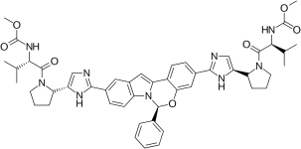
[Table/Fig-1]:ChemicalstructureofEBS
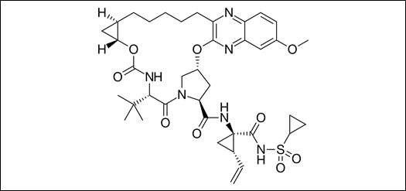
[Table/Fig-2]:ChemicalstructureofGZP

Factors Responses
Ru n A: Ethanol(mL) | B: Flow Rate(mL/Min) | C:  Temperature(ºC) | Resolution | Theoretical plates | RT2
1 60 | 0.50 | 35.00 | 5.45 | 4488 | 2.84
2 63 | 0.53 | 36.80 | 5.52 | 4472 | 2.90
3 60 | 0.50 | 32.00 | 5.35 | 4259 | 2.67
4 57 | 0.47 | 36.80 | 5.51 | 4845 | 2.75
5 63 | 0.53 | 33.20 | 5.41 | 4327 | 2.89
6 60 | 0.50 | 35.00 | 5.43 | 4488 | 2.85
7 60 | 0.55 | 35.00 | 5.22 | 4524 | 2.72
8 60 | 0.50 | 35.00 | 5.42 | 4478 | 2.84
9 60 | 0.50 | 38.00 | 5.62 | 4691 | 2.85
10 57 | 0.47 | 33.20 | 5.39 | 4437 | 2.55
11 60 | 0.50 | 35.00 | 5.42 | 4460 | 2.86
12 60 | 0.50 | 35.00 | 5.46 | 4460 | 2.87
13 55 | 0.50 | 35.00 | 5.21 | 4807 | 2.50
14 57 | 0.53 | 36.80 | 5.43 | 4922 | 2.60
15 63 | 0.47 | 36.80 | 5.73 | 4233 | 3.03
16 60 | 0.45 | 35.00 | 5.73 | 4333 | 2.84
17 60 | 0.50 | 35.00 | 5.46 | 4460 | 2.88
18 57 | 0.53 | 33.20 | 5.03 | 4431 | 2.54
19 63 | 0.47 | 33.20 | 5.86 | 4152 | 2.88

Eco-FriendlyStabilityIndicatingHPLCMethodforEstimationofElbasvirand Grazoprevir byQuality byDesignApproach

20 65 0.5 35 5.76 4179 3.03

[Table/Fig-3]:rCCDmatrixisusedinconjunctionwiththeresponse'sspecificationsforthe suggested technique.
Grazoprevir (GZP) is chemically known as (1R, 18R, 20R, 24S, 27S)- N- {(1R, 2S)-1- [(cyclopropylsulfonyl)carbamyl]-2-vinyl(cyclopropyl)-7-methoxy-24-(2-methyl-2-propanyl)-22,25- dioxo-2,21-dioxa-4,11,23,26-tetraazapentacyclo[24.2.1.03.12.05.1.0.0.18.20]nonacosa-3,5,7,9,11- pentaene-27-carboxamide.[5] Grazoprevir is a second-generation protease inhibitor approved for the treatment of hepatitis C virus (HCV) in combination with Elbasvir as the fixed-dose combination productZepatier(FDA)Byinhibitingproteaseactivity,Grazoprevirpreventstheformationofstructural and non-structural proteins required for replication and assembly [6]. Elbasvir and grazoprevir are direct-acting antiviral agents against HCV; elbasvir is a potent inhibitor of HCV nonstructural protein 5A (NS5A) and grazoprevir is a potent reversible inhibitor of HCV nonstructural protein 3/4A (NS3/4A) protease. Elbasvir and grazoprevir are P-glycoprotein (P-gp) substrates, but intestinal P-gp transporters minimally affect the absorption of either drug. Both elbasvir and grazoprevir are metabolized by CYP3A enzymes, but metabolites of either drug are not found in plasma. [6-7]. The Chemical structure of EBS and GZP are shown in [Table/Fig 1,2]
Thus,theprimegoalofgreenchemistryistoreduceand/oreliminatetheuseofchemicalsthataremore hazardousandtosearchthesolventsthat arecomparativelysafe.AliteraturesurveyforEBSandGZP revealed that several methods based on varied techniques like spectrophotometry [8-11], HPLC [12- 24],andLC-MS[25]UPLC[26]areavailableforindividualandcombinationdrugs.Analyticalquality by design (AQbD) has promoted the advancement of GAC principles in analytical procedures. The major goal was to provide a new framework for incorporating GAC principles alongside AQbD philosophies.Thisintegratedframeworkwasutilizedtoadvanceanenvironmentallyfriendlyandrobust HPLCevaluationofthepharmaceuticalsinbulkandmarketedformulations.Thecurrentstudyfocused on determining the greenness of the method utilizing the National Environmental Method Index (NEMI), Green Analytical Procedure Index (GAPI), and Analytical Greenness (AGREE). [27-28]

MaterialsAndMethods Materials and Reagents
EBSandGZPwereprocuredfromSpectrumPharmaResearchSolutions,Hyderabad,India.Thefixed- dosecombinationZepatiertabletcontainingelbasvir-grazoprevir(50mg/100mg)isFDA-approvedfor the treatment of chronic hepatitis C and purchased from the local market; Ethanol, HPLC grade was supplied by Sigma Aldrich, Germany. Water used throughout the procedure was HPLC grade

Equipment
AgilentTechnologies1260LCsystemwithbinarygradientpump,LC-10ATVPsolvent delivery system, Qualisial C18(250cm×4.6mm) 5µm column, UV chamber (Camag), SPD M-10AVP photo diode array detector.

Preparationofcalibration standards
Standard stock solutions ofEBS and GZP were prepared with ethanol at 100 µg/mL concentrations. Further diluted to the concentrations of about 5, 10, 15, 20, 25, and 30 µg/mL for EBS and 10, 20, 30,40,50,and60µg/mLforGZP.Theworkingsamplesolutionwasfilteredintoavialusinga0.22µm polyvinylidene fluoride (PVDF) filter.

Pharmaceuticalformulationanalysis
TentabletsofZepatiercontaining50mgEBSand100mgGZPwereweighedandtheiraverageweight was calculated for tablet dosage form analysis. The tablets were finely powdered, and the powder equivalentto20mgEBSand40mgGZP,transferredintoa50mLVolumetricflaskandsolubilizedin 25mLethanol andsonicatedfor 15min,madeuptothemarkwithethanol andfilteredover Whatman filterpaper.Analiquotpartfromthesamplesolutionwastransferredintoa25mLvolumetricflaskand dilutedusingamobilephase.Thefinalconcentrationsofthesolutionsobtainedwere15and30µg/mL for EBS and GZP. Triplicate injection of aliquot 5 μL, followed by an estimation of the concentration of the drug in its dosages with the above-described procedures.

Validation[29-31]

The developed HPLC method was validated for system suitability, linearity, accuracy, precision, robustness, Limit of Detection (LOD), and Limit of Quantification (LOQ) in accordance with ICH guidelines.

Linearity
From stock solution, aliquots of 5, 10, 15, 20, 25,and 30 µg/mLfor EBSand 10,20, 30,40,50, and 60 µg/mL for GZP were transferred into 10 ml volumetric flasks and diluted up to the mark with mobile phase such that the final concentration of the range 5-30 µg/ml for EBS and 10-60µg/ml for GZP was injected with the help of syringe.All measurements were repeated five times for each concentration and a calibration curve was constructed by plotting the peak area versus the drug concentration. Regression analysis was performed using the least square regression approach and used to determine linearity.

Accuracy
Accuracy is measured as a percentage recovery. A known amount of EBS and GZP standard drug powder corresponding to 80, 100, and 120 percent of label claim were added, mixed, and analyzed by running chromatograms in optimized mobile phase.

Precision
Precisionofthemethodwasassessedbyrepeatability,intra-dayandInter-day.Theprecisionmeasures the similarity of measurements obtained from multiple samplings of the same homogeneous sample under the specified conditions. The intra-day precision was determined by analyzing standard drug solutions three times on the same day within the calibration range of individual drugs. Inter-day precision was determined by analyzing drug solutions over a week on three different days within the calibration range.

Ruggedness
Different analysts used aliquots from homogenous lots and operational and environmental circumstances to assess an analytical method's robustness. The assay was conducted utilizing the parameters, such as in various settings, by various analysts, and on various dates.

Robustness
Robustness was studied by comparing the results obtained for deliberate changes in chromatographic conditions.

LimitofDetection(LOD)andLimitofquantitation(LOQ)
Concentrations in the calibration curve's lower linear range were used to determine the detection and quantification limits. The amount of drugs used versus the average response (peak area) was plotted, andtheregressionequationwasdetermined.Response standarddeviations(S.D.)werecomputed.The average of standard deviations was calculated from this data (A.S.D.). LOD was calculated using the formula (3.3 xA.S.D.)/b, and LOQ was calculated using the formula (10 xA.S.D.)/b, where "b" corresponds to the slope obtained in the method's linearity study.

Specificity
Thespecificityofthemethodwasdeterminedbymeansoftheentireseparationofstandarddrugsinthe presence of other excipients normally present in the dosage forms.

System suitability
The suitability of the system was evaluated in order to ensure the chromatographic system's quality performance.SixreplicatesofEBSandGZPworkingstandardssampleswereinjected,andparameters such as capacity factor (K), injection repeatability tailing factor (T), theoretical plate number (N), and resolution (Rs) for the main peak and its degradation product were tested. The system suitability parameters were revealed to be within acceptable limits.

SolutionStability
EBS and GZP standard sample solutions were checked for stability over three days at 35 ± 2°C. The percentage assay value for the analyzed standard samples was compared to that of freshly prepared samples.

Forceddegradationstudies

Test solutions (10 µg/ml) of EBS and GZP were exposed to different conditions like 0.1M HCl, 0.1M NaOH, 3% H2O2, dry heat, and photo light, and the extent of degradation was analyzed to the time of exposure.

ResultsandDiscussion
DevelopingananalyticalmethodbykeepingintactGACprinciples was a revolutionaryideologyfora sustainable,eco-friendlymethod.However,developingagreenanalyticalmethodwithoutapplyingthe AQbD approach may suffer from method performance and needs revalidation. Applying these principlestogetherintheHPLCmethodhelpsenhancemethodstabilityandsustainability.Hence,these three approaches have been utilized to develop an eco-friendly and robust method. The whole process of developing this innovative method is as follows

Analyticaltargetprofile
Analytical Target Profile (ATP) summarizes the estimationcriteriafor quality attributes tomeetby an analyticalmethod.TheelementsofATPforthe presentmethodweresetasdeterminingEBSandGZP simultaneously in bulk and tablet dosage form using HPLC-PDA was set as a target analyte, and stability-indicating assay method with green analytical principles were set as the target method application. Finally, the HPLC approach with PDA detection was selected as the analytical technique based on ATP. The Critical Material Attributes (CMA) were chosen as resolution, theoretical plates, and second peak retention time.

RiskAssessmentorScoutingPhase
Differentone-factor-at-a-time(OFAT)studieswereusedaspartofscoutingtechniques.TheRP-HPLC methodwaschosenduetothemolecule'spropertiesandstructure.Themethodwasdevelopedwiththe following parameters:mobile phase A is 0.1 % trifluoroacetic acid (v/v); mobile phase B is ethanol (40: 60v/v); Kinetex phenyl hexyl (50 × 4.6mm, 2.6 µm) column; column temperature set to 50 °C; flowrate0.7mL/min;detectionwavelength253nm;Isocraticelution.Itshowsanimproperpeakshape and resolution with substantial fronting and lacks reproducibility. For LC, a single ionized state is required at the set pH to avoid tailing/fronting, which may happen if the molecule shifts between a single ionized state to another type when the set mobile phase pH and substances.
The ionization affects the substance's retention in the stationary phase. Furthermore, based on the literature,trifluoroaceticacidwaschosenasthebuffer.Accordingtoonesource,thelackofpictograms onthelabelimpliesthattheproductisenvironmentallyfriendly.Theisocraticapproachwasexpanded to determine the organic phase concentration in the mobile phase at which EBS and GZP elute. The peak forms of EBS and GZP compounds were significantly enhanced. Degradation peaks were successfully separated from the EBS and GZP peaks as well. At this point, a stationary phase, PhenomenexC18(502.1mm,2m),wasalsotestedwithsmallerparticlesizes.Itwasagreedtocontinue with the investigation of the previous separation of EBS and GZP. It created powerful peaks and increased resolution between EBS in comparable circumstances.
The method was evaluated using degraded samples from the EBS and GZP drug solution degradation trials.TheprimarygoalwastoincreaseselectivitybetweenEBSandGZPanditsdegradationproducts. Two columns were used to test the degradation samples: Kinetex phenyl hexyl and Phenomenex C18.
When using a Phenomenex C18 column, the EBS and GZP peaks looked to be improved, as did the separationof variousdegradation products.Based onthe features ofdeterioratedpeaks,specificpeaks eluted very early, with minimal retention but a better ratio factor. The influence of the mobile phase composition was investigated.Ethanol changed the morphology of compounds' peaks and separated active medicinal components from degraded products. At startup, the flow and temperature of the columnwerebothrelativelyhigh(0.7mL/minand50°C,respectively).Ahightemperaturecangreatly reduce the longevity of the column. As a result, the pumping flow rate and temperature were reduced (0.5 mL/min and 35°C, respectively) to extend column lifetime. When using Temperature changes effect the optimization data, the EBS and GZP peaks appeared to be enhanced. The method time was doubled to adequately elute all degradation products, but it was retained at 3.5 minutes to minimize solvent waste.

ExperimentalDesign
MethodOptimizationusingrotatableCentralCompositeDesign
Theoptimalorganicphaseconcentration(60%),flowrateof0.5min/mL,temperatureof35.07°C,and PhenomenexC18(502.1mm,2m)columnweredeterminedtobethemostpromisingbytherisk

assessment approach. Additionally, the mobile phase composition of 0.1% TFA and ethanol (40:60) wasdeterminedtobethemostpromising.Greateranalyticalefficiencyismadepossiblebyshorterrun times since they result in less mobile phase being used, better time management in the lab, and waste management that follows GAC principles. After that, DoE principles were applied to all pertinent CMPs,andtheirresultsweresolelymonitoredbyCMAsinordertoexaminethepropermethodmodel equations. The study employed a rotatable central composite design using a quadratic design model.
Based on the first approach of risk assessment, the following parameters were selected for the DoE analysis:thepercentageofethanol,columntemperature(32–38°C),andflowrate(0.45–0.55mL/min). Thefollowingcriteriawereselected:resolutionbetweentwodrugs>1.5;theoreticalplatesofthe GZP
>3000;retentionperiodoftheseconddrug;andpracticalexecution

Statisticalmethodvalidationanddesignspace
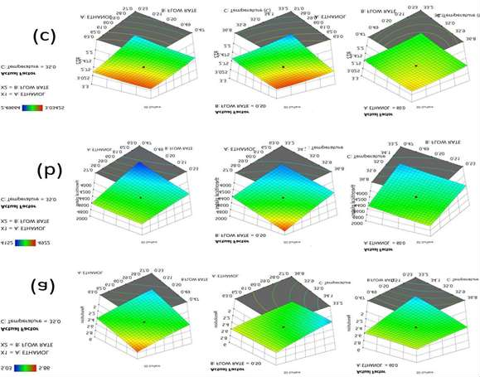
[Table/Fig-4]:3DContourplotsforoptimizedmethodwithinteractionofthreefactorson(a)R1,
(b) R2,and(c)R3.

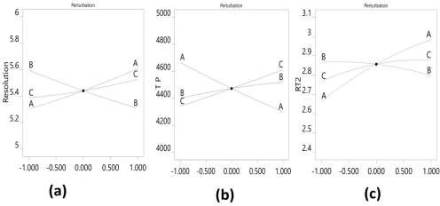
[Table/Fig-5]:Perturbationplotsforoptimizedmethodwithinteractionofthreefactorson (R 1, (b) R 2, and (c) R 3.
Based on the DoE results, the process model equations were derived and statistically confirmed using ANOVA for each model coefficient. This section's model coefficients were statistically significant (P values 0.0001). Furthermore, the F-ratios illustrate the significance of each coefficient in the model. larger R2 and lower LOF values imply a well-fitting model, whereas larger F-ratios show statistical significance for the analyticalmodel equation. [Table/Fig- 4,5]showthe 3Dcontour and perturbation plots for the A, B, and C interactions.
Table/Fig6:Constraintsandgoalsselectedfortheoptimizedmethod
A:ETHANOL istarget= 57.027 |  | 62.97 | 1 | 1 | 3
B:FLOWRATE istarget= 0.47 |  | 0.52 | 1 | 1 | 3
0.50
C: Temperature isin range | 33.21 | 36.78 | 1 | 1 | 3
Resolution isin range | 5.03 | 5.86 | 1 | 1 | 3
Theoretical isin range | 4152 | 4922 | 1 | 1 | 3
RT2 isin range | 2.496 | 3.034 | 1 | 1 | 3

Name Goal Lower Upper Lower Upper Importance 60.0

plates

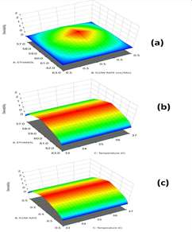

[Table/Fig-7]:3Ddesirabilityplotsfortheoptimizedmethodwithinteractionofthreefactorson(a) R 1, (b) R 2, and (c) R
To ensure that the regression models were statistically viable for all three answers, ANOVA findings, LOF non-significance suitable standards of R2, and adjusted and expected R2 were used. These interwoven responses emphasised the importance of a practical strategy. Derringer's statistical model of desirability was used to find the optimal set of conditions based on the relevance and constraints of each response. The desirability technique demonstrated the attainment of specified goals within the limits established, and a specific experimental zone was searched for configurations in which the constraints set were attained to the maximum, i.e., cohesiveness.[Table/ Fig-6,7]

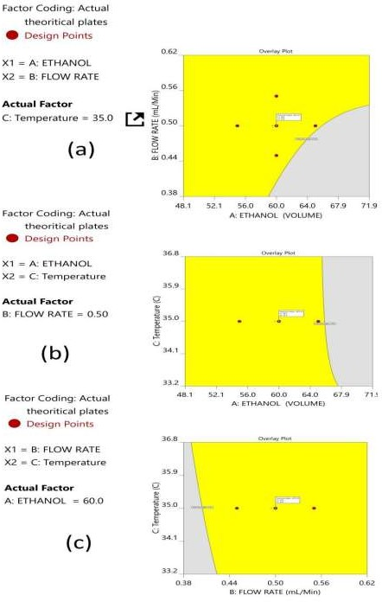

[Table/Fig-8]:Overlayplotsforthevariablesandresponseswithinteractionoffactors on(a)R1,(b) R 2, and (c) R 3
CMA models and robustness simulations were used in the development of the MODR, also known as the control space. The DoE zone for the optimised technique, also known as a desirability region, is depictedinFig.5as3DcontourplotsforvariouscombinationsofCMAs.TherobustnessMODRvalues areasfollows:columntemperatureis32–38°C;flowrateis0.45–0.55mL/min.Theidealmobilephase percentage variance is 5%. An ideal operating point within MODR was determined to be 0.5 mL/min flow rate and 34.609 °C column temperature. The expected CMAs for the working period were Rs = 5.425,N=4442,andRT2=2.843.ThegenuineCMAsatthepracticallyexecutedwereRsat5.413,N at4429,andRT2at2.84.Theoverlayplotsfortheoptimizedplotsindicatingthattheyellowregionis therangethatdoesnotrequireanyrevalidationfurtherwitheachinteractionaredepictedin[Table/Fig- 8]

ValidationaccordingtoICHguidelines Linearity study
Six distinct proportions of standard concentrations were prepared individuallytomeasure the linearity range.Thecalibrationcurvewasobtainedaspeakareaversusstandardsolutionconcentration.TheEBS andGZPstudysolutions were preparedwithaconcentration rangingfrom 5to30µg/mLand10to60 µg/mL,respectively.Correlationcoefficients(R²)forEBSandGDP0.9994and0.9998wereobserved.

A.
70
60
50
40
30
20
10
0
100000
80000
60000
40000
20000
0
y=2100x+1272,9
R² = 0,9994
140000
120000
B.

 |  |  |  | y =9965,3x | - 53,467
 |  |  |  | R² =0, | 9998

Table/Fig9:Linearitygraphsfor(a)EBSand(b)GZP
350000
300000
250000
200000
150000
100000
50000
0
0
5
10
15
20
25
30
35

Accuracy:

Drug | Amount | Amountfound | AmountfoundMean | %  Recovery | Avg. | Pooled  %  recovery | SD | % RSD
 | 10 | 37.8 | 37.703 | 100.80 |  |  |  | 1.436
 | 10 | 38.19 | 37.703 | 101.84 | 100.54 |  |  | 1.436
 | 10 | 37.12 | 37.703 | 98.99 |  |  |  | 1.436
 | 20 | 75.66 | 75.393 | 100.88 |  | 100.16 | 1.16  6 | 1.040
 | 20 | 74.51 | 75.393 | 99.35 | 100.52 | 100.16 | 1.16  6 | 1.040
EBS | 20 | 76.01 | 75.393 | 101.35 |  | 100.16 | 1.16  6 | 1.040
EBS | 30 | 112.67 |  | 100.15
EBS | 30 | 112.25 | 111.827 | 99.78 | 99.40 |  |  | 0.998
 | 30 | 110.56 |  | 98.28
 | 20 | 20.32 | 20.17 | 101.60 |  |  |  | 0.893
 | 20 | 19.97 | 20.17 | 99.85 | 100.85 |  |  | 0.893
 | 20 | 20.22 | 20.17 | 101.10 |  |  |  | 0.893
 | 40 | 40.37 | 40.506 | 100.93 | 101.27 | 100.67 | 1.14  6 | 0.501
 | 40 | 40.74 | 40.506 | 101.85
 | 40 | 40.41 | 40.506 | 101.03
GZP | 40 | 40.41 |  | 101.03
GZP | 60 | 60.96 |  | 101.60
 | 60 | 59.84 | 59.933 | 99.73 | 99.89 |  |  | 1.640
 | 60 | 59 |  | 98.33
Table/Fig10:Accuracyresultsforthedevelopedmethod
The consistency of an analytical technique refers to how similar the method's results are to the actual value.Asseenin[Table/Fig-10],accuracyresultsshowedapercentagerecoveryof98.4–101.9%atal three levels (80, 100, and 120 %). The percentage recovery findings were within the acceptable level and, ranged from 98.33 % to 101.84 %, respectively, indicating that the procedure should be used for routine drug evaluation.

Precision:

Intra-day

Inter-day

Conc.[μg/mL] | Amountfound Mean ± SD  [ n = 3] | [μg/mL]  % RSD | Amountfound Mean ± SD  [n = 3] | [μg/mL]  % RSD
5 | 4.94 ±4.12 | 0.967 | 5.02 ±2.67 | 1.136
10 | 9.04 ±4.12 | 1.217 | 9.93 ±2.21 | 0.300
15 | 15.96±2.12 | 0.790 | 32.02±3.56 | 0.674
10 | 10.08±1.67 | 1.081 | 10.04±1.78 | 1.278
20 | 19.96±3.01 | 0.708 | 19.98±1.14 | 0.511
30 | 30.98±3.78 | 0.572 | 29.03±1.89 | 0.904
[Table/Fig-11]:ResultsofPrecisionStudies(Intra-dayandInter-day)
The intermediate precision results indicated that the method is accurate within reasonable limits forboth solutions. [Table/Fig-11] shows that the acceptable precision RSD was less than 2.0 %.

Systemsuitability:

S.No | Parameter | EBS | GZP
1 | RetentionTime | 1.703 | 2.849
2 | Resolution | 5.14 | 5.24
3 | Tailing Factor | 1.02 | 1.11
4 | TheoreticalPlates | 7435 | 44654
[Table/Fig-12]:Systemsuitabilityparametersforthedevelopedmethod
Aftersixrepeatedinjections,thesystemsuitabilityresultsshowedalackofsignificantdifferenceinthe CAAslikeKʹ,RT2,andRsofEBSandGZP.The%RSDvalueswerelessthan2%,indicatingthatthe chromatographic instrument has high accuracy [Table/Fig-12].

SolutionStability

Time
RT Numberof
theoreticalplates

 | EBS | GZP | GZP | EBS
0 min | 1.696 | 2.849 | 44924 | 7521
Sample 24 h | 1.694 | 2.856 | 44857 | 7555
72 h | 1.695 | 2.852 | 44752 | 7455
%RSD | 0.059 | 0.12312 | 0.19333 | 0.67702
0 min | 1.703 | 2.765 | 44721 | 7420
Standard 24 h | 1.714 | 2.745 | 44825 | 7506
72 h | 1.711 | 2.742 | 44924 | 7521
%RSD | 0.33266 | 0.45456 | 0.22647 | 0.72839
[Table/Fig-13]:SolutionstabilityofthedevelopedHPLCmethod
EBS and GZP standard sample solutions were checked for stability over three days at 35 ±2 °C. The percentage assay value for the analyzed standard samples was compared to freshly prepared samples shows within limits with an acceptable % RSD of < 2. The overall results are depicted in [Table/Fig- 13]

Specificity
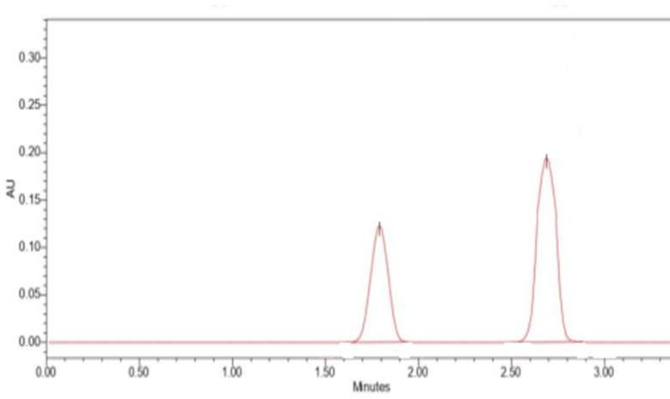

Table/Fig14:ChromatogramofEBSandGZP
Specificityreferstothesubstance'sabilitytobemeasuredpreciselyinthepresenceofthematrixeffect andanyadditivesusedtoensuretheidentificationoftheanalyte(s)ofinterest.Theblank,standard,and assaytest solutionswere analyzed, andeachsolution'sEBSandGZPpeaks werecalculated. ThePDA detector was used to determine the peak purity under specified chromatographic conditions. Both compounds were separated, and there was no evidence of analyte retention time drift.as shown in [Table/Fig -14].

Robustness

ChromatographicConditions | EBS  tR | GZP  tR
FlowRate (mL/min)
0.90 | 1.78 | 2.83
1.00 | 1.80 | 2.84
1.10 | 1.82 | 2.76
Mean±SD | 1.8±0.35 | 2.8±0.42
Mobilephasecomposition(v/v)
45:55 | 1.76 | 2.77
40:60 | 1.82 | 2.83
35:65 | 1.86 | 2.79
Mean±SD | 1.81±0.19 | 2.79±0.157
ChangeinColumn Temperature  25 ⁰C | 1.78 | 2.78
b)30 ⁰C | 1.81 | 2.83
Mean±SD | 1.79±0.45 | 2.80±0.78
[Table/Fig-15]:RobustnessStudies
The standard deviation of peak areas was calculated for each parameter and %R.S.D. was found to be less than 2%. The low %R.S.D. values indicated method is robust. Results are shown in [Table/Fig - 15]

Ruggedness
The proposed method wasevaluated by two different analysts in the ruggednessstudy. The results for EBSwere found to be99.89 %, 99.91 %and forGZP 100.23, 99.97 %, respectively.

LimitofDetection(LOD)andLimitofquantitation(LOQ)
LODofEBSandGZPwerefoundtobe13.45and45.86.LOQofEBSandGZPwerefoundtobe
124.23and144.14respectively

Forceddegradationstudies
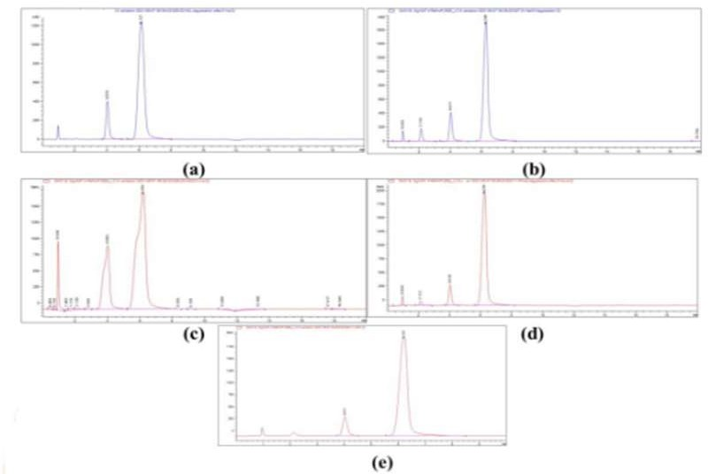
[Table/Fig-16]:ForceddegradationofEBSandGZPa)Acidicconditionb)BasicConditionc)
Oxidationd)Dryheate)Photolightcondition

Drug Condition | Time | % Assay | % Degradation
Acid | 6 h | 87.478 | 12.522
Base | 6 h | 89.438 | 10.56
EBS Oxidation | 6 h | 82.245 | 17.755
Dryheat | 6 h | 97.77 | 2.43
Photolight | 6 h | Nodegradation | Nodegradation
Acid | 6 h | 87.633 | 12.367
Base | 6 h | 97.485 | 2.51
GZP Oxidation | 6 h | 92.97 | 7.03
Dryheat | 6 h | 91.55 | 8.45
Photolight | 6 h | Nodegradation | Nodegradation
[Table/Fig-17]:ForceddegradationstudiesforEBSandGZP.
ForceddegradationtestswereundertakenontheEBSandGZPdrugcombinations.The0.1MHCl,0.1 MNaOH,3%H2O2,dryheatandUVlightwaspickedasprimarystresscondition.Thisgavereliable information regarding the stability of EBS and GZP. No drug was degraded instantly after adding the acid,base,orperoxide,allowingittostandfor1,3,and6h.Thestudyreportof1and3hhasnotshown a noticeable degradation, further allowed to stand for 6 h and found the drugs tend to degrade at this time, and the results and the degradation peaks were portrayed in [Table/Fig -16,17]

Assayofmarketed formulation
This demonstrates the selectivity of the technique for determining EBS and GZP in tablets, where resulting as good and were achieved without any detected interference from the excipients.The suggested approach is successfully used to determine the presence of EBS and GZP in tablets.

Greenassessmentofdevelopedandreportedmethod
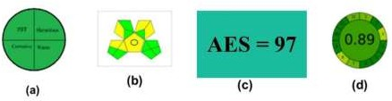

[Table/Fig-18]:GreenAssessmentresultsa) NEMIb)GAPIc)AESd) AGREE
The developed method was assessed using green assessment tools, and the results were depicted in [Table/Fig-18],Theresultsshowthatthenewmethodiscompletelyeco-friendlyandcanbeusedasa long-termmethod. Ithasascore of nine green pictogramsoutoffifteen for GAPI, four greenpartsfor NEMI, a score of 97 for AES, and a score of 0.89 for AGREE.
Stability-indicatingHPLCmethodwasdevelopedforthesimultaneousestimationofEBSand GZPin its tablet dosage form. Quantification was achieved with ultraviolet detection at 253 nm. Green analytical chemistry (GAC) has mainly focused on developing analytical methods that are safe for the environment.Therefore,itisimperativethattheGACprinciplesbeappliedinpharmacologicalanalysis. Arotatablecentralcompositedesignwasemployed,andtheoptimizedconditionsforchromatographic separation were made with a run time of 5 minutes using Zorbax C18 column (4.6× 150 mm, 5 µm) with 0.1% Trifluoroacetic acid and ethanol (40:60 v/v) as components of a mobile phase, flowing at a rateof1.0ml/minute.TheretentiontimeobtainedforEBSwasat1.8minandforGZPwasat2.84min. The result obtained with the detector response was found to be linear in the concentration range of 5- 30 μg/ml for EBS and 10-60 μg/ml for GZP. The value of correlation coefficients greater than 0.999 indicate good linearity response in the above-mentioned range. The sensitivity of the method was assessed by determining LOD and LOQ. For EBS, LOD and LOQ was found to be, 13.45 and 124.23 respectively. For GZP, LOD and LOQ was found to be 45.86 and 144.14 respectively. The proposed methodwasappliedforpharmaceuticalformulationand %labelclaimfor EBSand GZPwasfoundto be 99.70. and 99.91, respectively. The amount of drugs estimated by proposed method was in good agreement withthelabel claim. Therecoverystudieswerecarriedout at 80,100,120%level. %RSD valueslessthan2indicativeofaccuracyofthemethod.Themethodwasfoundtobepreciseasindicated bytheinter-day,intra-dayandrepeatabilityanalysis;%RSDlessthan2.Inrobustnessstudy,different parameters(mobilephasecomposition,changeinflowrate,columntemperature)werestudiedandthe effects on the results were examined. Low values of % RSD proved method to be robust.
StabilityofEBSandGZPwascarriedoutbyforceddegradationstudy. [32-33]Thechromatogramsof samples degraded with acid, base, hydrogen peroxide and light showed well separated spots of pure EBS and GZP as well as some additional peaks at different Rt values. The method is successively applied to pharmaceutical formulation; No chromatographic interferences from the tablet excipients were found. The suitability of this HPLC method for quantitative determination of the compounds is proved by validation in accordance with the requirements of ICH guidelines. 3 randomized response surface designs with a full fraction design were used with 20 trial runs to study the impact of three factorsonthethreekeyresponsevariables.Inthisdesign3factorswereevaluated,eachat3levels,and experimental trials were performed at 3 possible combinations. The resulting data were fitted into DesignExpert10Softwareandanalyzedstatisticallyusinganalysisofvariance(ANOVA)andF-Test. The data were also subjected to 3-D response surface methodology to determine the influence of flow rate, temperature and mobile phase composition on dependent variables. [34-35]
Four greennessassessmentmethods wereapplied inthe presentedstudy. In NEMI, circle symbol with fourquarterswasdesignedasapictogram;eachquartersignifiedacomponentofthemethodthatcould potentially negatively influence the environment.[36] GAPI is good semi quantitative tool for laboratory practice and educational purposes. It evaluates and quantities the environmental impact involved in each step of an analytical method. It has many advantages of being simple method has a pictogram with three levels (red, yellow, and green), assess the green character of an entire analytical methodology. The greenness of the current method was assessed by utilizing the analytical eco-score tool,calculatingthepenaltypoints.Theeco-scorevalueof97isintherangeofexcellent

greenness.AGREEis a modern tool that evaluates all 12 green principles using appropriate software. The AGREE circle is divided into 12 parts; each part describes one green principle, and the estimated AGREE value of the current method is 0.89.[37].

Conclusion
The developed method showed green analytical procedure regarding GAC principles. This study demonstratestheinnovativeincorporationofAQbDandgreenanalyticalchemistry(GAC)throughthe analytical method development for the determination of EBS and GZP in bulk and its dosage forms. The eco-friendly methods provide better method performances, being an additional motivation for implementation of the GAC concept in the R&D departments and quality control labs in the pharma industry.GreenAnalyticalPerformancesbytheQbDtechniqueforevaluatingstabilityofthedrugwas found to be environment friendly.The implementation of the green strategies in the pharma analysis will provide benefits for the analysts healthier working environment, this technique will also help commercial and industrial lab research and testing departments adopt and evaluate the various combination in bulk and dosage forms.

References:
- Turner.Sustainableanalyticalchemistry-morethanjustbeinggreen. PureAppl.Chem.2013;85(12):2217– 2229 .https://doi.org/10.1351/pac-con-13-02-05
- GałuszkaA,MigaszewskiZ,NamiesnikJ.The12principlesofgreenanalyticalchemistryandthesignificance mnemonic of green analytical practices. Trends in Analytical Chemistry. 2013;50:78-84. DOI: 10.1016/j.trac.2013.04.010
- BagaglioS,UbertiFC,MorsicaG.ResistanceMechanismsinHepatitisCVirus:implicationsforDirect-Acting Antiviral Use. Drugs. 2017;77(10);1043-1055 doi: 10.1007/s40265-017-0753-x
- https://www.drugbank.ca/drugs/DB11574
- https://en.wikipedia.org/wiki/Grazoprevir
- Zepatier(elbasvir/grazoprevir) [prescribing information] Whitehouse Station, NJ: Merck & Co Inc; January 2016.
- ZeuzemS,GhalibR,ReddyKR.Grazoprevir-elbasvircombinationtherapyfortreatment-naivecirrhoticand noncirrhoticpatientswithchronichepatitisCvirusgenotype1,4,or6infection:Arandomized trial. Ann Intern Med. 2015;163(1):1–13.
- Attia AAM,Nasr MEA,Ahmed EO,Ahmed HA.Simultaneous Spectrophotometric Determination of ElbasvirandGrazoprevirinaPharmaceuticalPreparation.JAOAC2018;101(2):394-400.doi:10.5740/ jaoacint. 17-0037
- ZeidAM,AhmedHA,MohammedS.Simultaneousspectrophotometricquantitativeanalysisofelbasvirand grazoprevir using assisted chemometric models.Spectrochimica Acta Part A: Molecular andBiomolecular Spectroscopy.. 2021;251. 119505 https://doi.org/ 10.1016/j.saa. 2021.119505
- Attia KAM, El-Olemy A, Ramzy S, Abdelazim AH, Hasan MA, Abdel-Kareem RF.Simultaneousdetermination of elbasvir and grazoprevir in their pharmaceutical formulation by synchronousfluorescence spectroscopy coupled to dual wavelength method.Spectrochim Acta A Mol BiomolSpectrosc. 2021;248:119157. doi: 10.1016/j.saa.2020.119157. Epub 2020 Nov 4.
- AttiaKAM,El-OlemyA,RamzyS,AbdelazimAH.Applicationofdifferentspectrophotometricmethodsfor Simultaneous determination of Elbasvir and Grazoprevir in pharmaceutical preparation, Spectrochimica Acta Part A: Molecular and Biomolecular spectroscopy.2018;189(15): 154- 160.10.1016/ j.saa.2017.08.026
- AttiaKAM,AbasawiNME, OlemyAE,AbdelazimAH,DosokyA.SimultaneousDeterminationofElbasvir and Grazoprevir in Their Pharmaceutical Preparation Using High-Performance Liquid Chromatographic Method Journal of ChromatographicScience.2018;56(8):731– 737.https://doi.org/10.1093/ chromsci /bmy049
- AkramN,UmamaheshM,RamachariT.AnewvalidatedRP-HPLCmethodforthedeterminationofelbasvir and grazoprevir in its bulk and pharmaceutical dosage forms. International Journal of Chemical & Pharmaceutical Analysis. 2017; 4:1-11

- Rao V,Rao AM ,Prasad SVU M. A Novel Stability Indicating RP-HPLC Method for Simultaneous EstimationofAnti-ViralClassofElbasvirAndGrazoprevirInBulkAndPharmaceuticalDosageForm, International Journal of Pharmaceutical Sciences and Research. IJPSR. 2019; .10(2): 655-660.
- Nallagundla,ReddyHS,VemulaV,KumarB,NallagundlaS.AnalyticalMethodDevelopmentandValidation ofElbasvirandGrazoprevirinBulkandTabletFormulationsbyRp-HPLC.InternationalJournalof Pharmaceutical Science Invention.2017 ;6(8): 01-05
- Raju GE,Shiny S, Rao N , Raghava R .Method development and validation for simultaneous estimation of elbasvir and grazoprevir by RP-HPLC world journal of pharmaceutical and life science.2022; 8(10):124-134
- Kumar VP ,Kumar AV , Sivagami B ,Sireesha R ,Kumar RC , Babu MN.Stability indicating RP-HPLC method development and validation for the simultaneous estimation of Grazoprevir and Elbasvir in bulk and pharmaceutical dosage form.International Journal of Research In Pharmaceutical Chemistry and Analysis.2018;1(1): 1-7
- KumarDV,RaoJVLNS.AnewvalidatedstabilityindicatingRP-HPLCmethodforsimultaneousestimation of grazoprevir and elbasvir in tablet dosage forms. Int J Pharm Sci & Res .2020; 11(4): 1653-59. doi: 10.13040/IJPSR.0975-8232.11(4).1653-1659.
- Labidi A, Jebali S, Safta M. ..RP-HPLC Stability Indicating Method Development and Validation for Simultaneous Determination of Grazoprevir and Elbasvir. Chemistry Africa.2021;4, 607–619 https://doi. org/10.1007 /s42250-021-00253-9
- Thoddi P,GautamGK ,NarasimhaCH, Raju BH. Stability indicating validated RP-HPLC method for Simultaneous estimation of Elbasvir and Grazopravir in Bulk and Pharmaceutical Dosage form. Research J. Pharm. and Tech. 2020; 13(2):950-955. doi: 10.5958/0974-360X.2020.00179.1
- Girija D, Reddy BV.Development and validation of new stability indicating RP-HPLC method for simultaneous estimation of elbasvir and grazoprevir in bulk and pharmaceutical dosage form.Indian drug. 2020; 57(9): 53-59.https: //doi.org/10.53879/id.57.09.11644
- VanchaAR,NareshD,Sowjanya1P,KumarGV.Analyticalmethoddevelopmentandvalidationforelbasvir andgrazoprevirincombinepharmaceuticaldosageformsbyRP-HPLC.IntJResDevPharmLifeSci 2016;4:94-101
- Kavitha V, Usha Kondla U,Kumar PV,Swapna G. A Rapid Novel Analytical Method For Simultaneous EstimationOfGrazoprevirAndElbasvirByUsingRP-HPLCEPRAInternationalJournalofResearch and Development. 2022; 7(9):108-114.DOI: 10.36713/epra2016
- HarithaP,RaoBS,SunandammaY.Picogramlevelquantificationofgrazoprevirandelbasvirwithdeuterated internal standards in human plasma samples by LC–ESI-MS/MS. Indian J Pharm Educ. 2016; 50 (4): 612-619.
- SaibabaSV,AshokH,PravalikaG,NikithaM,PavithraM,LavanyaP.MethodDevelopmentandValidation forSimultaneousEstimationofGrazoprevirandElbasvirinBulkDrugandFormulationbyUsingRP- HPLCInternational Journal of Scientific Research and Engineering Development.2022; 5(3) :1048- 1054
- MadhaviS,PrameelaRani,SimultaneousReverse-PhaseUltraPerformanceLiquidChromatographyMethod DevelopmentandValidationForEstimationOfGrazoprevirandElbasvir.2018;11(4):100-104. DOI: https:// doi.org/ 10.22159 /ajpcr.2018. v11i4.21721.
- Pena-pereira F,Wand W, Tobiszewski M. AGREE—analytical greenness metric approach and software. Anal. Chem.2020; 92: 10076–10082 .https:// doi.org/ 10.1021/ acs. analchem.0c01887
- Wasylka, J.P.(2018) A new tool for the evaluation of the analytical procedure: Green Analytical Procedure Index.Talanta.2018; 181: 204–209.https:// doi.org/ 10.1016/ j.talanta. 2018.01.013
- Int. Conf. on Harmonization (ICH) of Technical Requirements for the Registration of Pharmaceuticals for Human Use, Validation of Analytical Procedures: Methodology, ICH Q2B, Geneva 1996.
- Int. Conf. on Harmonization (ICH) of Technical Requirements for the Registration of Pharmaceuticals for Human Use, Validation of Analytical Procedures, ICH-Q2A, Geneva 1995.
- ICHGuidelineQ2(R1),Validationofanalyticalprocedures:textandmethodology, 2005, http://www.ich.org/LOB/media/MEDIA417.pdf
- BlessyM,PatelRD,PrajapatiPN,AgrawalYK.Developmentofforceddegradationandstabilityindicating studies of drugs—A review,Journal of Pharmaceutical Analysis. 2014; 4(3): 159-165.https://doi.org/10.1016/ j.jpha.2013.09.003
- Sutar SV, Yeligar VC and Patil SS. A Review: Stability Indicating Forced Degradation Studies. Research Journal of Pharmacy and Technology, 2019;12(2):885-890
- Fares MY, Hegazy MA, El-Sayed GM, Abdelrahman MM,Abdelwahab NS. Quality by design approach for green HPLC method development for simultaneous analysis of two thalassemia drugs in biological fluid with pharmacokinetic study. RSC Adv. 2022 May 9;12(22):13896-13916. doi: 10.1039/d2ra00966h. PMID: 35548387; PMCID: PMC9084420.
- Rathinam S,Santhana LK. Analytical quality by design approach for estimating rosuvastatin calcium in pharmaceutical formulation by green HPLC method: Ecologically evaluated and stability- indicating.Journal of Applied Pharmaceutical Science.2021 ; 11(11):150-160.DOI: 10.7324/JAPS.2021.1101119

- Guardia S.A.M.dela ,A green evaluation of existing analytical methods, in, Green Anal. Chem., ed.M.D.La Guardia and S.B.T.-C.A.C. Armenta,no.11,2011,ch.3, vol.57,pp.39–57.
- GałuszkaA,Migaszewski Z M, Konieczka P, Namieśnik J. Analytical Eco-Scale for assessing the greenness of analytical procedures. Trends Analyt. Chem.2012, 37, 61–72. 10.1016/j.trac.2012.03.013

