Mercury Metal in Sediment and Water Column of Taluduyunu River and its Control Strategy

.
ABSTRACT
Mercury pollution can have a negative impact on the environment and the health of local communities. However, there is no scientific information related to mercury content in Taluduyuno River as the location of unlicensed mining activities. The purpose of this study is to analyses the level of mercury in the sediment and water column of Taluduyunu River. This information will be critical in developing effective strategies to reduce mercury pollution. The sampling location was Taluduyunu River, Hulawa Village, Buntulia Sub-district, Pohuwato Regency. This study used survey and observation methods as well as laboratory. The sampling locations are presented on the map below. The results show that the mercury content in the sediment and water column is above the quality standard with varying concentrations. And the results also show that the mercury content in the sediment is higher than in the water column. The high mercury content in the Taluduyunu River has the potential to threaten the health of the river ecosystem and humans. It is necessary to educate and socialize the dangers of mercury for ecosystems and humans by involving community leaders and law enforcement.

Keywords: mercury pollution; sediment; water column; Taluduyunu

1. INTRODUCTION

Mercury is a heavy metal known for its toxic effects on human health and the environment. Mercury is commonly found in various forms, including elemental mercury, inorganic mercury compounds, and organic mercury compounds. The presence of Mercury in the environment is Maily caused by human activities such as industrial processes, coal combustion, and waste incineration. Mercury pollution in water bodies is a serious environmental problem . It has the potential to pose serious risks to human health and aquatic ecosystems. The presence of mercury in water can be attributed to various sources as industrial discharges, mining activities, and fossil fuel combustion (Wang et al., 2004).
Mercury once released into the environment will accumulate in the food chain through bioaccumulation and biomagnification . The implication can result in high mercury levels in fish and other aquatic organisms. This in turn poses a threat to human health when consumed (Pant et al., 2024). Mercury pollution in water bodies not only poses a risk to human health but also has a detrimental impact on the ecosystem as a whole. High mercury content can cause reproductive problems, neurological damage, and even death in aquatic organisms.
According to (Balali-Mood et al., 2021) mercury is the most dangerous of all heavy metals and has no active excretion mechanism in the human body. Mercury poisoning can have serious health effects, especially on the nervous system and kidneys. In addition, mercury pollution can disrupt ecosystem balance, leading to a decrease in biodiversity and overall ecosystem health (Cristiano et al., 2021).
According to Wahl et al. (2021), studies related to small-scale gold mining in several regions have been a significant source of mercury contamination in rivers. Disposal of mercury mining waste, especially from mercury mines, is also a concern. Due to high concentrations of mercury and sulfate, it can cause mercury methylation. While the other side reported by (Agustin et al., 2024)
Pohuwato Regency in Gorontalo Province has several gold mining and processing sites carried out by the community, especially in Buntulia District, Paguat District, and West Popayato District. These activities often produce waste that is discharged without adequate treatment, potentially contaminating the river with heavy metals. This pollution can have a negative impact on the environment and the health of local communities. However, there is no scientific information regarding the mercury content in Taluduyuno River as the location of unlicensed mining activities.
The purpose of this study is to analyze mercury levels in the sediment and water column of the Taluduyuno River. This information will be critical in developing effective strategies to reduce mercury pollution and protect the overall health of the river ecosystem.

2. material and methods

This research was conducted from September to November 2024. The sampling location was carried out in the Taluduyunu River, Hulawa Village, Buntulia District, Pohuwato Regency. This research uses survey and observation methods and laboratories.
The tools used in this study include; sample bottles for taking water samples, plastic bags for taking substrate and sediment samples, thermometers for measuring temperature, cool box containers for storing temporary samples, aluminium foil for covering or protecting sample bottles, label paper for marking samples, tissue for cleaning tools and litmus paper for measuring pH., and global positioning system (GPS) for location determination tools. While the materials used in this study are water samples and substrates for research objects.IIndicate the coordinates of the sampling stations/locations
Determination of sampling points is carried out using purposive sampling method, namely seeing with certain considerations (selected sampling points that have traditional gold mining activities from upstream, middle and downstream locations). The sampling locations are presented on the map below.
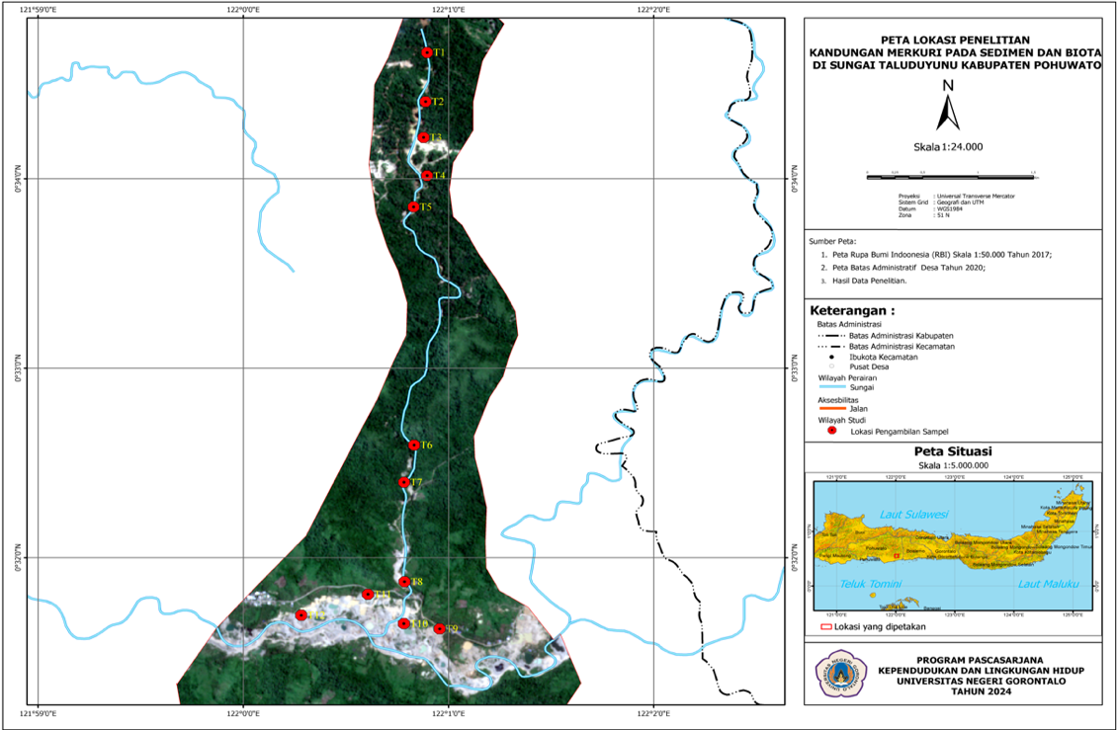
Figure 1. Research location, red dots indicate sampling stations.

3. results and discussion

The presence of mercury metal in river waters and sediments is due to anthropogenic and natural factors. One of the anthropogenic sources of mercury is the traditional mining activities carried out by the community. The following outlines the results and discussion covering the mercury content in the sediments and water column of the Taluduyunu River.
1. Mercury Content in Sediments
Based on the measurement of mercury in the sediment at the research location, the laboratory analysis results are presented in the table below.

Table 1. Mercury Content in the Sediments of the Taluduyunu River
Station | Concentration(ppm) Sediment | Quality Standards (ppm)
T1 | 0,61 | 0,3
T2 | 3,75 | 0,3
T3 | 2,23 | 0,3
T4 | 2,24 | 0,3
T5 | 1,72 | 0,3
T6 | 1,35 | 0,3
T7 | 1,61 | 0,3
T8 | 2,76 | 0,3
T9 | 1,33 | 0,3
T10 | 1,35 | 0,3
T11 | 1,21 | 0,002
T12 | 0,91 | 0,002
(Source: Laboratory Test Results, 2024)
Based on Table 1 above, it shows that the mercury content in the sediment varies. The table also provides information that the content of heavy metal mercury in the sediment of the Taluduyunu River is above the quality standard. The highest concentration of 3.7528 ppm is at station 2. This location is the site of the largest traditional mining activity along the Taluduyunu River. While the lowest is at station 12. This illustrates that the concentration of mercury in the sediment is absolutely influenced by traditional mining activities carried out by the Community. This is in line with statement a (Lechler et al., 2000) that one of the factors contributing to the high mercury content in water bodies is traditional mining.

2. Mercury Content in water

Based on mercury measurements in the water column at the research location, the results of laboratory analysis are presented in the table below.

Table 2. Mercury Content in Water of the Taluduyunu River

Station | Column (ppm) | Quality standards
T1 | 0,1450 | 0,002
T2 | 0,8950 | 0,002
T3 | 0,7660 | 0,002
T4 | 0,2970 | 0,002
T5 | 0,4870 | 0,002
T6 | 0,4280 | 0,002
T7 | 0,0470 | 0,002
T8 | 0,0810 | 0,002
T9 | 0,0390 | 0,002
T10 | 0,0650 | 0,002
T11 | 0,0530 | 0,002
T12 | 0,0790 | 0,002
(Source: Laboratory Test Results, 2024)
Based on Table 2 above, it shows that the mercury content in the water column varies. And the table also provides information that the content of heavy metal mercury in the Taluduyunu River water column is above the quality standard. The highest concentration, namely 0.8950, is at station 2. Based on field observations, this location is the site of the largest traditional mining activity along the Taluduyunu River. While the lowest concentration is at station 4. According to (Ullrich et al., 2001; Whalin et al., 2007), the factors that cause the easy loss of mercury concentration on the water surface are its high volatility and because of photochemical and bacterial aspects.

Figure 2. Comparison of Mercury in Sediment and Water Column

Based on the graph in Figure 2 above, it shows that overall, the mercury content in the sediment is higher compared to the water column. According to (Ignatavičius et al., 2022), the high mercury content in sediments is due to the property of mercury to easily bind and the high organic matter content in sediments. (Ekawati et al., 2023) state that the deposition of heavy metals in water occurs due to the presence of hydroxyl and carbonate chloride anions. Heavy metals have the property of easily binding with organic materials and settling at the bottom of water bodies, thus merging with sediments, resulting in higher concentrations of heavy metals in the sediments than in the water. Based on research According to Insiani (2020) the amount of mercury used depends on the size of the drum or spindle used, but the average mercury use per drum or spindle ranges from 100 grams to 1 kilogram. The high use of mercury causes high levels of mercury to be discharged into river water bodies.

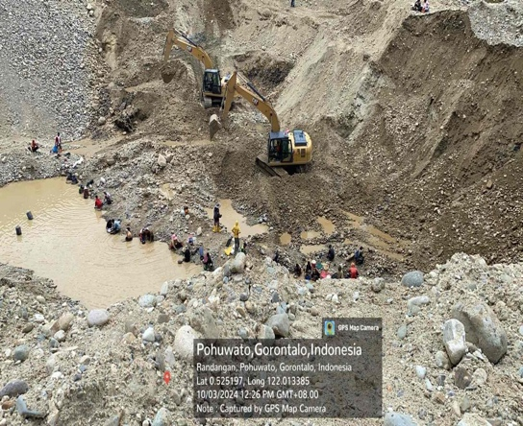

Figure 3. Traditional mining conditions on the Taluduyunu River

Traditional mining communities generally believe that their activities will not damage the river ecosystem, including having a negative impact on humans. This condition occurs because the average community engaged in traditional mining activities belongs to a group with relatively low educational levels. In addition, economic pressures drive them to make traditional mining their livelihood choice. Thus, a comprehensive approach to controlling mercury metal pollution in the Taluduyunu River includes: 1. Cultural approach through traditional leaders, religious leaders, and community leaders; 2. Social approach through non-formal education about the dangers of mercury for the survival of living beings, including humans; 3. Economic approach through life skills training to encourage the transformation of livelihoods to more sustainable practices; 4. Legal approach through effective law enforcement against activities that violate regulations.

4. Conclusion

The mercury content in the sediment and water column of the Taduluyunu River exceeds the threshold. And the mercury content in the sediment is higher than in the water column. This means that traditional mining activities have had a significant impact that has the potential to have a negative impact on the ecosystem and humans. Control through an integrative approach is very important, including a cultural approach, an economic approach, an educational approach and a legal approach in controlling mercury pollution in this river.

References

Agustin, R., Muhammad, D., & Kalsum, U. (2024). Persepsi Risiko Kontaminasi Merkuri pada Pekerja Penambangan Emas Skala Kecil (PESK) di Kecamatan Limun. Jurnal Ilmiah Universitas Batanghari Jambi, 24(2), 1357. https://doi.org/10.33087/jiubj.v24i2.4901
Balali-Mood, M., Naseri, K., Tahergorabi, Z., Khazdair, M. R., & Sadeghi, M. (2021). Toxic Mechanisms of Five Heavy Metals: Mercury, Lead, Chromium, Cadmium, and Arsenic. Frontiers in Pharmacology, 12(April), 1–19. https://doi.org/10.3389/fphar.2021.643972
Cristiano, W., Giacoma, C., Carere, M., & Mancini, L. (2021). Chemical pollution as a driver of biodiversity loss and potential deterioration of ecosystem services in Eastern Africa: A critical review. In South African Journal of Science (Vol. 117, Issues 9–10). Academy of Science of South Africa. https://doi.org/10.17159/SAJS.2021/9541
Ekawati, W., Chaerul, M., & Marzuki, I. (2023). Characteristics of Distribution of Heavy Metals in Rivers Around Laterite Nickel Mining Sites in the Tanggetada Area, Kolaka Regency, Southeast Sulawesi Province. Astonjadro, 12(3), 814–822. https://doi.org/10.32832/astonjadro.v12i3
Ignatavičius, G., Unsal, M. H., Busher, P. E., Wołkowicz, S., Satkūnas, J., Šulijienė, G., & Valskys, V. (2022). Geochemistry of mercury in soils and water sediments. In AIMS Environmental Science (Vol. 9, Issue 3, pp. 277–297). American Institute of Mathematical Sciences. https://doi.org/10.3934/ENVIRONSCI.2022019
Lechler, P. J., Miller, J. R., Lacerda, L. D., Vinson, D., Bonzongo, J.-C., Lyons, W. B., & Warwick, J. J. (2000). Elevated mercury concentrations in soils, sediments, water, and fish of the Madeira River basin, Brazilian Amazon: a function of natural enrichments? The Science of the Total Environment, 260, 87–96.
Pant, R., Mathpal, N., Chauhan, R., Singh, A., & Gupta, A. (2024). A Review of Mercury Contamination in Water and Its Impact on Public Health BT - Mercury Toxicity Mitigation: Sustainable Nexus Approach (N. Kumar, Ed.; pp. 93–115). Springer Nature Switzerland. https://doi.org/10.1007/978-3-031-48817-7_4
Ullrich, S. M., Tanton, T. W., & Abdrashitova, S. A. (2001). Mercury in the aquatic environment: A review of factors affecting methylation. Critical Reviews in Environmental Science and Technology, 31(3), 241–293. https://doi.org/10.1080/20016491089226
Wahl, A.-M., Bose-O’reilly, S., Mambrey, V., Rooney, J. P. K., Shoko, D., Moyo, D., Muteti-Fana, S., Steckling-Muschack, N., & Rakete, S. (2021). Analysis of the Mercury Distribution in Blood as a Potential Tool for Exposure Assessment-Results from Two Artisanal and Small-Scale Gold Mining Areas in Zimbabwe. Biological Trace Element Research, 200, 961–968. https://doi.org/10.1007/s12011-021-02714-1/Published
Wang, Q., Kim, D., Dionysiou, D. D., Sorial, G. A., & Timberlake, D. (2004). Sources and remediation for mercury contamination in aquatic systems—a literature review. Environmental Pollution, 131(2), 323–336. https://doi.org/10.1016/J.ENVPOL.2004.01.010
Whalin, L., Kim, E. H., & Mason, R. (2007). Factors influencing the oxidation, reduction, methylation and demethylation of mercury species in coastal waters. Marine Chemistry, 107(3), 278–294. https://doi.org/10.1016/j.marchem.2007.04.002

Insiani,2020

